**Data Structures** are different ways of organizing data on your computer, that can be used effectively.

**Algorithms –** set of steps to accomplish a task. In CS, it’s a set of rules for a computer program to accomplish a task.

What makes a good algorithm?

* Correctness
* Efficiency

**Types of Data Structures**

1. Primitive data structures – built in the programming language itself and are available to the programmer e.g. integer, float, character, string, and Boolean
2. Non-primitive data structures – user defined data structures, combine two or more data structures divided into:

Linear data structure – data items are arranged in memory in a linear sequential manner and can be static or dynamic. Static linear DS – structured associated memory locations are fixed in the runtime but in dynamic linear DS memory locations change.

Non-linear DS – data item is connected to several other data items.

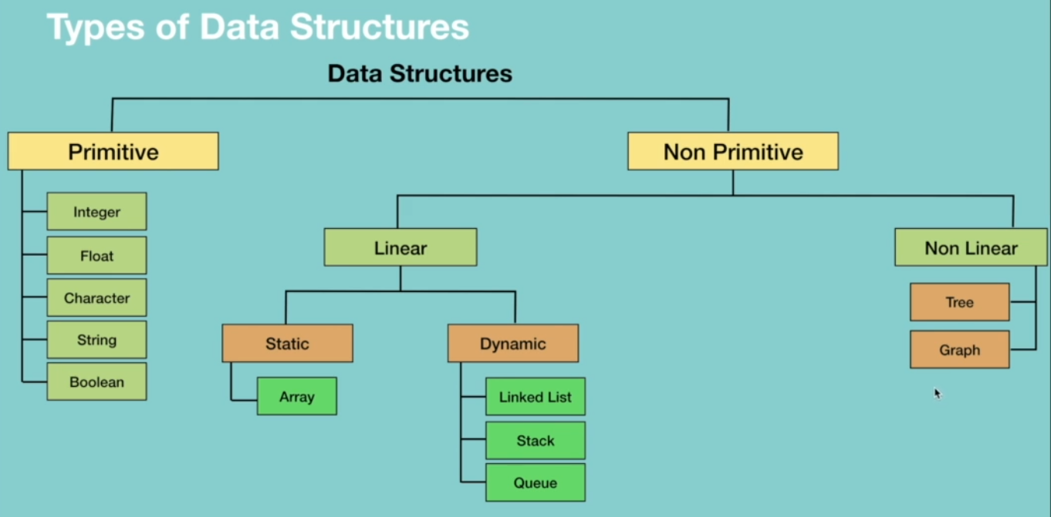



**Types of Algorithms**

They are classified either based on the type of problem they are trying to solve or based on the problem-solving technique.

They include:

* Simple recursive algorithms
* Divide and conquer algorithms
* Dynamic programming algorithms
* Greedy algorithms
* Brute force algorithms
* Randomized algorithms

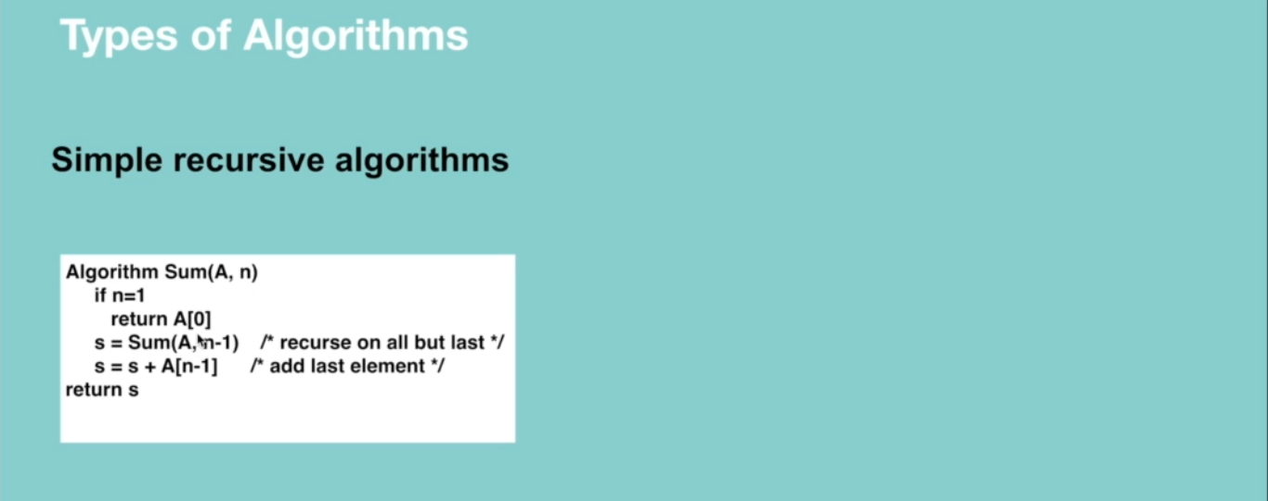

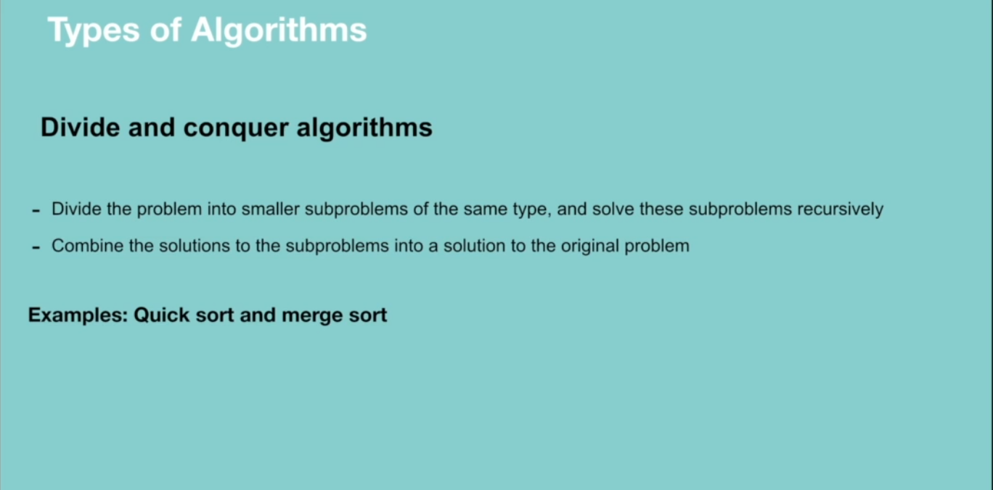

Dynamic programming works on memoization which means the algorithm remembers the past results and use them to find new results. It’s generally used for optimization problems i.e. to find the best solution among multiple solutions.

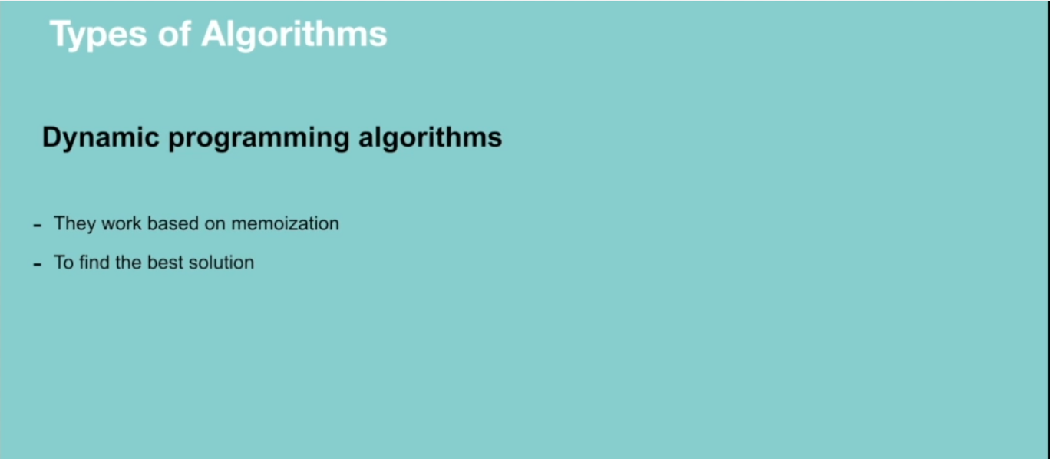

Greedy algorithm works in phases. It’s also used for finding the best solution i.e. optimization problems.

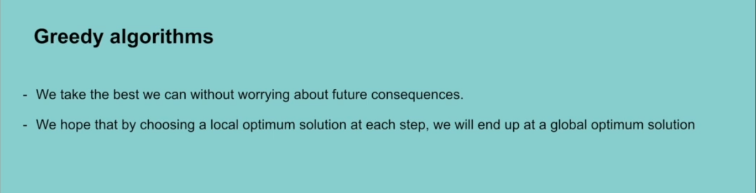

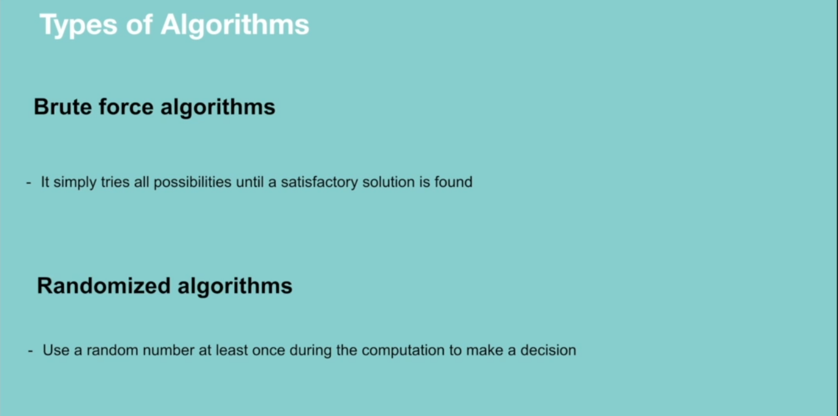

**RECURSION**

A way of solving a problem by having a function calling itself.

**Properties of recursion**

* Performing the same operation multiple times with different inputs.
* In every step we try smaller inputs to make the problem smaller.
* A base condition is needed to stop the recursion.

**Why Recursion?**

* Recursive thinking is really important in programming and it helps you break down big problems into smaller ones and easier to use. Note: There are situations when iterations perform better than recursion.

When to choose recursion – when you can divide the problem into similar subproblems. The subproblem must be similar otherwise recursion is not a choice.

**How do you know that the subproblem is similar in nature?**

* Design an algorithm to compute nth…
* Write code to list the n…
* Implement a method to compute all.

**Why Recursion**

* The prominent usage of recursion in data structures like trees and graphs.
* Many big companies ask questions in relation to recursion in the interviews.
* It is used in many algorithms (divide and conquer, greedy and dynamic programming)

**How Recursion works**

When designing a recursive call, we have to consider two conditions:

* A condition where a method calls itself with similar values.
* A condition to exit from the infinite loop.

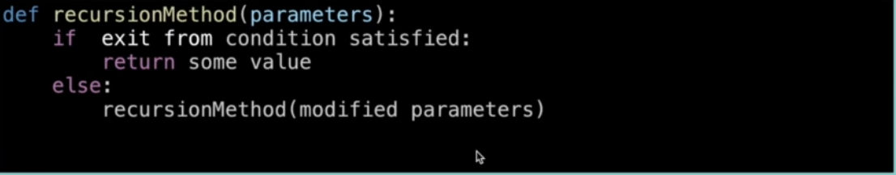

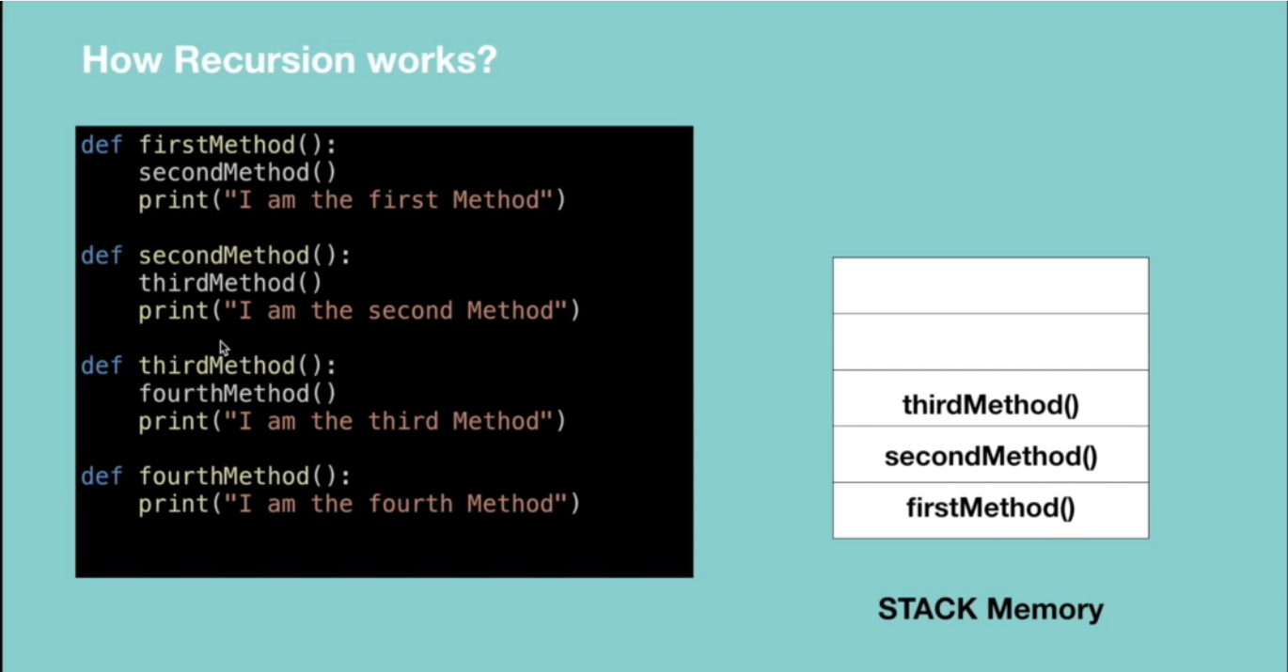

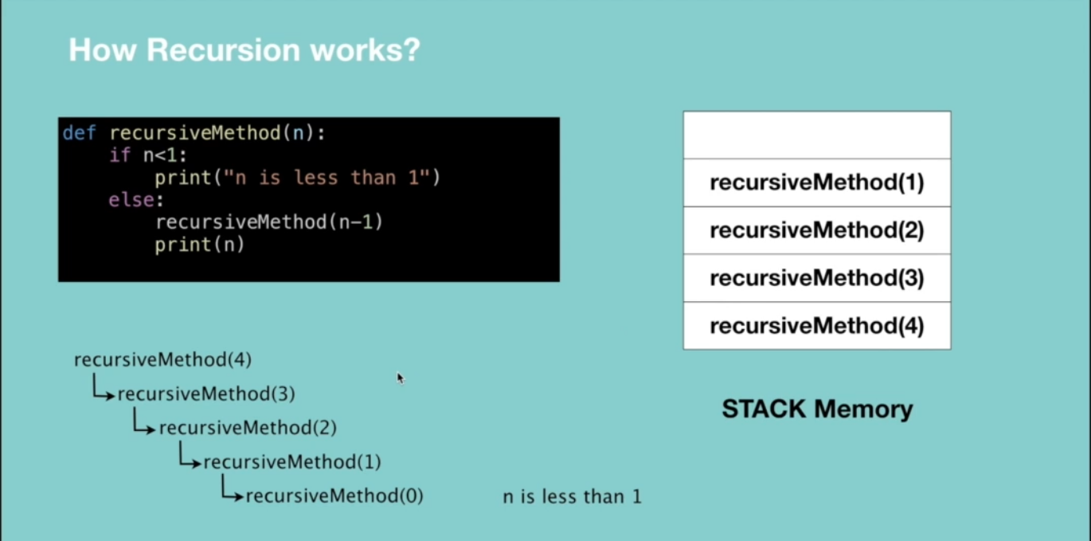

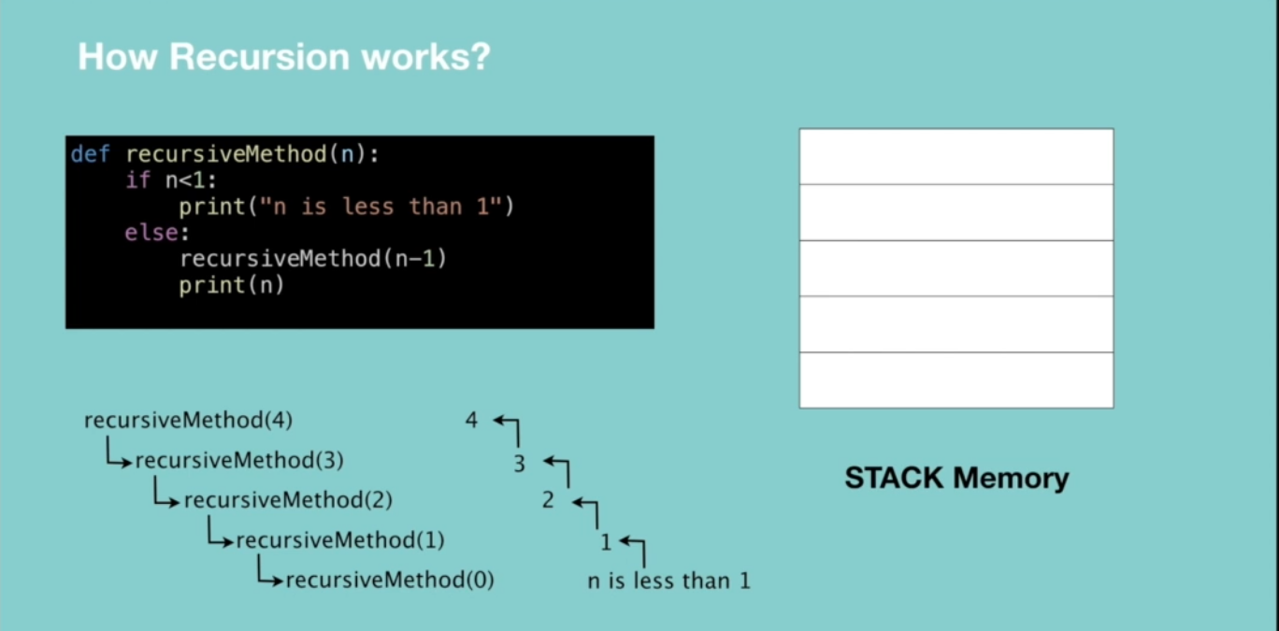

**Recursive vs Iterative solutions.**

All recursive methods can be implemented iteratively.

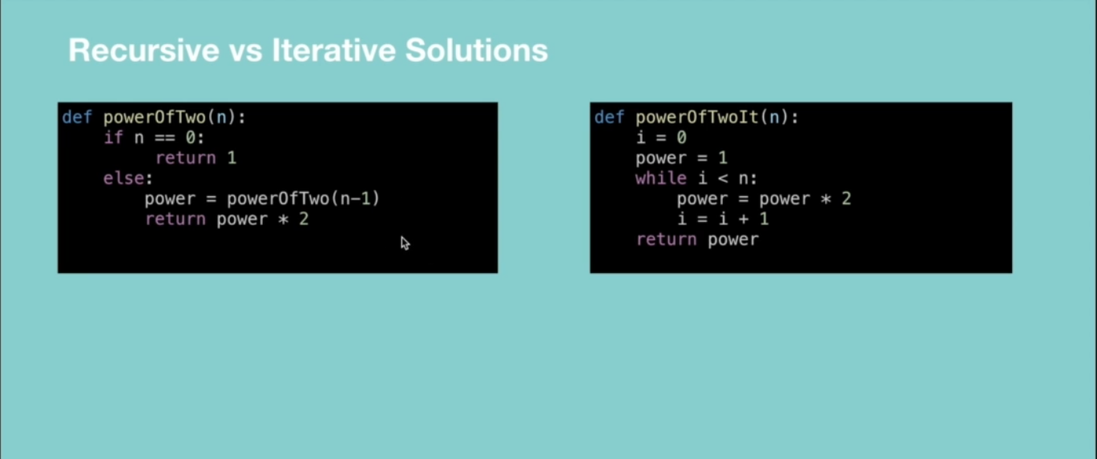

* In recursion, a conditional statement determines the termination of the function while in iterative solutions a controlled variable value decides the termination.
* In recursion, infinite recursion can lead to a system crash while infinite iterations consume CPU cycles.
* Recursion repeatedly invokes the mechanism consequently overhead of method calls, this is expensive in both processor time and memory space while iteration does not.
* Recursive algorithm can be very space inefficient. i.e. if your algorithm resources to the depth of N, it uses at least O(N) memory hence it’s better to implement recursive algorithm iteratively.

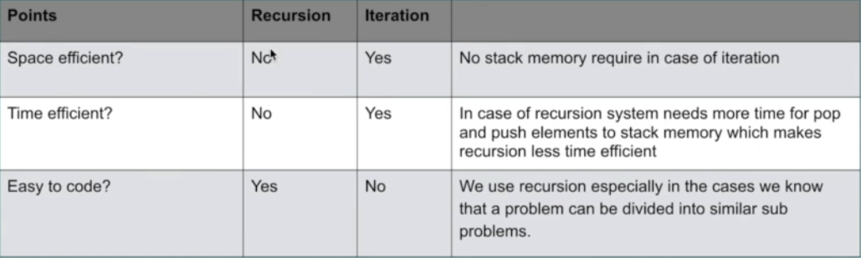

**When to Use/Avoid Recursion?**

**When to use it?**

* When we use memoization in recursion – this reduces the time complexity.
* When we can easily breakdown a problem into similar subproblem
* When we are fine with extra overhead (both time and space) that comes with it. Note when you are developing a mobile app which should run on low memory devices, then here recursion is not advisable. If you’re designing a critical system like an airbag in the car, don’t use recursion.
* When we need a quick working solution instead of efficient one e.g. factorial and Fibonacci numbers.
* When traverse a tree

**When avoid it?**

* If time and space complexity matter for us.
* Recursion uses more memory. If we use embedded memory. For example, an application that takes more memory in the phone is not efficient.
* Recursion can be slow.

**How to write recursion in 3 steps**

Factorial => the product of all positive integers less than or equal to n.

**Step 1: Recursive case – the flow**

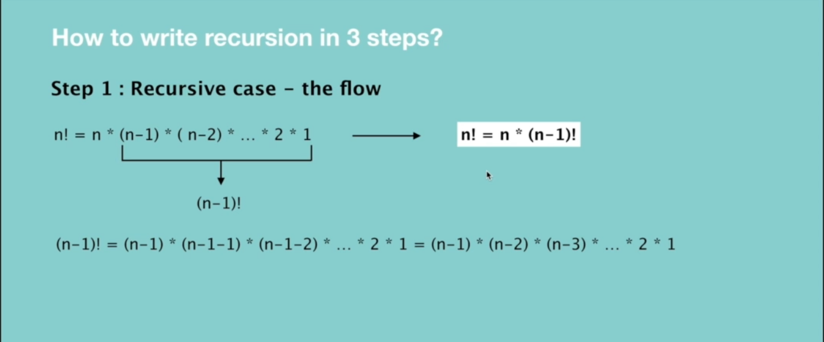

**Step 2: Base case – the stopping criteria**

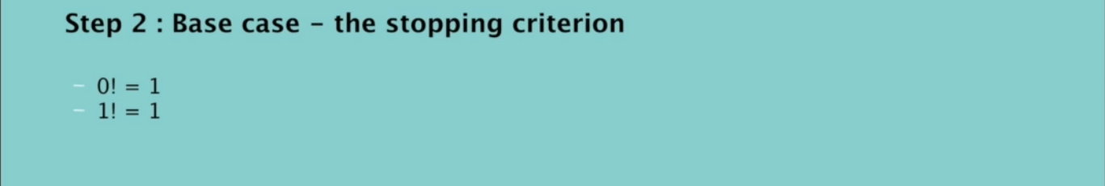

**Step 3: Unintentional case - the constraint**

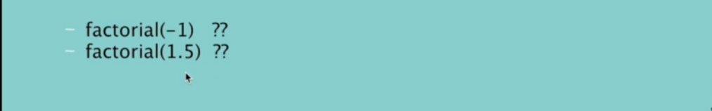

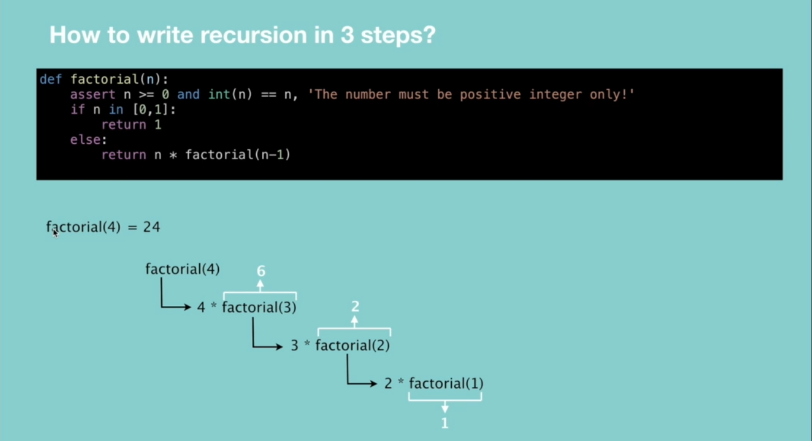

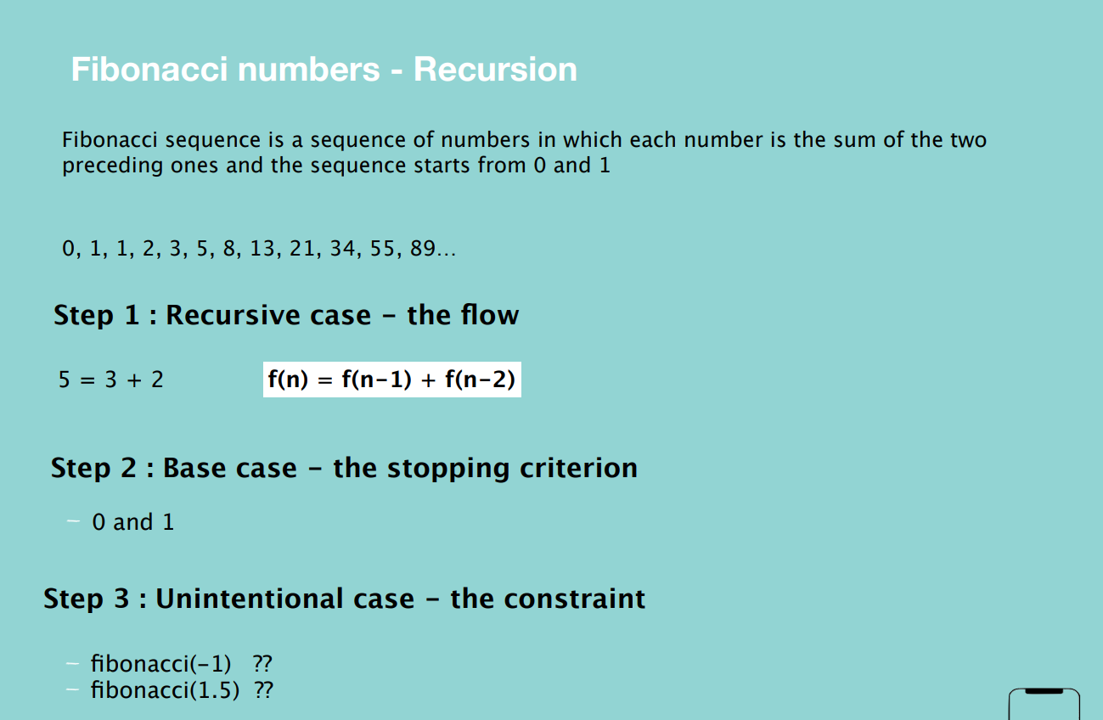

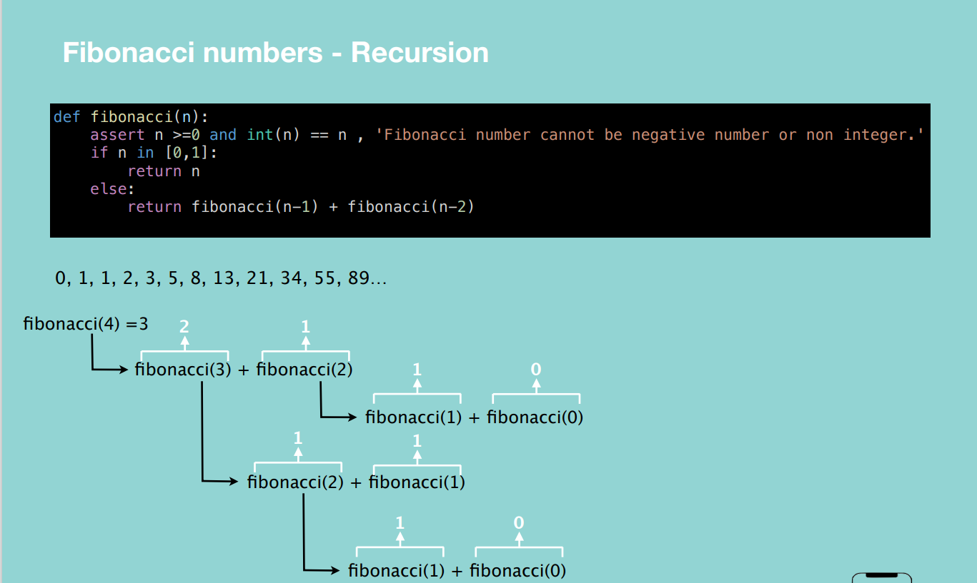

**Interview Questions**

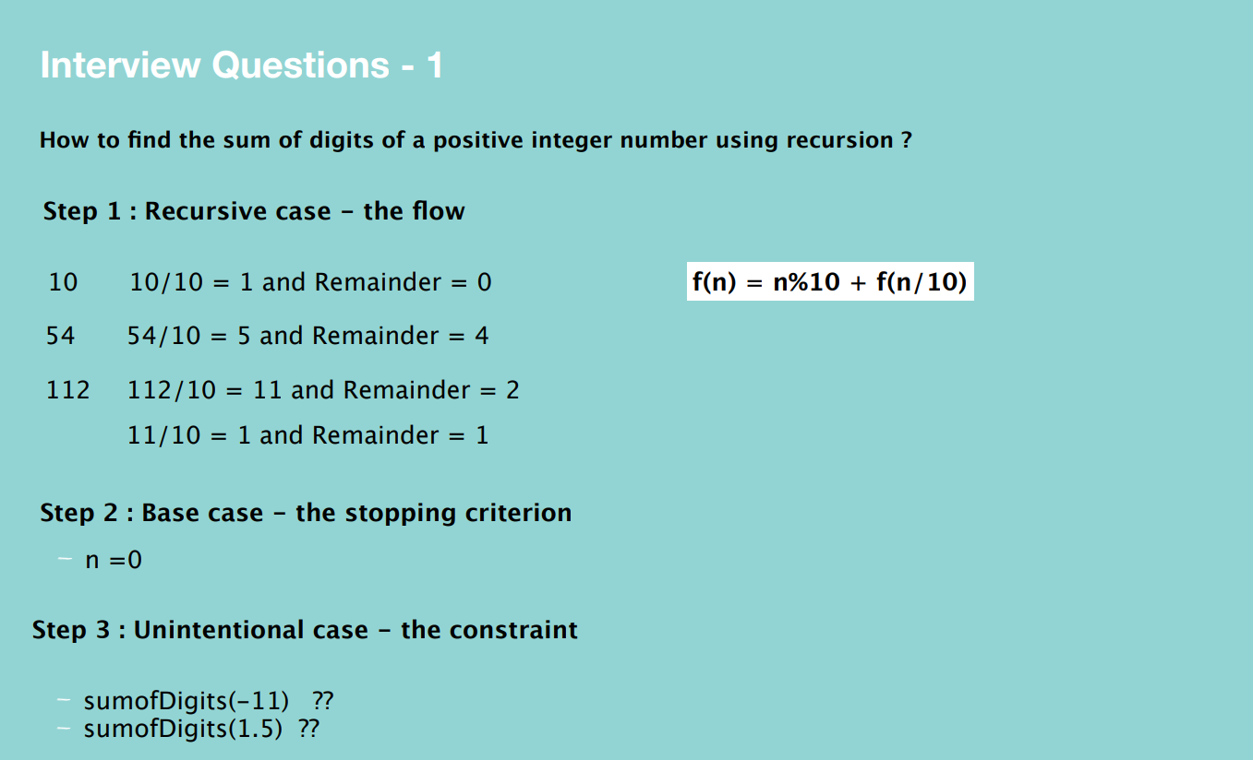

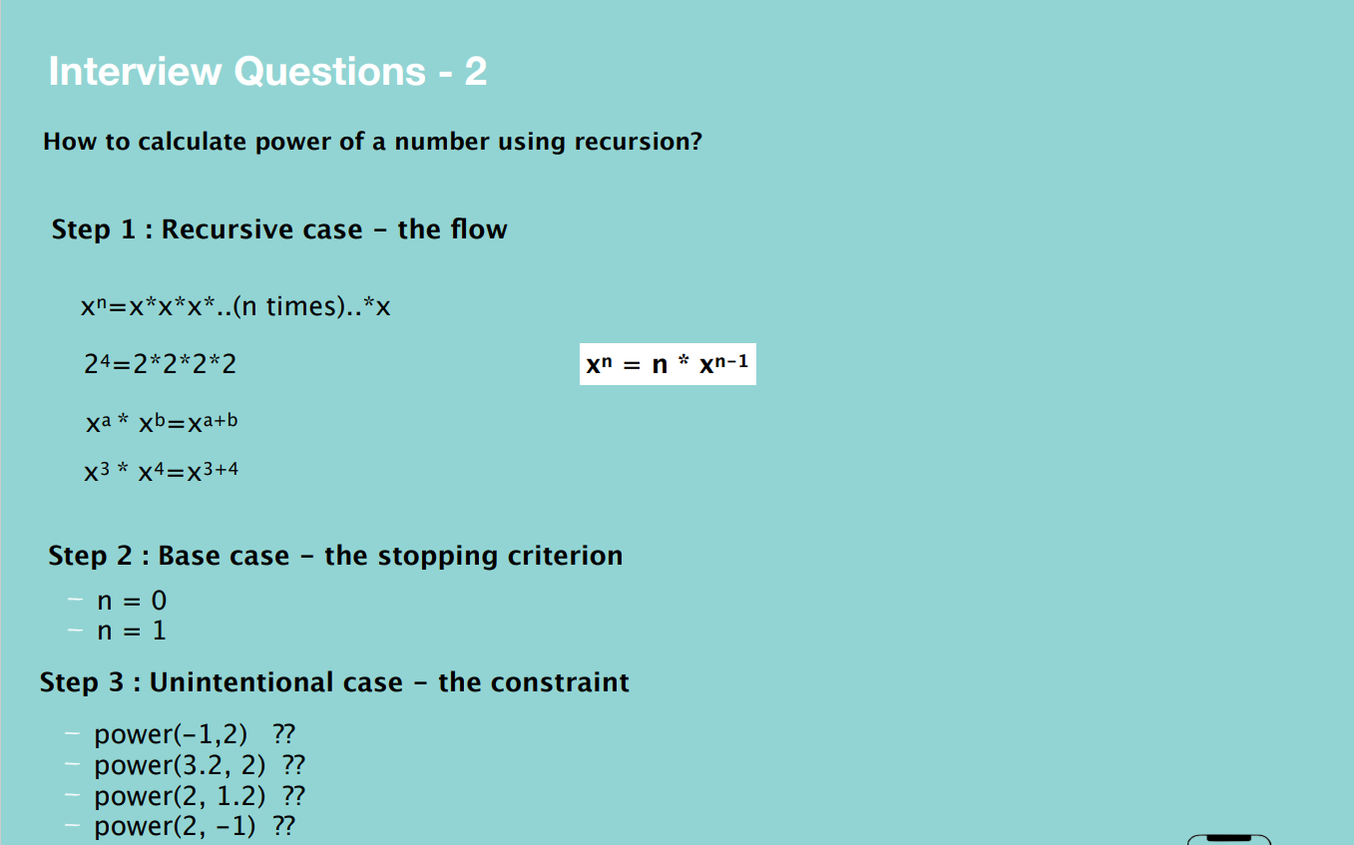

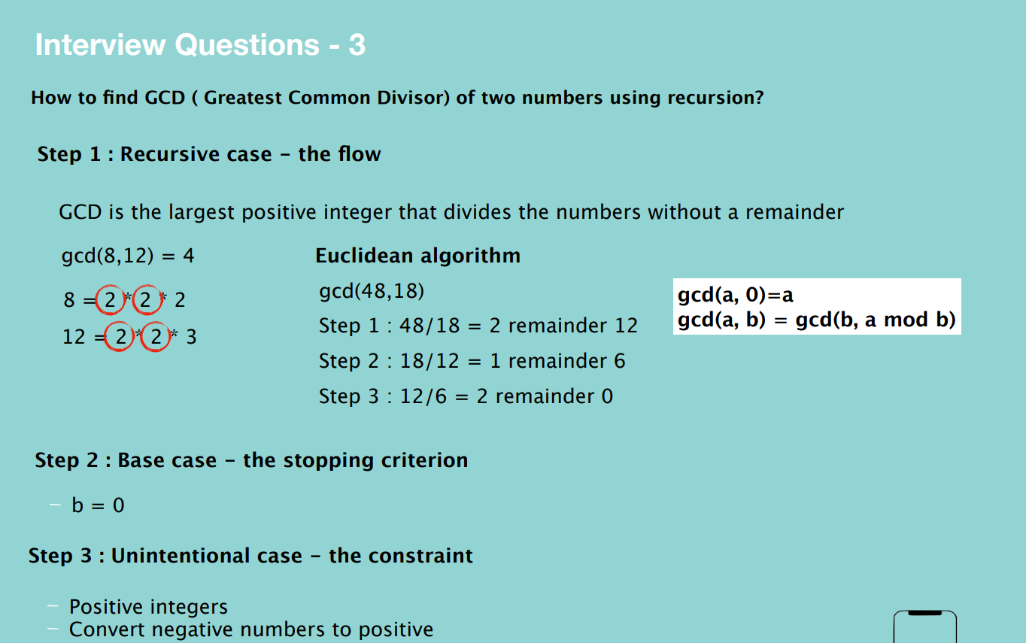

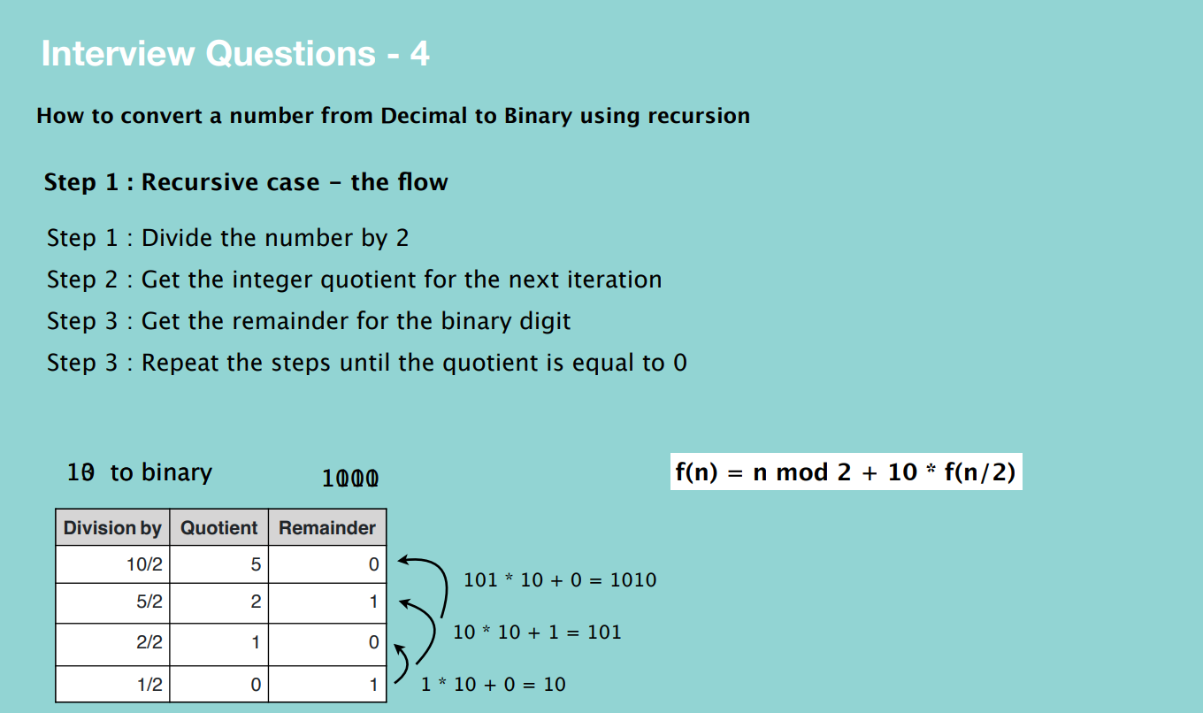

**BIG O**

Big O is the language and metric we use to describe the efficiency of algorithms.

**Time complexity –** shows how the runtime of a function increases as the size of input increases.

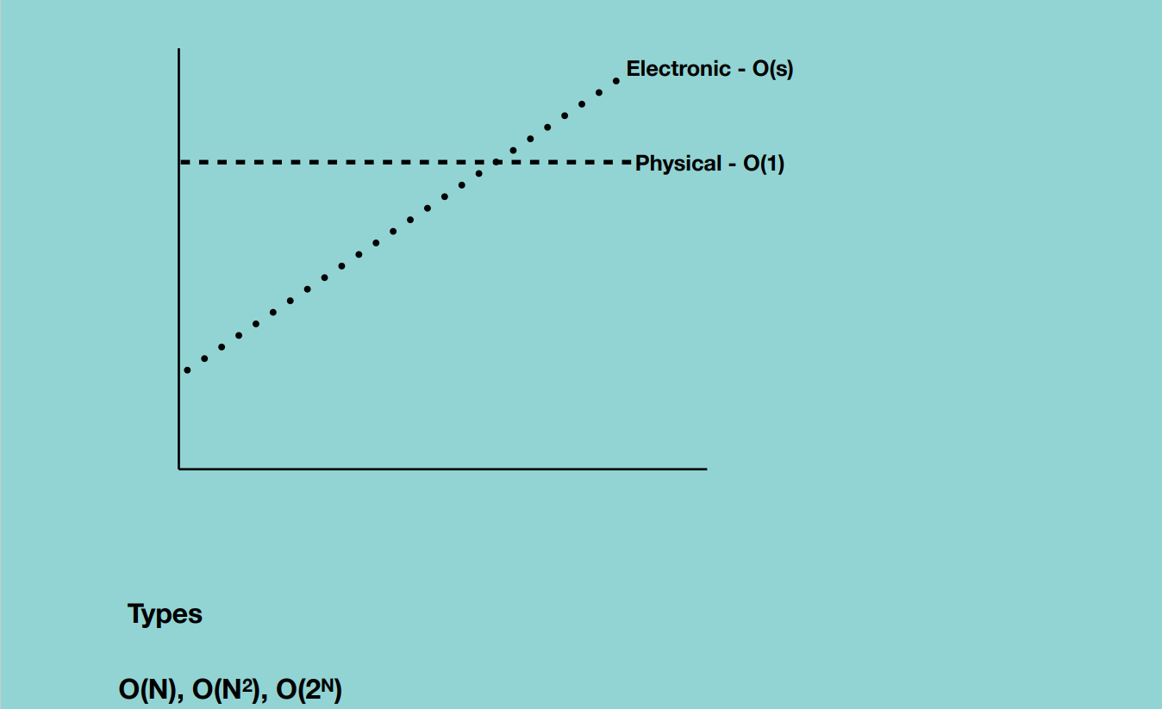

**Big O Notations**

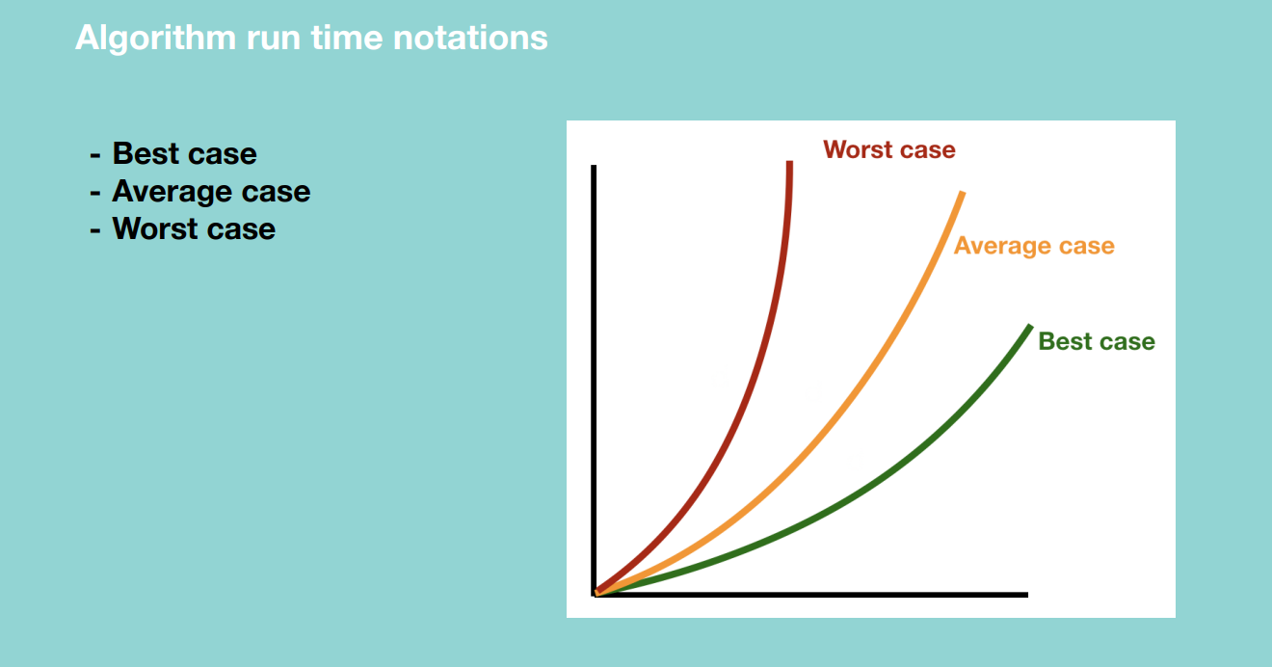

**Quick Sort Algorithm –** Best case, all numbers are equal and we pass through the numbers only once hence O(N).

* + Worst case, pivot is biggest in the array hence O(N^2)
  + Average case – sometimes the pivot number will be very high and sometimes will be very low but will not happen over and over again.

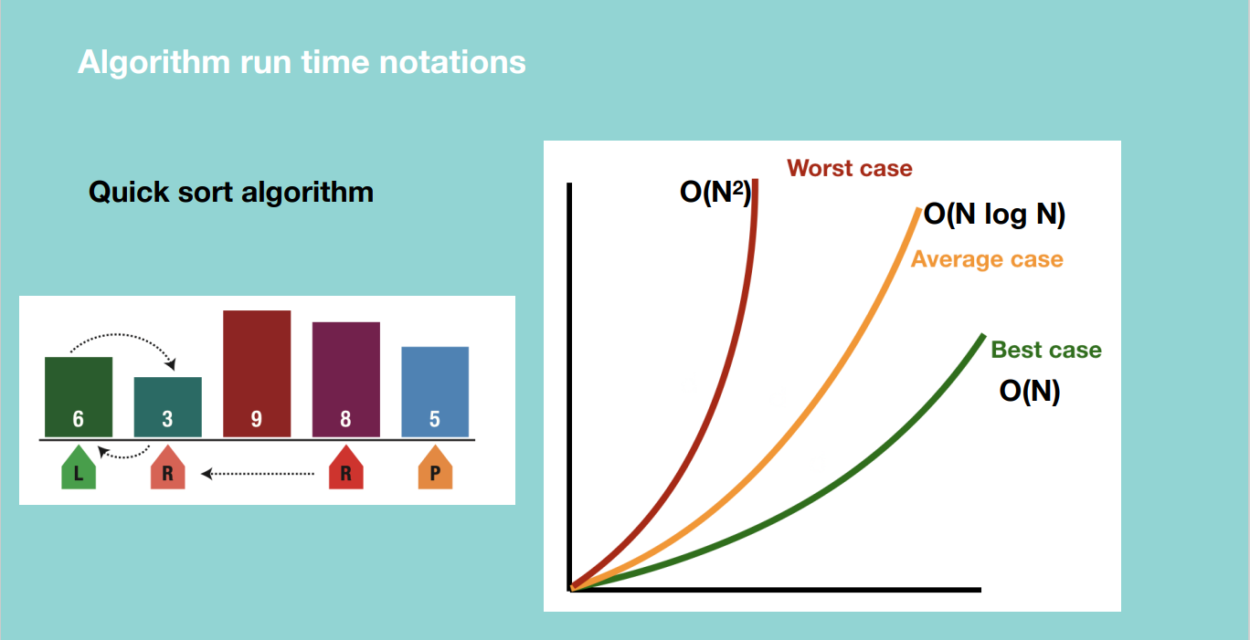

Big O – thinks of the maximum time i.e. a certain operation will never be more than a certain amount of execution time.

Big Omega – thinks of the minimum time i.e. a certain operation will never be less than a certain amount of execution time.

Big Theta – thinks of the average time i.e. if we have an algorithm with max execution time 10 seconds and minimum execution time 1 seconds, the average time will be 5 seconds.

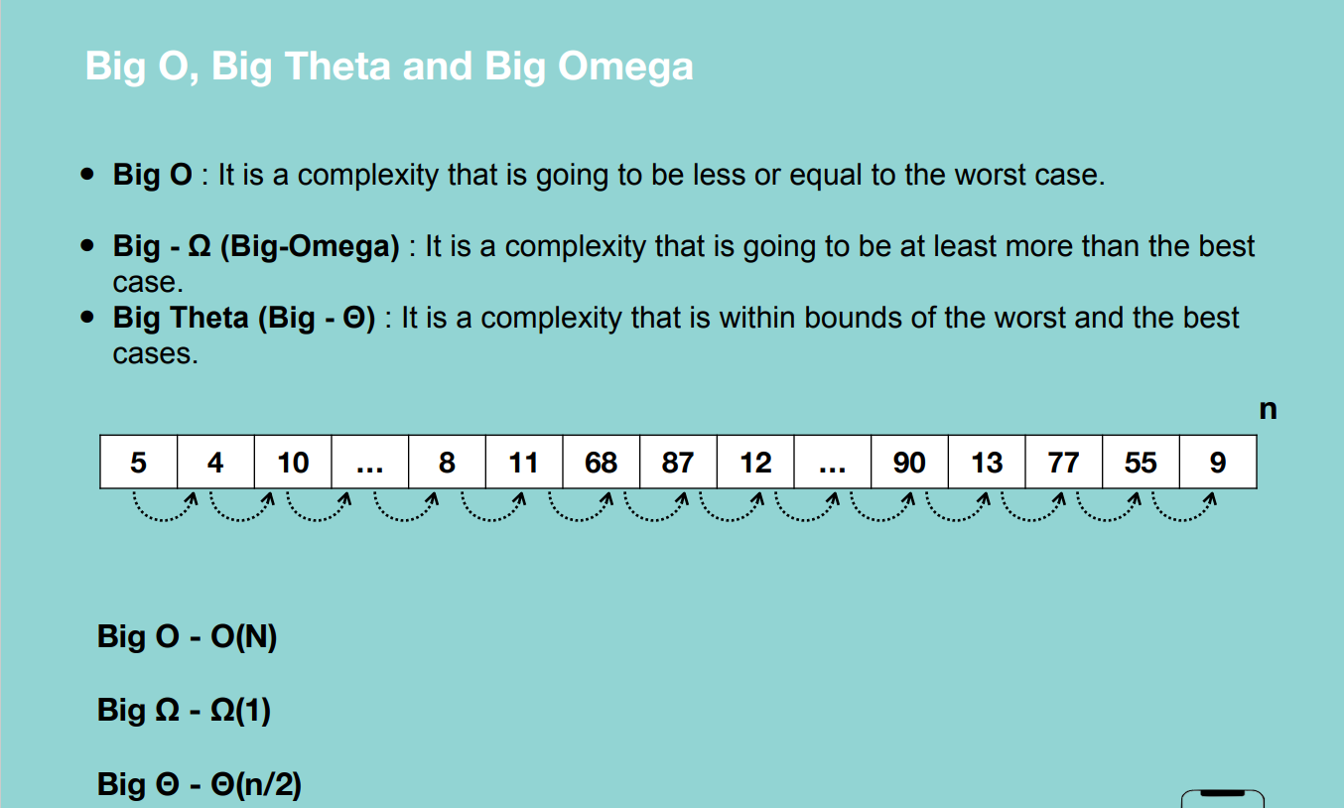

From the figure above, let’s say we take 1ms to move from one element of the array to another.

**Algorithm run time complexities.**

**O(1) –** for any given input, the execution time will not change.

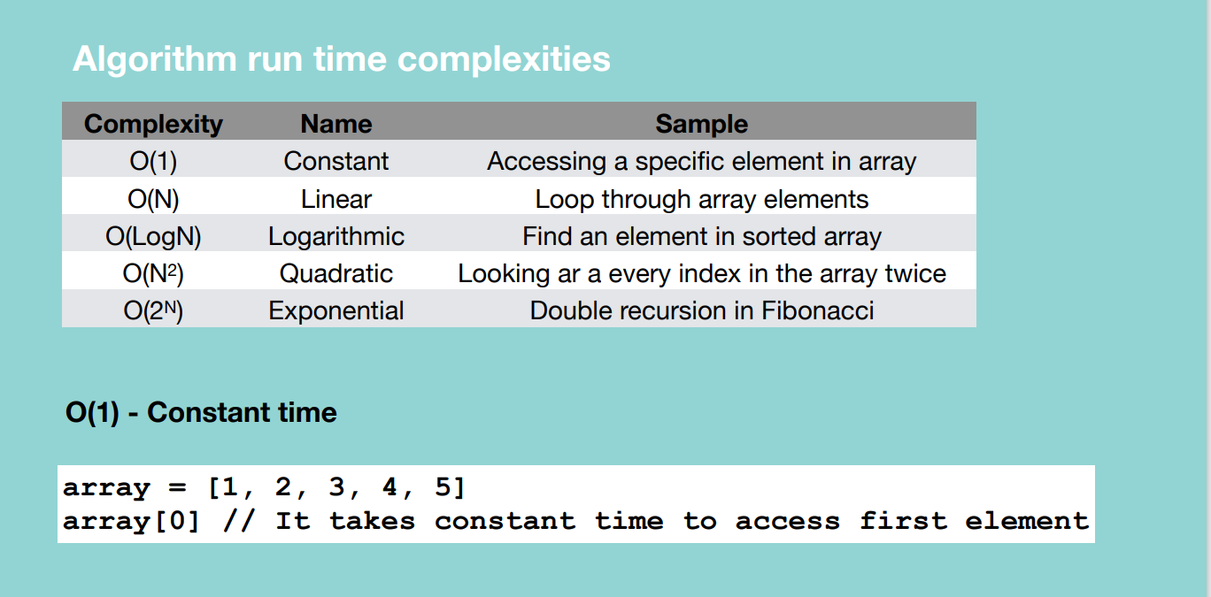

Grabbing a random card in a take takes constant time whatever we grab.

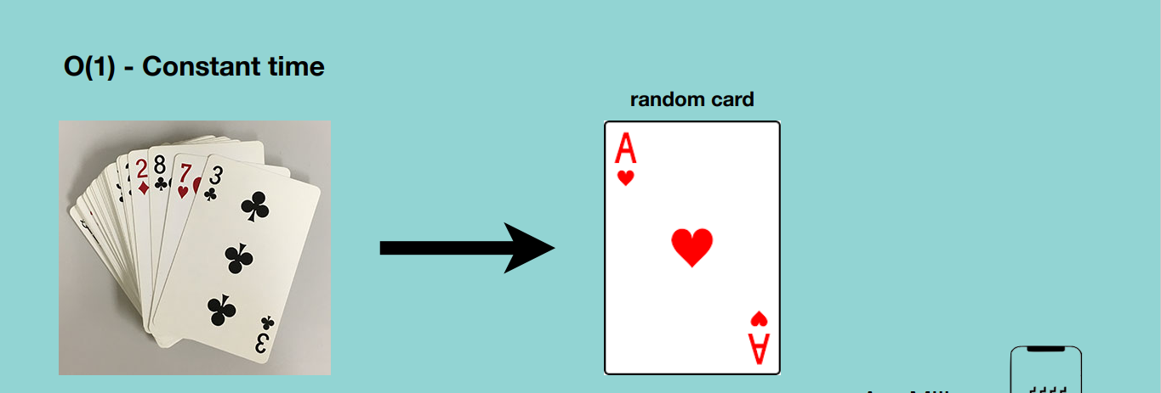

**O(N) – Linear time –** time complexity will grow directly proportional to the size of input data.

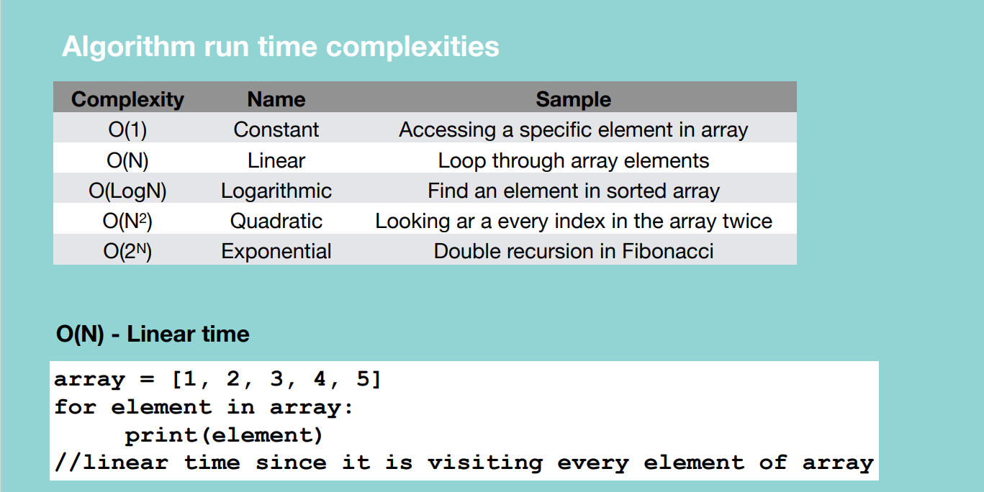

Grabbing a specific card in a take takes constant time whatever we grab.

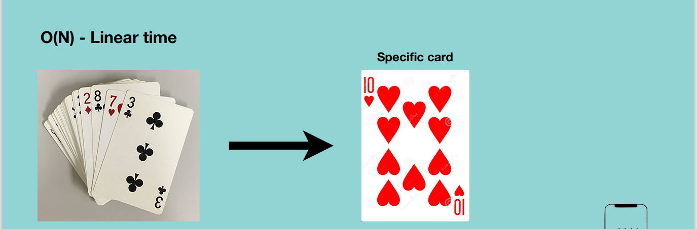

**O(LogN) – Logarithmic –** runs in proportional to the logarithmic of the input size. E.g. if the function doesn’t pass through all the elements in an array

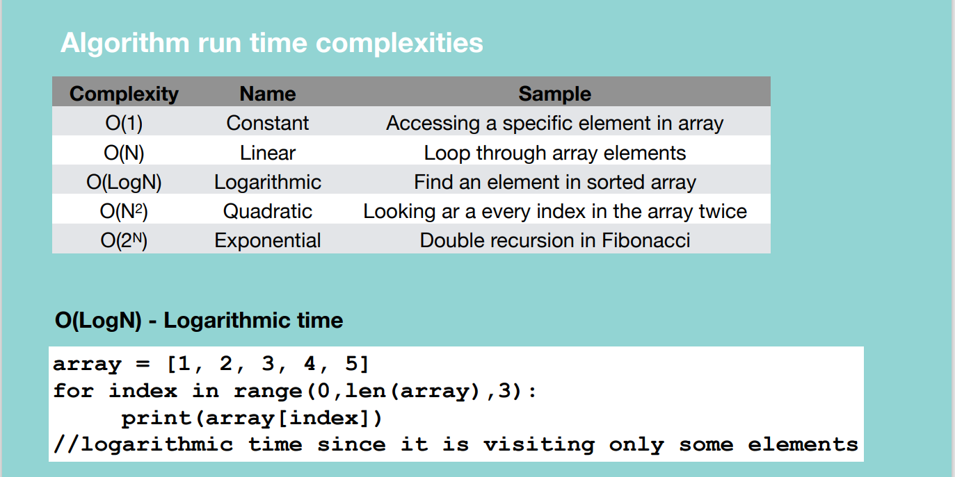

In the example above, we print elements of the array using a step of 3.

Below shows a procedure of trying to find a 10 of hearts in a sorted card deck by continuously dividing the problem space.

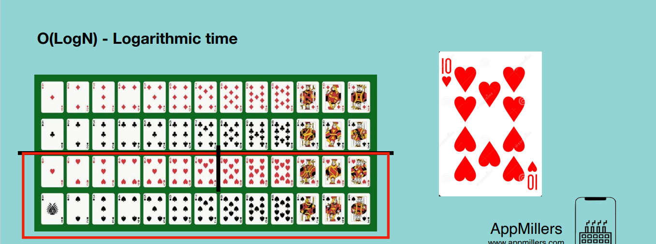

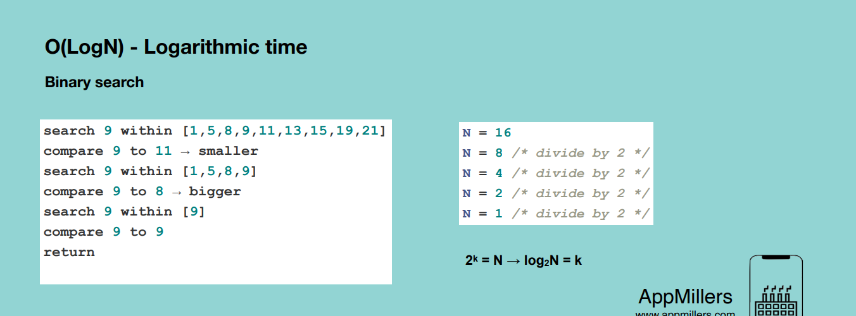

**O(N^2) – Quadratic time** – an algorithm whose performance is directly proportional to the square size of the input data set. It’s like linear algorithm but here the time complexity is increasing quadratically. It occurs whenever we nest our multiple iterations.

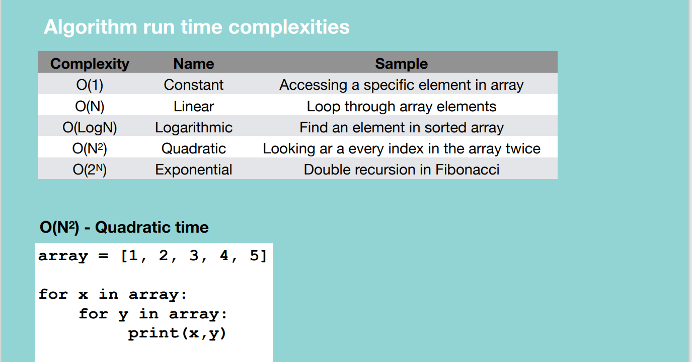

Eg. Revisiting the deck of cards each time we want to pick a card of 3.

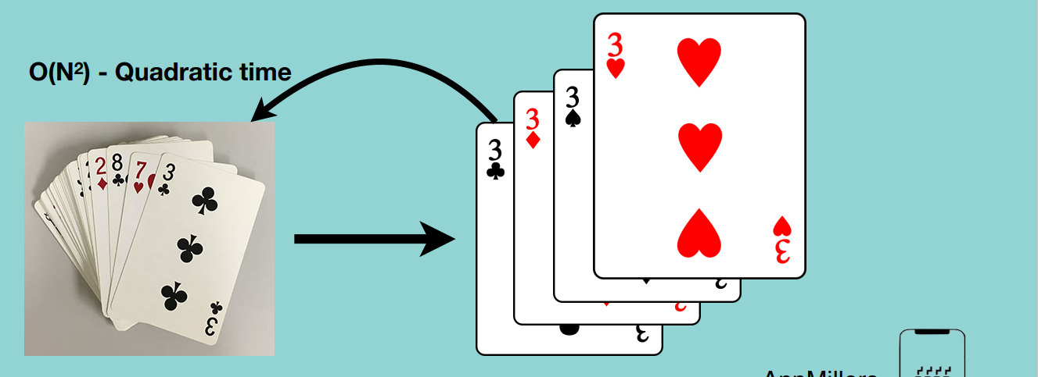

**O(2^N) – Exponential time –** algorithm whose growth doubles with each addition to the input set. Time complexity starts very shallow, rising at an ever increasing rate until the end.

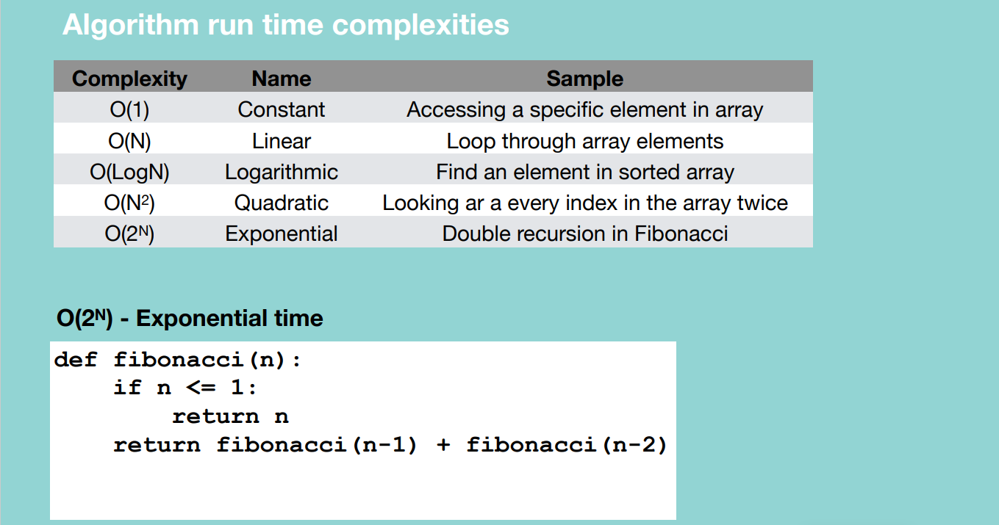

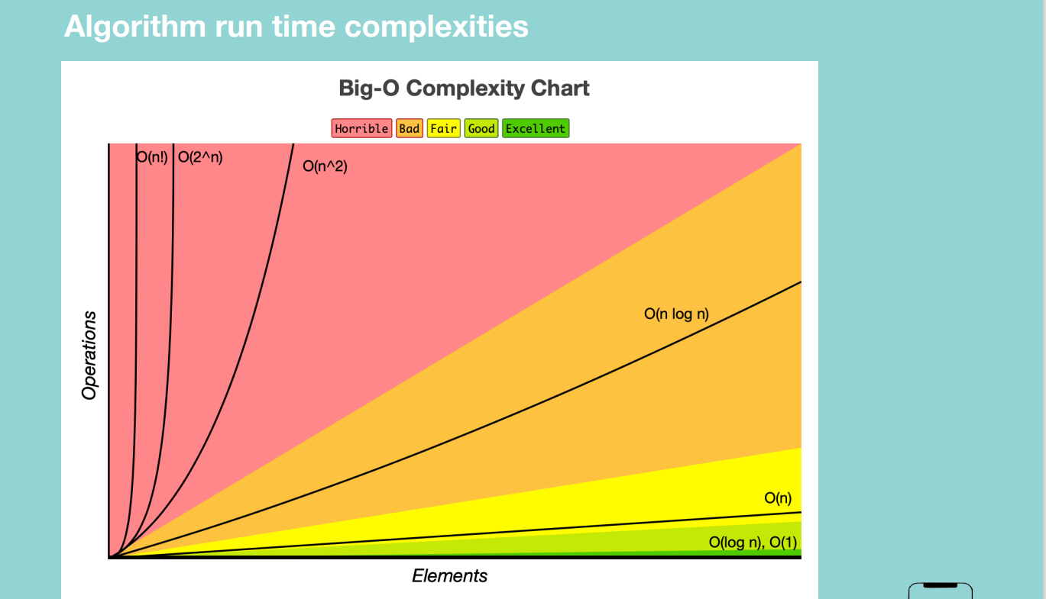

**Space complexity:** measure of the amount of working storage an algorithm needs.

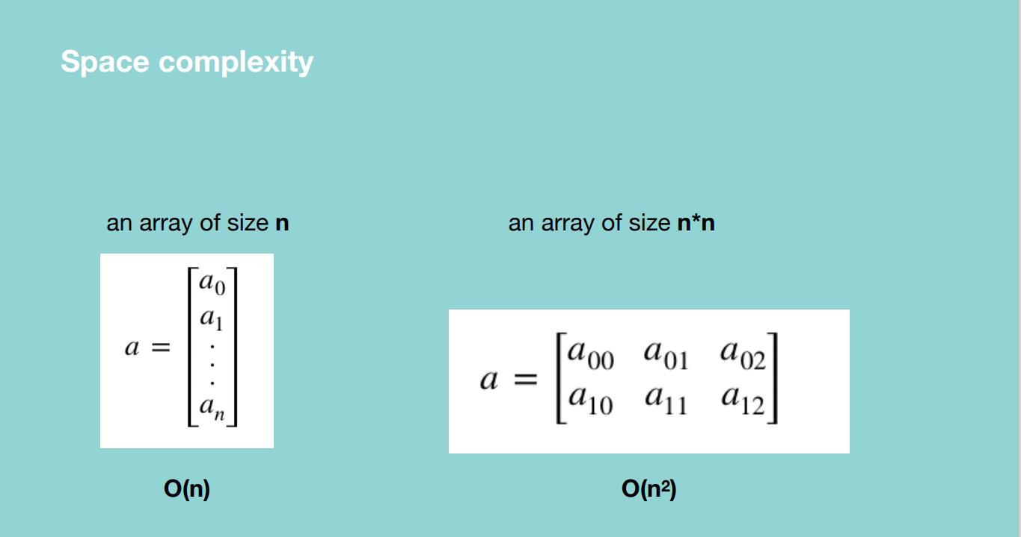

A function which is summing up the number from a given number till zero by calling recursive calls.

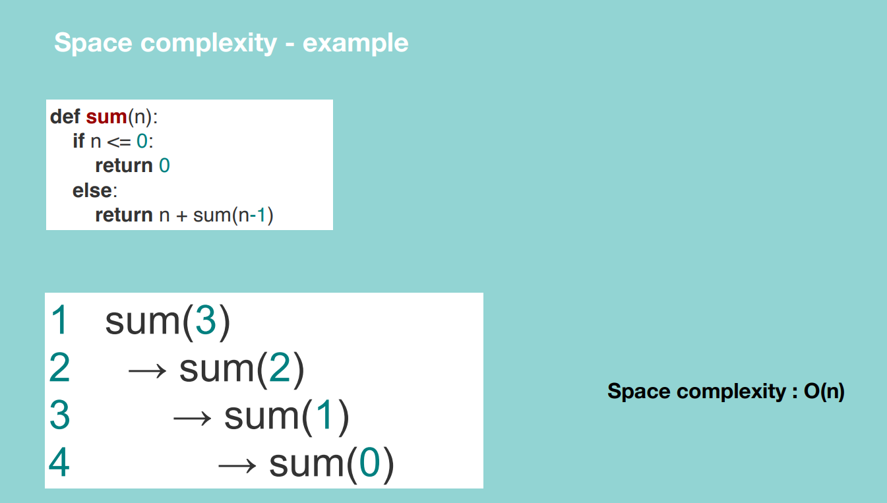

Since the function is not calling itself recursively or adding anything to the call stack.

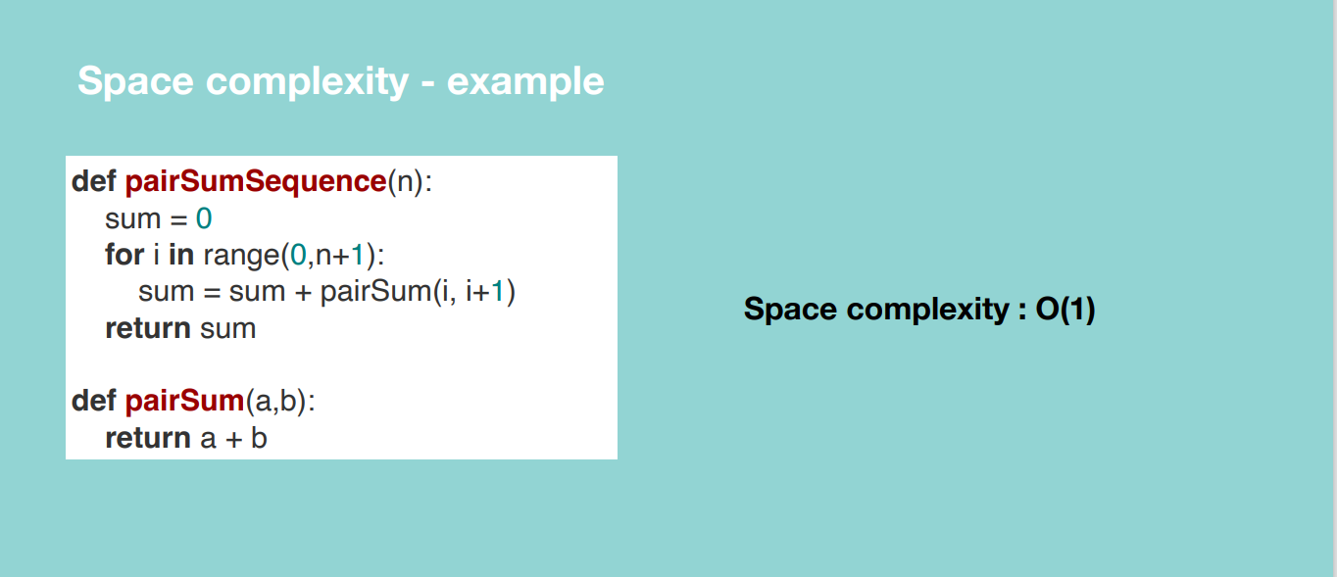

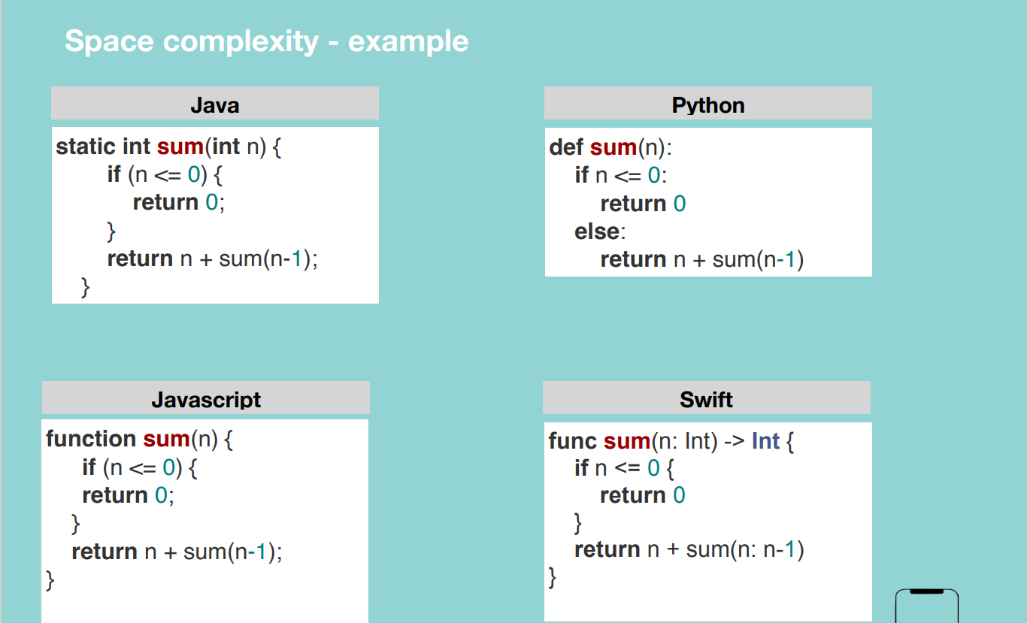

**Drop constants and Non-Dominant Terms**

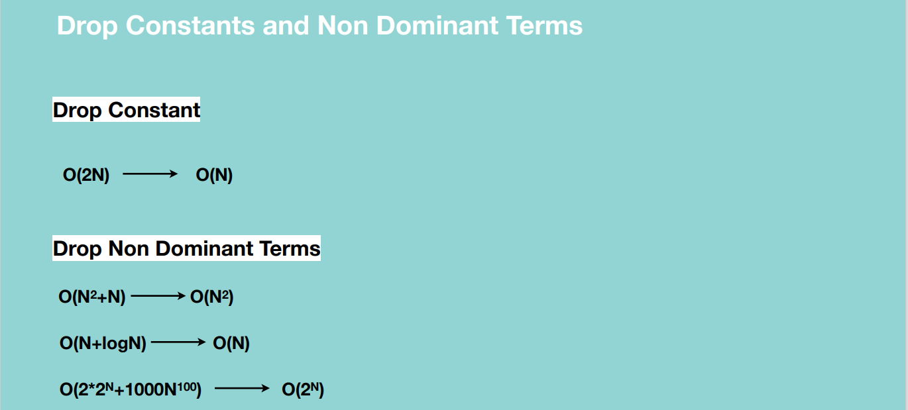

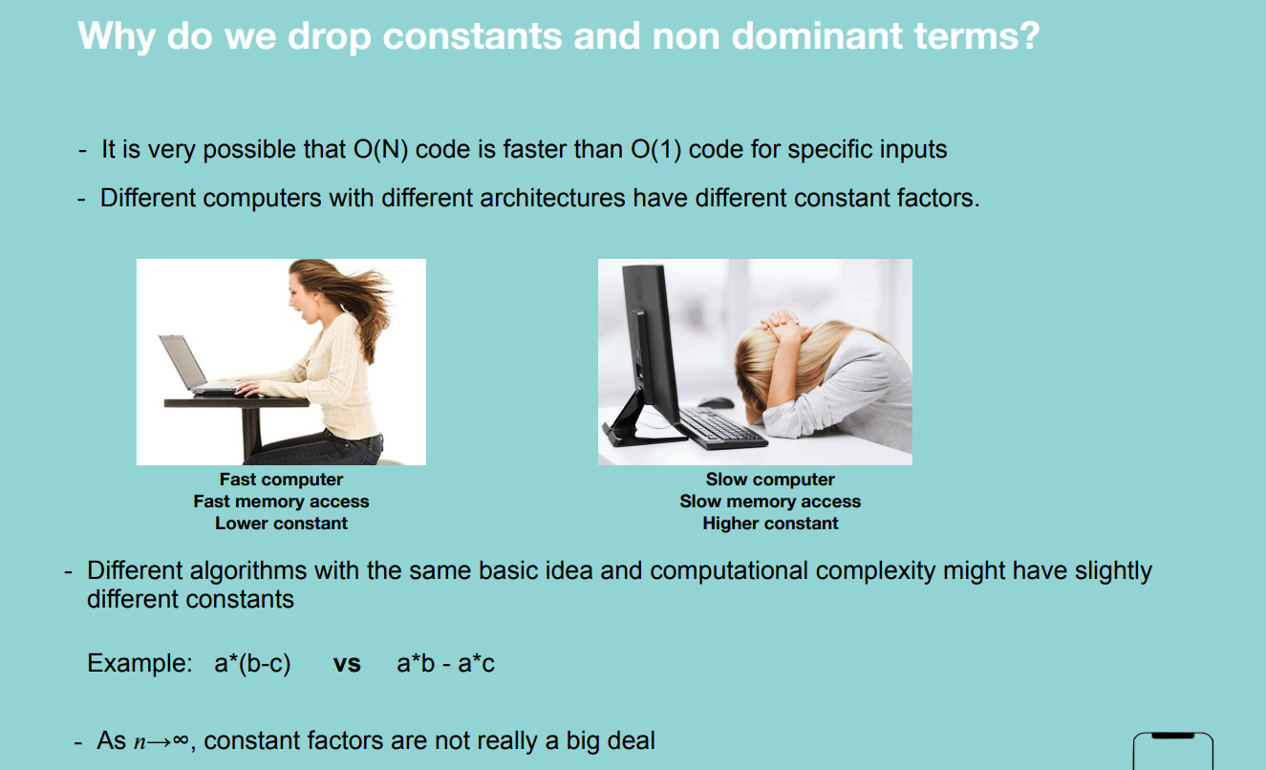

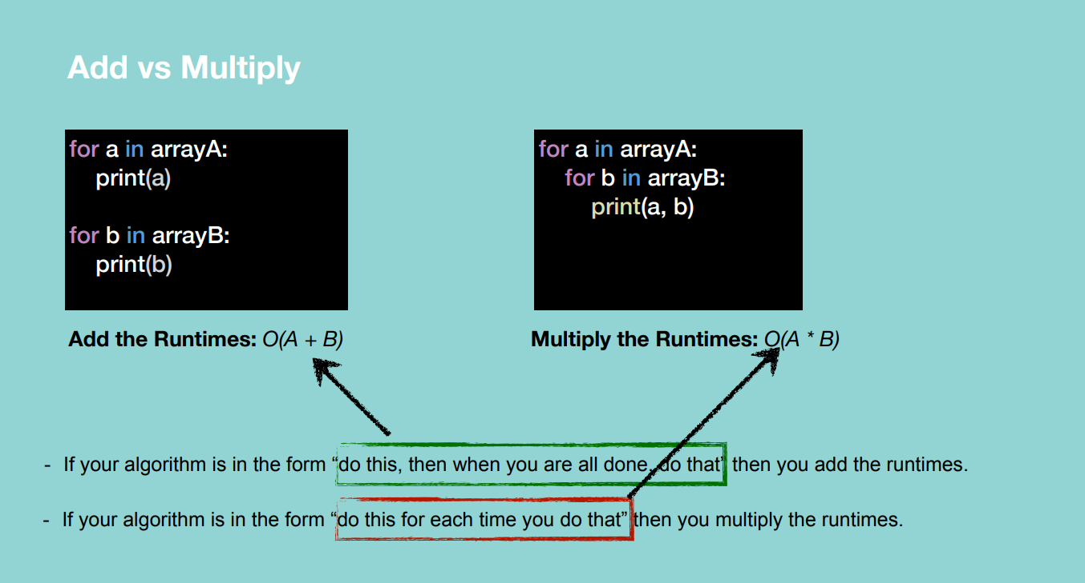

**Note:** the array has a million elements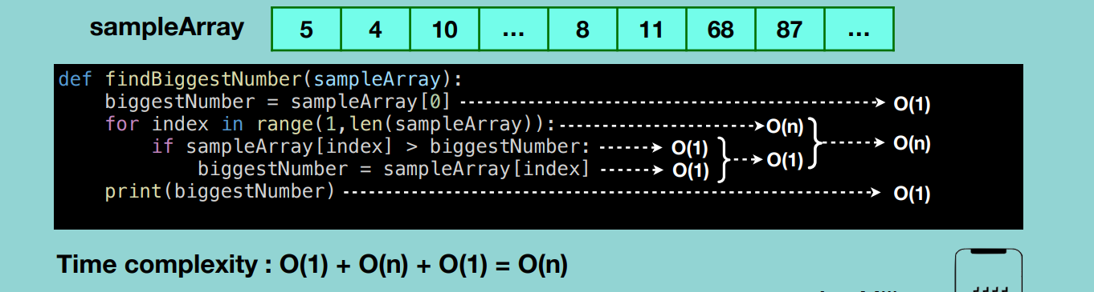

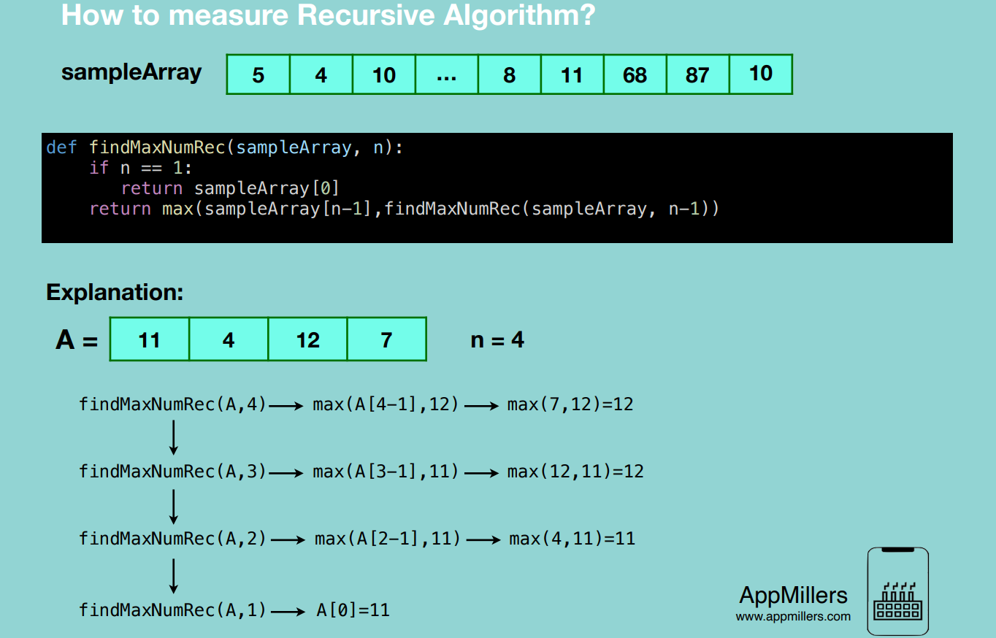

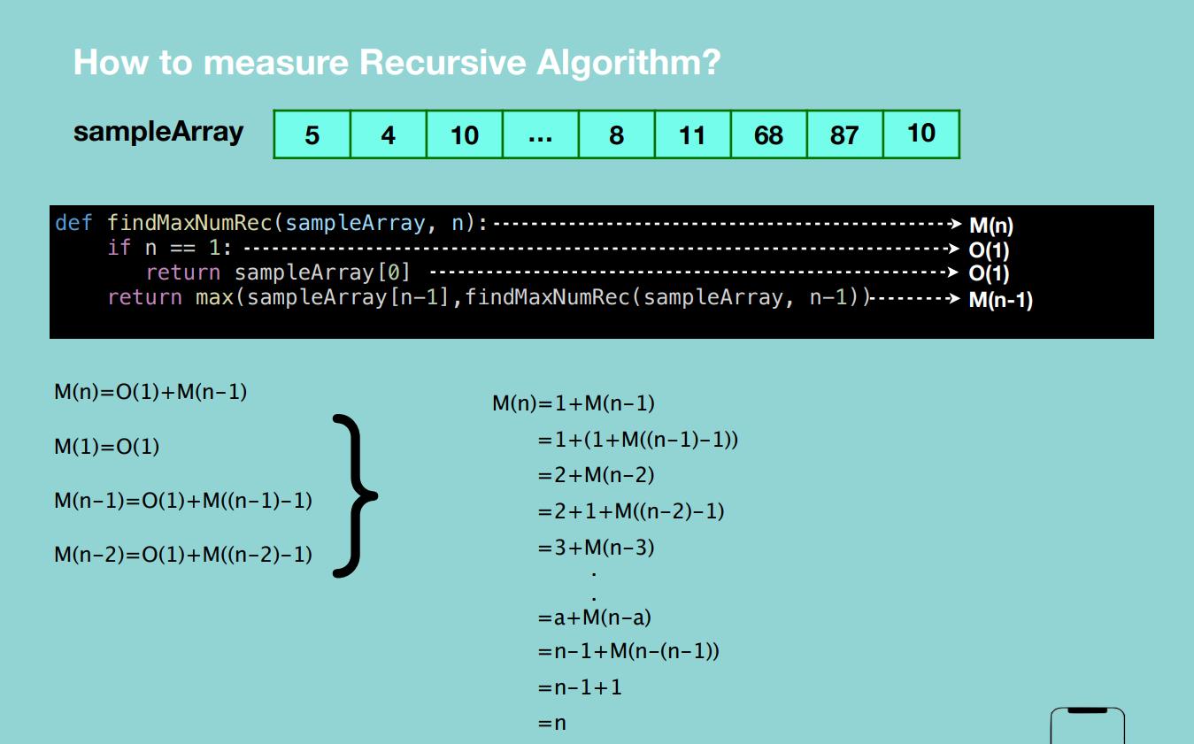

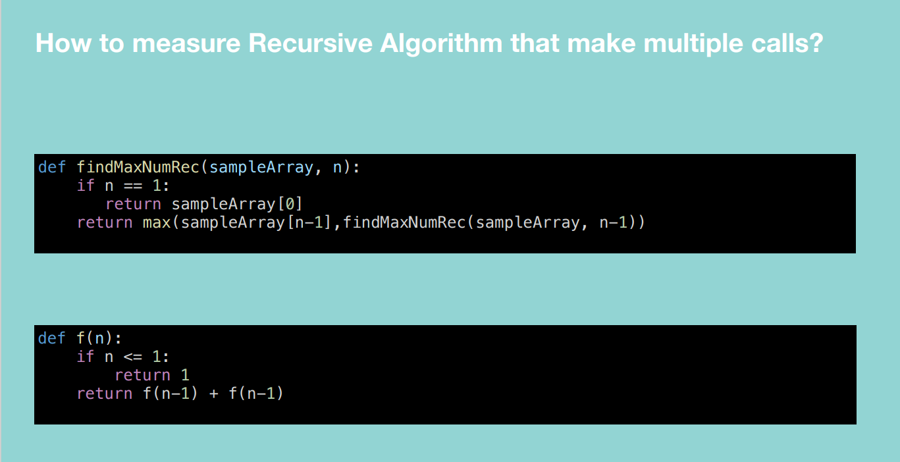

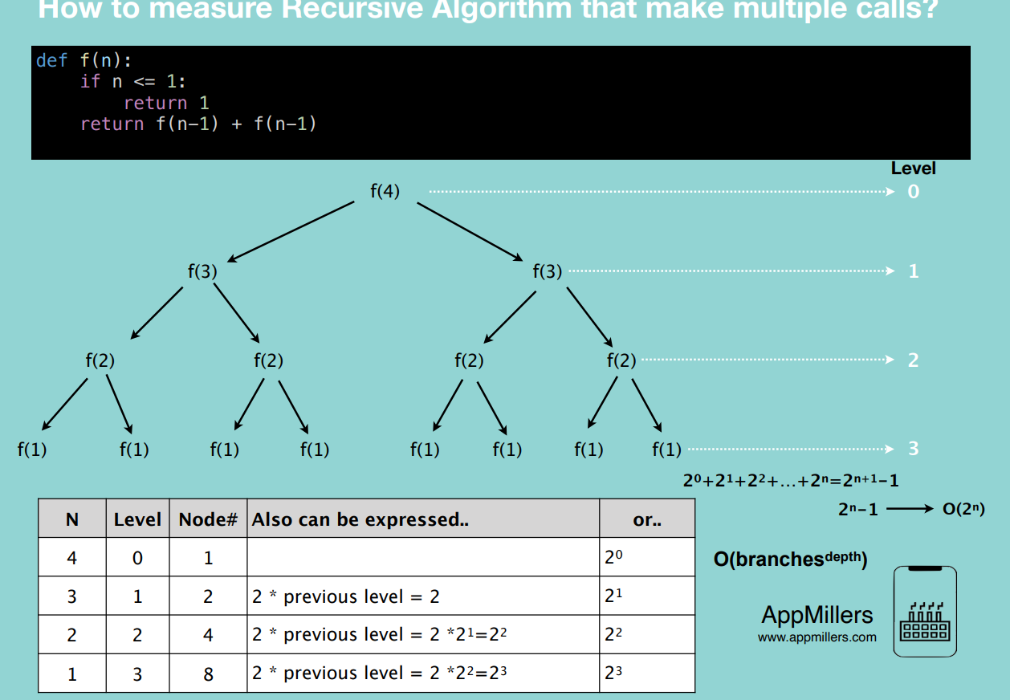

**For a** recursive algorithm with multiple calls, the complexity is **O(branches^depth)** e.g. double recursive calls = O(2^n). triple recursive calls = O(3^n)

**Top 10 Big O interview Questions**

**Found in Cracking the coding interview**

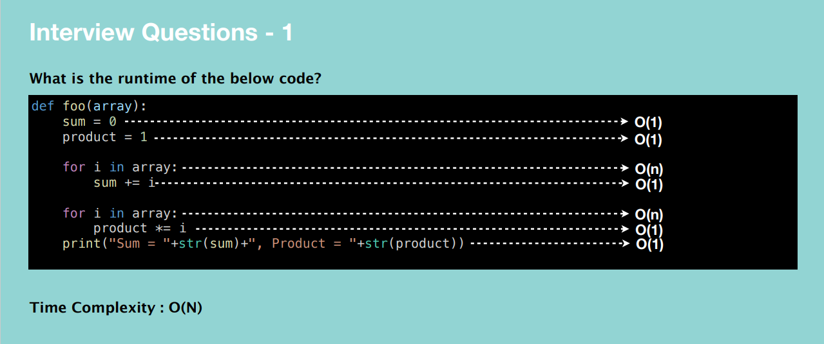

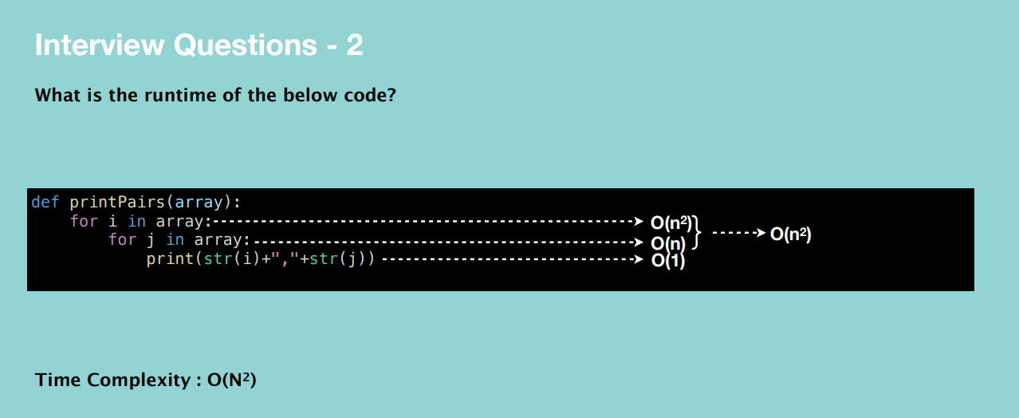

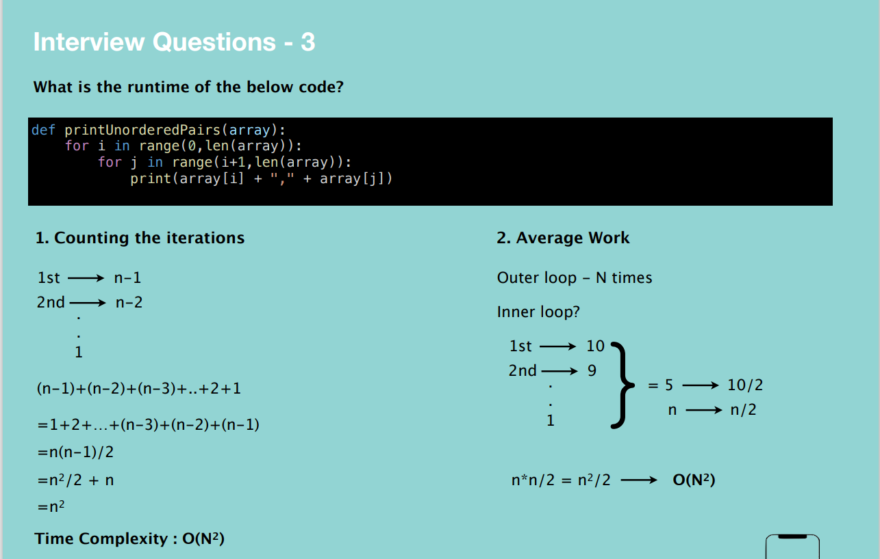

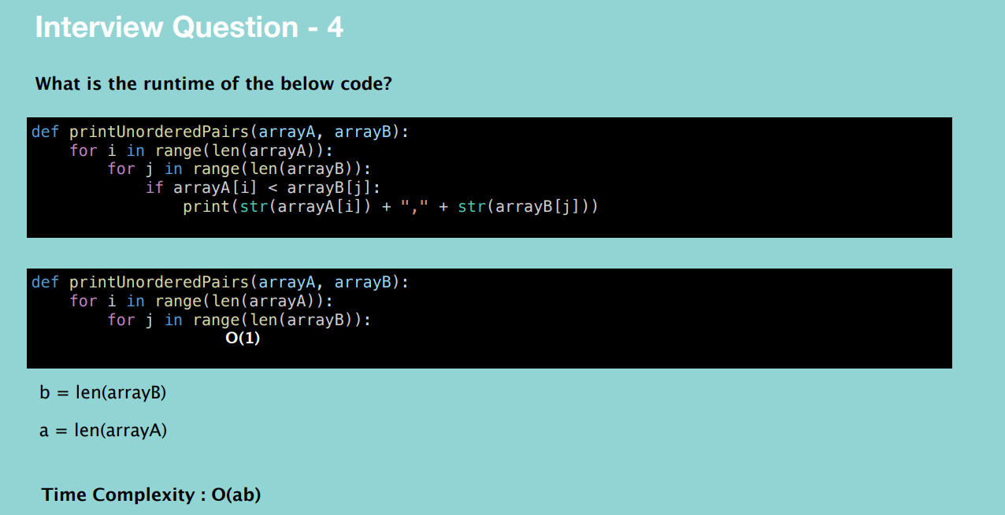

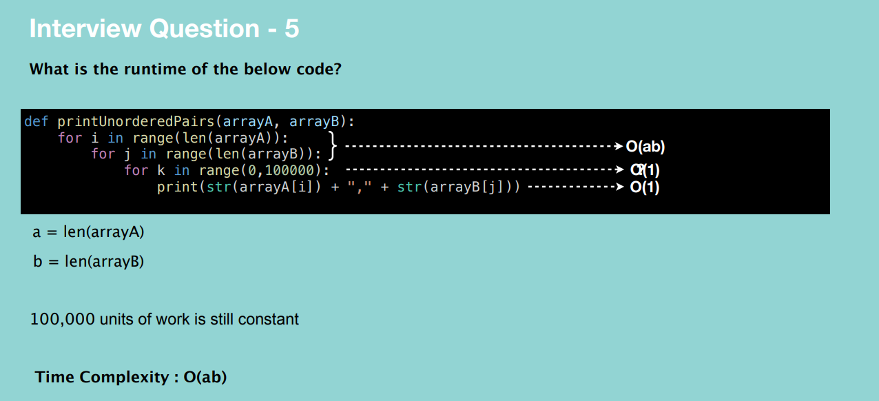

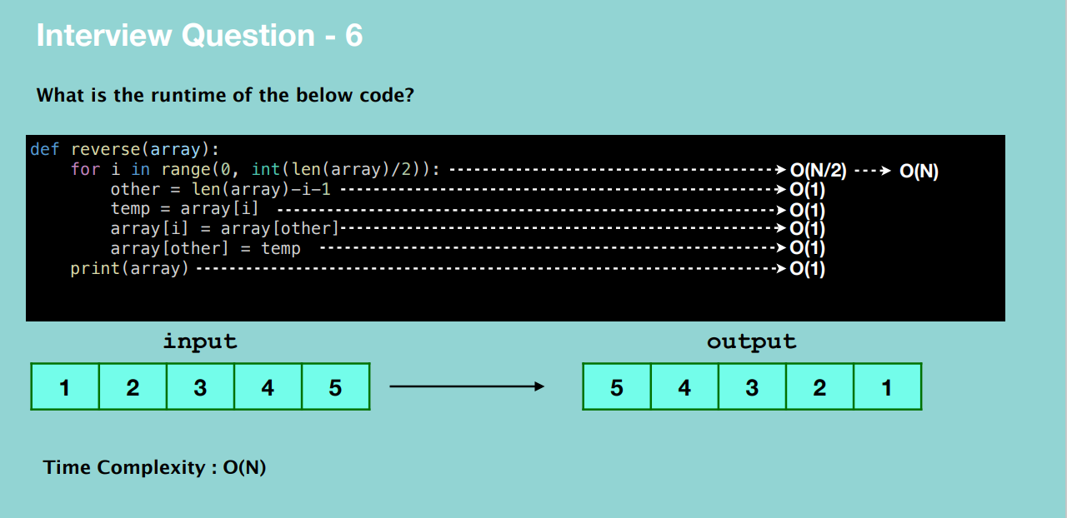

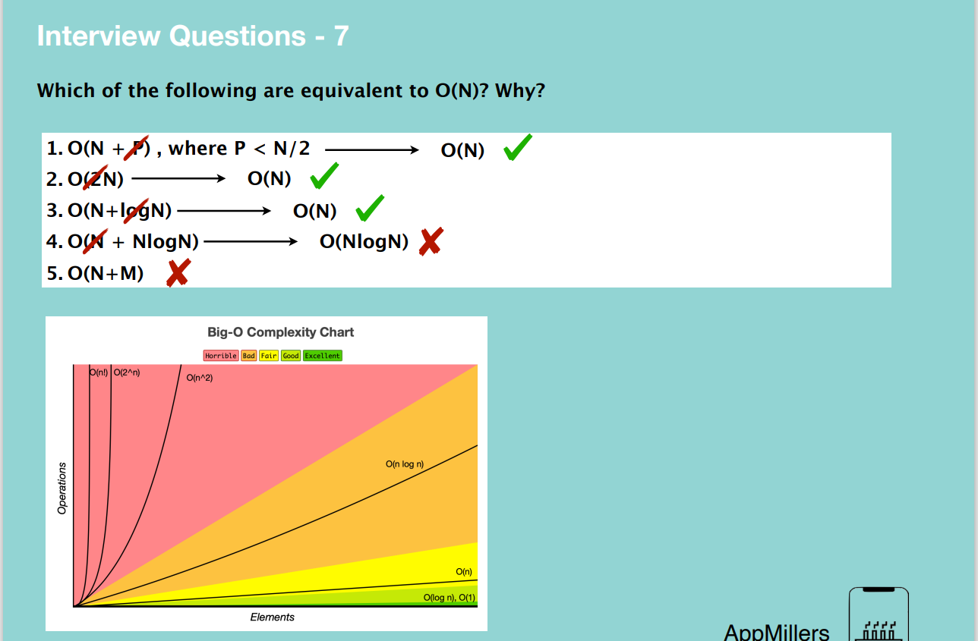

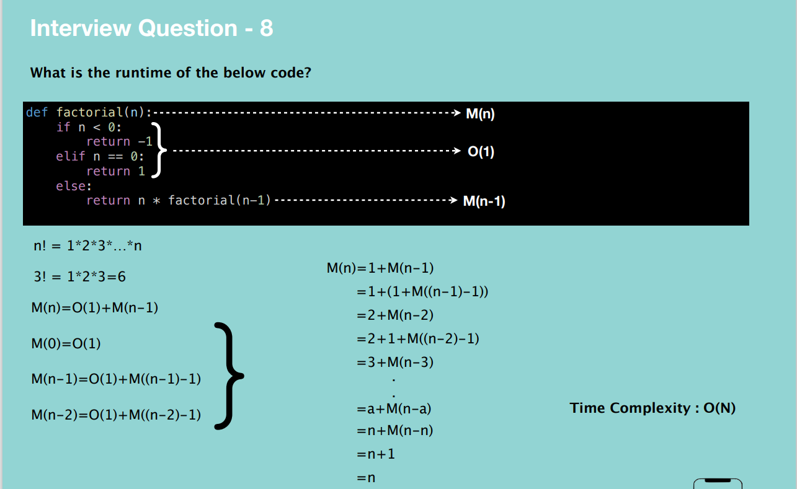

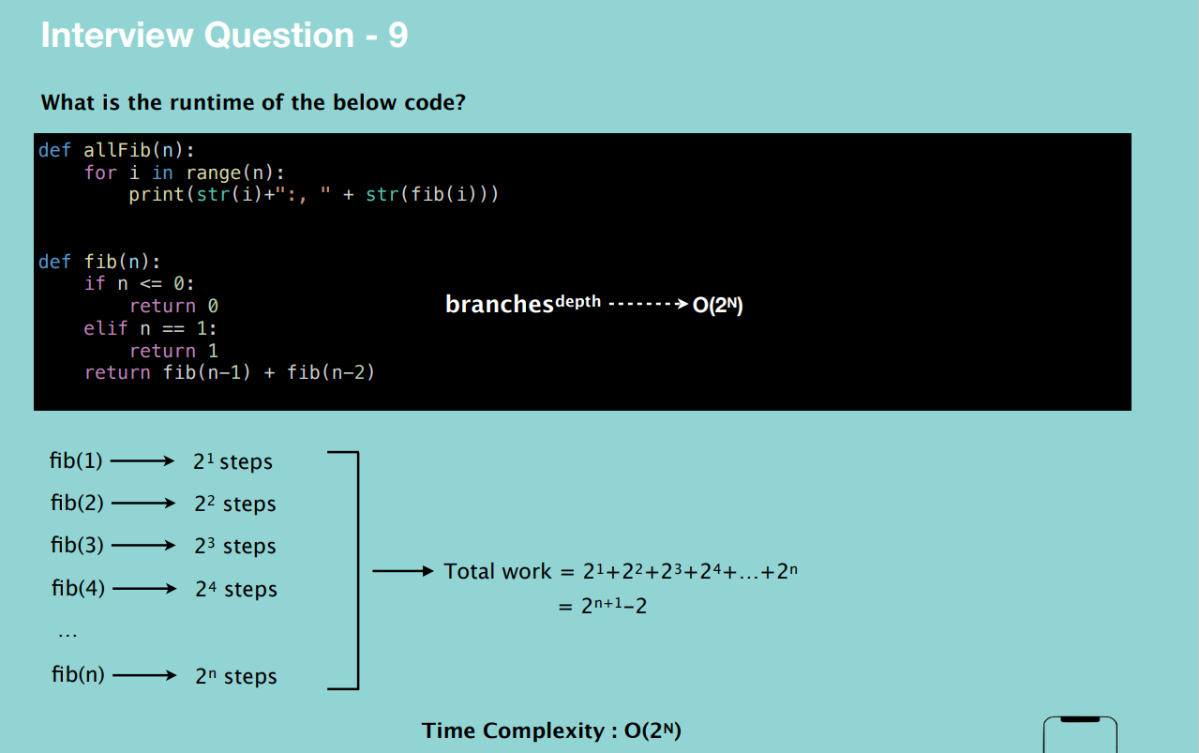

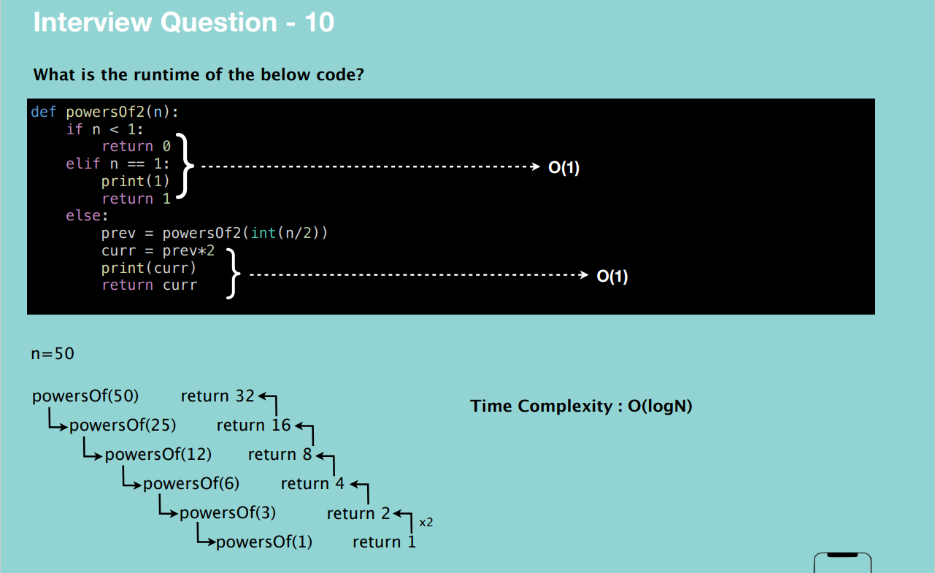

**Arrays – simple collection of objects or things (most used data structure) OR a data structure consisting of a collection of elements, each identified by at least one array index or key.**

Each item is identified uniquely based on their location.

The size of the array is predefined and cannot be changed.

All items in this array are next to each other. i.e. are located in a contiguous location in memory.

An array can store data of a specified type.

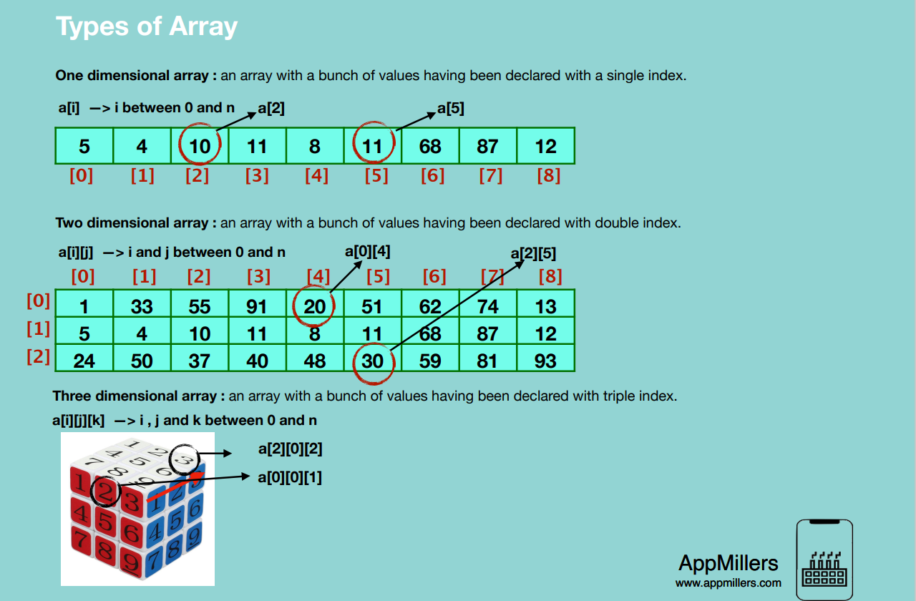

When we create an array, we”

* Assign it to a variable
* Define the type of elements that it will store
* Define its size (the maximum numbers of elements) **Note: not applicable to some programming languages which use dynamic arrays, they are easy to use but can cause performance issues.**

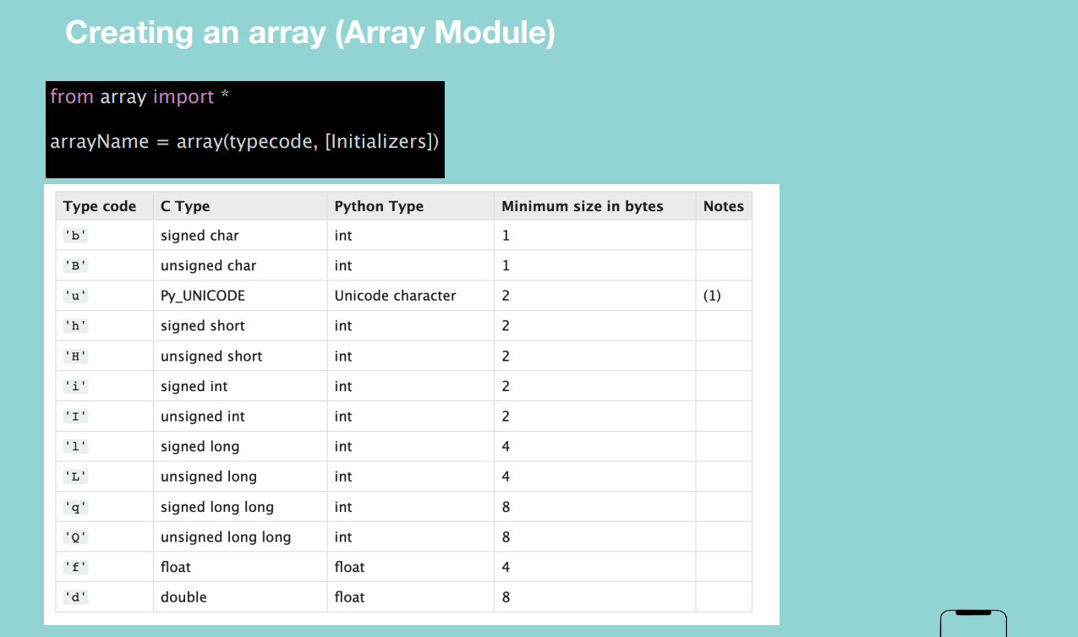

**Array Insertion**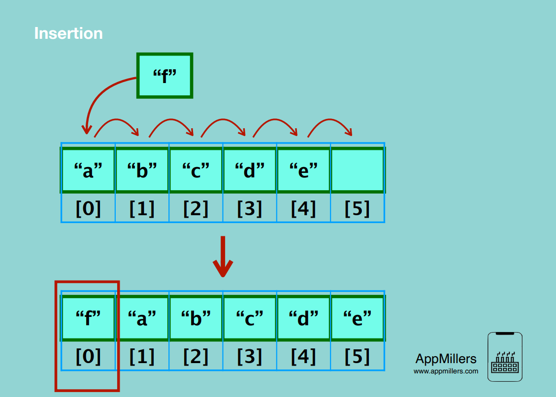

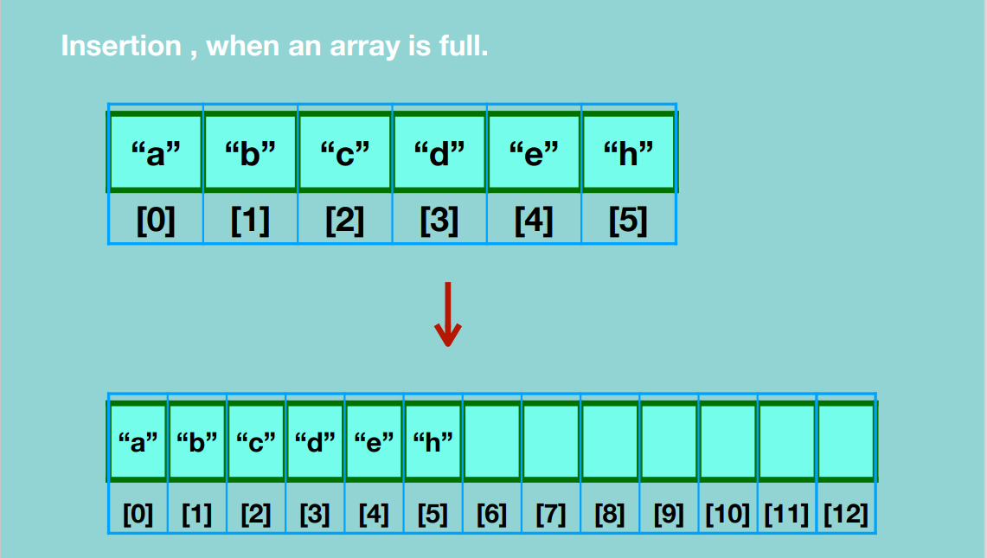

**Array Traversal**

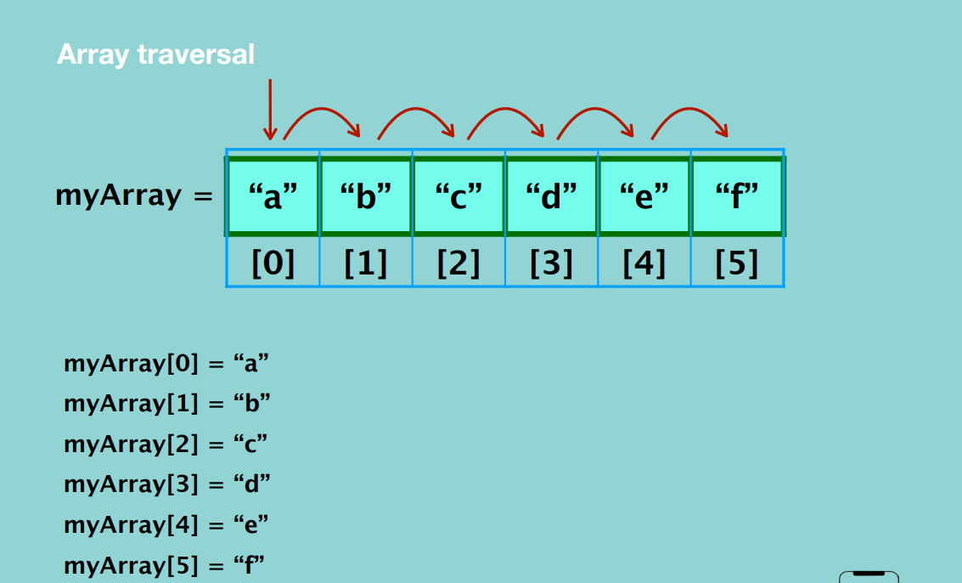

**Array accessing <<arrayName>>[index]**

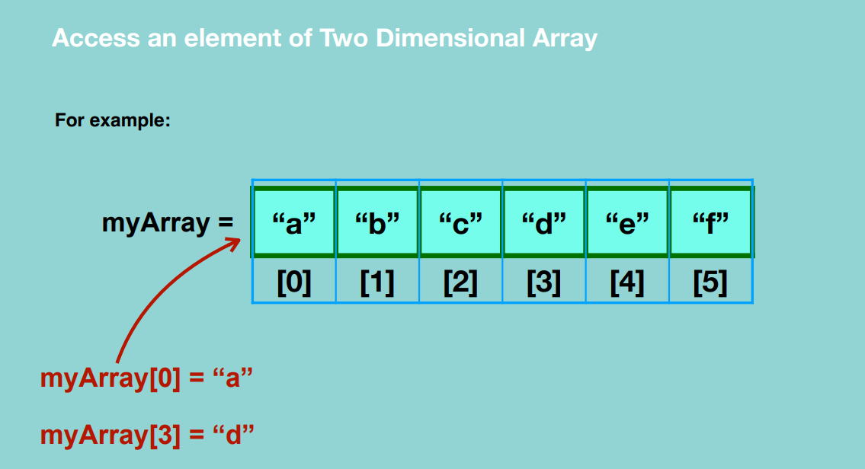

**Deleting element in the array**

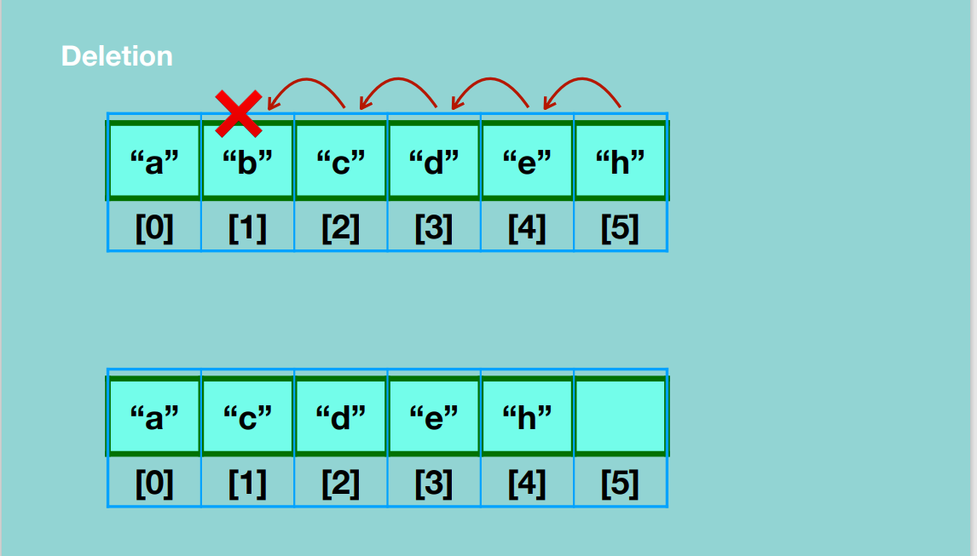

**Time and Space complexity in One Dimensional Arrays**

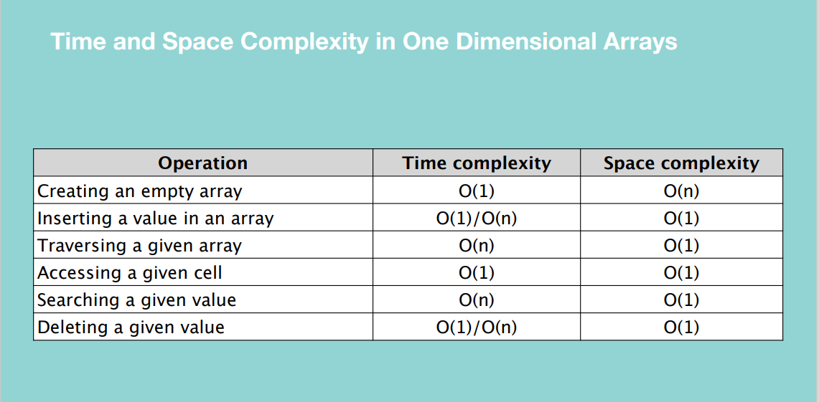

**Hence arrays are one of the most efficient DS when you need to easily access a value.**

**Two Dimensional Arrays**

**Insertion**

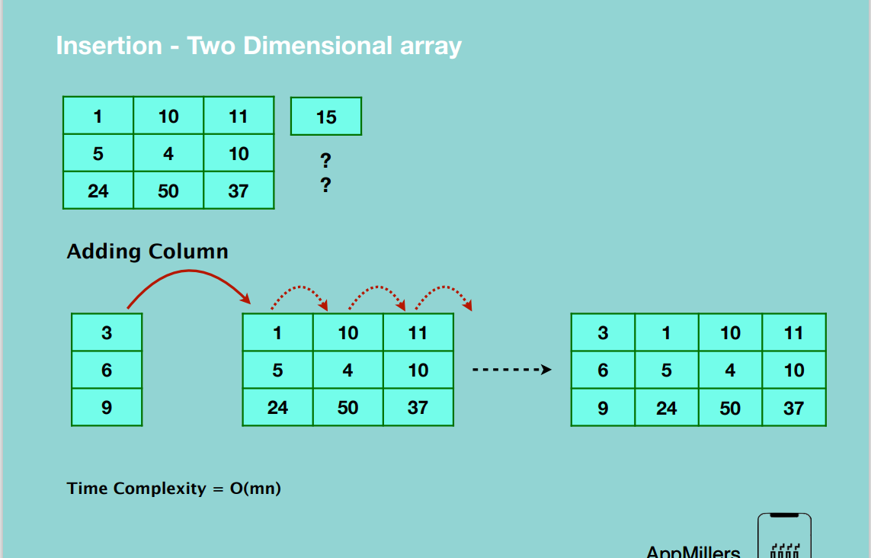

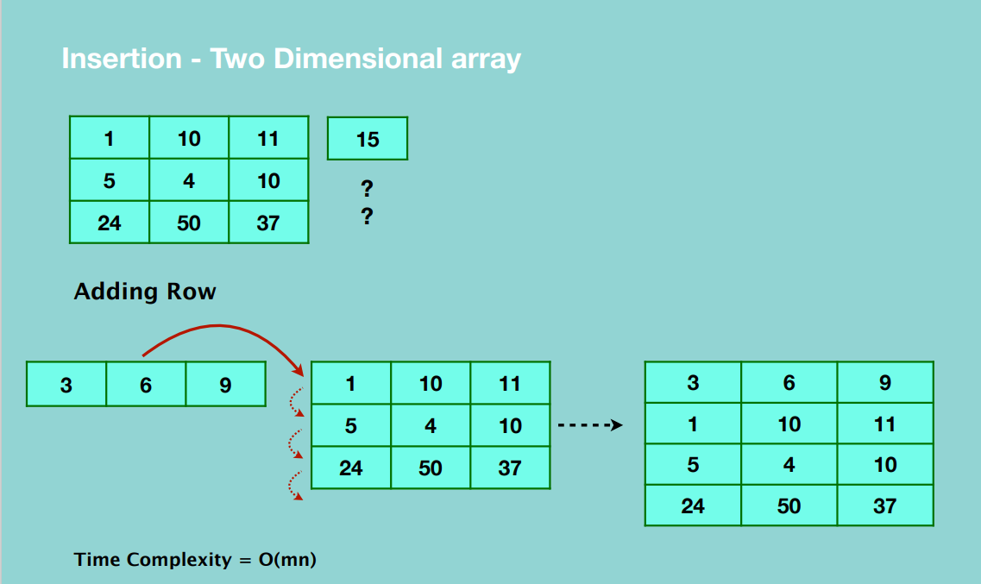

**Accessing elements in 2D array**

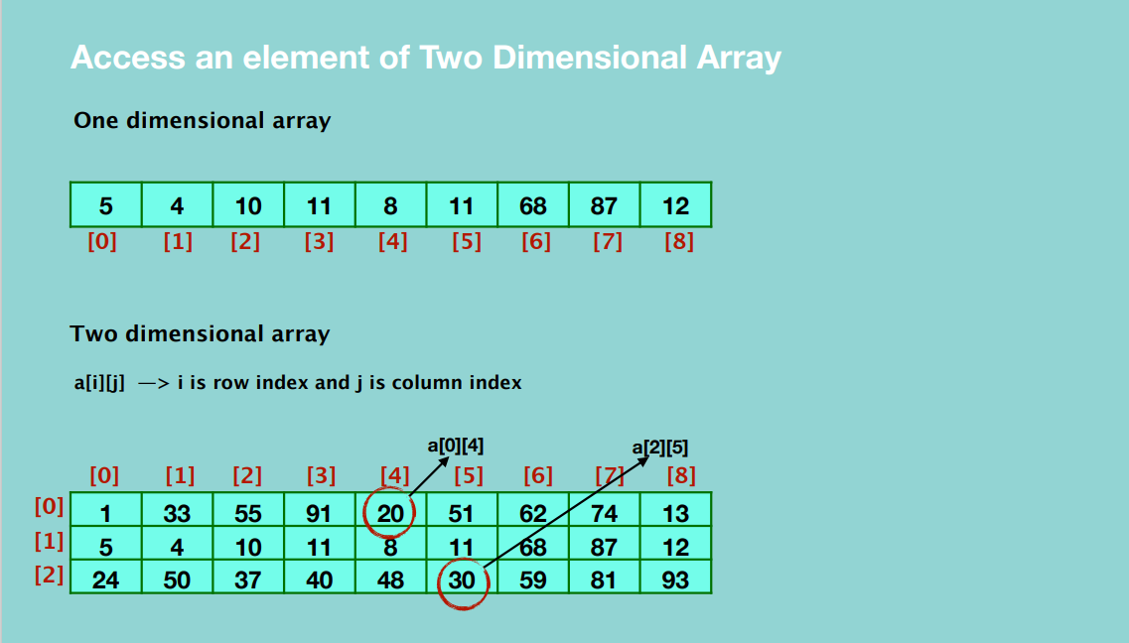

**Deletion**

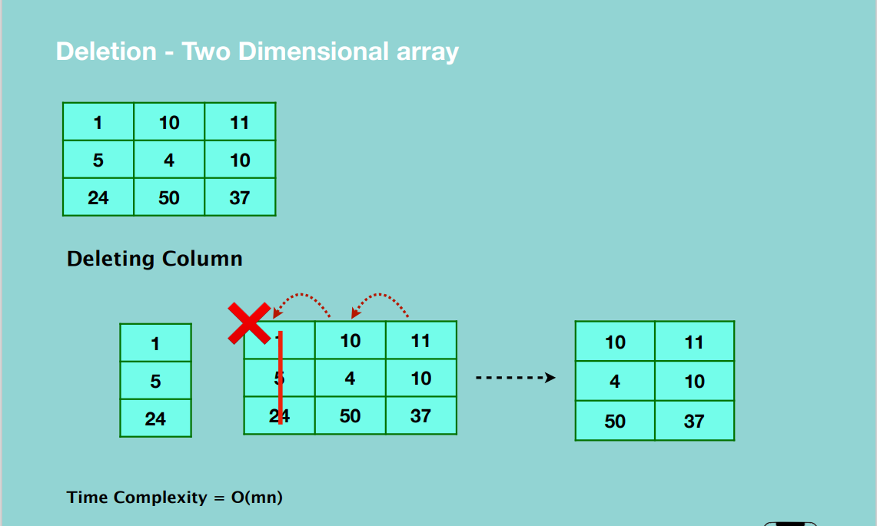

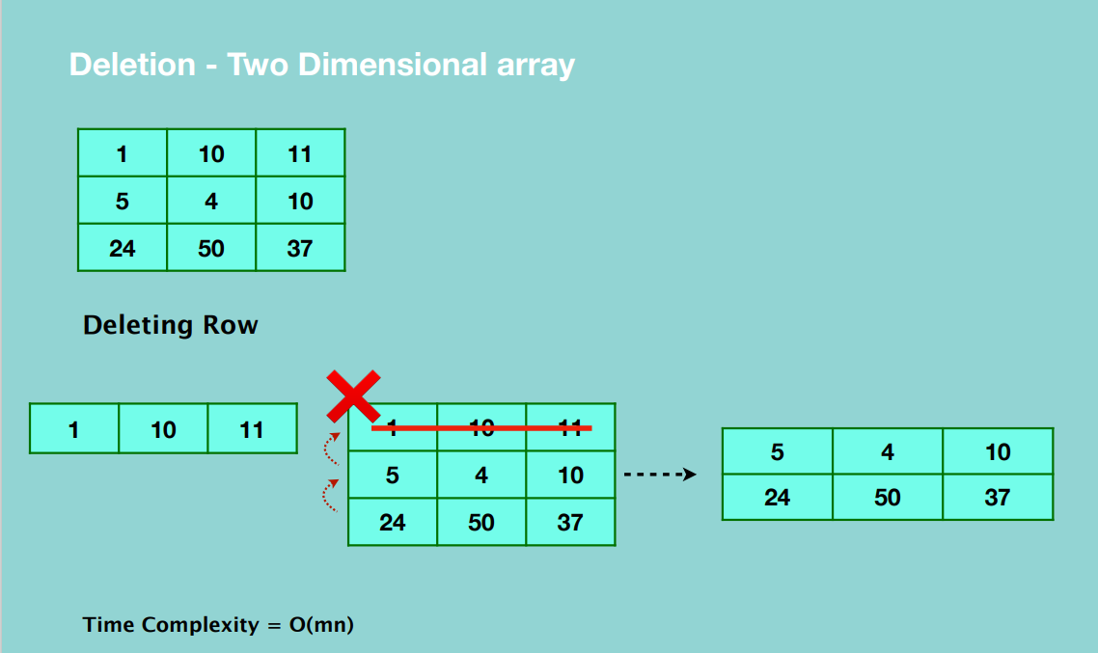

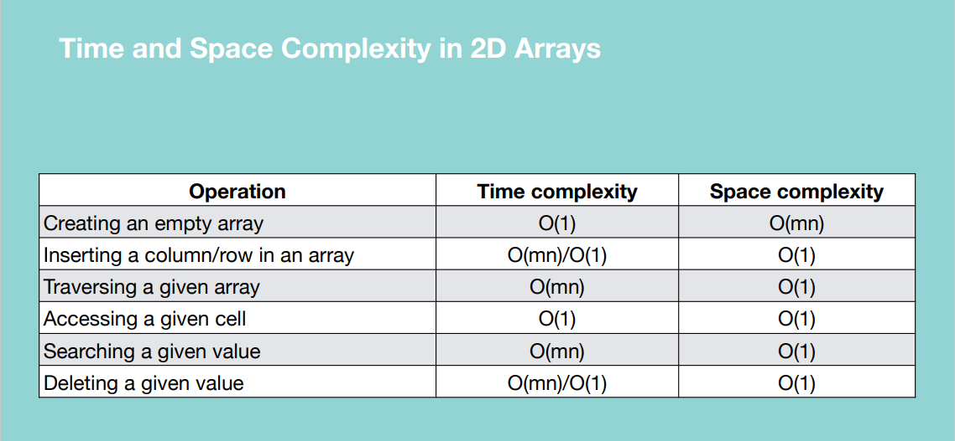

**When to use Arrays**

* To store multiple variables of the same data type
* Random access

**When to avoid**

* Same data type elements – specific to some languages
* Reserved memory

**Python Lists –** built in data structures

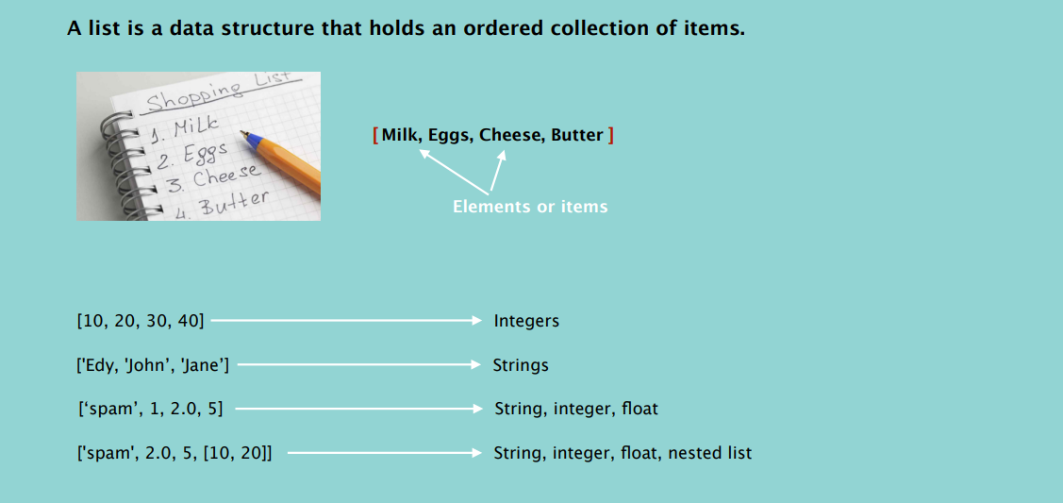

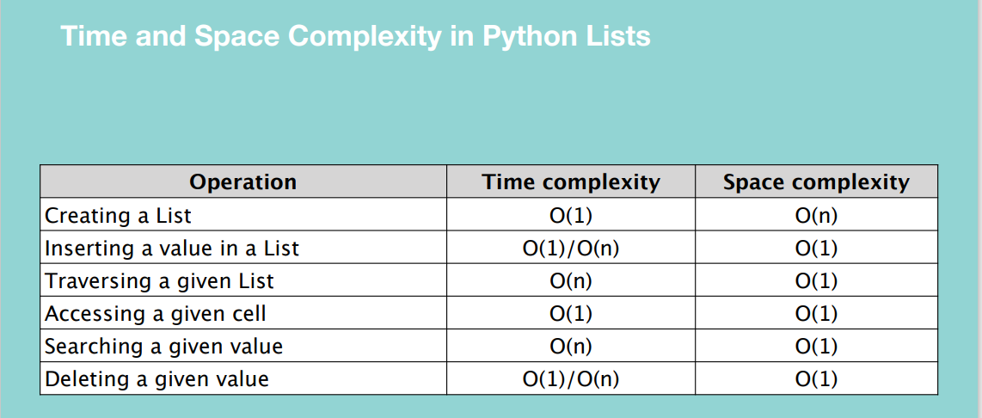

**Dictionary**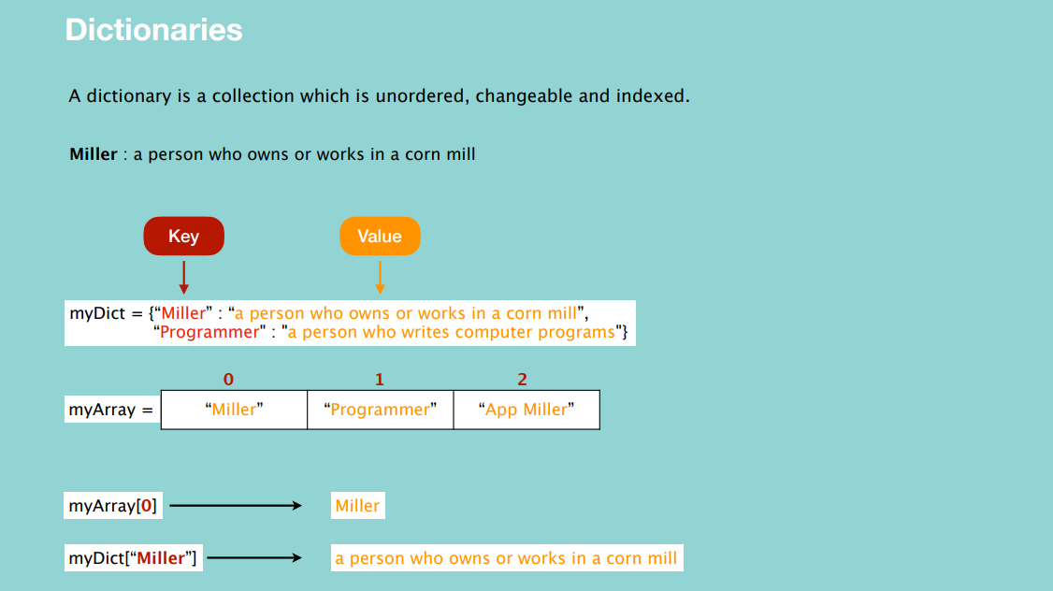

**NOTE:** Python dictionaries are implemented using hash tables.

The goal of the hash function is to distribute the index evenly in the array.

A good function minimizes the number of collisions.

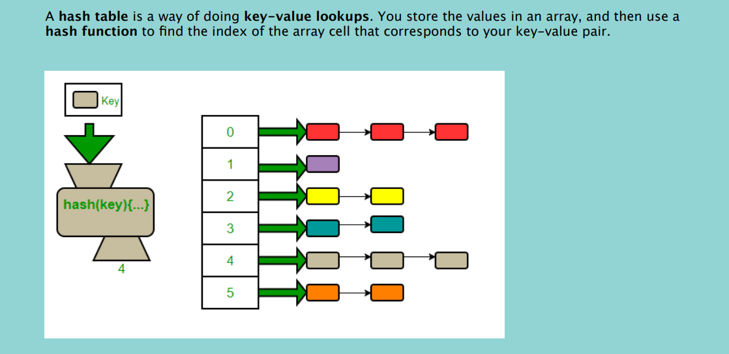

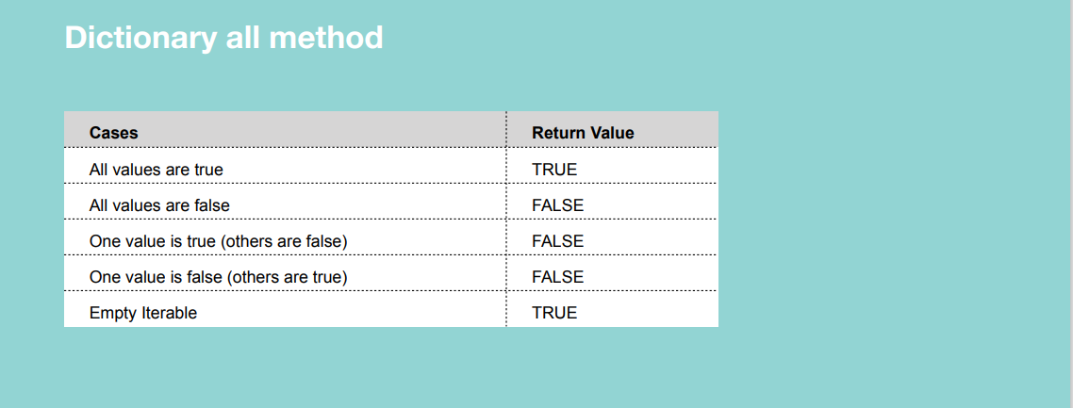

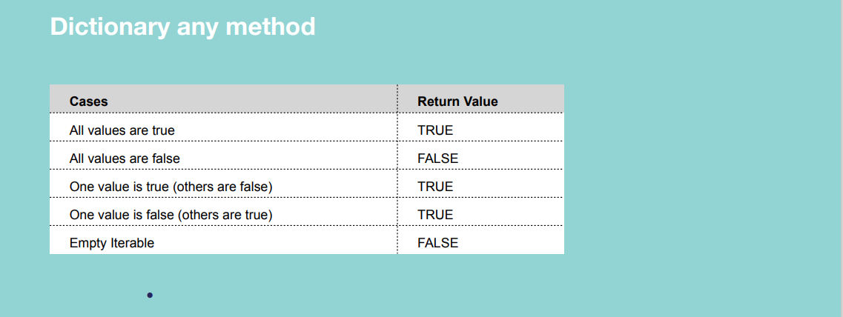

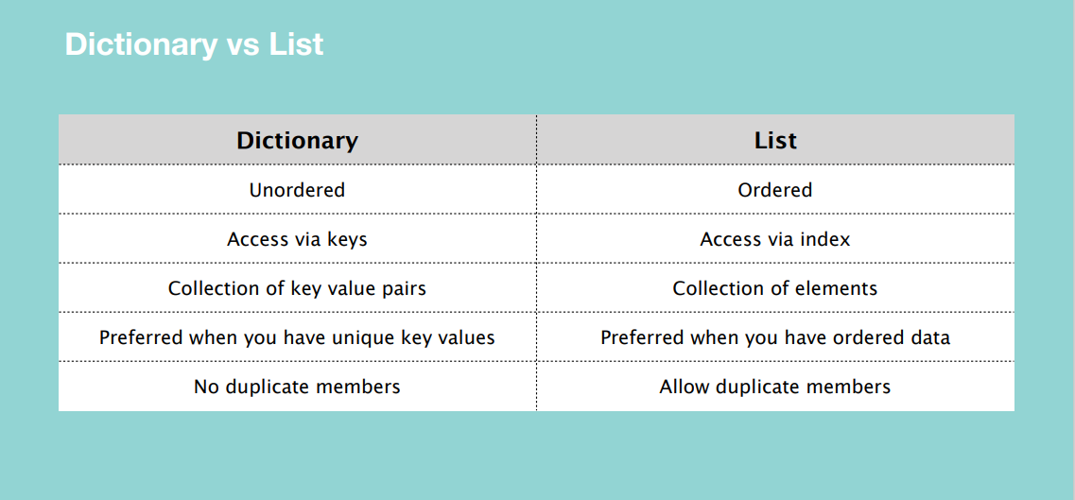

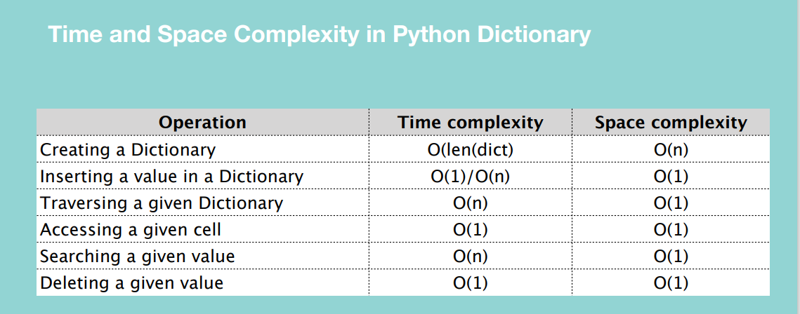

Creating a dictionary depends on the length of the dictionary because the hashfunction has to be executed to determine the index.

Searching using linear search is O(n) while with in operator it’s O(1) because it uses a hash function.

**TUPLE**

A tuple is an immutable sequence of Python objects.

Tuples are also comparable and hashable i.e. it has a value that remains the same during its live time.

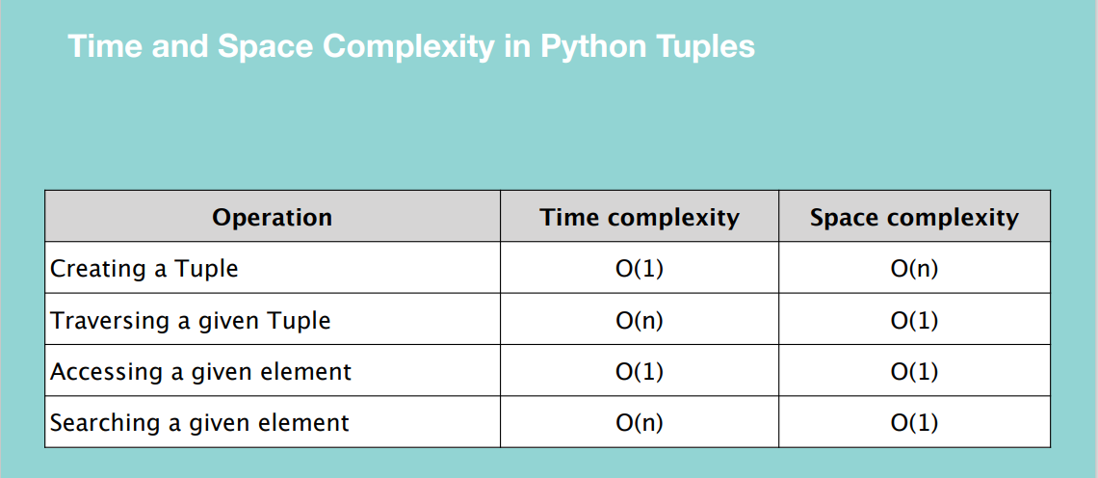

**LINKED LIST**

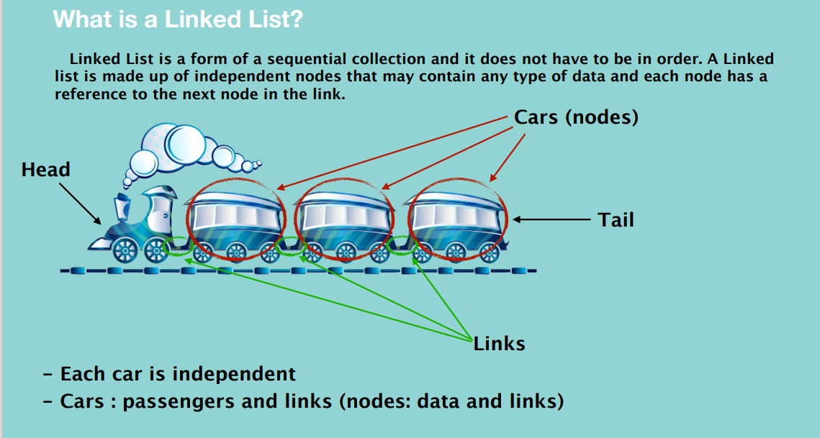

**NOTE:** The nodes of a linked list are not contiguous.

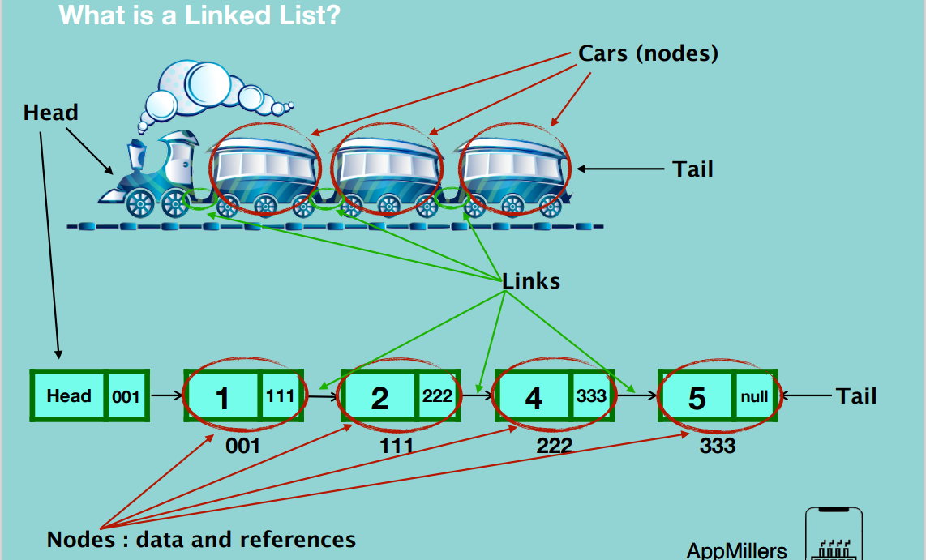

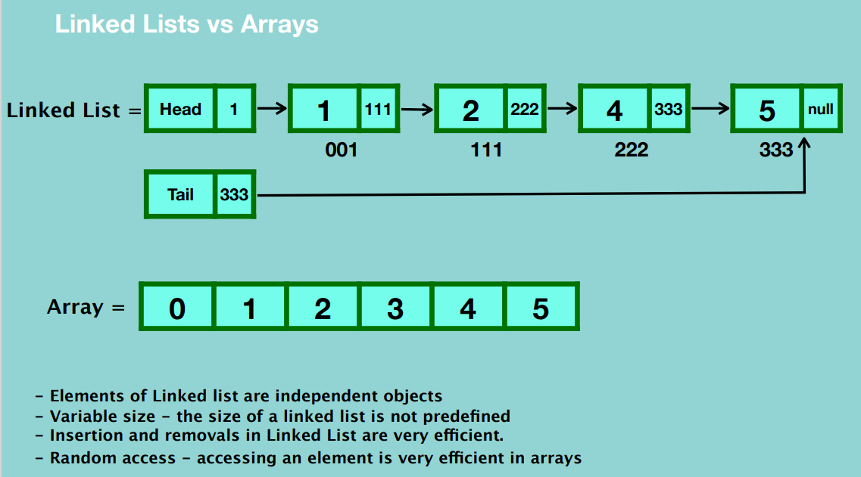

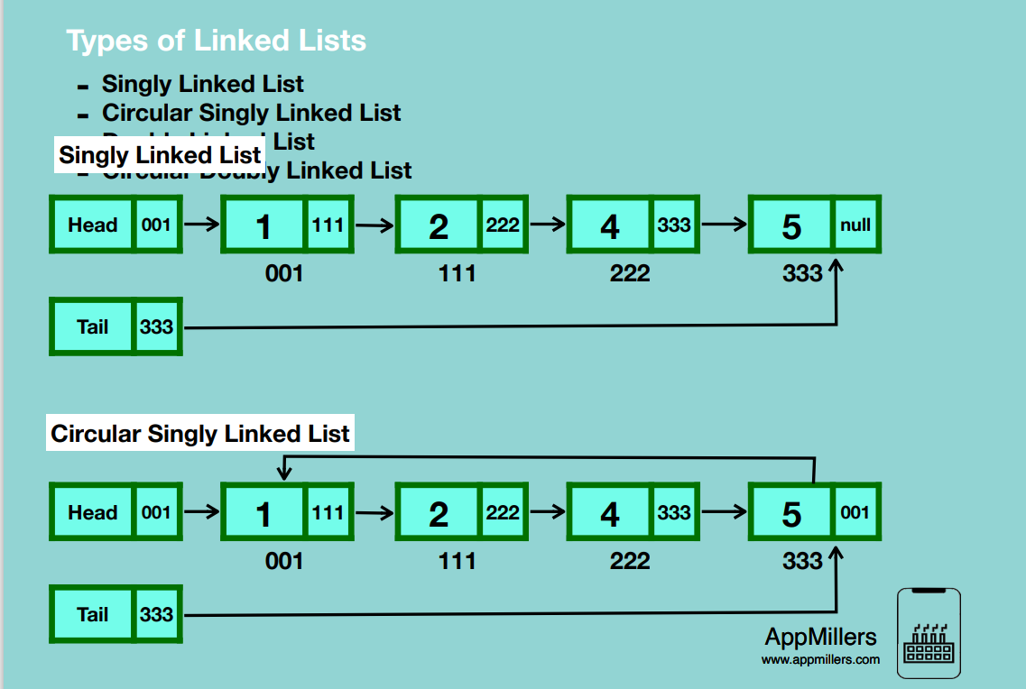

In Circular singly linked list, the last node stores a reference to the first node.

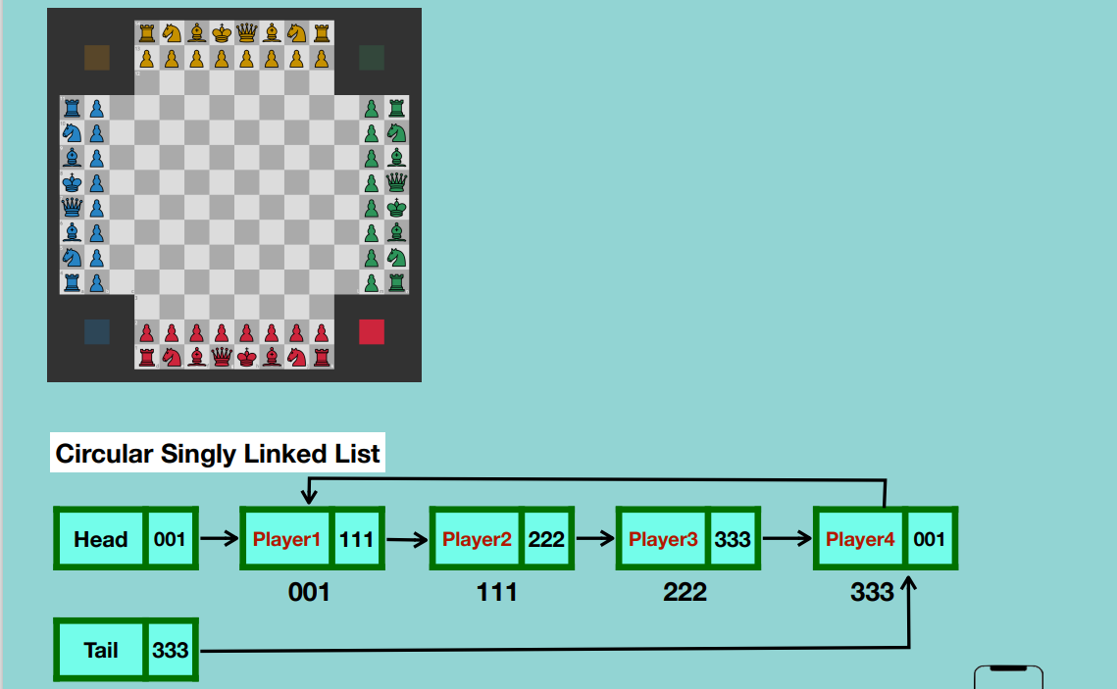

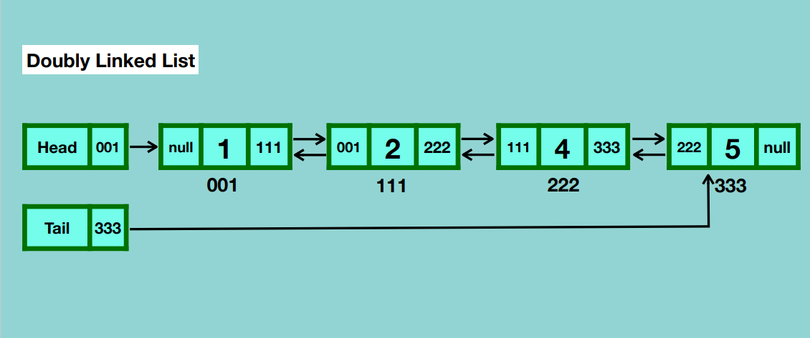

Each node has two references, one the next node and one to the previous node. It provides us flexibility of traversing in both directions.

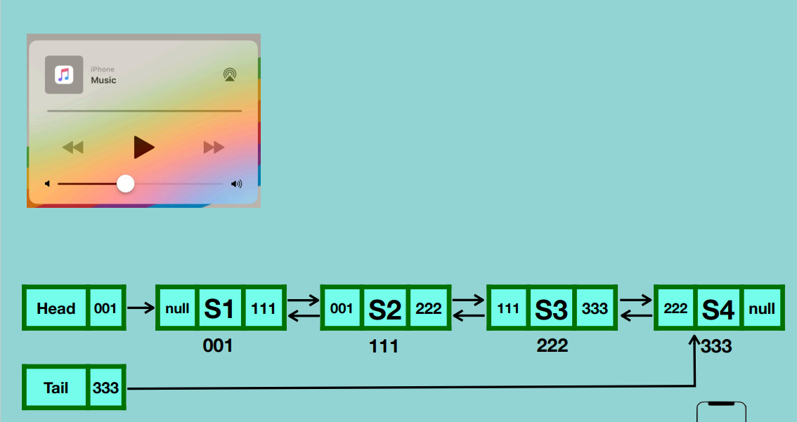

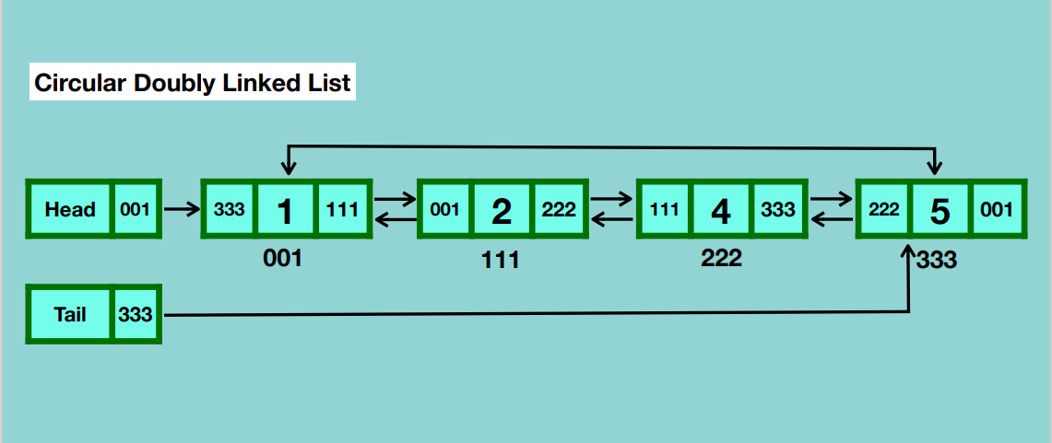

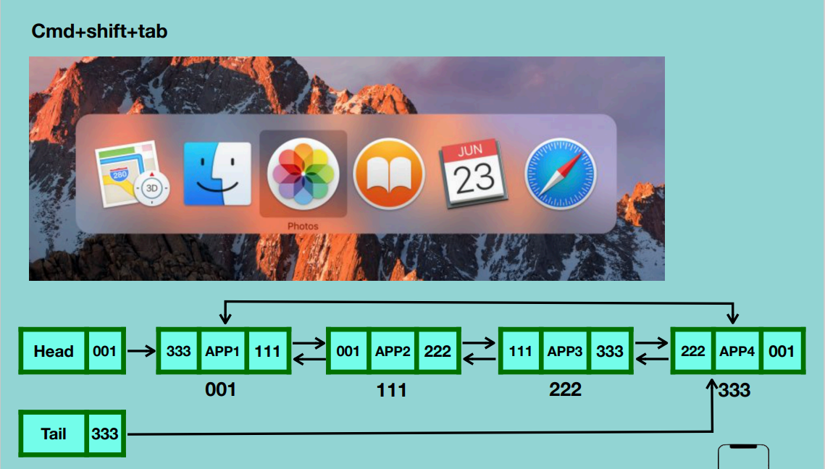

Looping through a list infinitely both forwards and backwards.

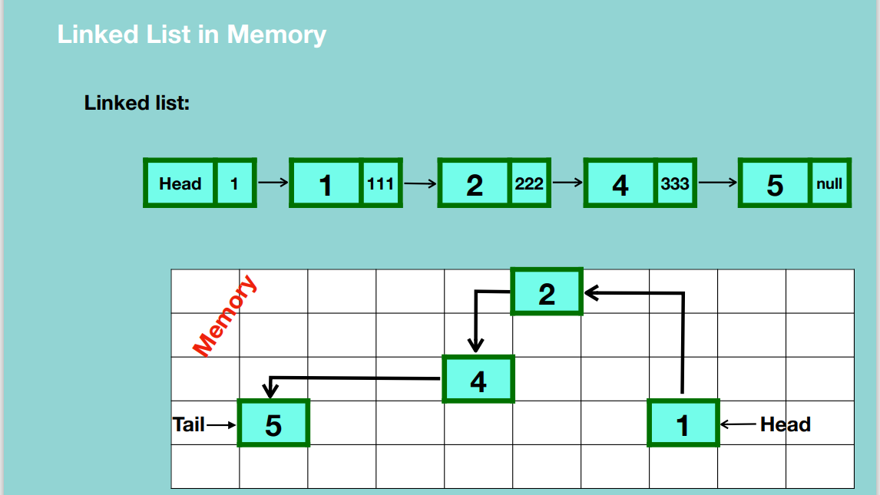

**Creation of a Singly Linked List**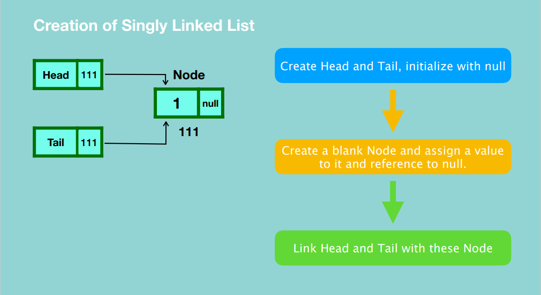

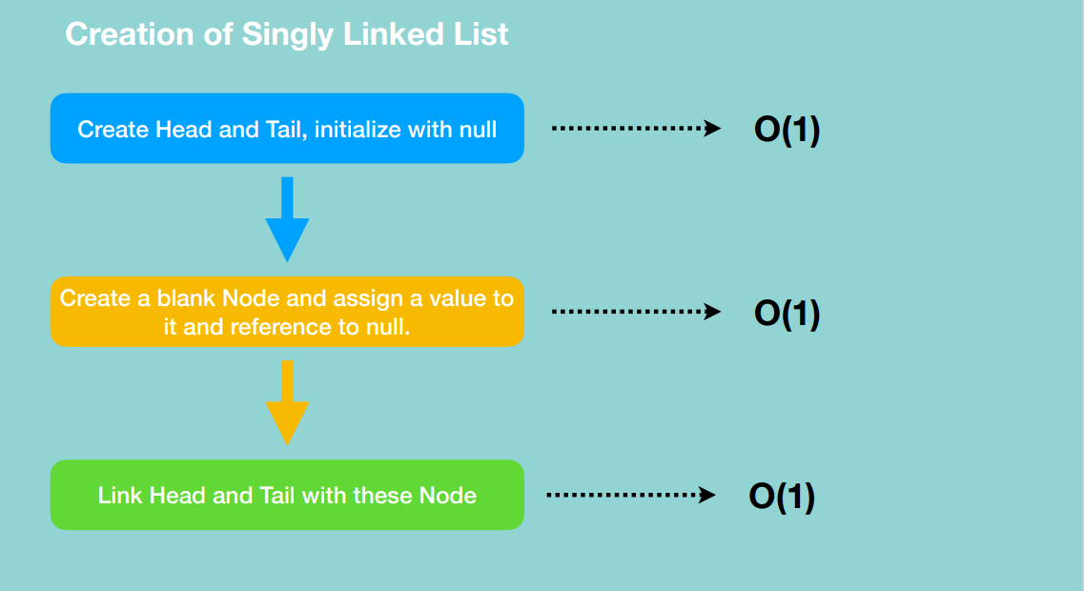

**INSERTION**

1. At the beginning of the linked list.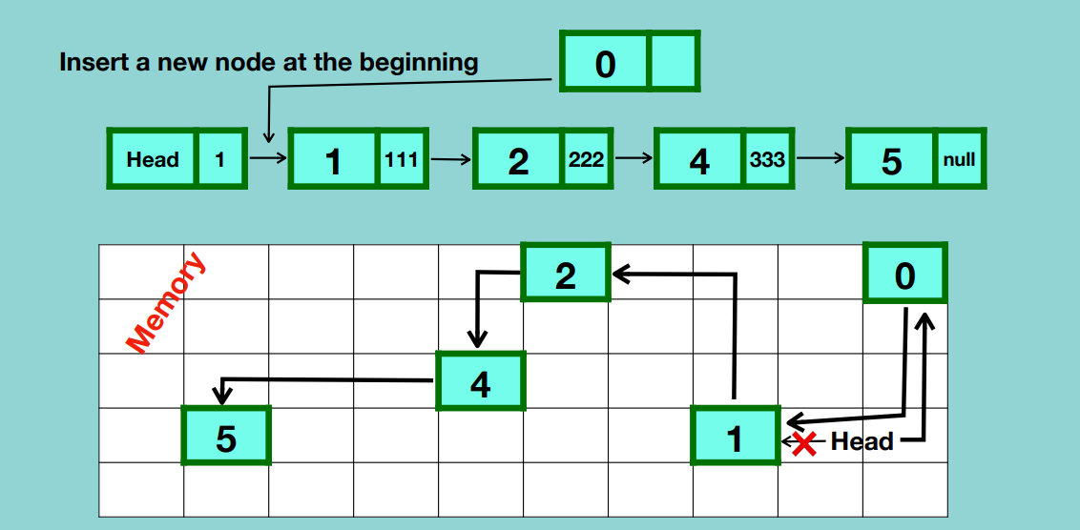

* Allocate random memory for the new node.
* Point the new node to the location of the first node.
* Point the head to the location of the new node and connection between the head and the previously first node will be broken.

2. After a node in the middle of linked list

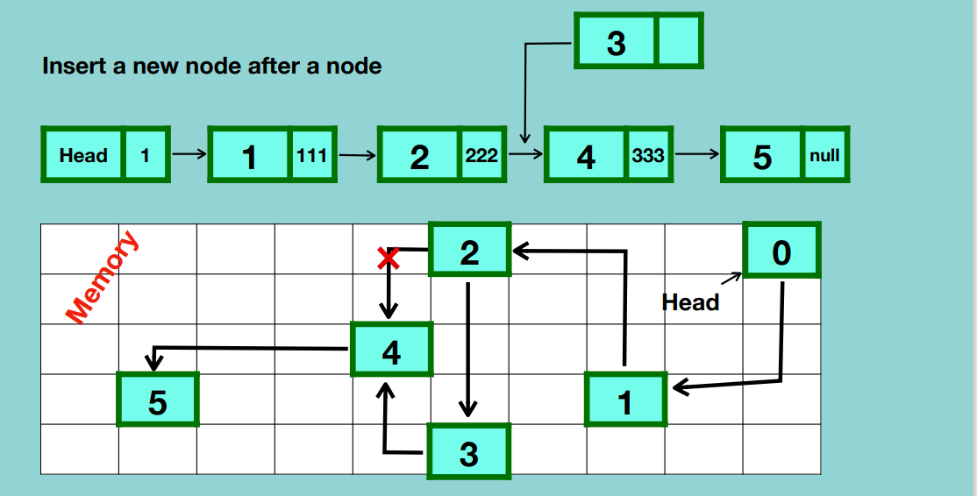

* Traverse from the head to the node after which the new node will be added i.e. 2.
* Allocate a random memory location for the new node.
* Point the new node to the next node of the node after which it’s going to be inserted.
* Point the current node i.e. 2 to the new node and the connection with the previous node will be broken.

1. At the end of the linked list.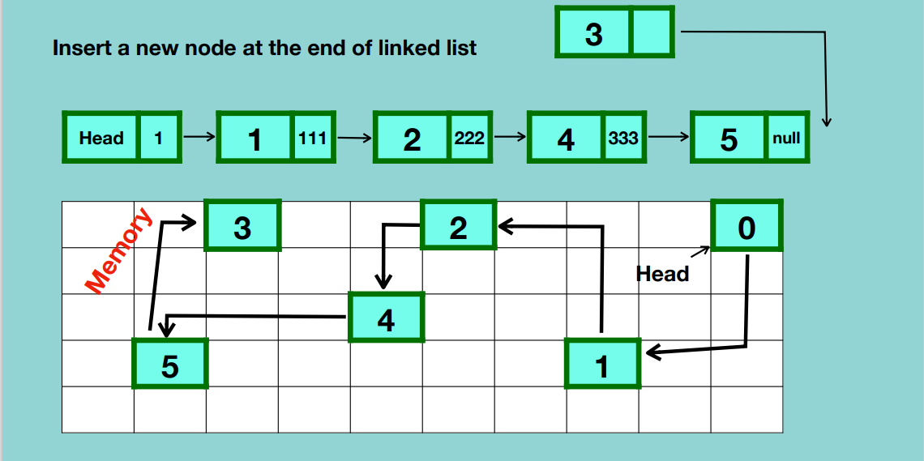

* Traverse from the first element to the last node.
* Allocate a random memory for the new node.
* Update the reference of the last node to point to the new node.
* Make the tail point to the new node.

Adding an element at the beginning of the linked list is very efficient because there is no updating of linking nor is there traversing while adding at the end of the linked list needs you to traverse the entire linked list and change the linking.

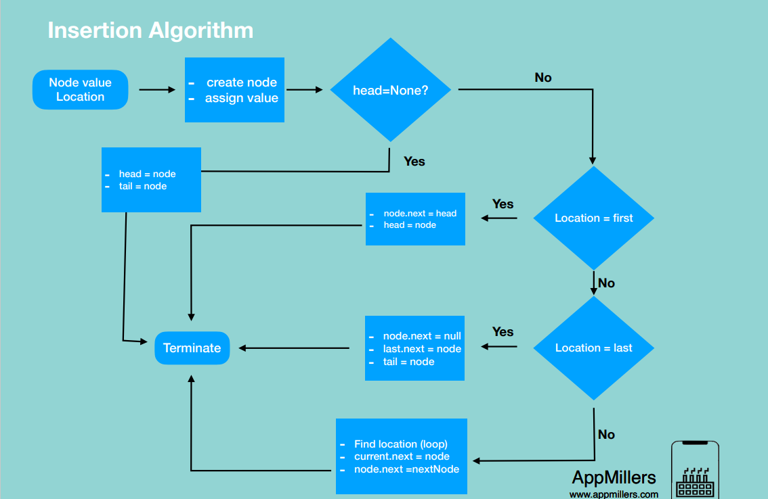

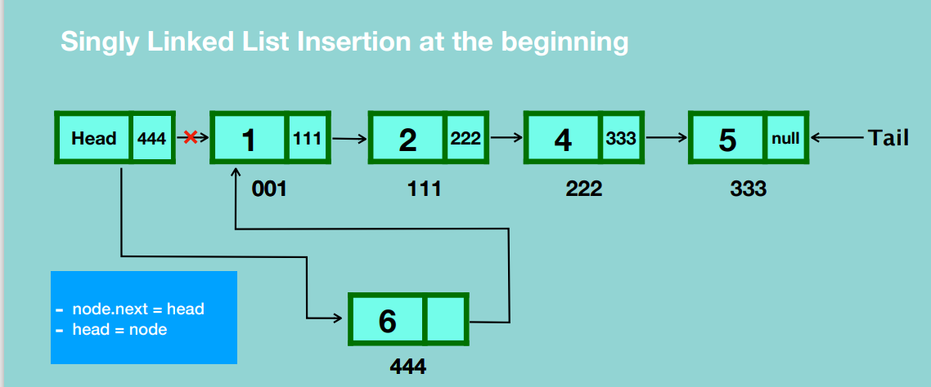

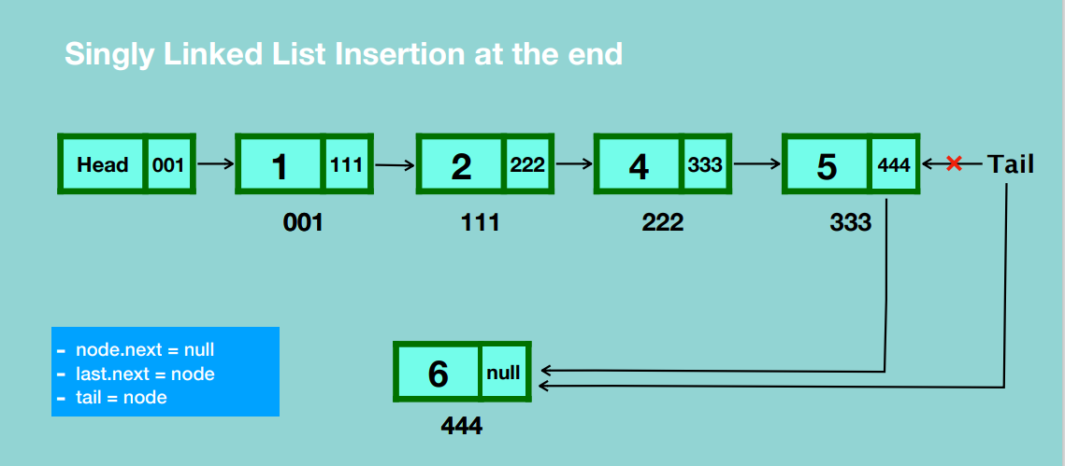

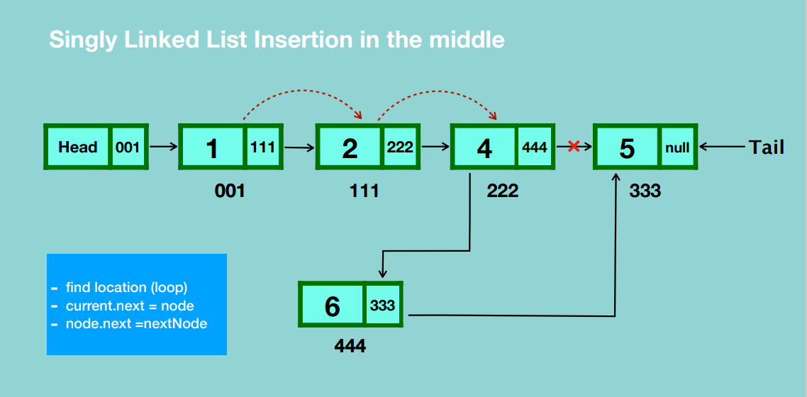

**TRAVERSAL**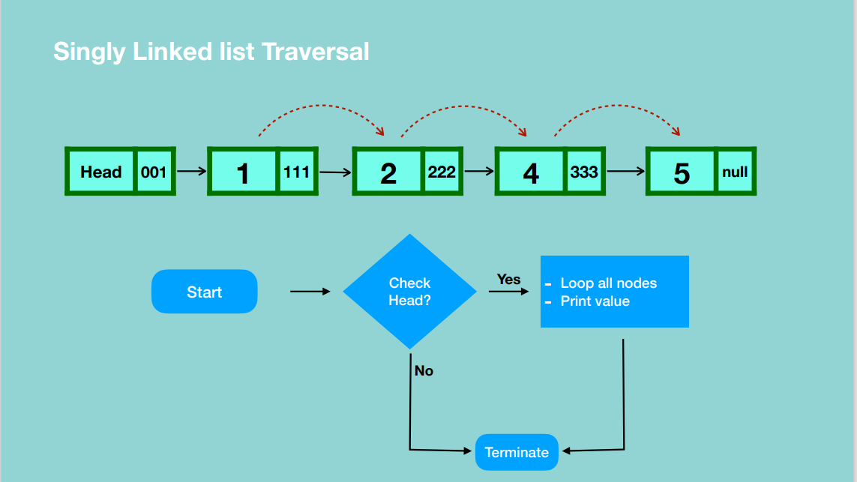

**SEARCH**

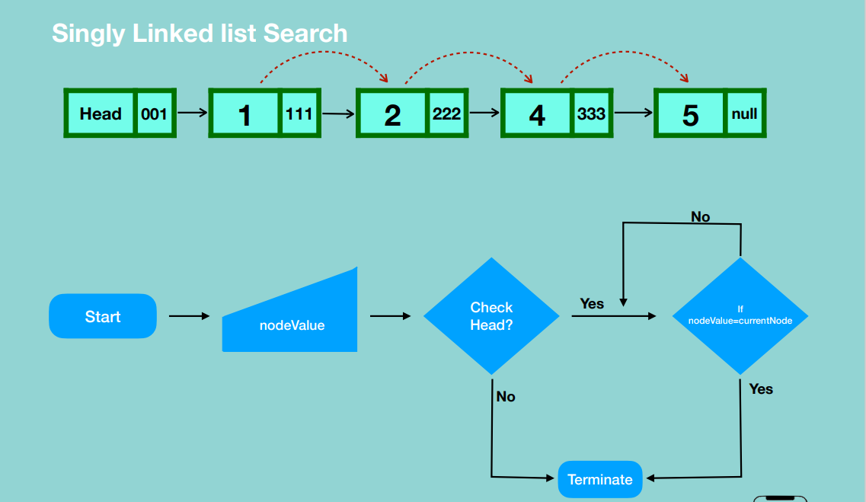

**DELETION**

1. Deleting the first node

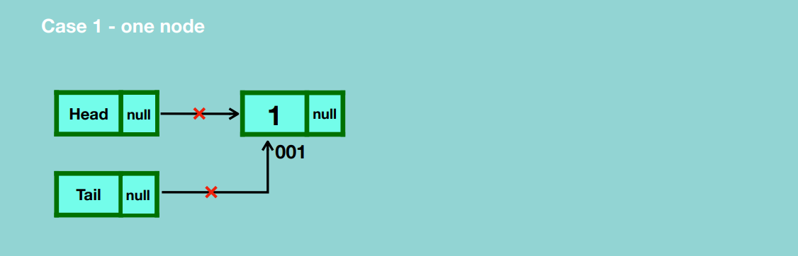

* Update head and tail references to null.
* Garbage collection deletes the node.

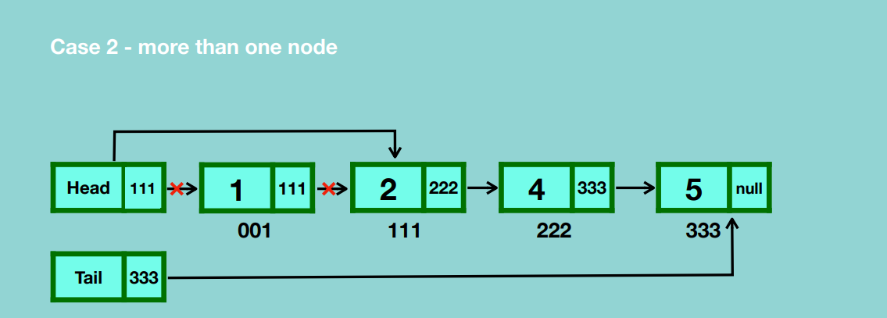

* Update the head reference to the second node which breaks the connection the the first node.
* Update the first node reference to null.
* Garbage collection takes place.

1. Deleting any given node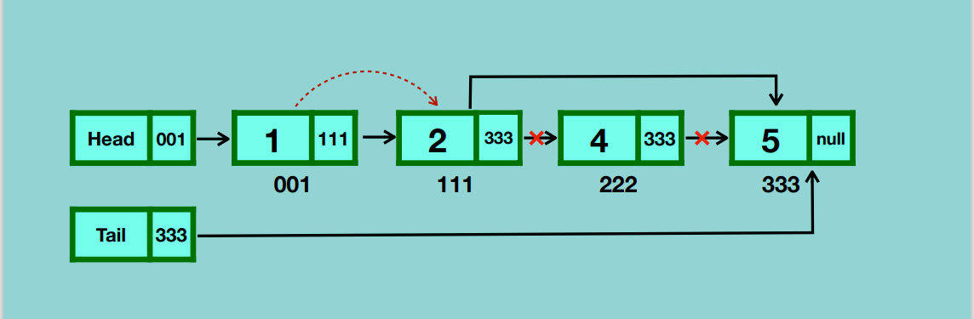

* Traverse to the node that is before the node that you want to delete.
* Update the reference of the current node to that of the node after the one you want to delete.
* Update the reference of the node you want to delete to null.
* Garbage collection takes place.

1. Deleting the last node

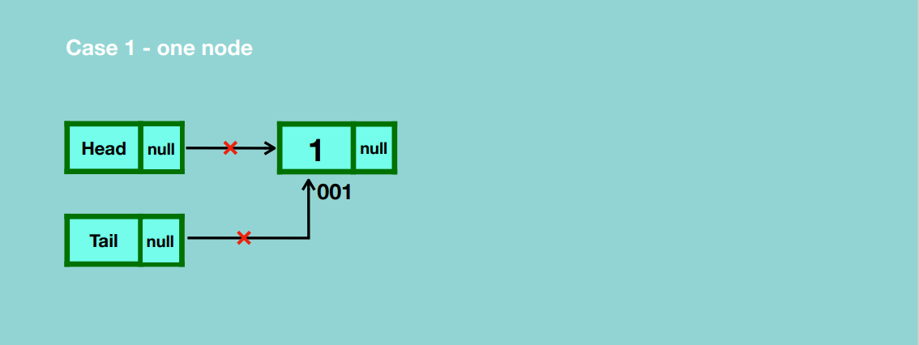

* Update the reference of head and tail to null.
* Garbage collection takes place.

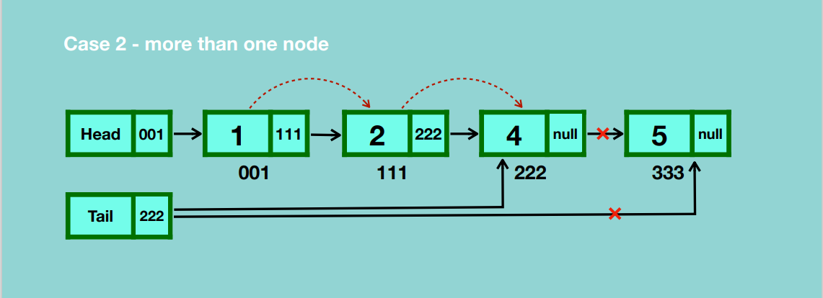

* Traverse to the node before the last node.
* Update the reference of the node before the last node to null.
* Update the reference of the tail to the node before the last node.
* Garbage collection takes place.

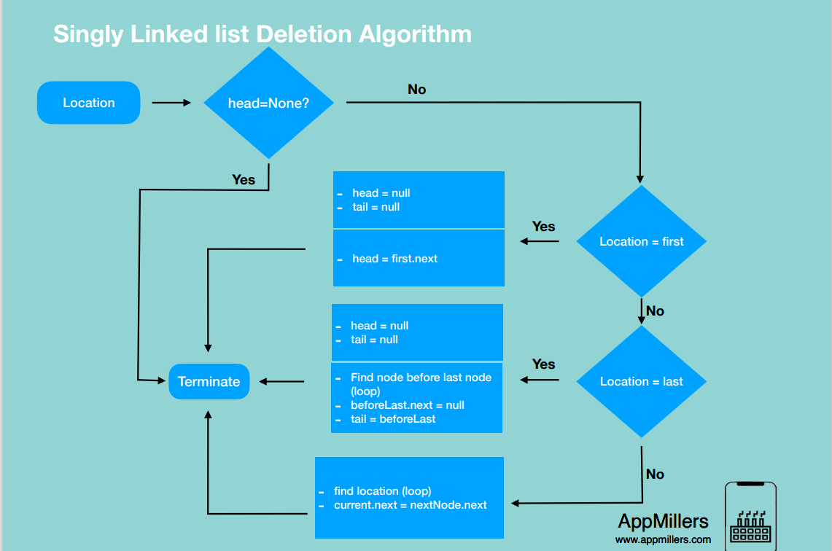

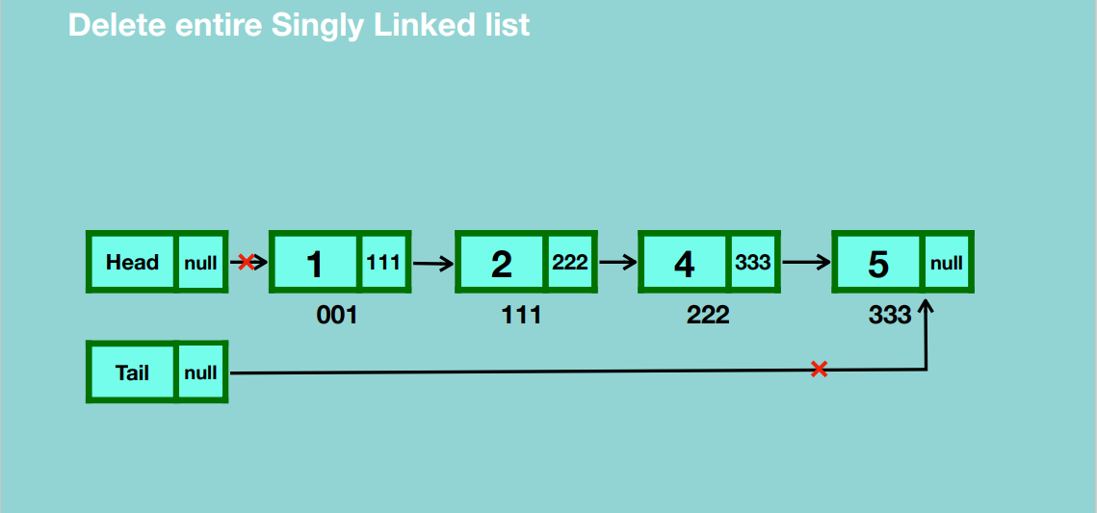

* Disconnect head and tail references from the first and last node of the linked list.
* Garbage collection will handle removal of all the nodes.

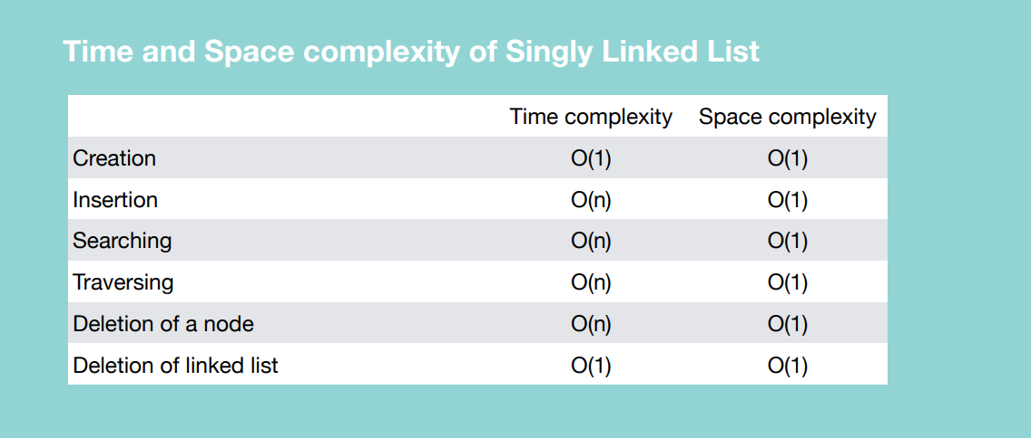

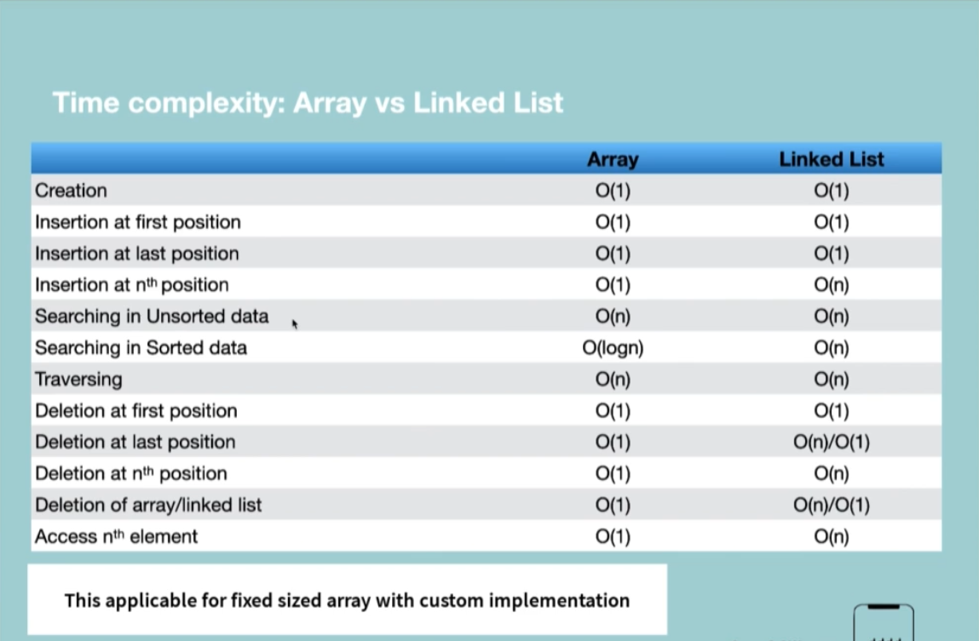

**CIRCULAR SINGLY LINKED LIST**

Last node points to the first node.

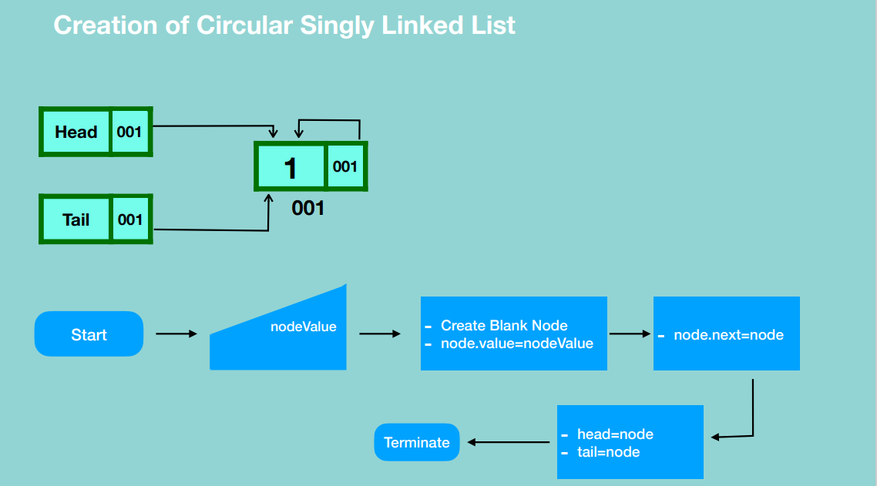

* Here the first node references itself after creation.
* The head and tail reference the first node.

**INSERTION**

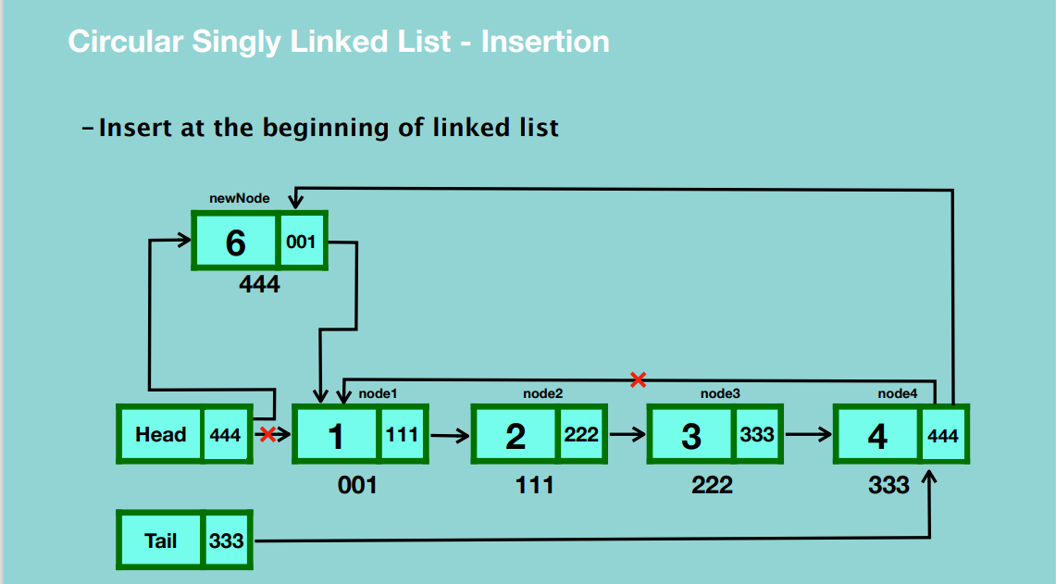

* Create a blank node and assign a value to it.
* Update the reference of the new node to the first node.
* Update the reference of the head to the new node.
* Update the last node’s reference to the new node.

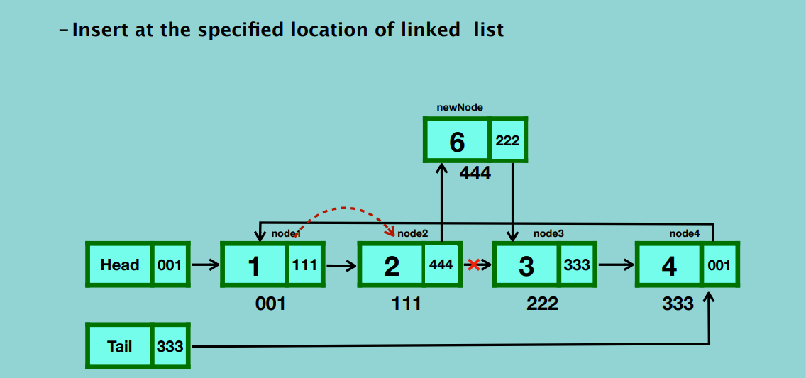

* Create a new node and assign a value to it.
* Traverse from the first node to the node after which you’re going to insert the new node.
* Update the reference of the new node to the node that the current node is pointing to.
* Update the reference of the current node to the new node.

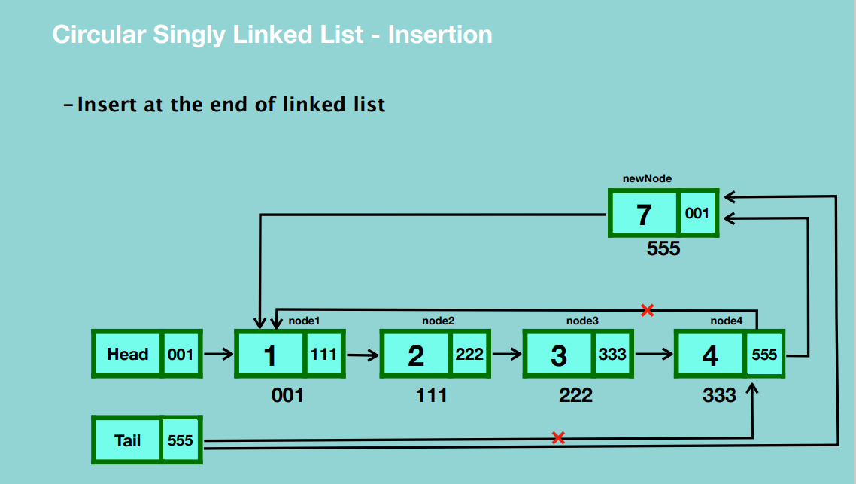

* Update the reference of the last node to the new node’s location.
* Update the reference of the tail to the new node.
* Update the reference of the new last node to the first node.

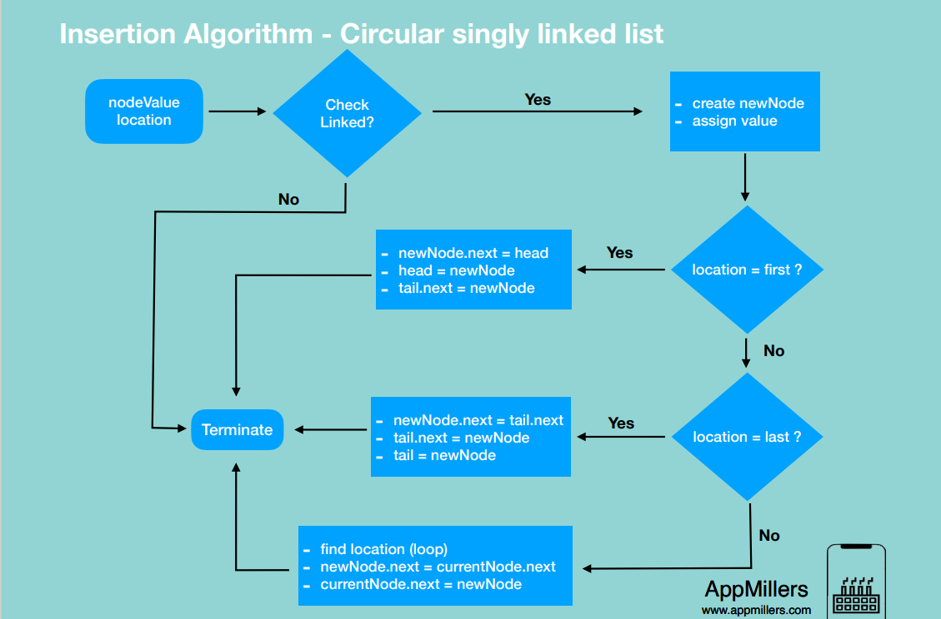

**SEARCHING**

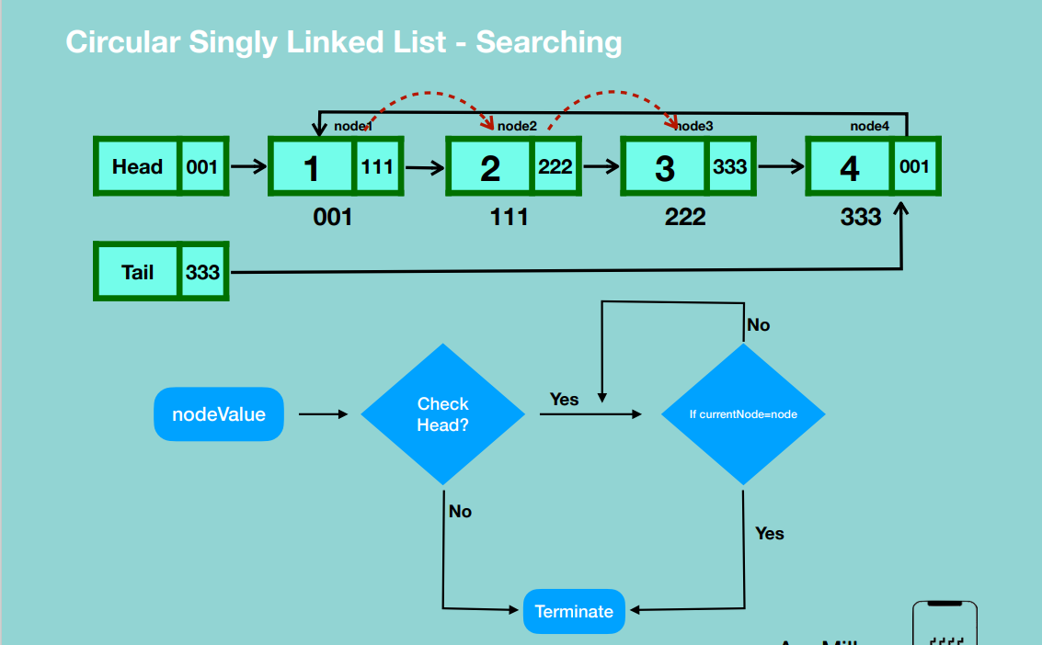

**DELETION**

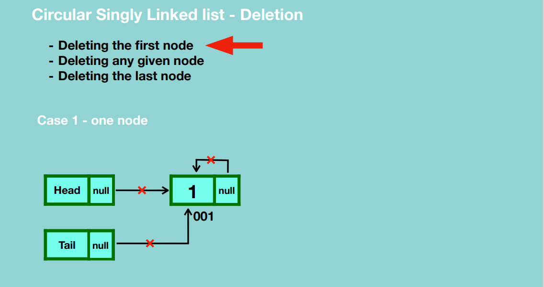

* Update all references that point to the node to null. i.e. update reference of head to null, reference of tail to null and reference of the node itself to null.
* Garbage collection takes place.

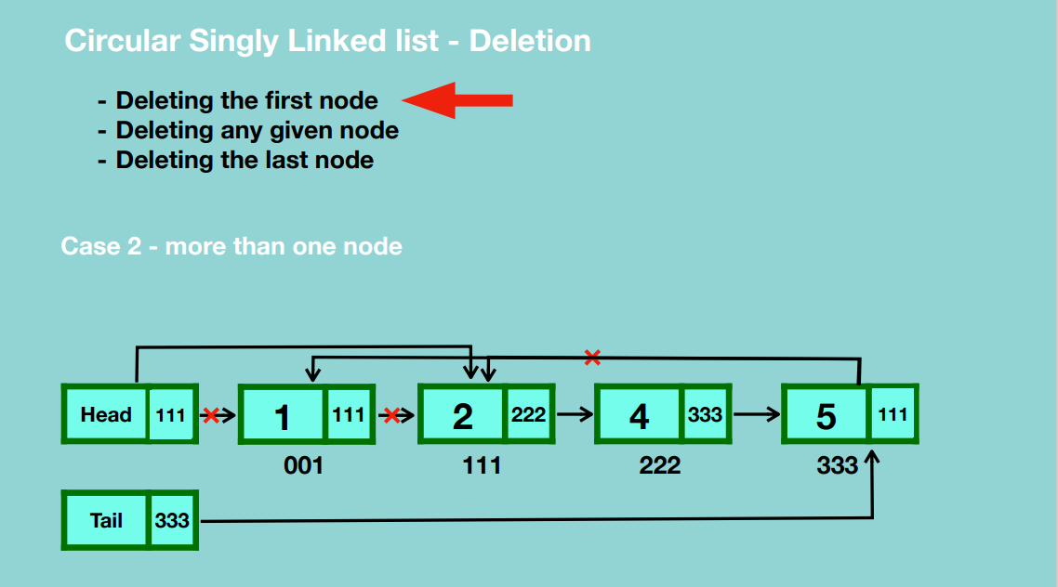

* Update reference of the head node to the second node.
* Update the reference of the last node to the second node.
* Garbage collection takes place.

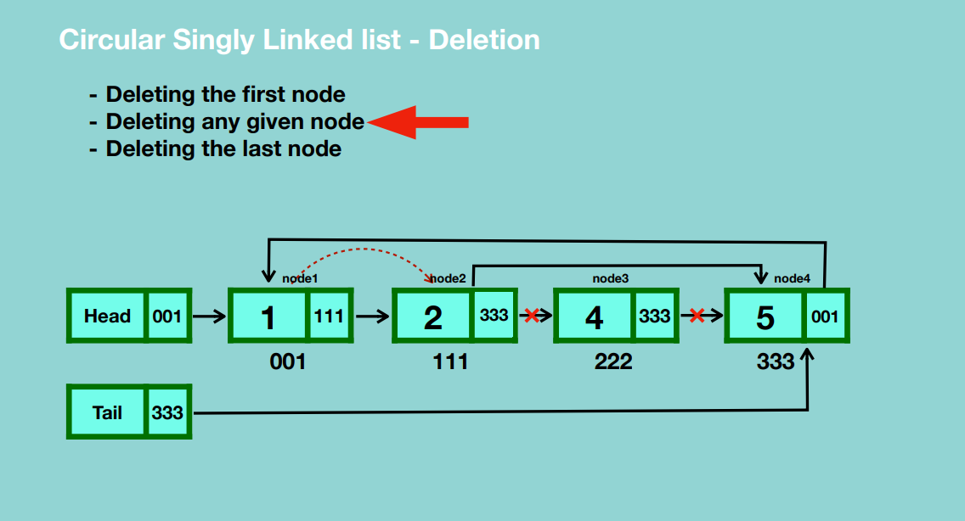

* Traverse from head node to the node before the one we want to delete.
* Update the current node’s reference to the one after the node we want to delete.
* Update the reference of the node we want to delete to null.
* Garbage collection takes place.

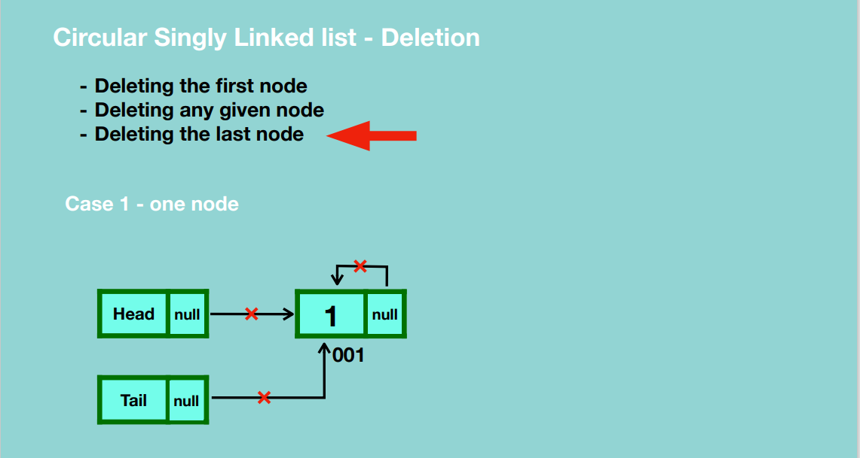

* Update head and tail references to null.
* Update the node’s reference to null.
* Garbage collection takes place.

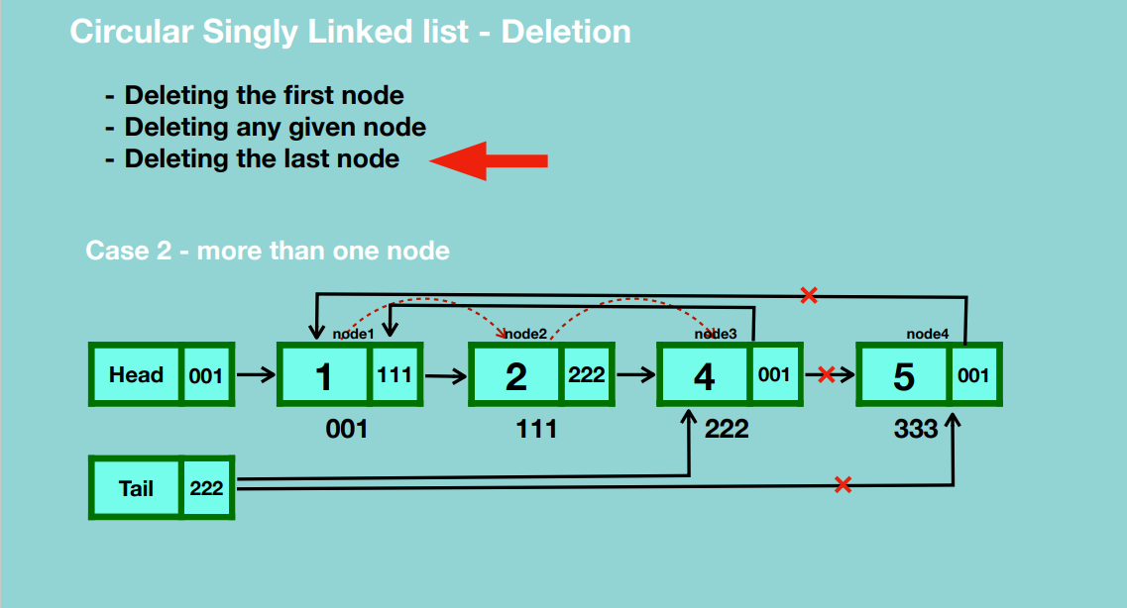

* Traverse till we reach the node before the last node.
* Update the reference of the current node to point to the first node.
* Update the reference of the node to be deleted to null.
* Update the tail reference to point to the current node.
* Garbage collection takes place.

**Delete entire linked list**

* Set head reference to null.
* Set reference of last node to null.
* Set tail reference to null.

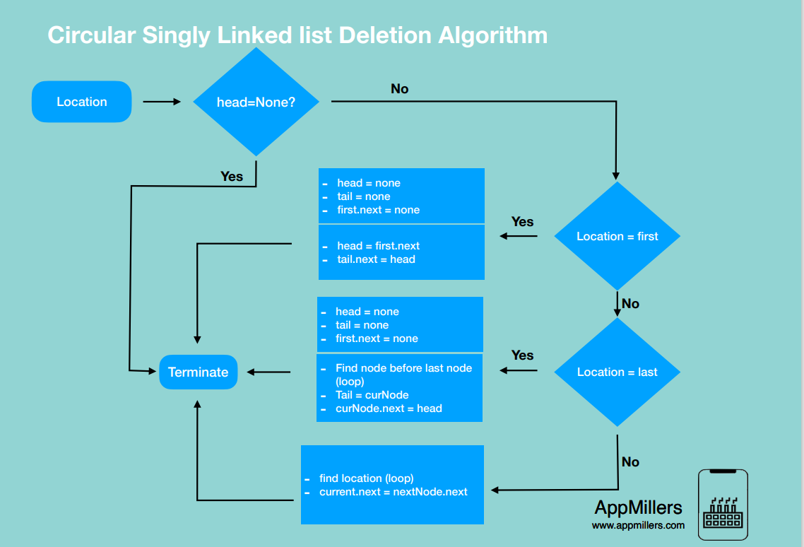

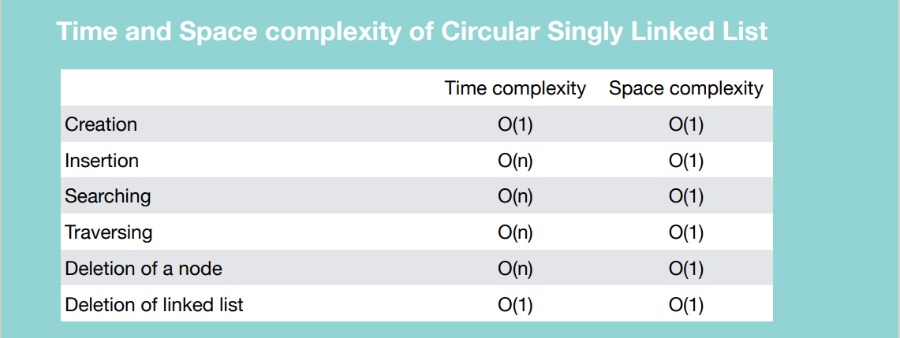

**DOUBLY LINKED LIST**

Each node contains two references, that references previously and forwards.

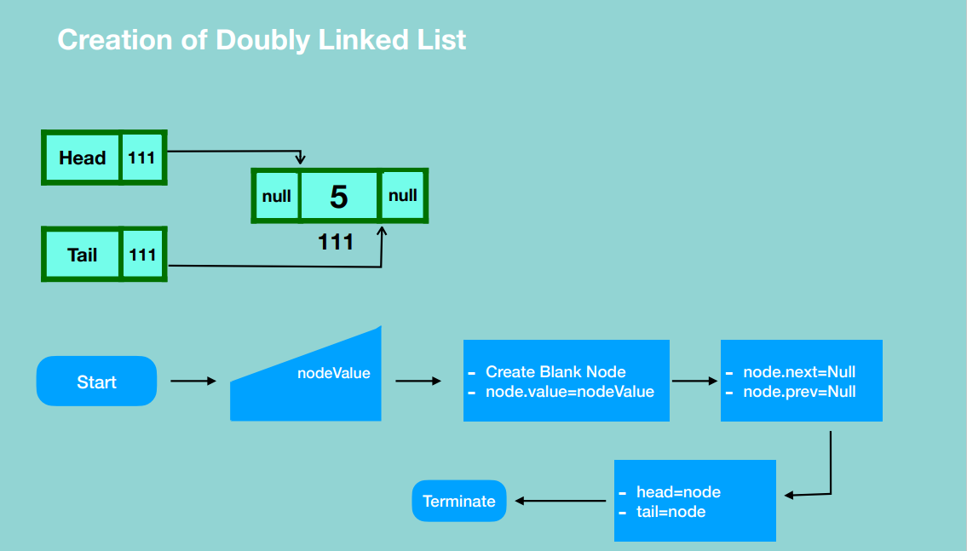

* Create head and tail references, then create a blank node and assign it a value giving it a previous and forward references to null.
* Update the head and tail references to point to the new node.

**INSERTION**

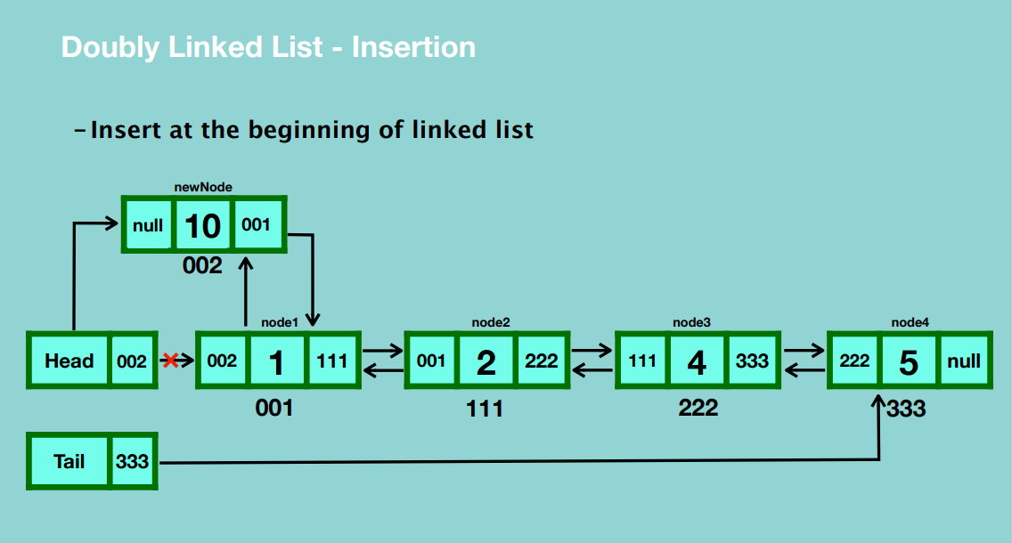

* Create a blank node in memory and assign it a value.
* Set the node’s previous reference to null.
* Set the new node’s next reference to the first node.
* Update the previous reference of the first node the location of the new node.
* Update the reference of the head to the location of the new node.

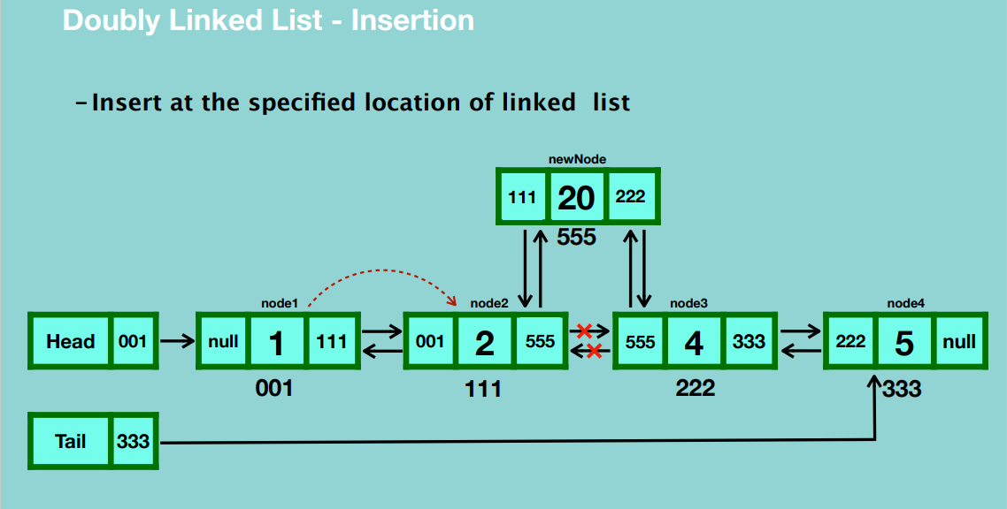

* Create a blank node and assign it a value.
* Traverse through the doubly linked list until we reach the node which is before the node we want to insert before.
* Update the new node’s next reference to the current node’s next reference.
* Update the previous reference of the new node to the location of the current node.
* Update the next reference of the current node to the location of the new node.
* Update the previous reference of the current node’s next reference to point to the new node.

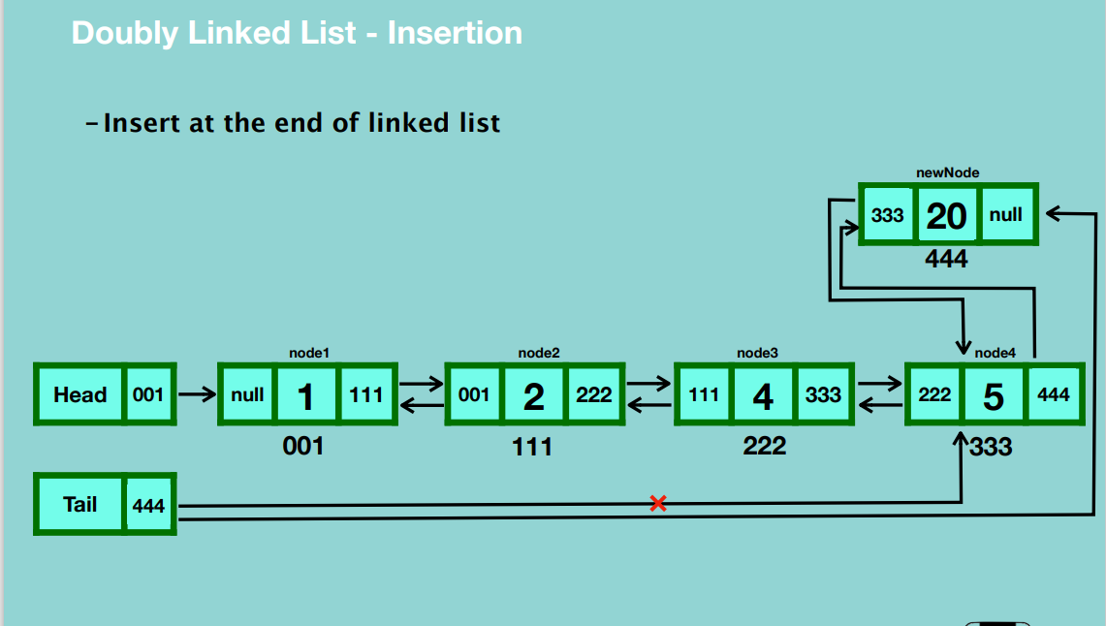

* Create a blank node and assign it a value.
* Update the next reference of the new node to null.
* Update the previous reference of the new node to the last node.
* Update the next reference of the last node to point to the new node.
* Update the reference of the tail to the new node.

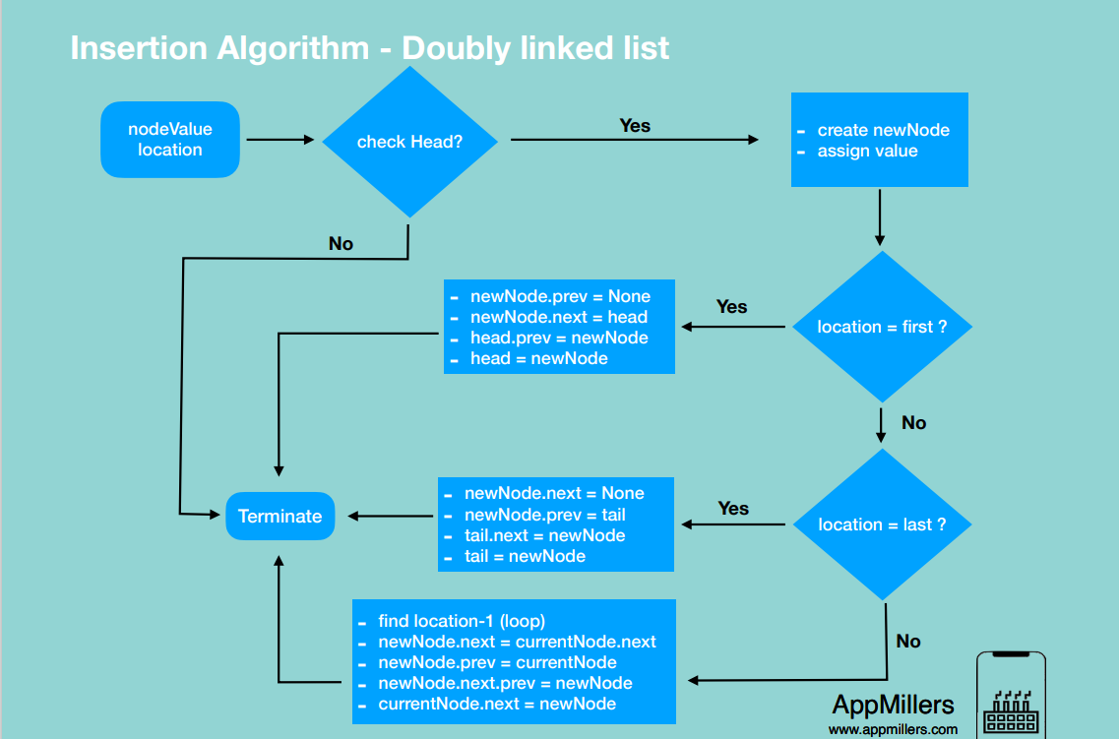

**DELETE**

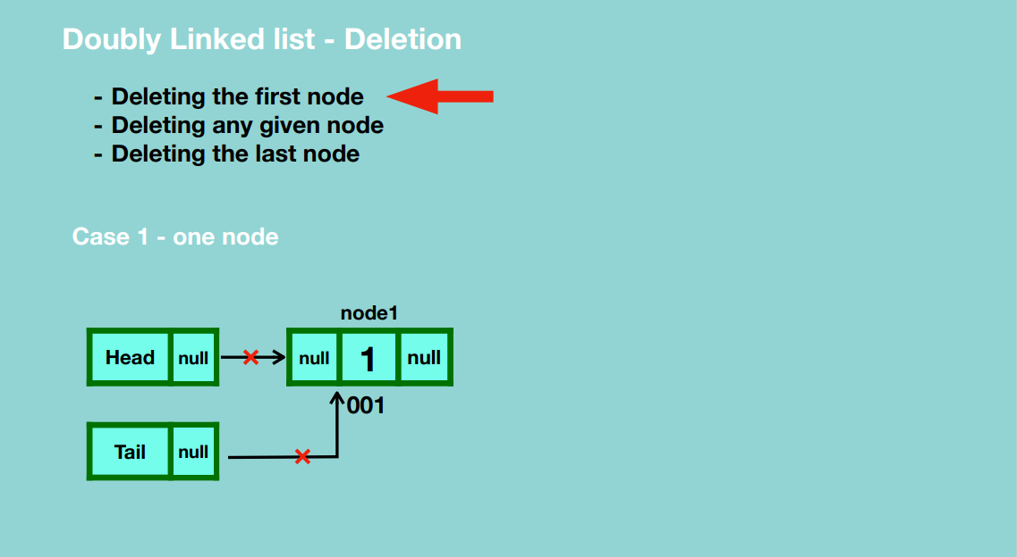

* Update the head and tail reference to null.
* Garbage collection takes place.

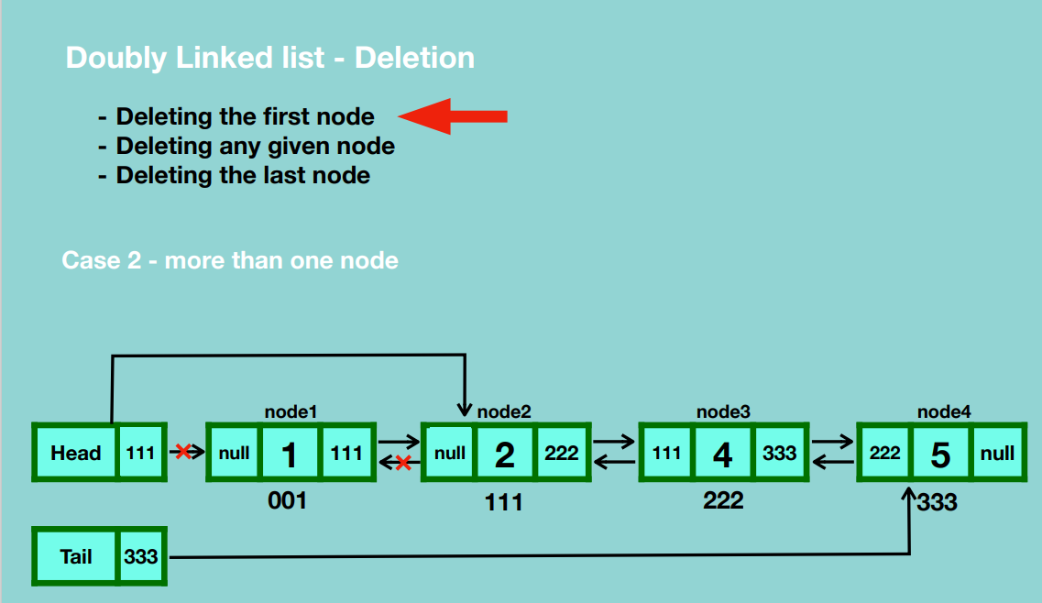

* Update head reference to point to the second node.
* Update the previous reference of the second node to null.
* Garbage collection takes place.

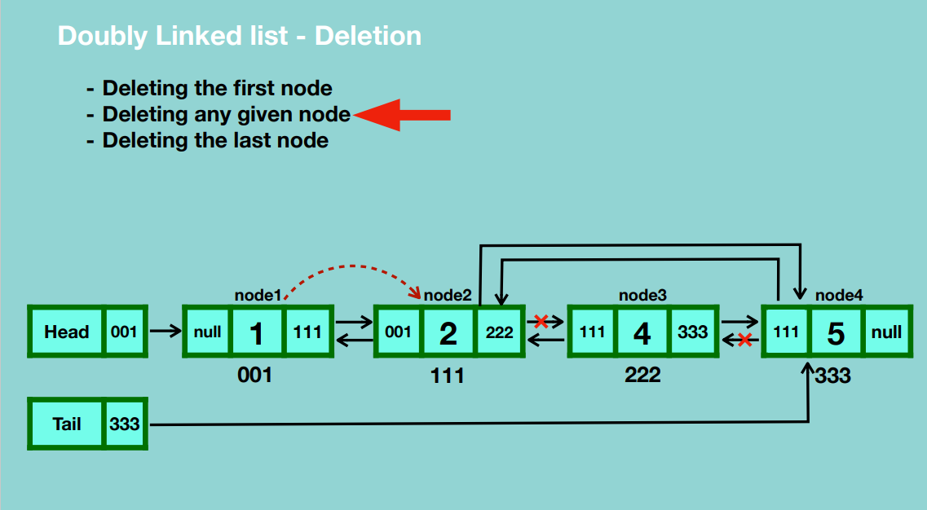

* Traverse from the first node up to the node before the one you’re deleting.
* Update the reference of the current node to the next reference of the node you’re planning to delete.
* Update the previous reference of the next node after the one we’re deleting to the current node.
* Garbage collection.

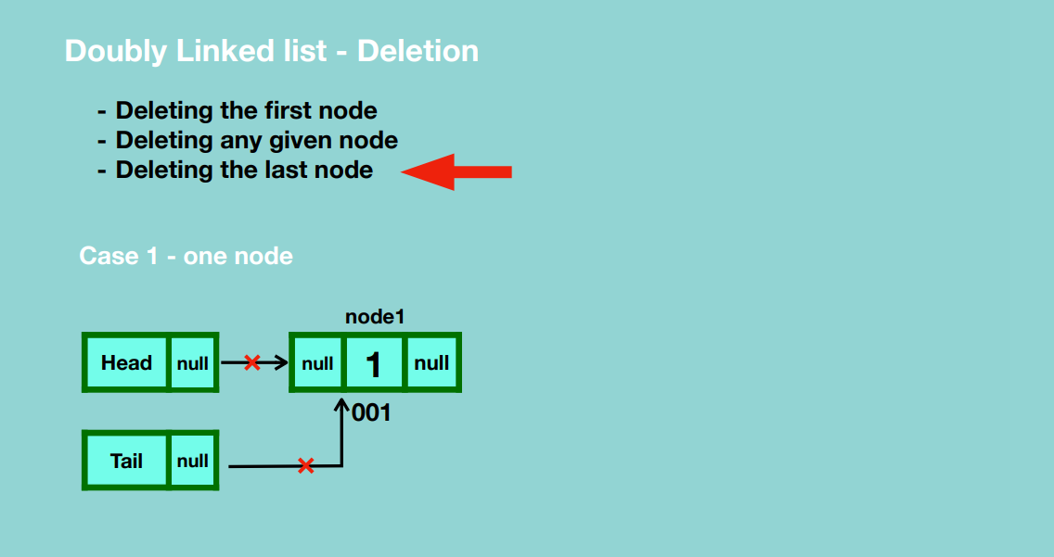

* Update the head and tail reference to null.
* Garbage collection.

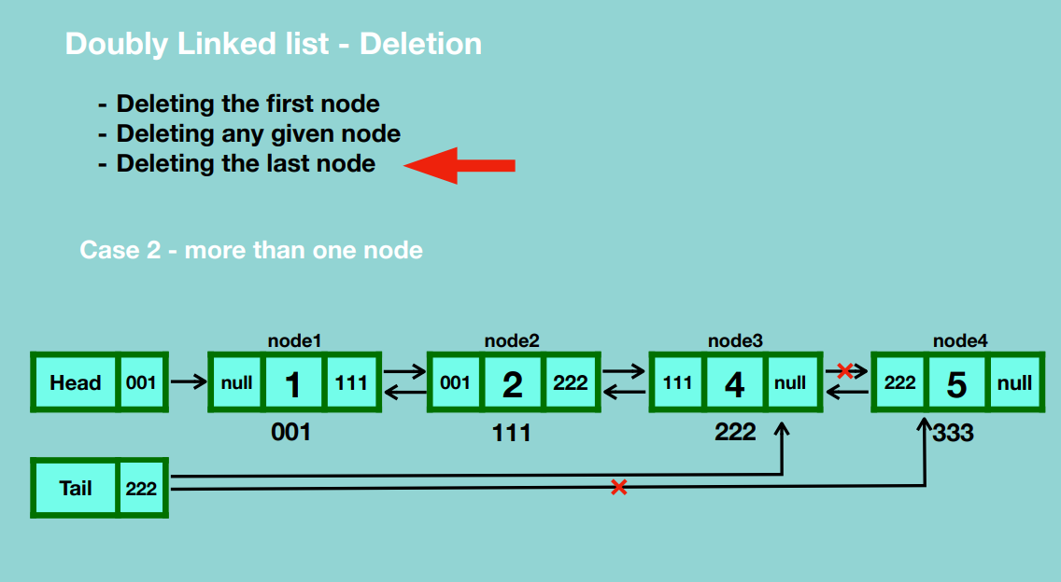

* Update the tail reference to point to the node before the last node.
* Update the next reference of the node before the last node to null.
* Garbage collection when no node points to that particular node.

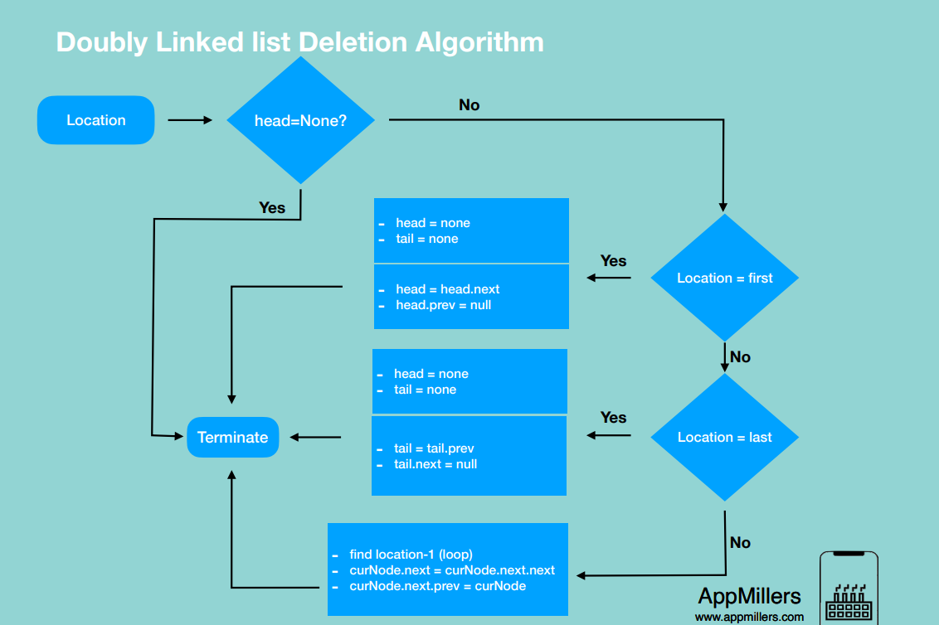

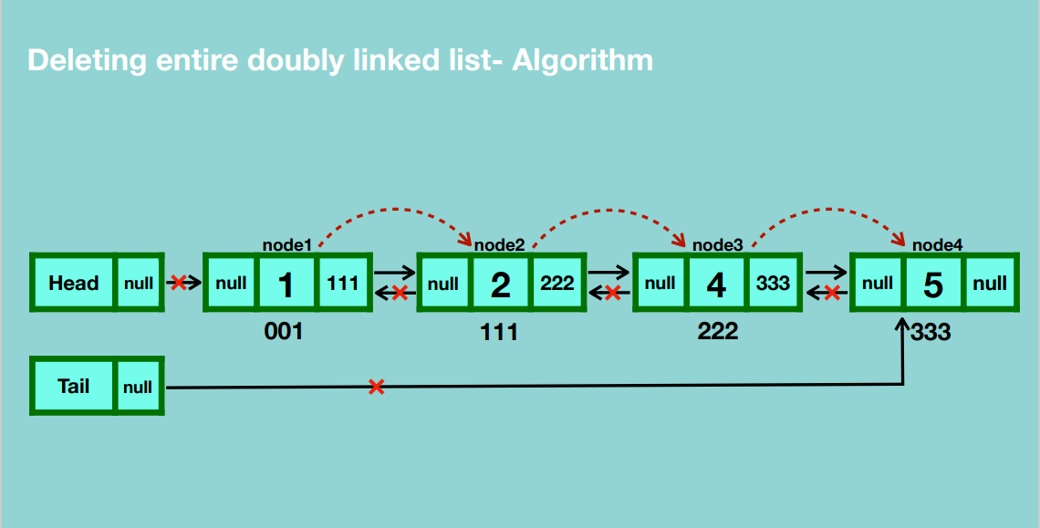

* Traverse through the linked list and update the nodes’ previous references to null.
* Set the head reference to null.
* Set tail reference to null.
* Garbage collection.

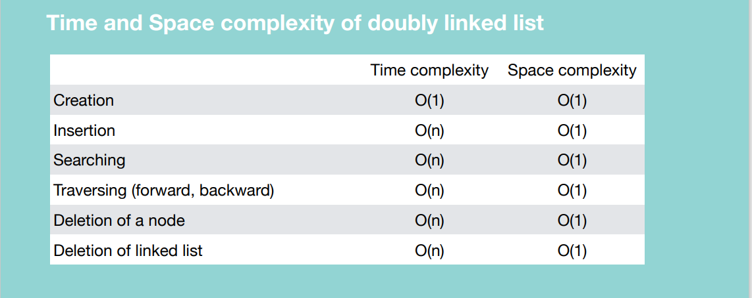

**CIRCULAR DOUBLY LINKED LIST**

**CREATION**

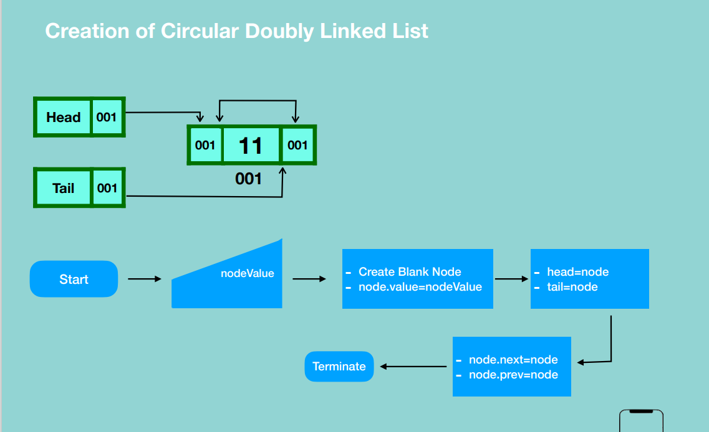

* Create a blank node and give it a value.
* Update the head’s reference to the location of the new node.
* Update the tail’s reference to the location of the new node.
* Update the new node’s previous and next references to itself.

**INSERTION**

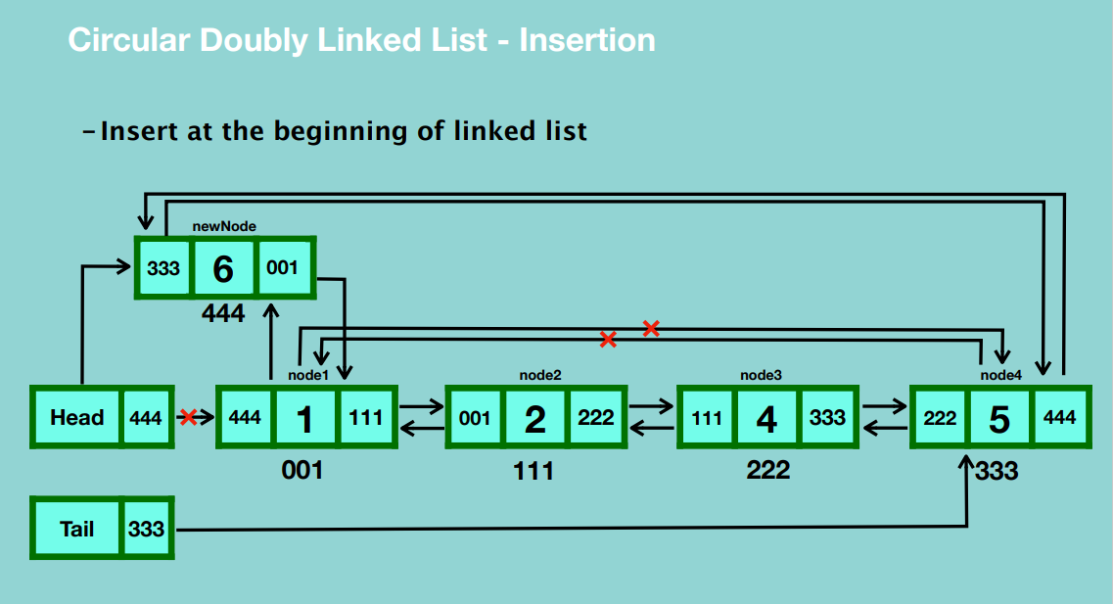

* Create a blank node and assign it a value.
* Update the next reference of the new node to the location of the first node.
* Update the previous reference of the new node to the last node.
* Update the last node’s next reference to the new node’s location.
* Update the first node’s previous location to the new node’s location.
* Update the head’s reference to point to the new node.

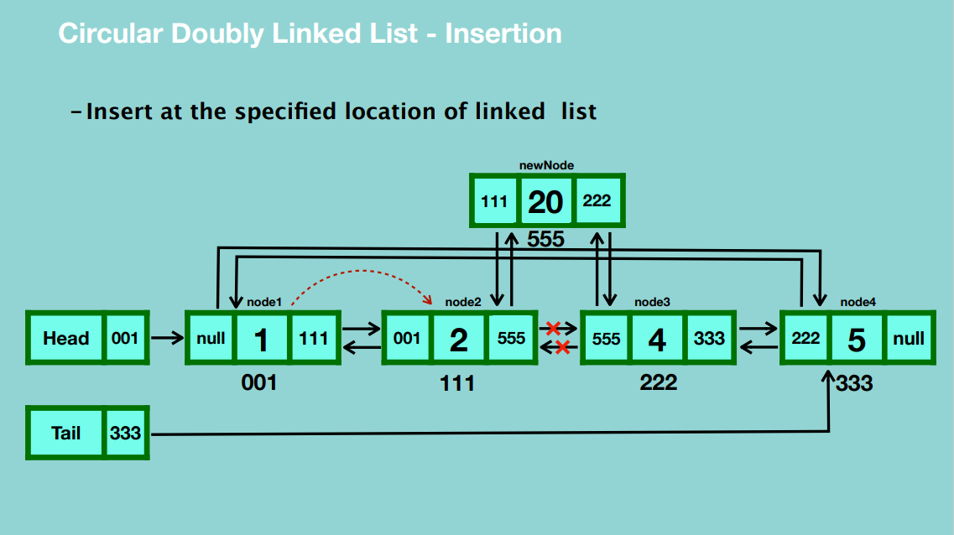

* Create a blank node and assign a value to it.
* Traverse to the node before the position you want to insert the new node.
* Update the new node’s next reference to the location of the node after the current node.
* Update the previous reference of the new node to the current node.
* Update the current node’s next reference to the location of the new node.
* Update the previous reference of the node after the current node to point to the location of the new node.

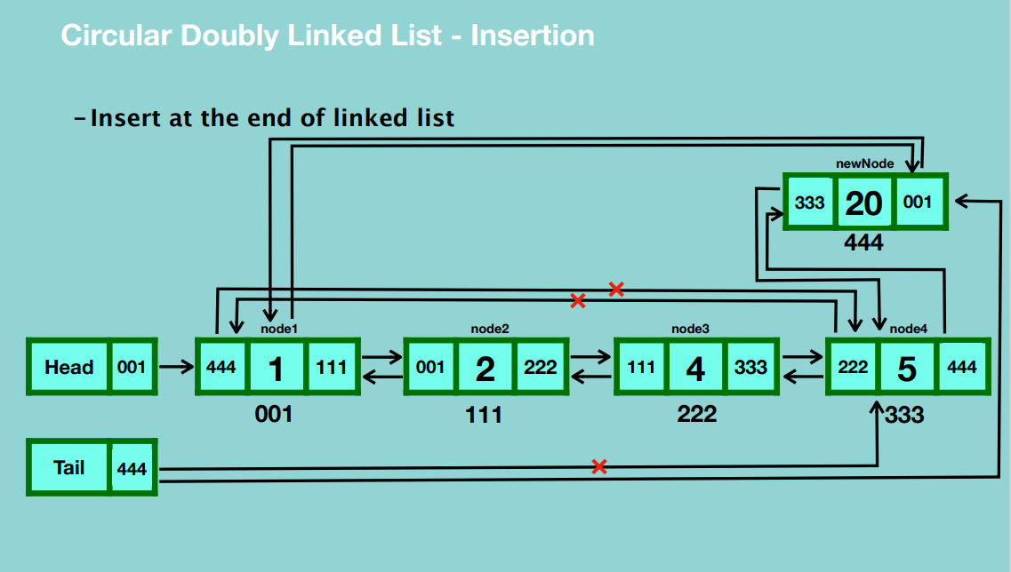

* Create a blank node and assign a value to it.
* Update the next reference of the new node to point to the first node.
* Update the previous reference of the new node to the location of the last node.
* Update the next reference of the last node to the location of the new node.
* Update the tail reference to point to the new node.
* Update the previous reference of the first node to the new node.

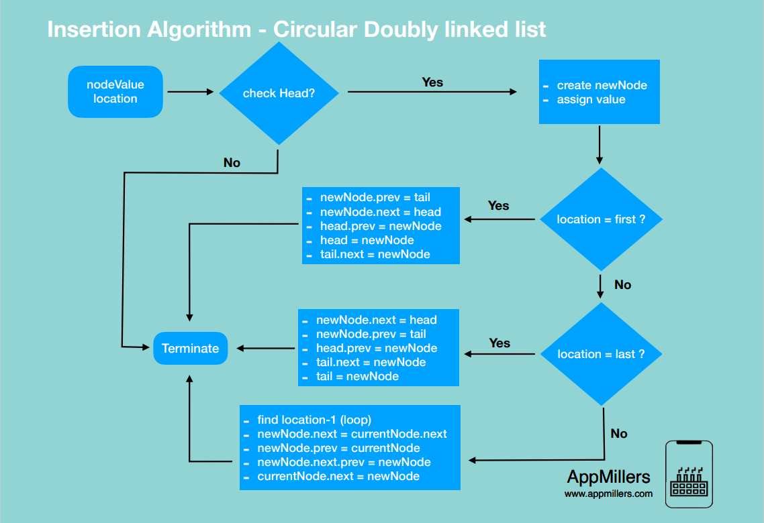

**DELETION**

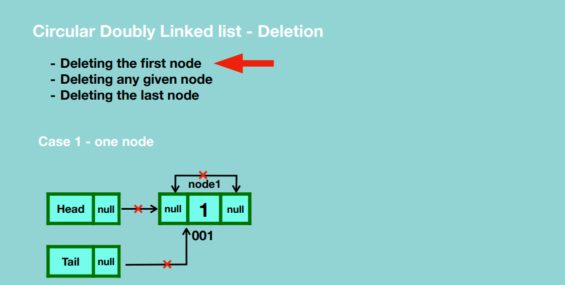

* Update the previous and next references of the node to null.
* Update the head and tail references to null.
* Garbage collection takes place.

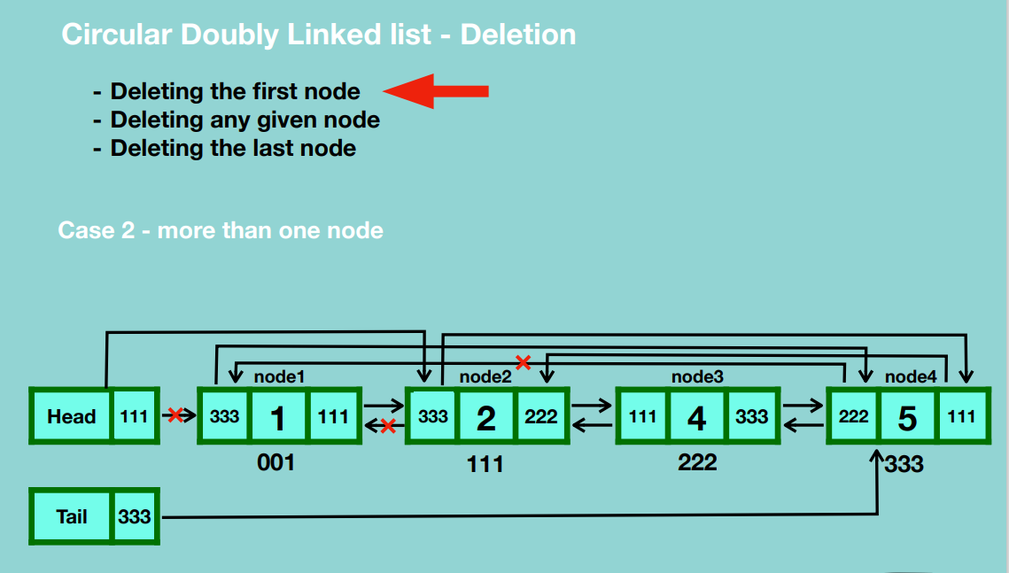

* Update the last node’s next reference to the second node.
* Update the head’s reference to point to the second node.
* Update the second node’s previous reference to the last node.
* Garbage collection takes place.

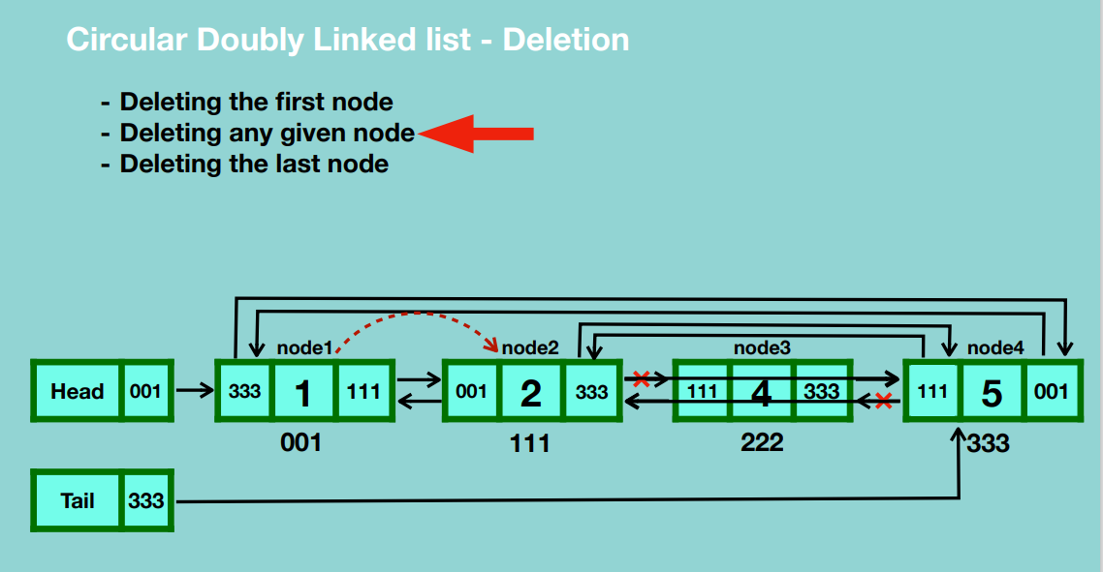

* Traverse to the node before the one you want to delete.
* Update the current node’s next reference to the node after the one you want to delete.
* Update the previous reference of the node after the one you want to delete to the current node.
* Garbage collection takes place.

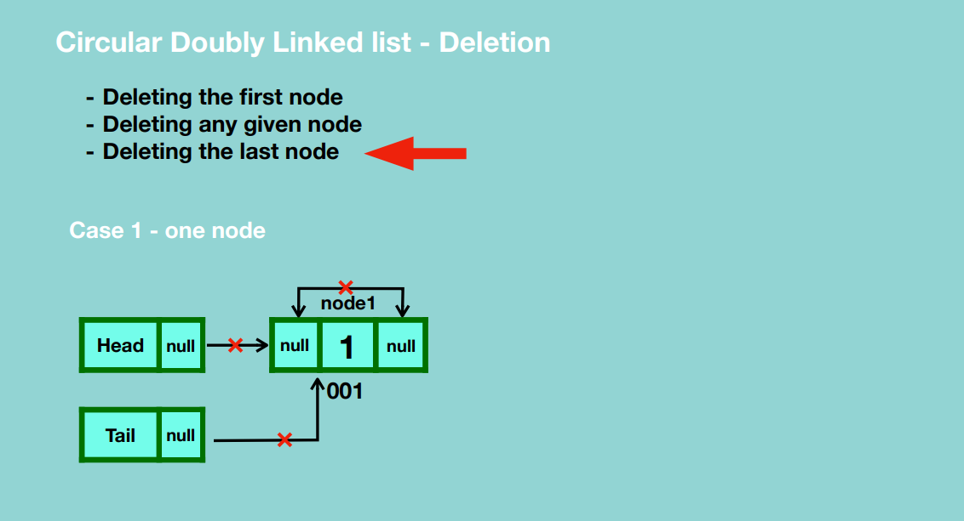

* Update the previous and next references of the node to null.
* Update the head and tail references to null.
* Garbage collection takes place.

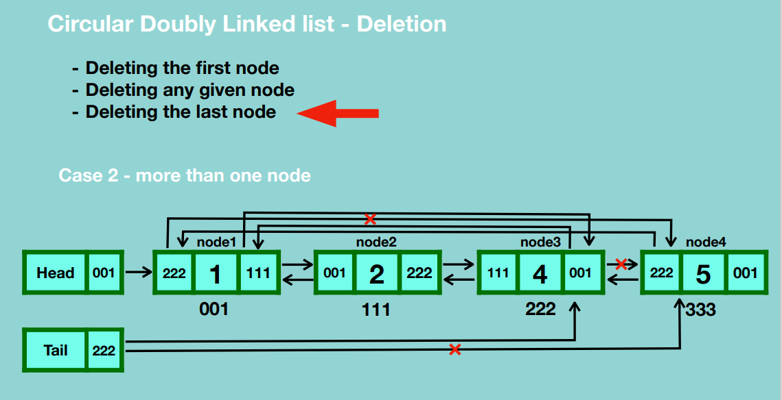

* Update the tail reference to point to the node before the last node.
* Update the next reference of the node before the last node to point to the first node.
* Update the previous reference of the first node to point to the node before the last node.
* Garbage collection takes place.

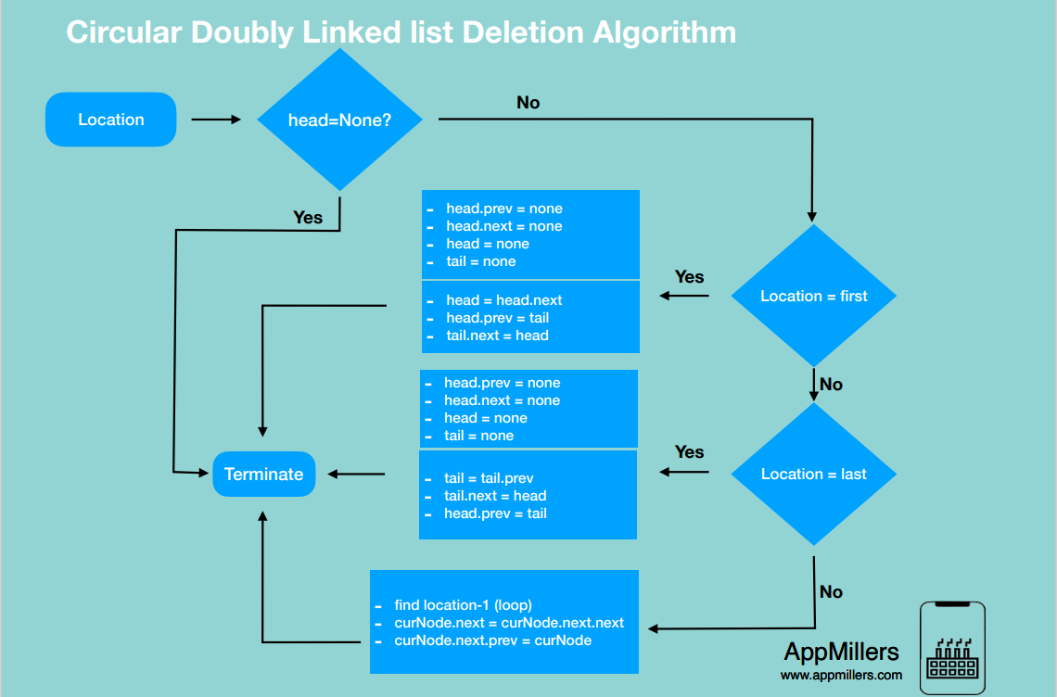

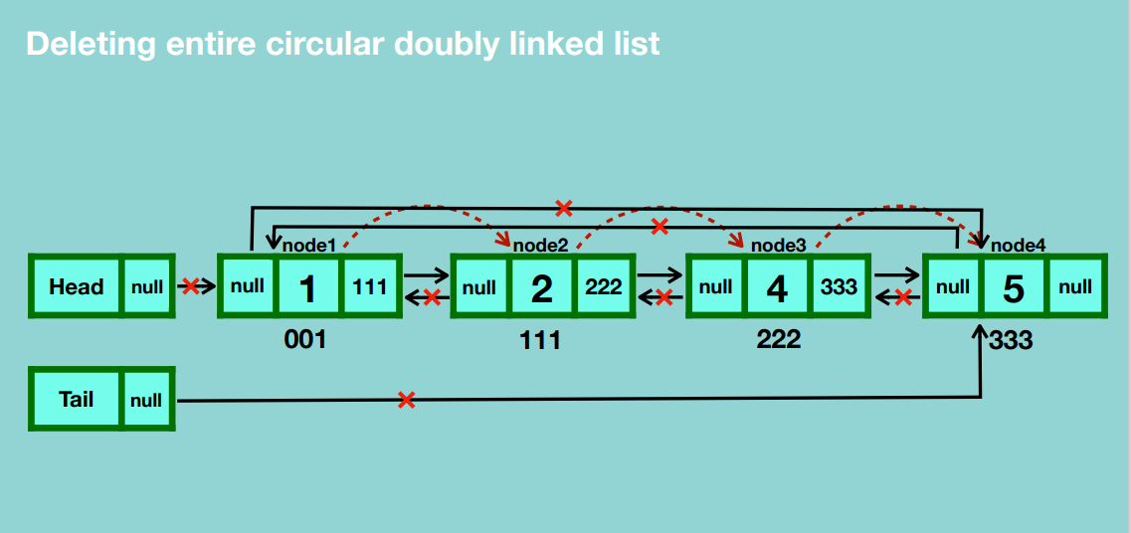

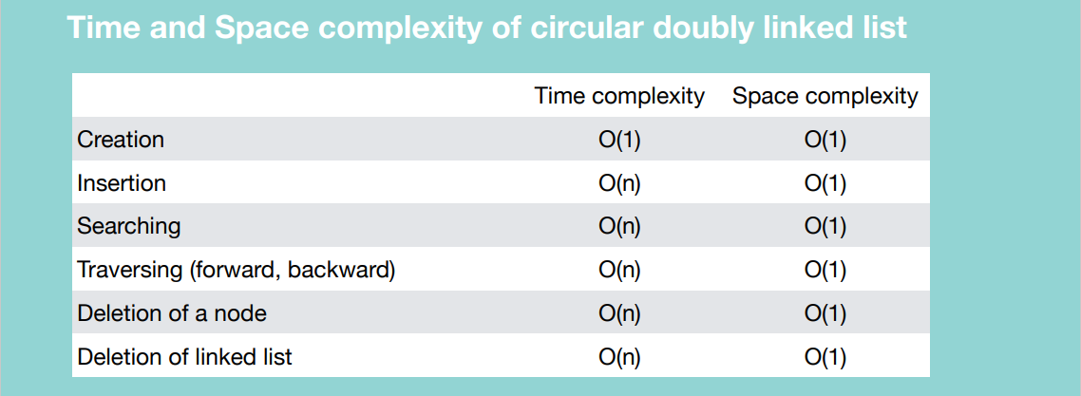

**STACK**

Stack is a data structure that stores items in a Last-In/First-Out manner.

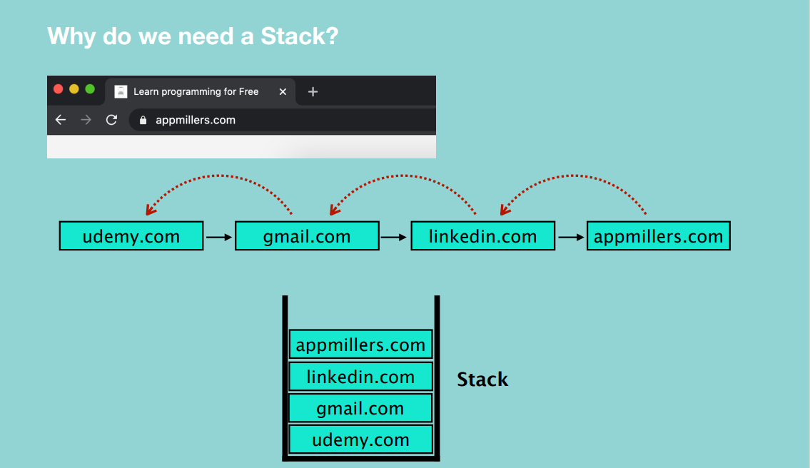

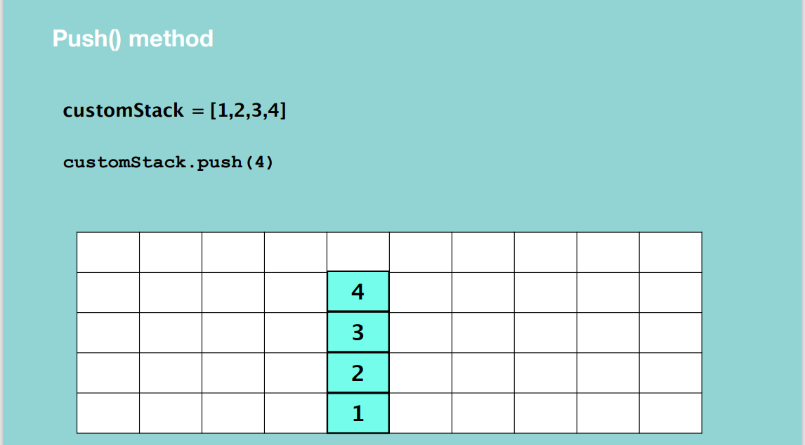

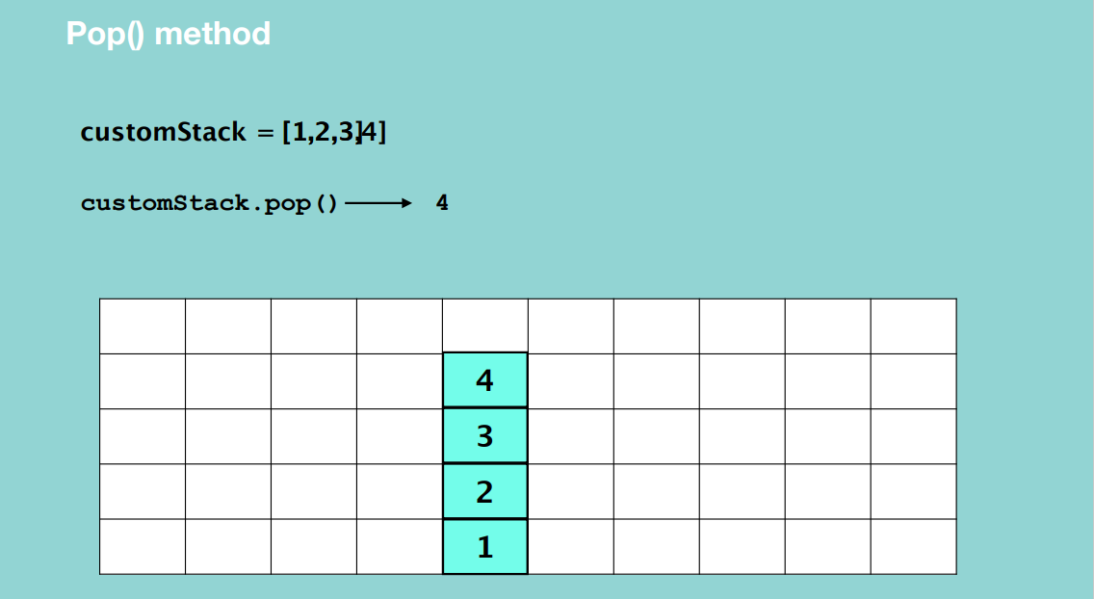

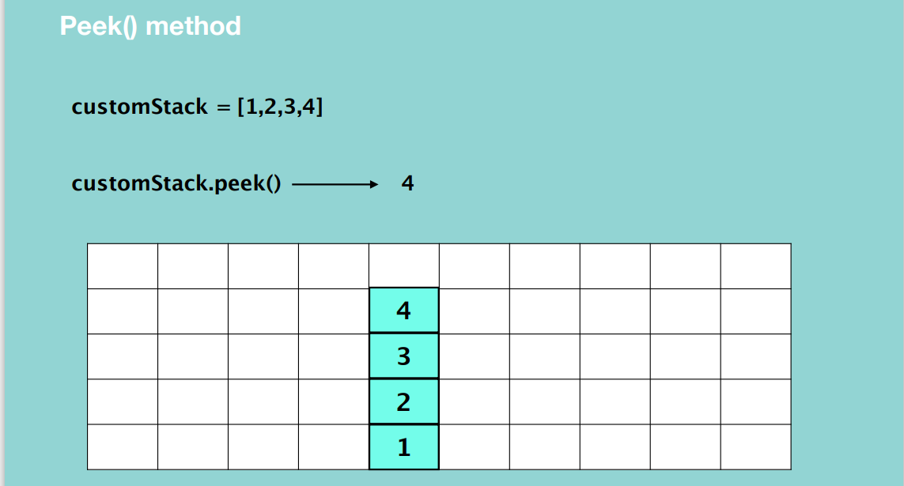

Just returns the top element of the stack DS.

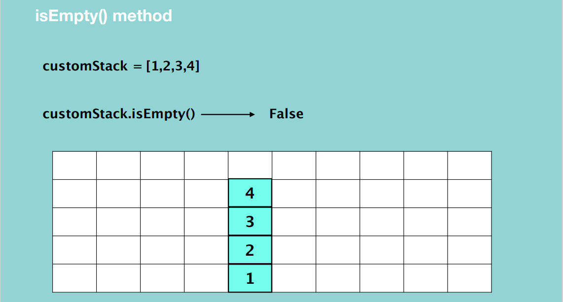

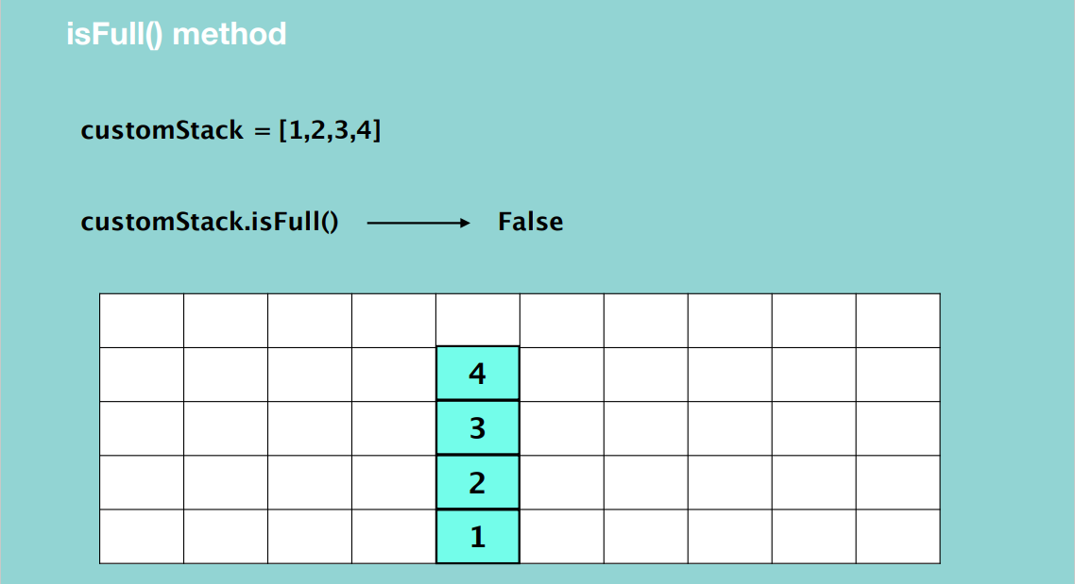

* Needed when you create a stack with size limit.

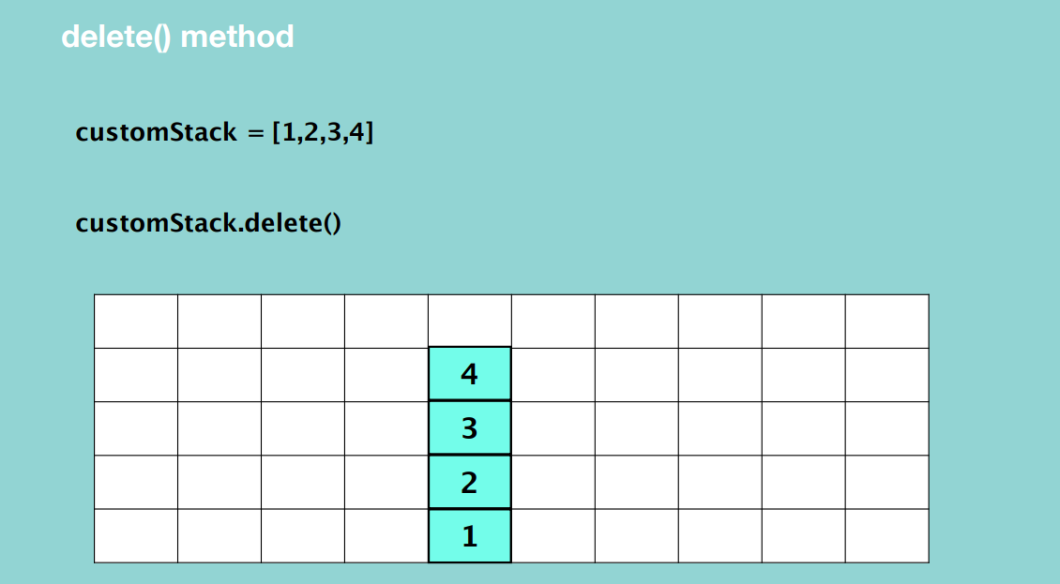

* Delete all elements from the stack.

**STACK creation**

Stack using List

* Easy to implement
* Speed problem when it grows because memory locations are contiguous hence there is an overhead for allocation.

Stack using Linked List

* Fast Performance because the memory locations are random
* Implementation is not easy

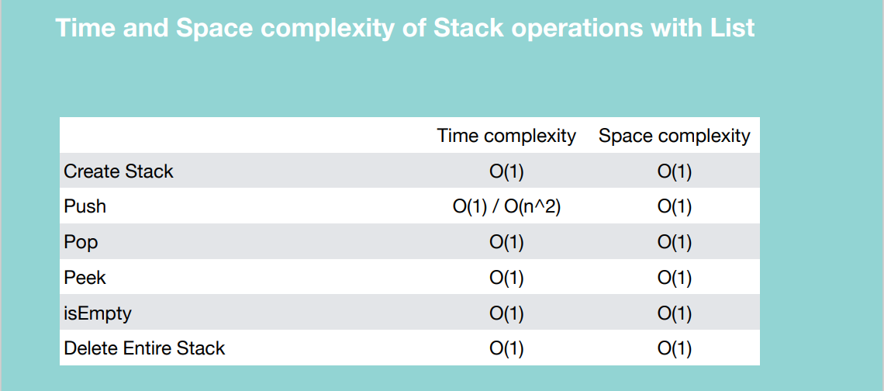

**Create a stack using linked list**

PUSH

* Create an object of the linked list class.
* Update the reference of the head reference to the new node.
* Update the reference of node 2 to the first node.
* Update the head reference to point to node.
* Update the reference of node 3 to node 2.
* Update the head reference to node 3.

Basically, you’re adding to the beginning of the linked list.

POP

* Update the head reference to the second node.
* Garbage collection takes place.

Basically, you’re deleting the node from the beginning of the linked list.

PEEK

* Just return the head value.

isEmpty()

* Just check if the head reference is None.

delete()

* Set the head reference to None.

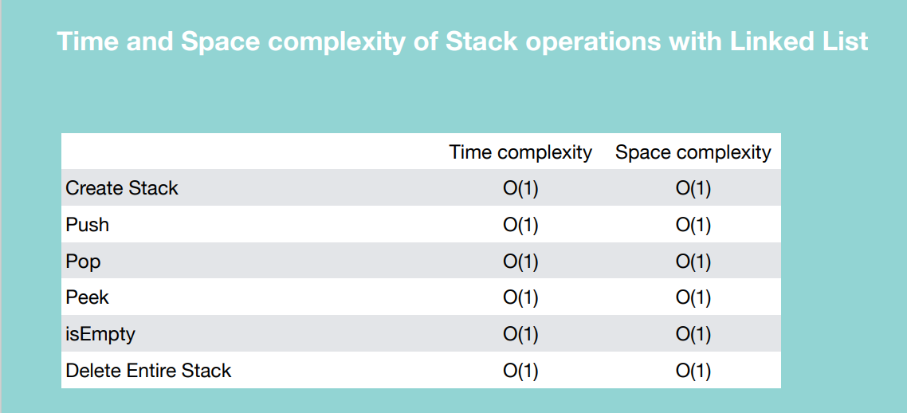

When to use / avoid Stack

Use:

* LIFO functionality
* The chance of data corruption is minimum (you cannot insert an element in the middle of the stack)

Avoid:

* Random access is not possible

**QUEUE**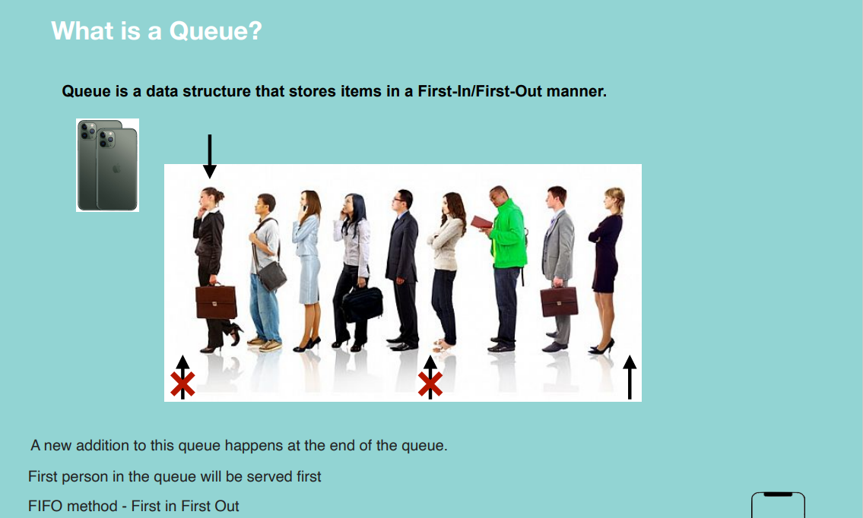

When we need Queue Data Structure?

* Point sale system of a restaurant
* Printer queue
* Call center phone systems

Implementation

1. Python List
   1. Queue without capacity (very time consuming)
   2. Queue with capacity (Circular Queue)
2. Linked List

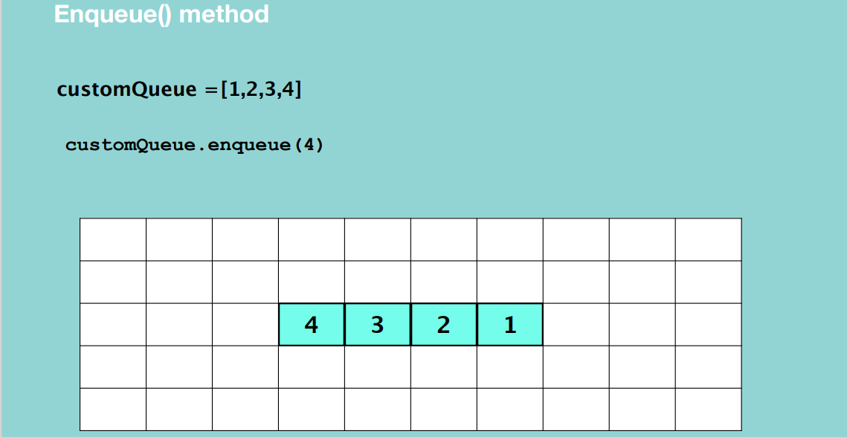

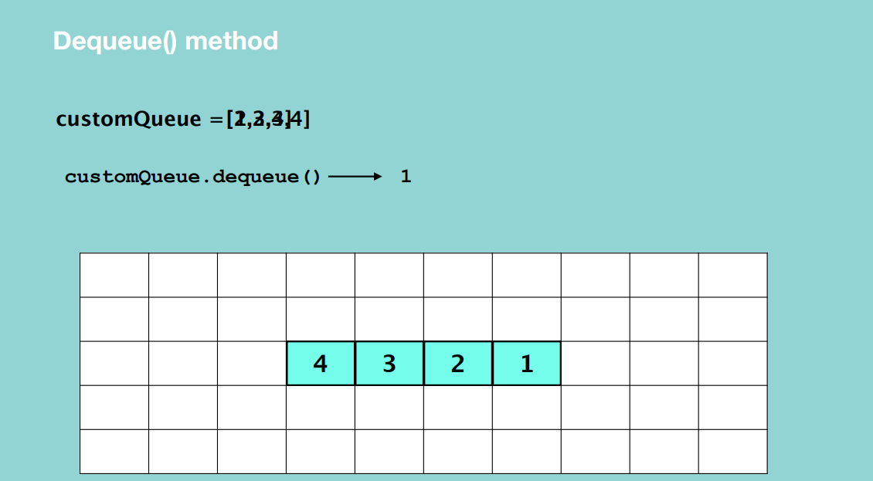

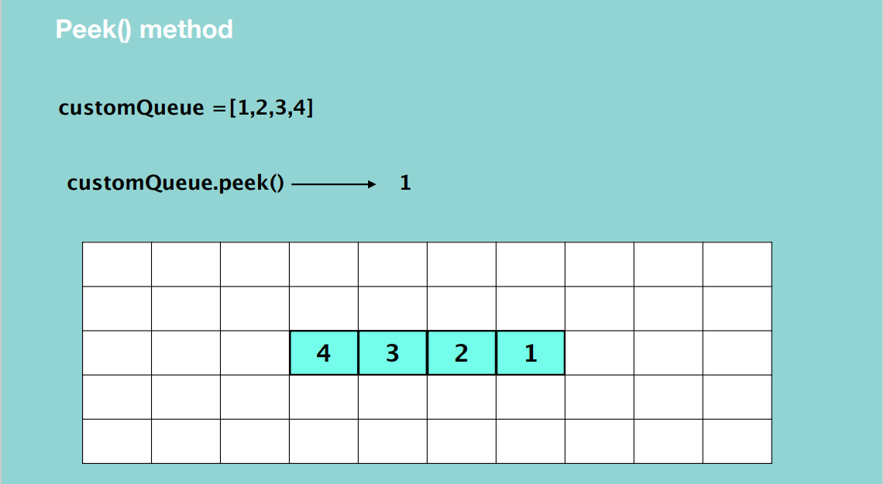

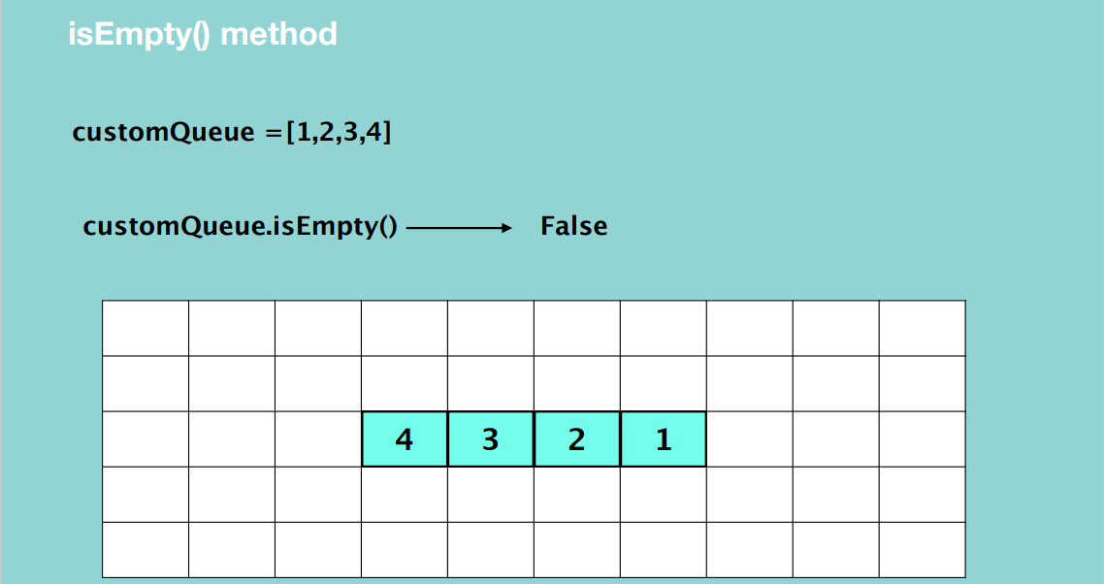

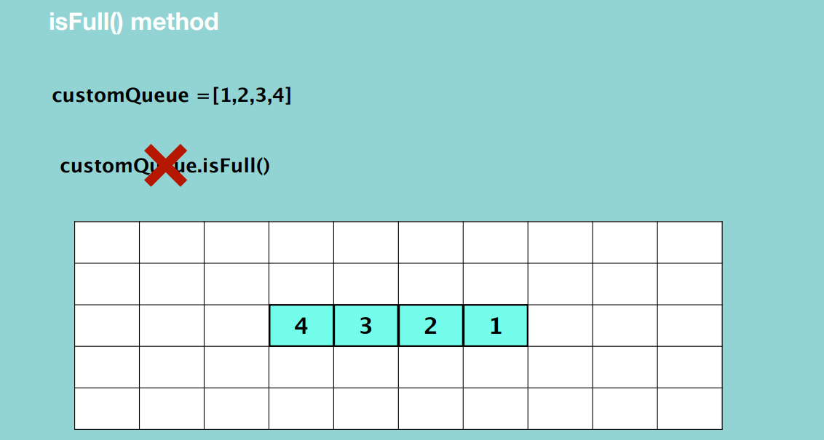

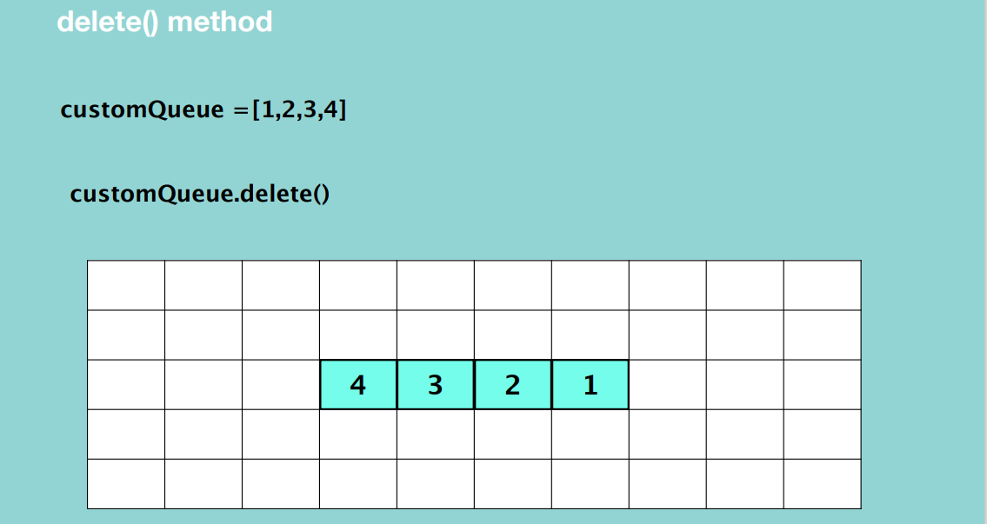

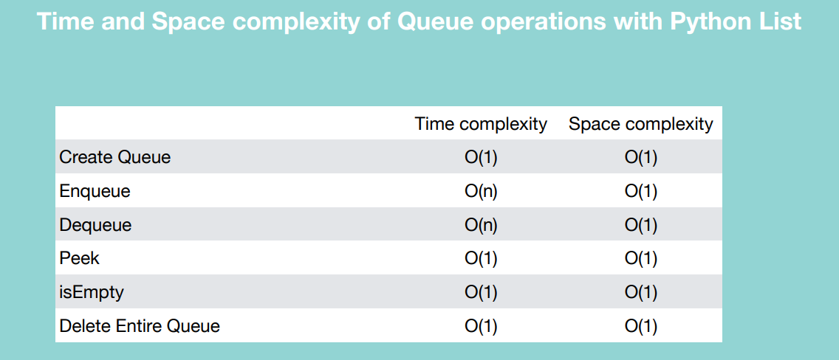

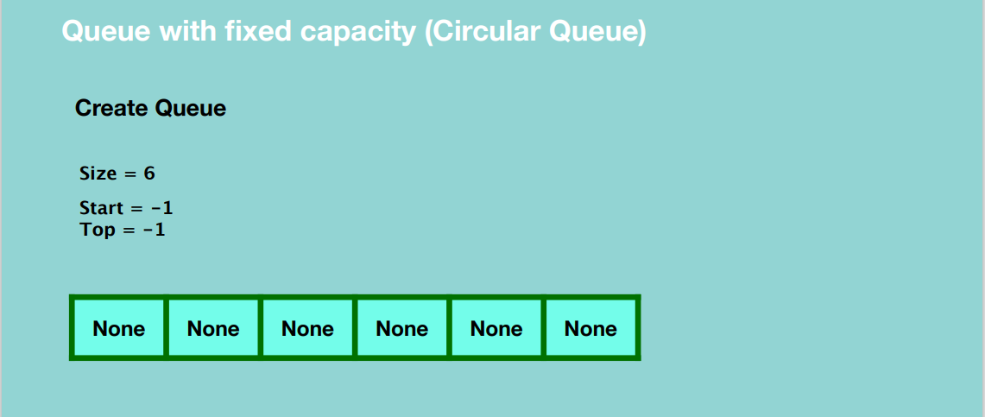

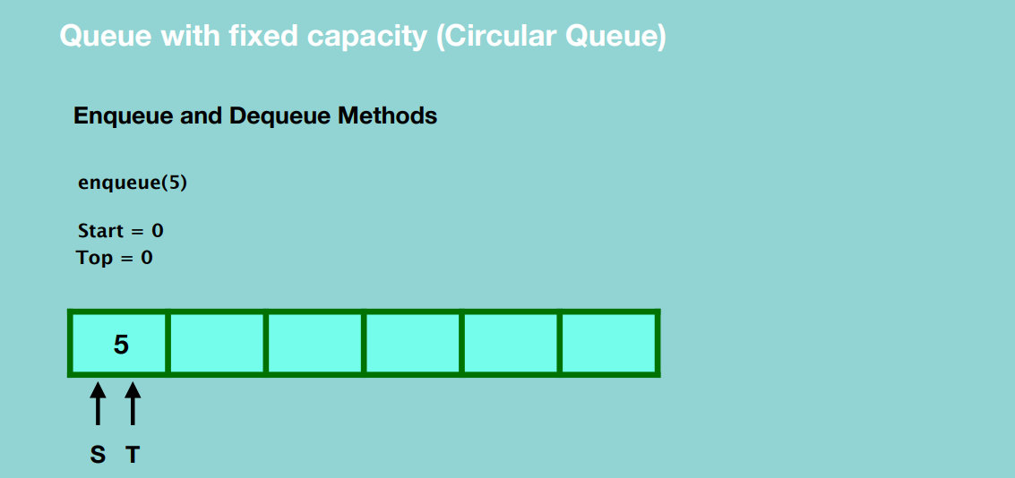

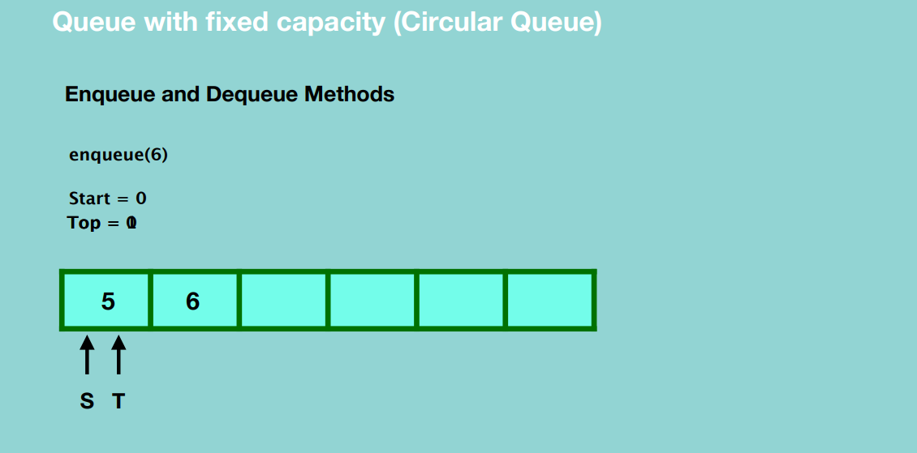

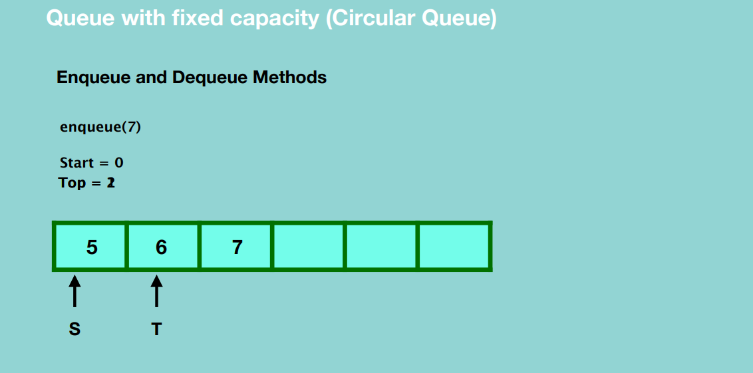

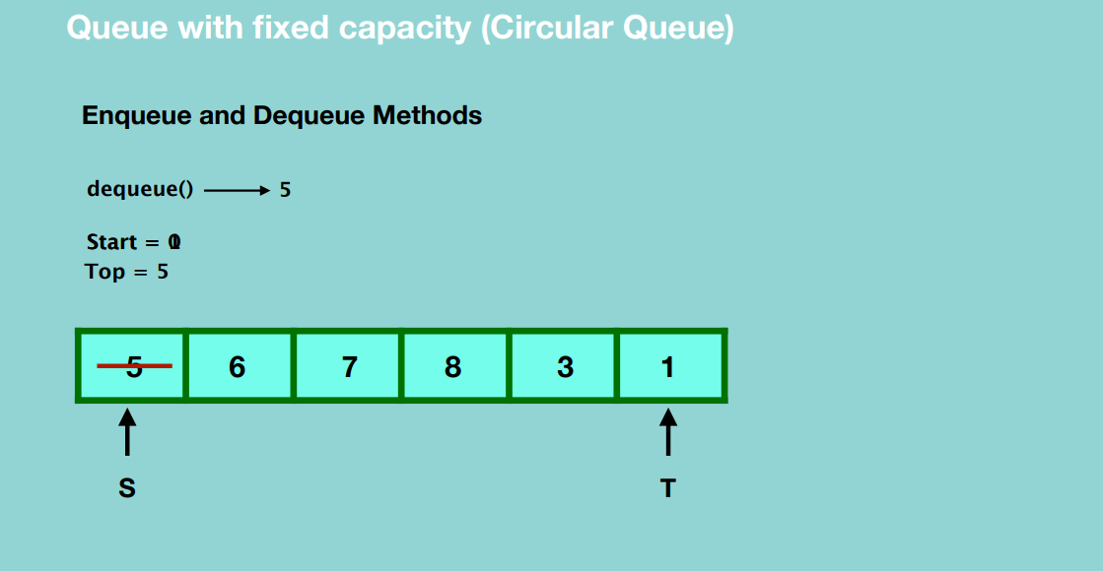

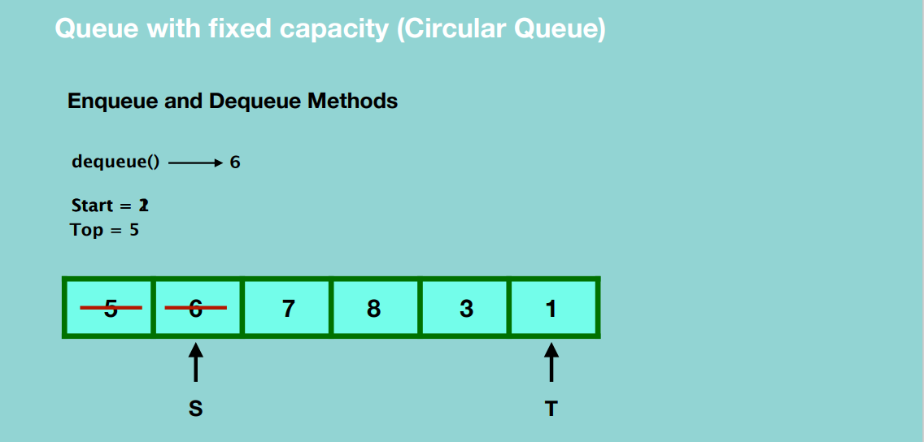

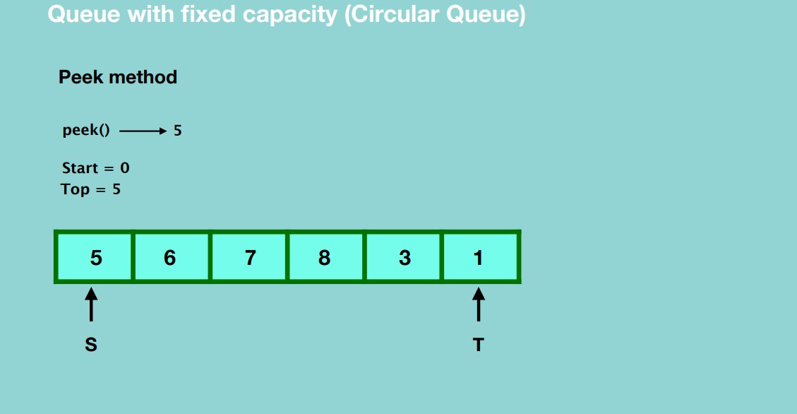

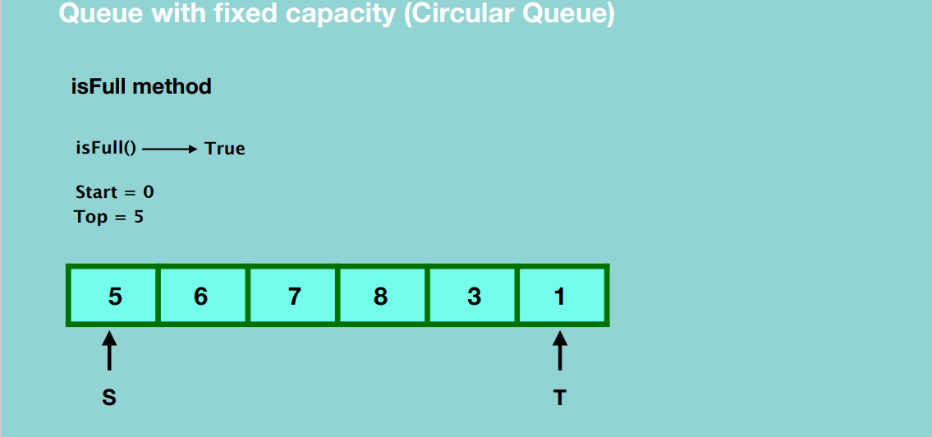

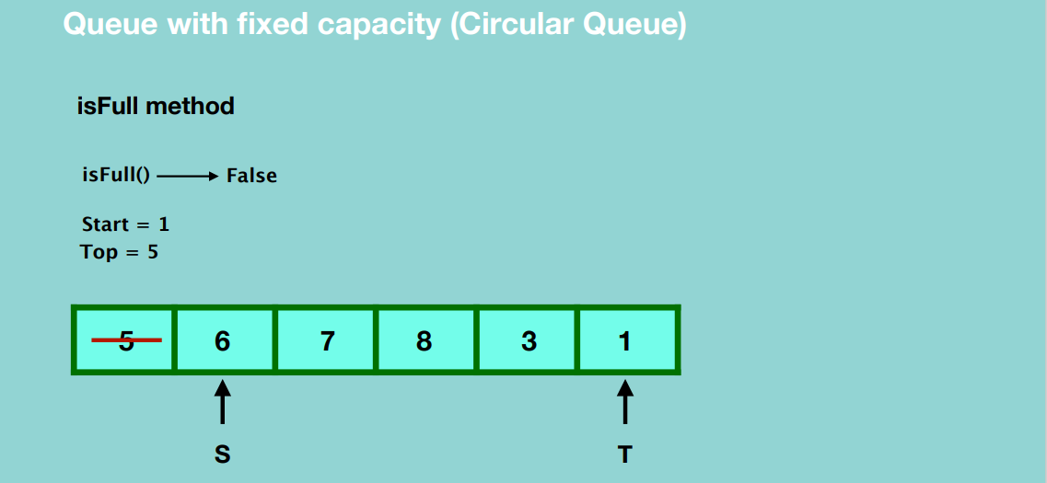

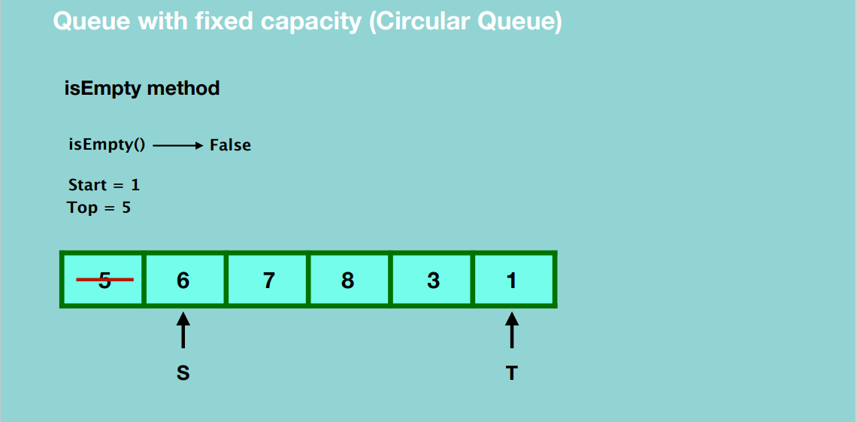

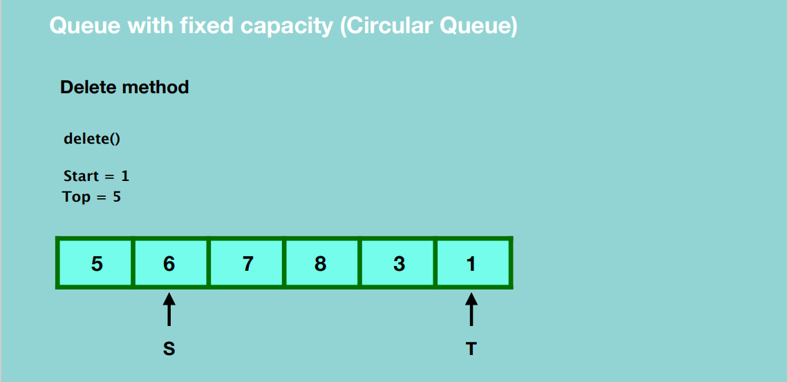

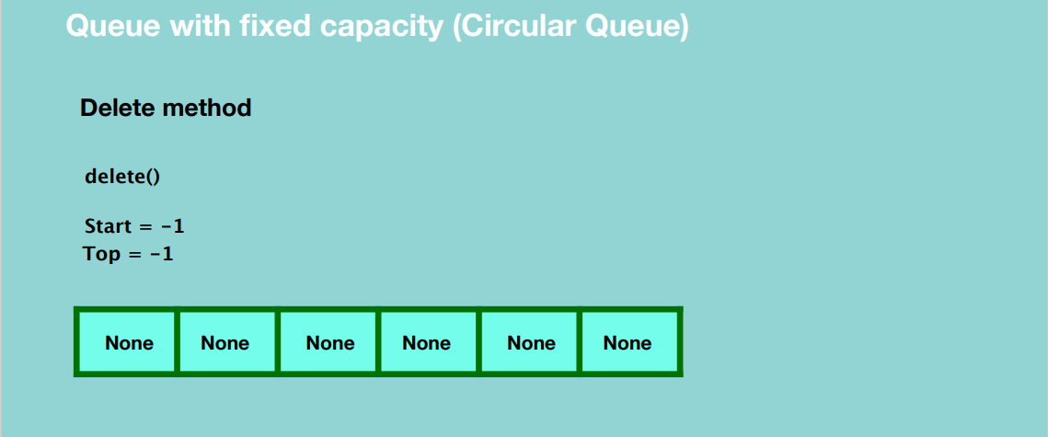

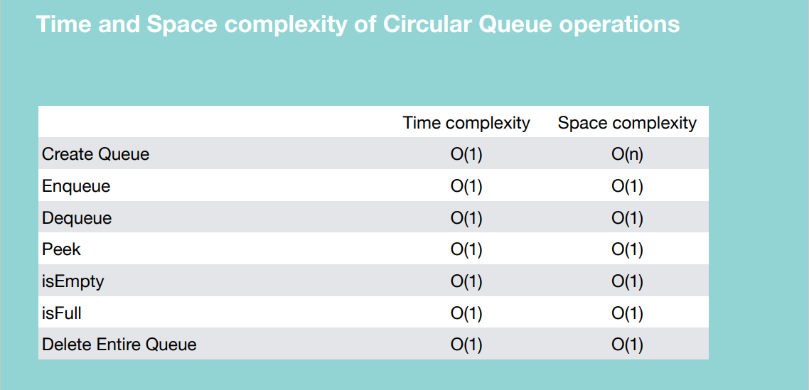

Queue using Linked List

Create a Queue

* Create an object of a linked list class

enQueue()

* Create a blank node and assign a value to it.
* Update the head reference and tail reference to point to the new node.
* To insert another node, create a new node and assign a value to it.
* Update the next reference of the first node to the new node.
* Update the tail reference to the new node.
* To insert another node, create a new node and assign a value to it.
* Update the next reference of the last node to the new node.
* Update the tail reference to the new node

So basically, you’re inserting a new node at the end of the linked list.

deQueue()

Basically, we remove the first element of the linked list.

* Update the head reference to point to the second node.
* Garbage collection takes place.

peek()

* Return the value of head.

isEmpty()

* If head is None, our queue is empty, otherwise it’s not empty.

**NOTE: We don’t have isFull method in a linked list.**

delete()

* Set the head and tail references to null.

Queue creation

Queue using List

* Easy to implement
* Speed problem when it grows

Queue using Linked List

* Fast Performance
* Implementation is not easy

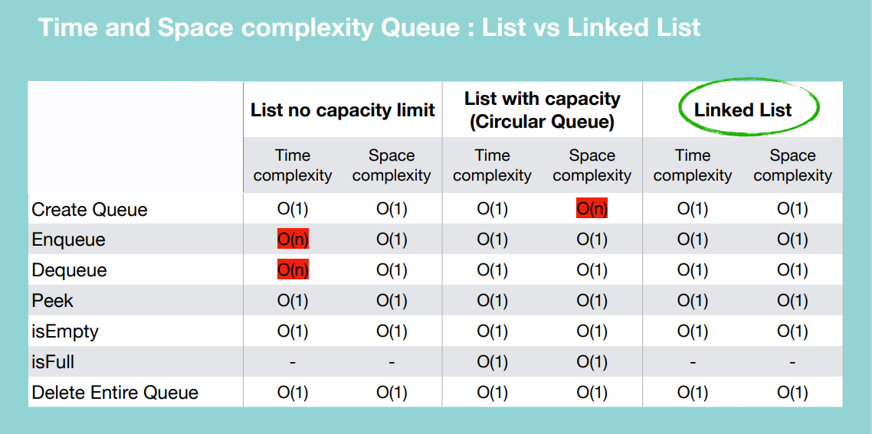

If you have few elements, you can use a list with no capacity limit. If you have many elements and don’t have to worry about space requirements, you can use the list with capacity. If you don’t want to use python lists and want efficiency throughout, use a linked list.

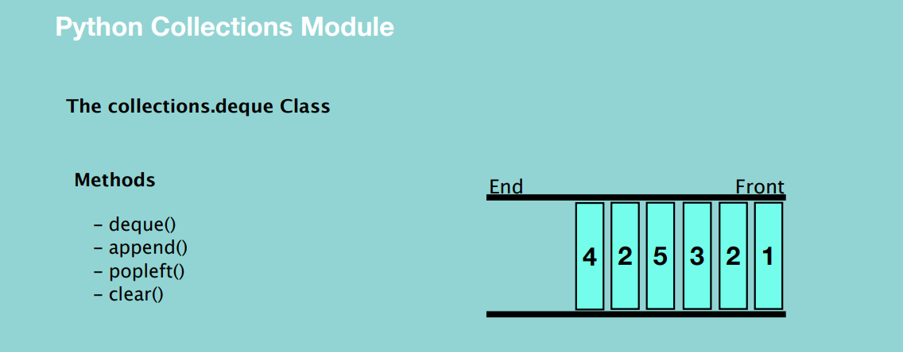

collections.deque class implements a double ended queue that allows adding and removing elements from either end. Here if the queue is full, it deletes the first element from the opposite end

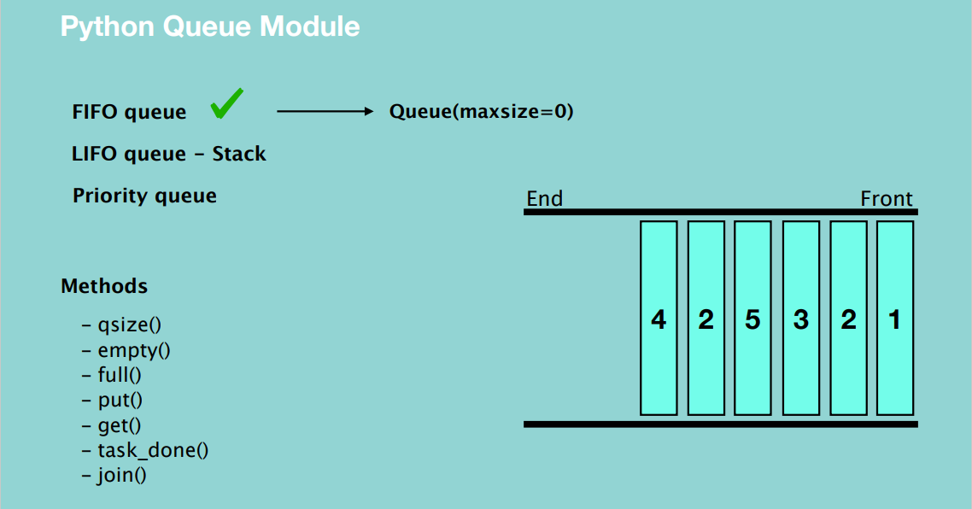

If maxSize is less than or equal to zero, then the queue size will be infinite.

**TREES**

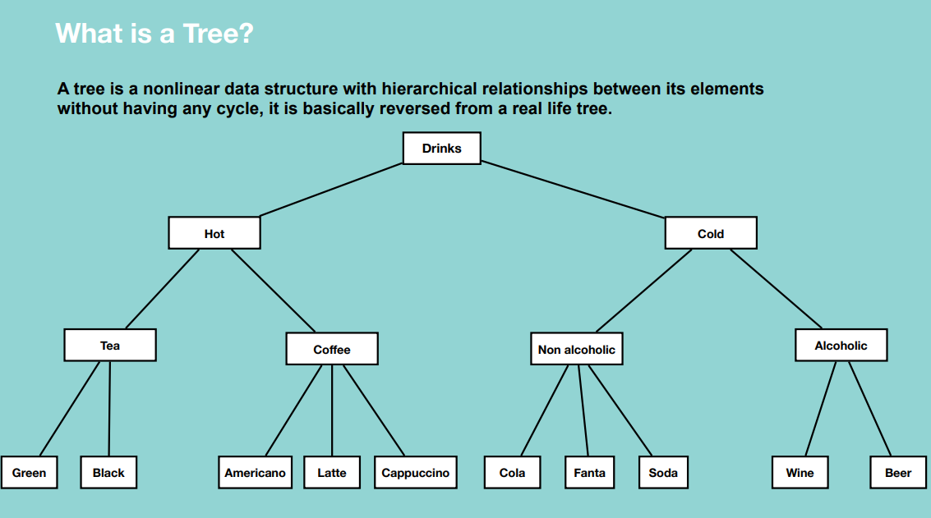

Properties:

* Represent hierarchical data – every time we go down, we’re doing a specialization.
* Each node has two components: data and a link to its sub category
* Base category and sub categories under it

Why a Tree?

* Quicker and Easier access to the data as it is a non linear data structure.
* Store hierarchical data, like folder structure, organization structure, XML/HTML data.

There are many different types of data structures which performs better in various situations

-Binary Search Tree, AVL, Red Black Tree, Trie

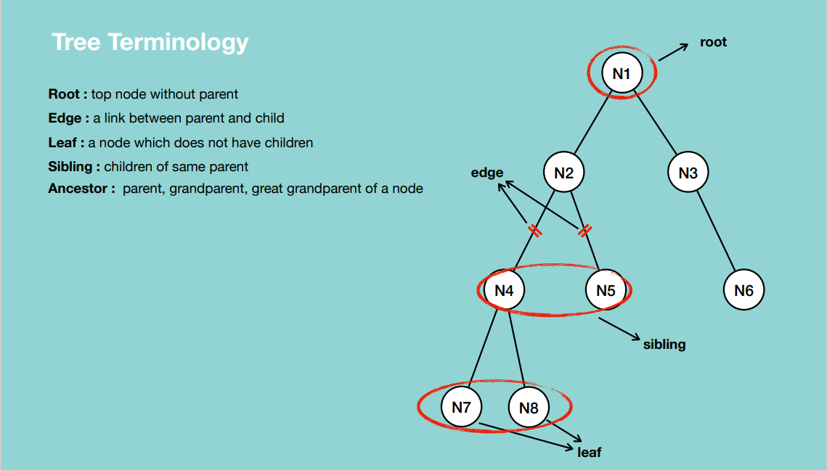

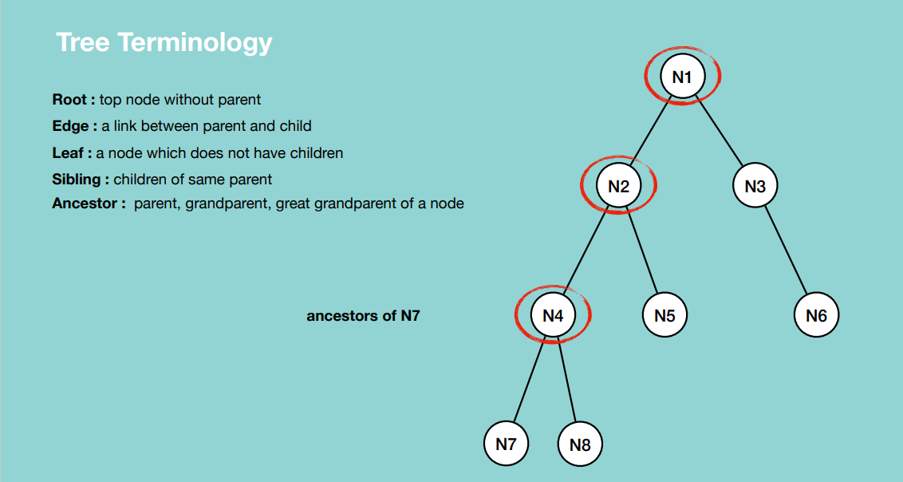

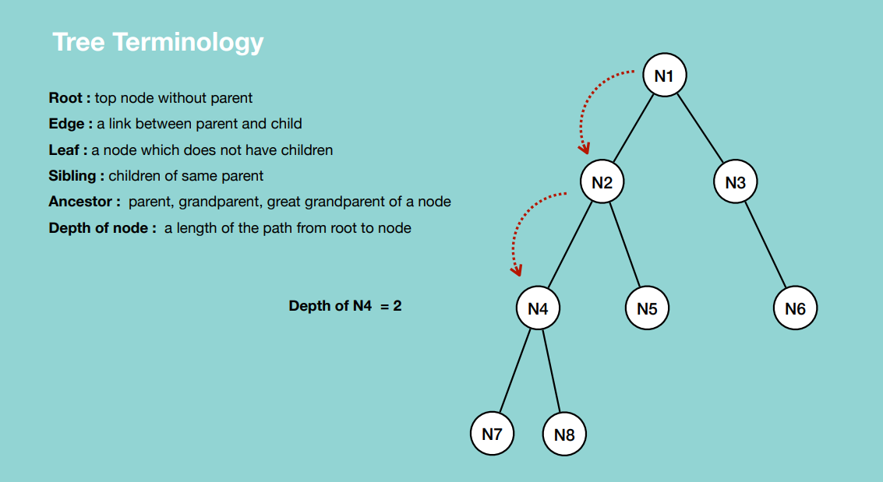

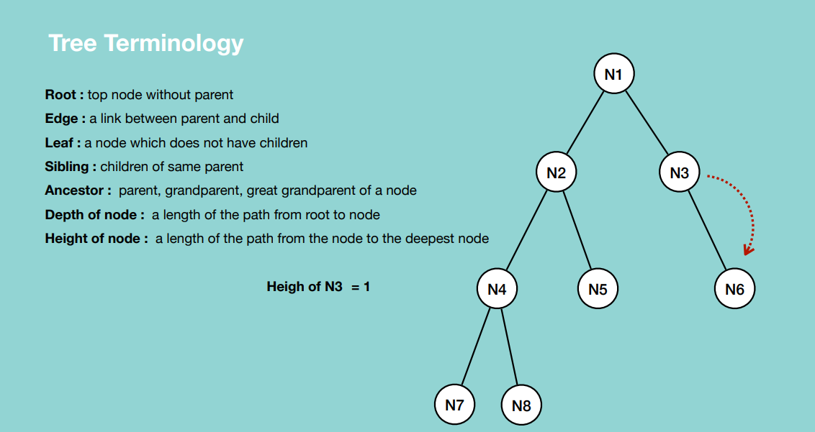

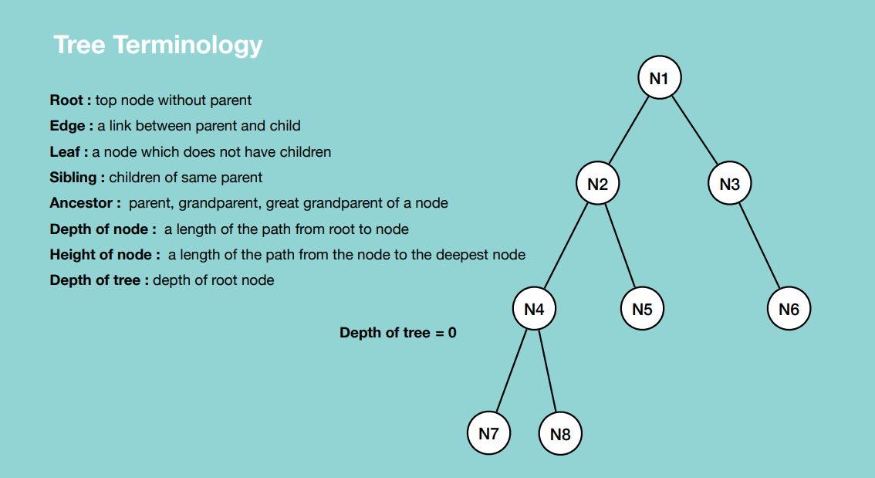

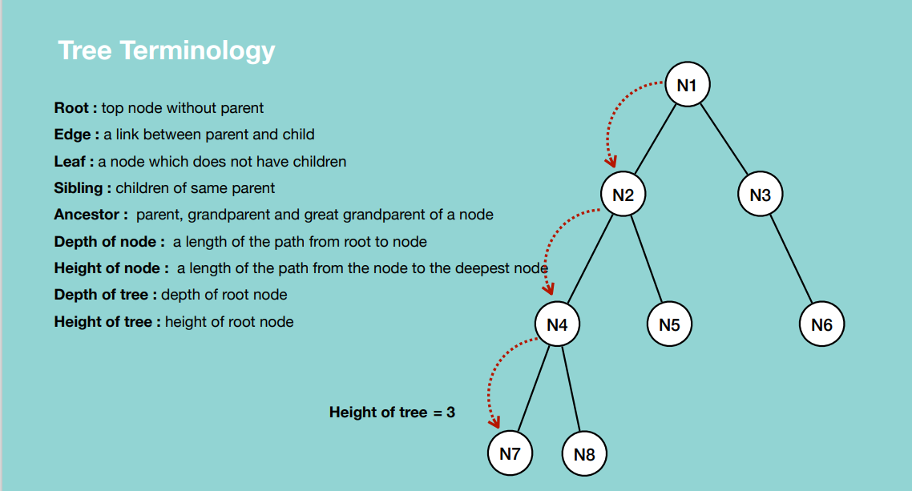

**BINARY TREES**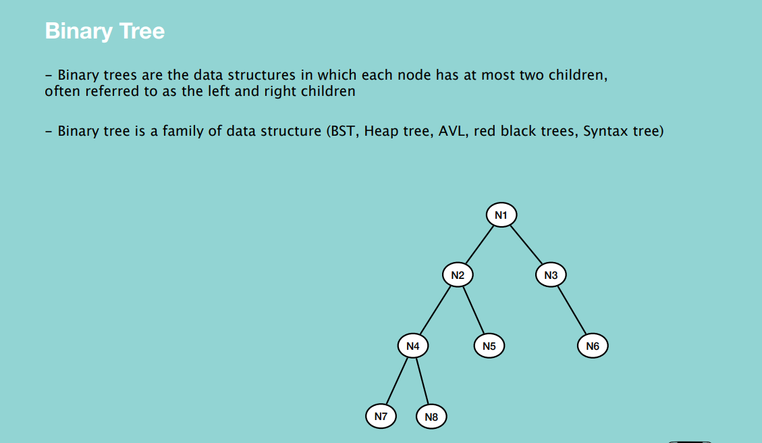

**Why Binary Tree?**

* Binary trees are a prerequisite for mode advanced trees like BST, AVL, Red Black Trees Huffman coding problem, heap priority problem and expression parsing problems can be solved efficiently using binary trees.

**Types of Binary Tree**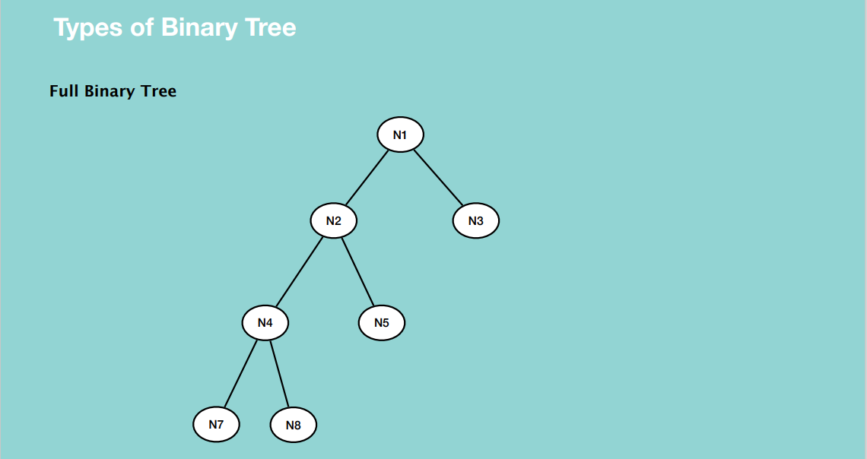

If each node of a binary tree has zero or two children but not one.

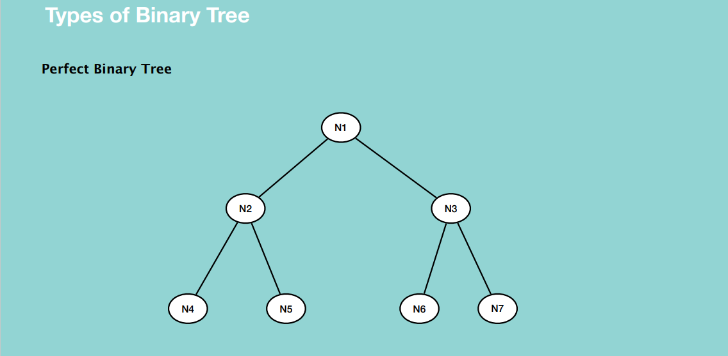

All non-leaf nodes have two children and leaf nodes are on the same level.

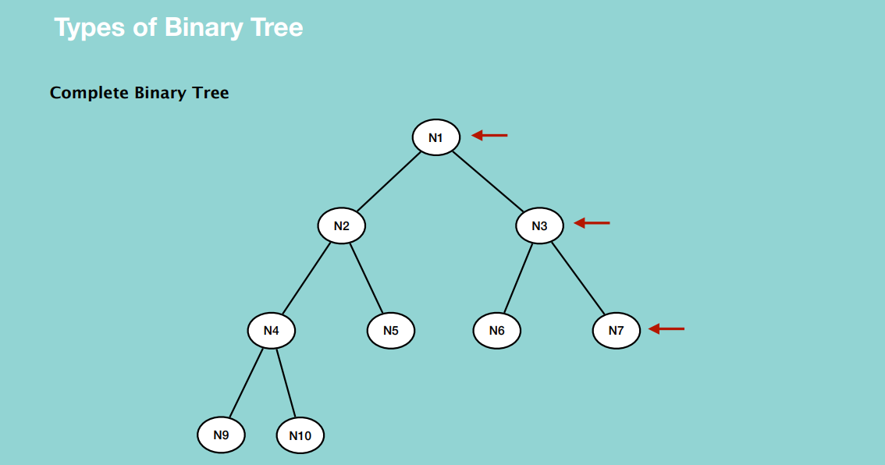

All levels are completely filled except the last one and they are left skewed on the last level.

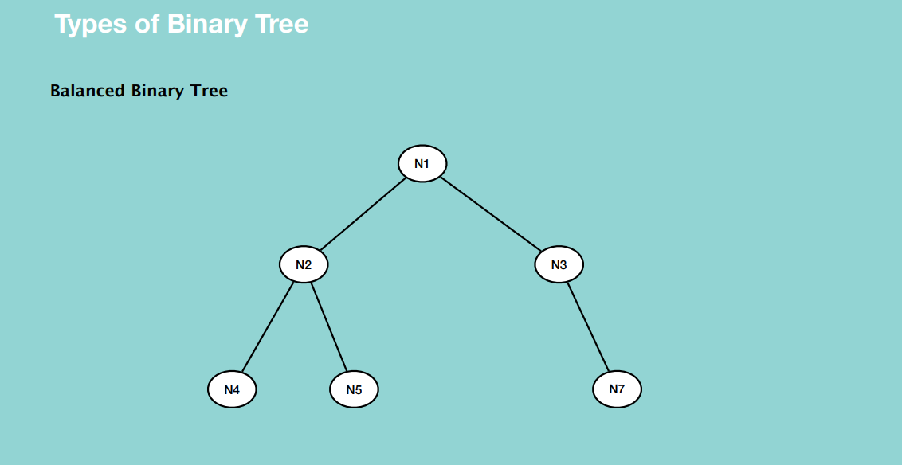

Each leaf is not more than a certain distance from the root node than any other leaf i.e. All leaf nodes are located from the root in the same distance.

A binary tree can be represented in two ways i.e. a linked list and python list(array)

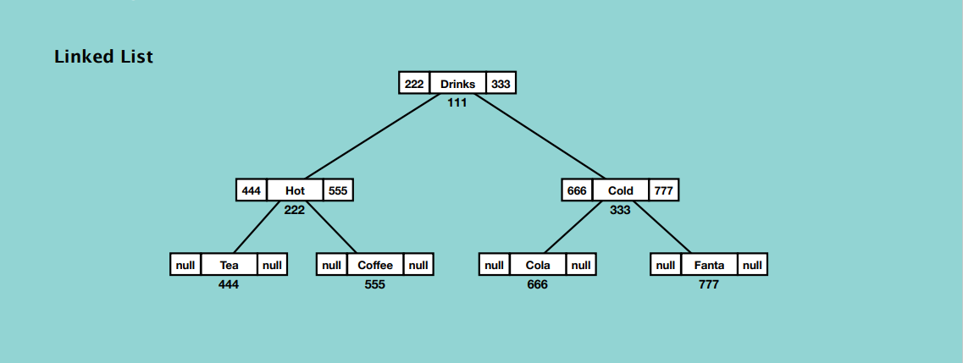

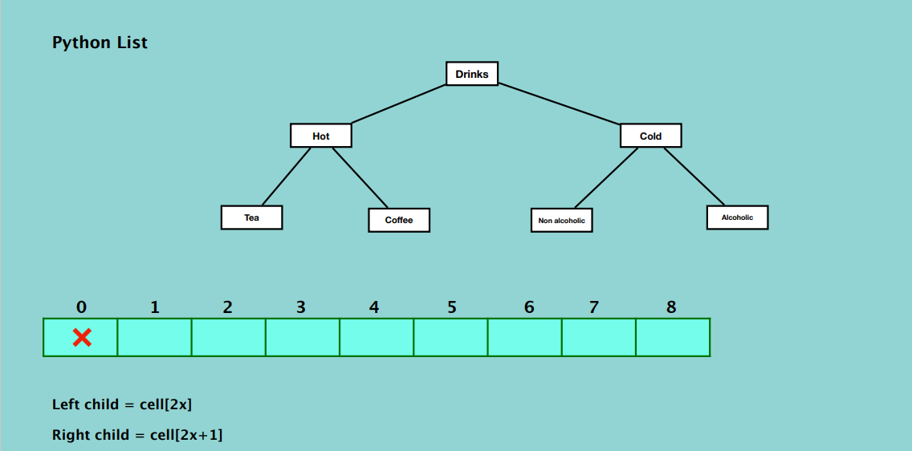

* Leaving the first index (zero) makes the mathematical calculation and assignment easier.

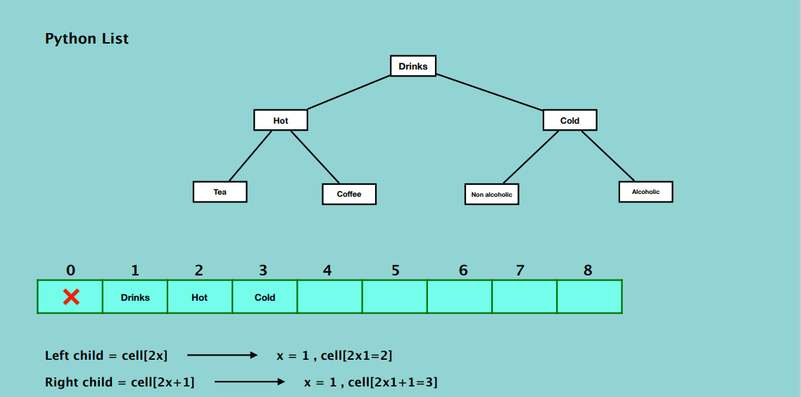

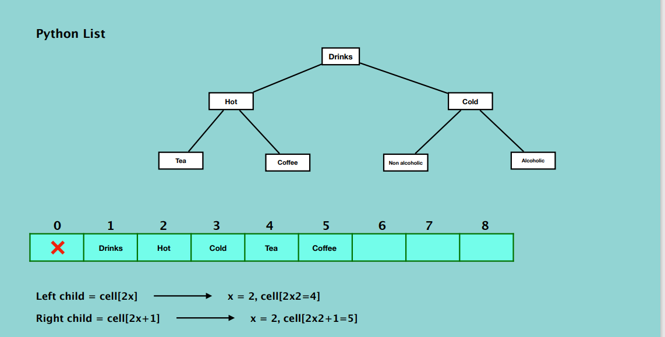

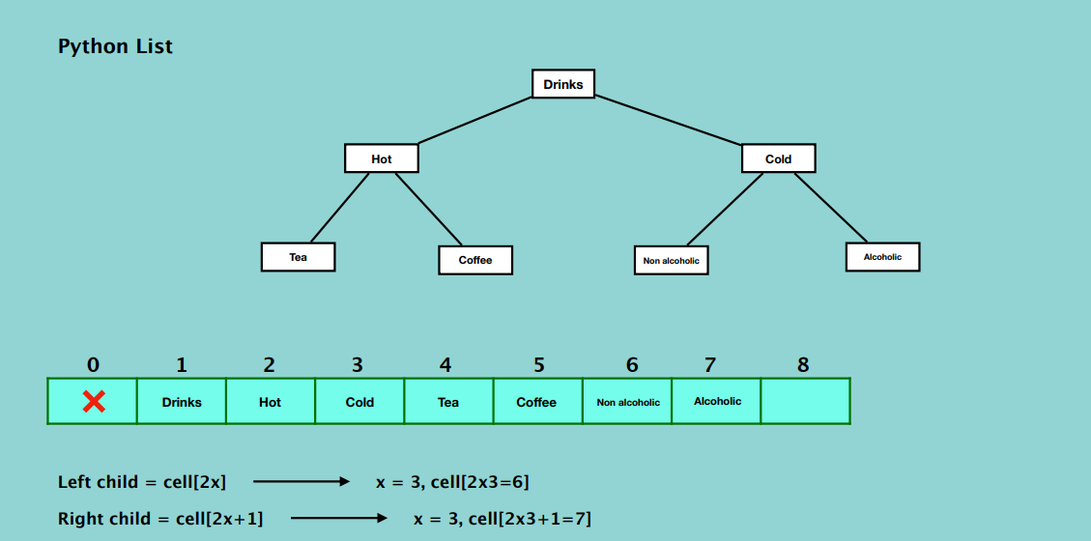

**TRAVERSAL**

Depth first search

* Preorder traversal
* Inorder traversal
* Post order traversal

Breadth first search

* Level order traversal

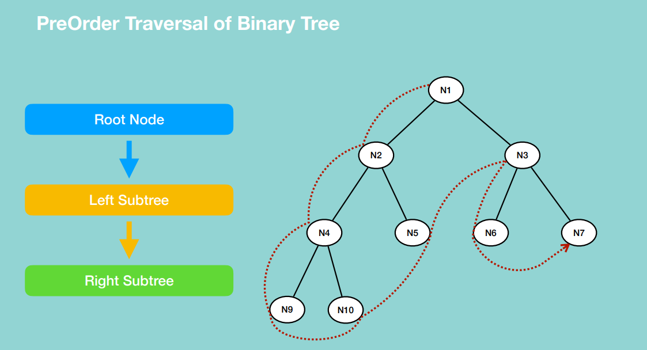

* The right subtree’s right leaf will be visited at the end.

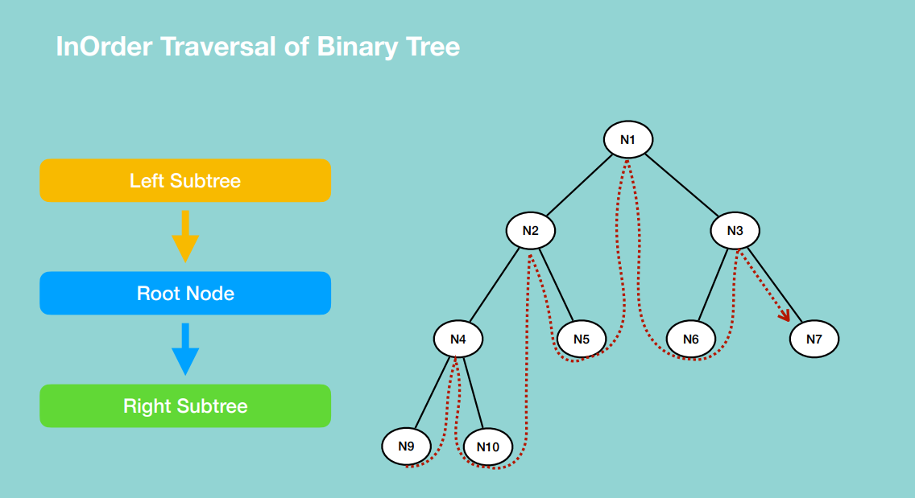

* The right subtree’s right leaf will be visited at the end.

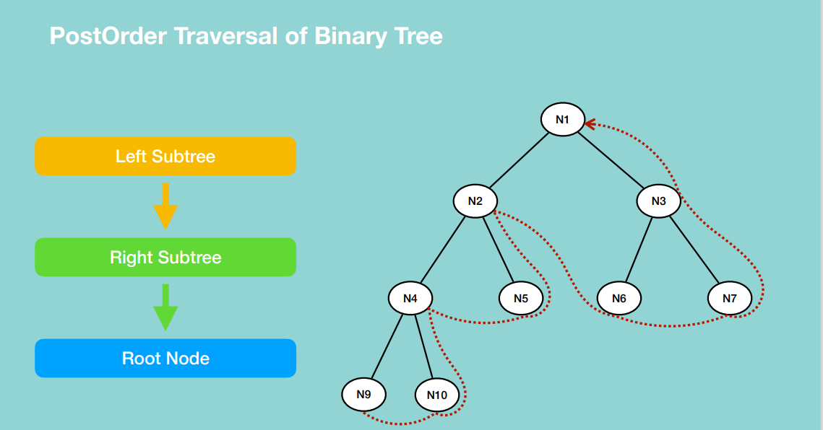

* The root node will be visited at the end.

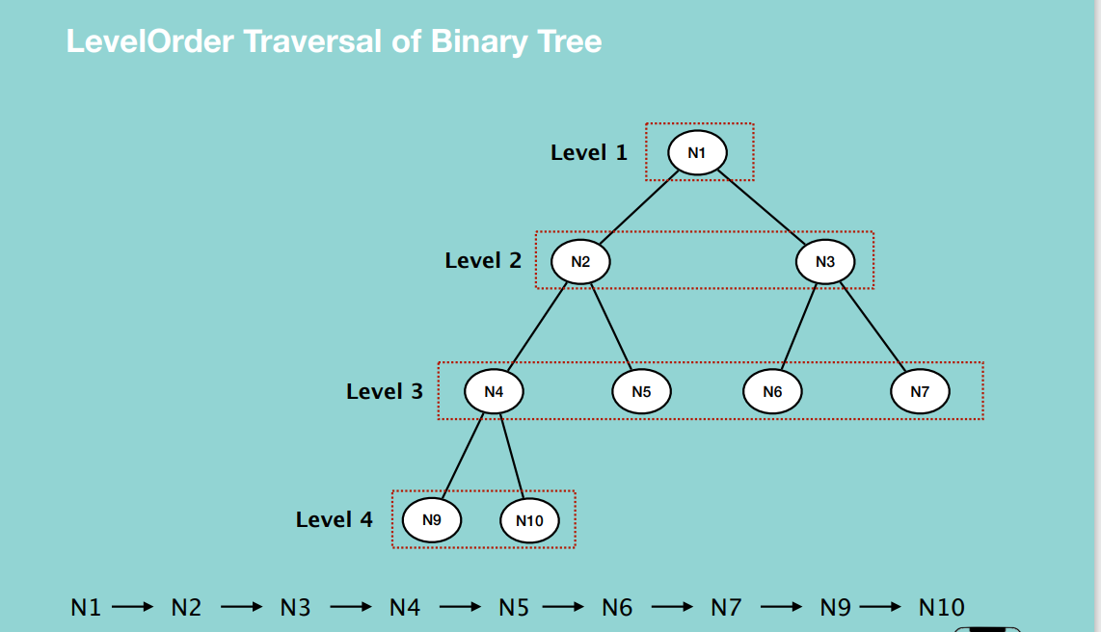

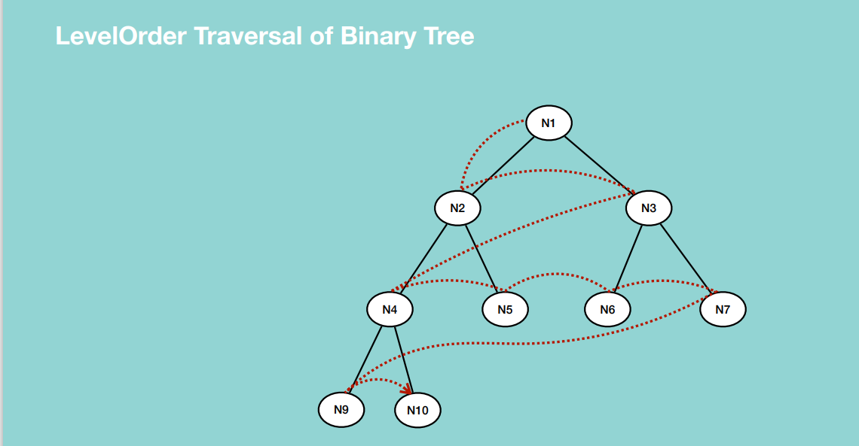

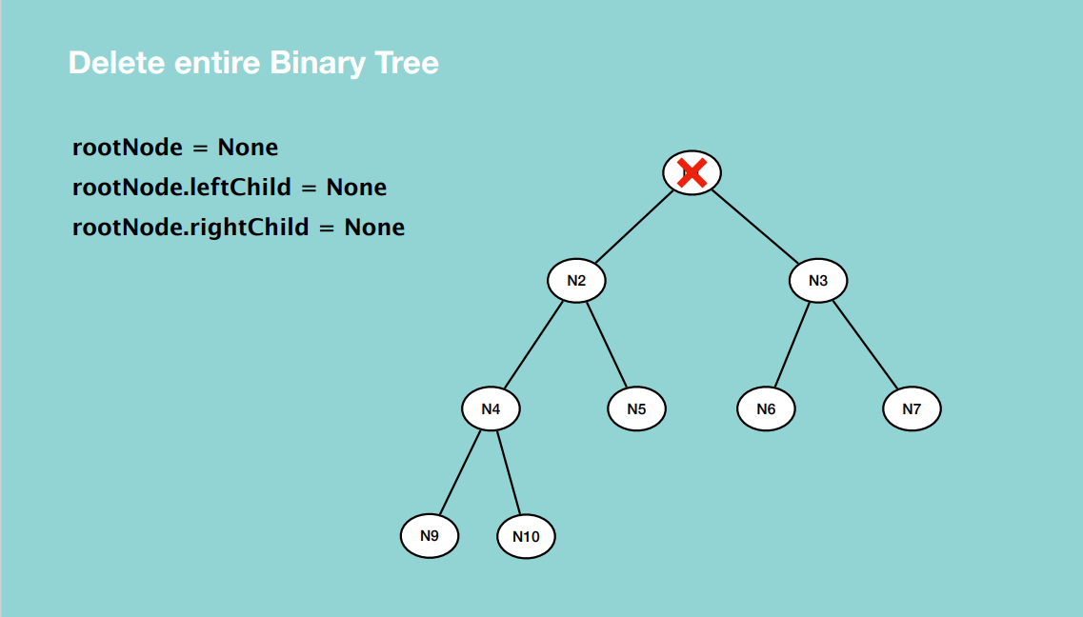

**BINARY TREE IN PYTHON LISTS**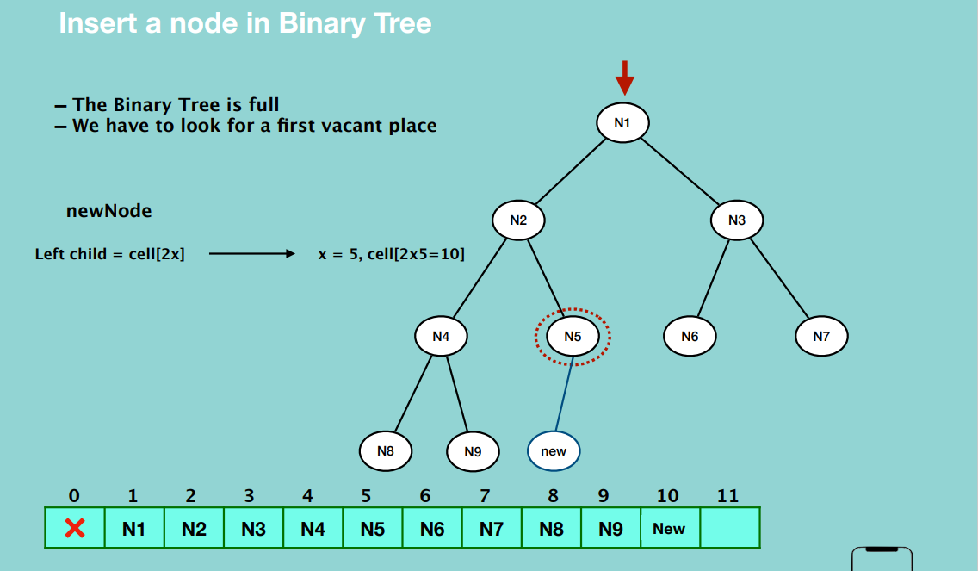

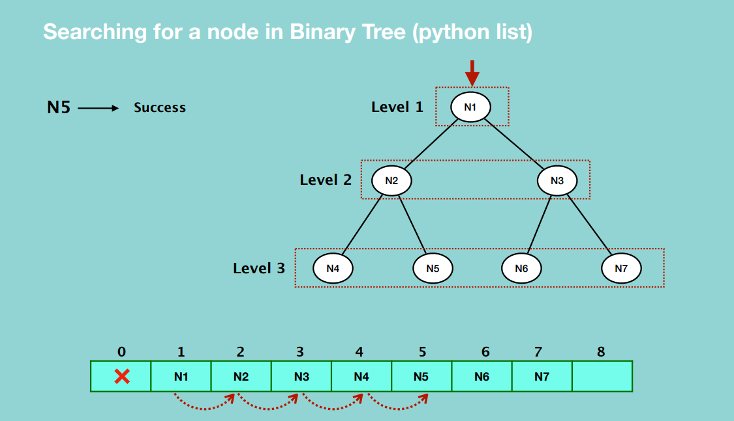

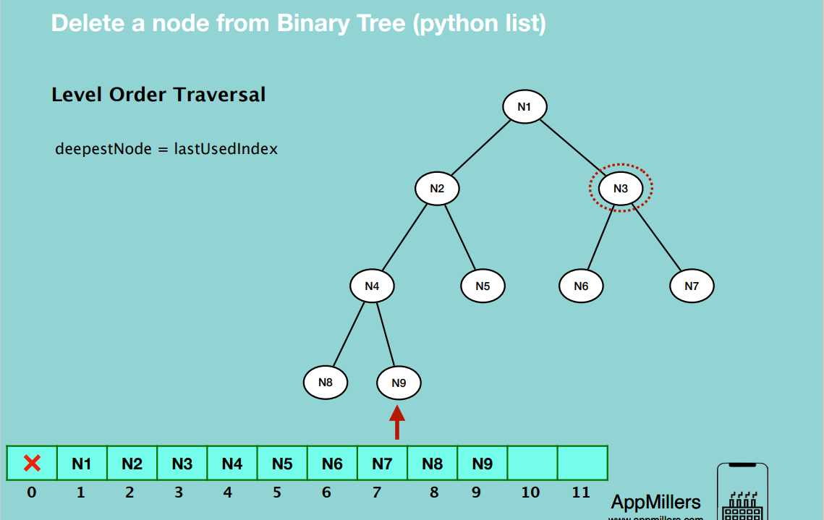

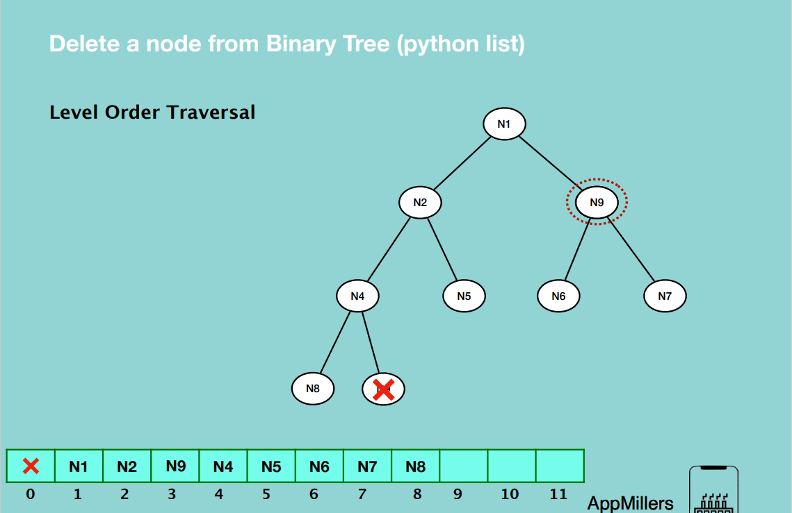

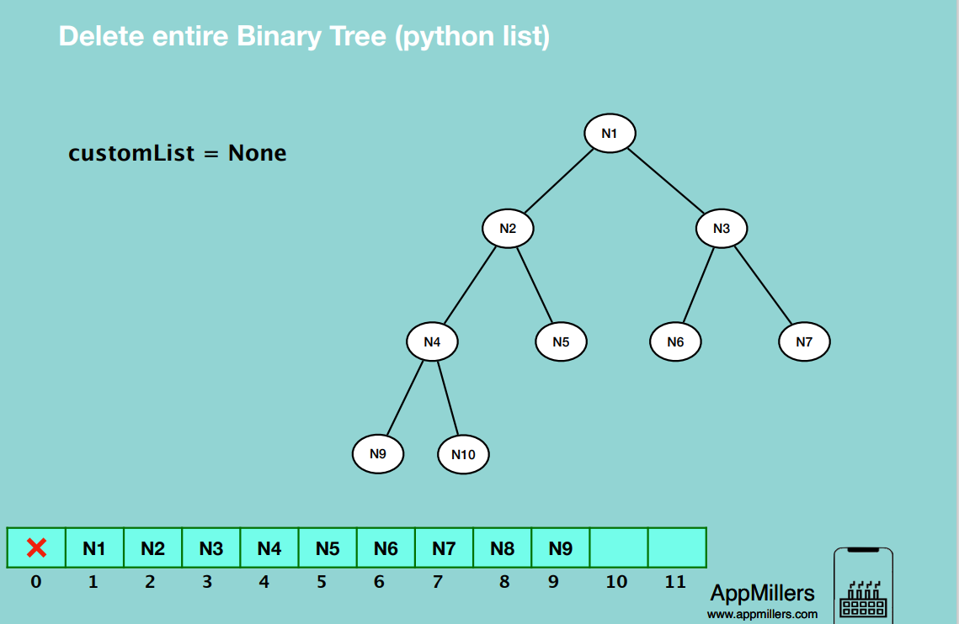

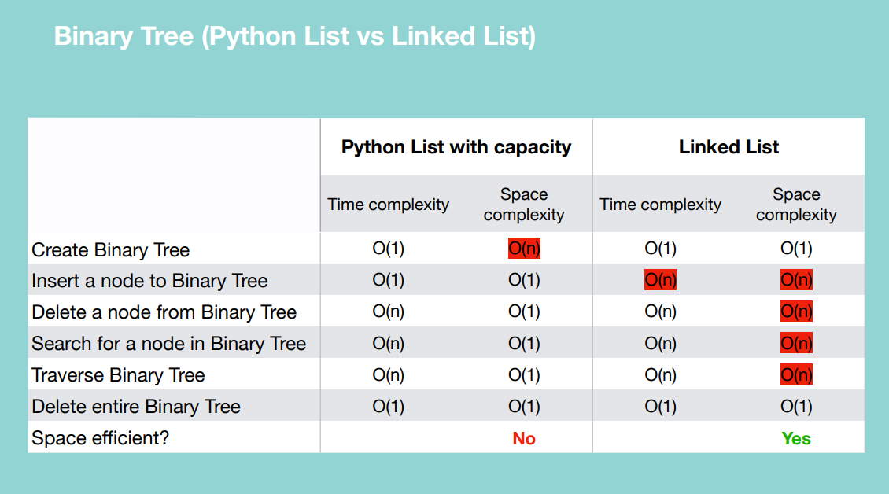

**Binary Search Tree**

In the left subtree the value of a node is less than or equal to its parent node’s value.

In the right subtree the value of a node is greater than its parent node’s value

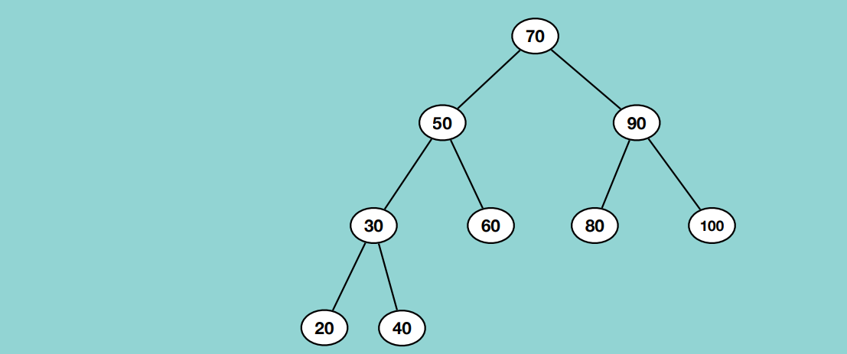

DELETE A NODE FROM A BINARY SEARCH TREE

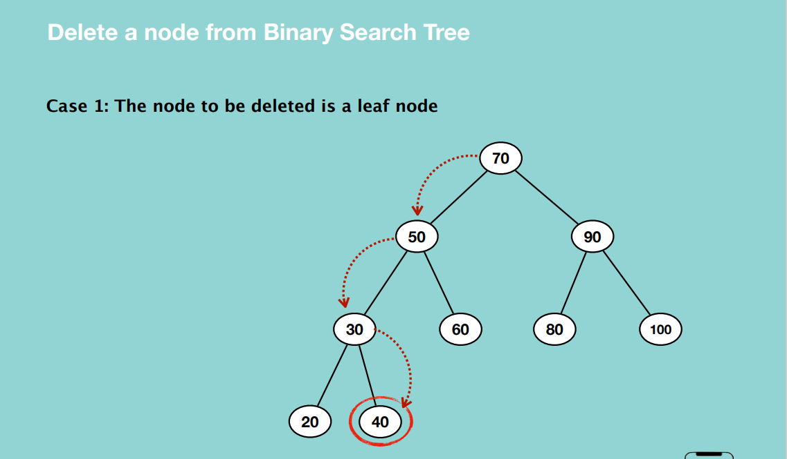

* Traverse to the intended node and delete it.

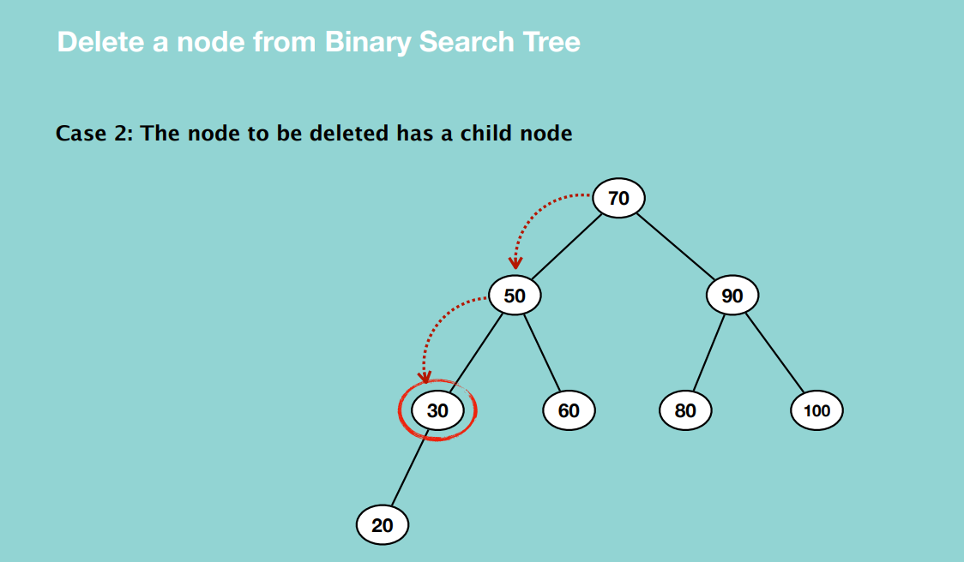

* Delete the node and assign it’s child to the deleted node’s parent node.

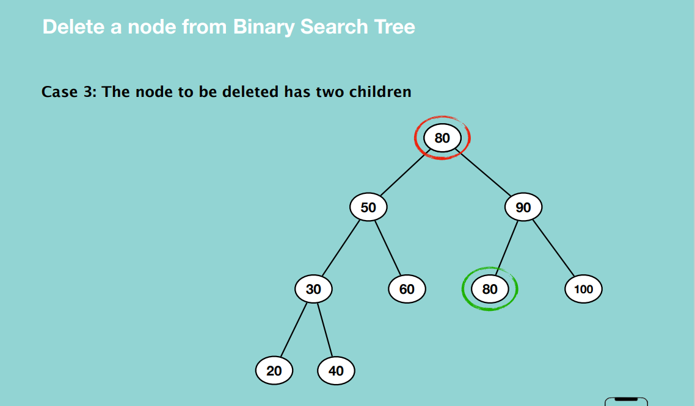

* Find its successor i.e. the smallest node in the right sub tree and replace the value of the node we want to delete with the value of its successor.

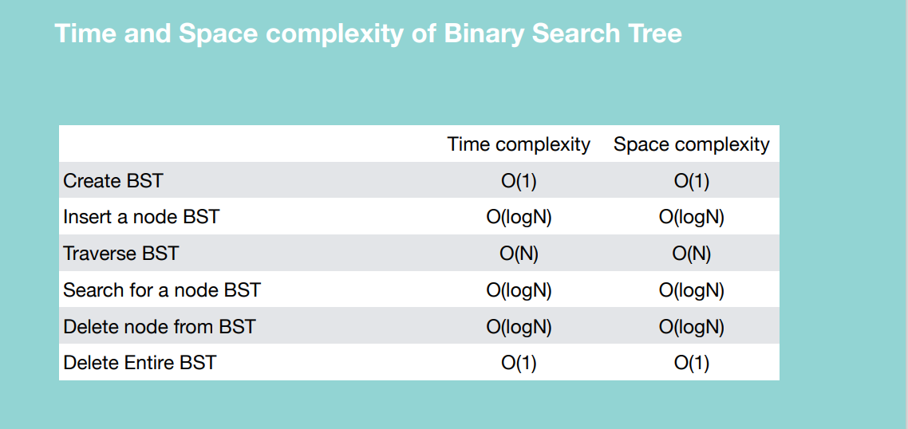

**What is an AVL Tree?**

An AVL tree is a self-balancing Binary Search Tree (BST) where the difference between

heights of left and right subtrees cannot be more than one for all nodes.

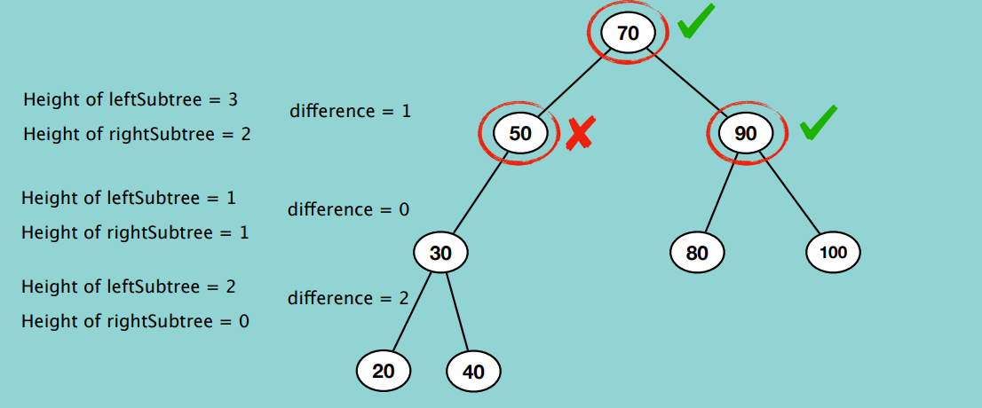

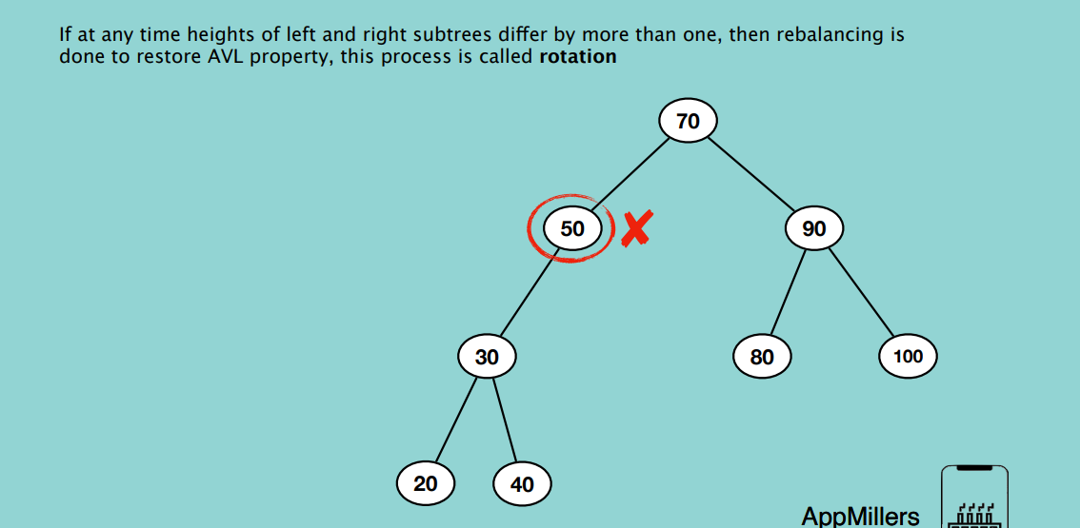

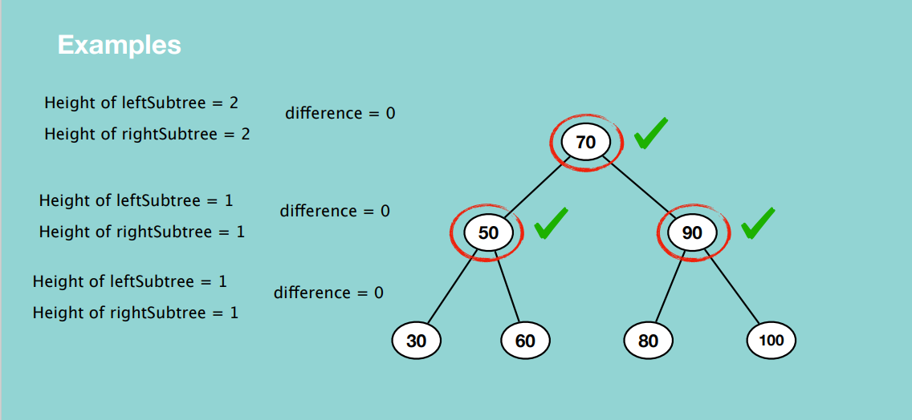

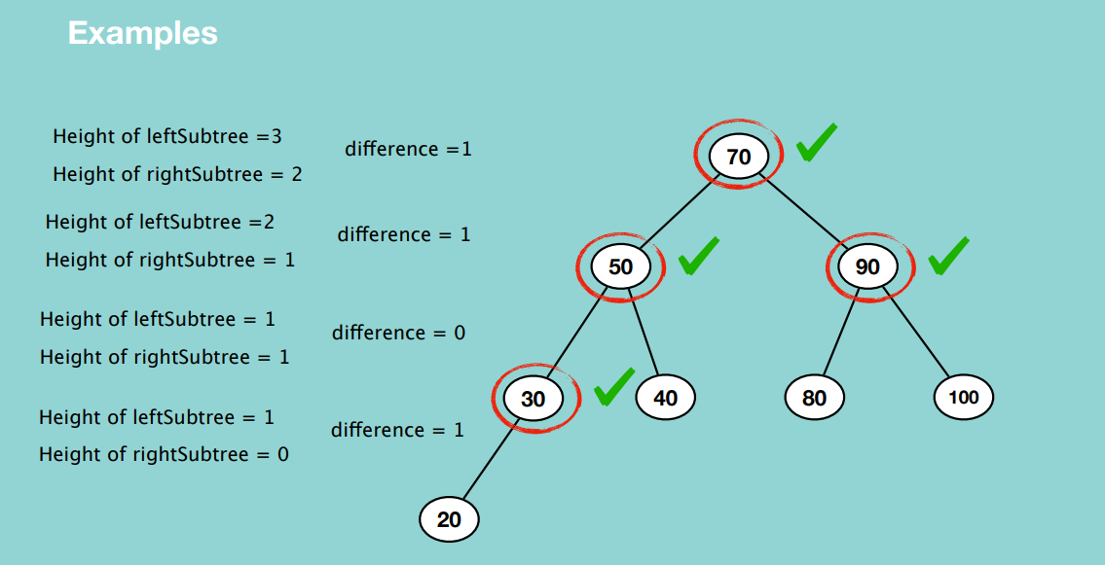

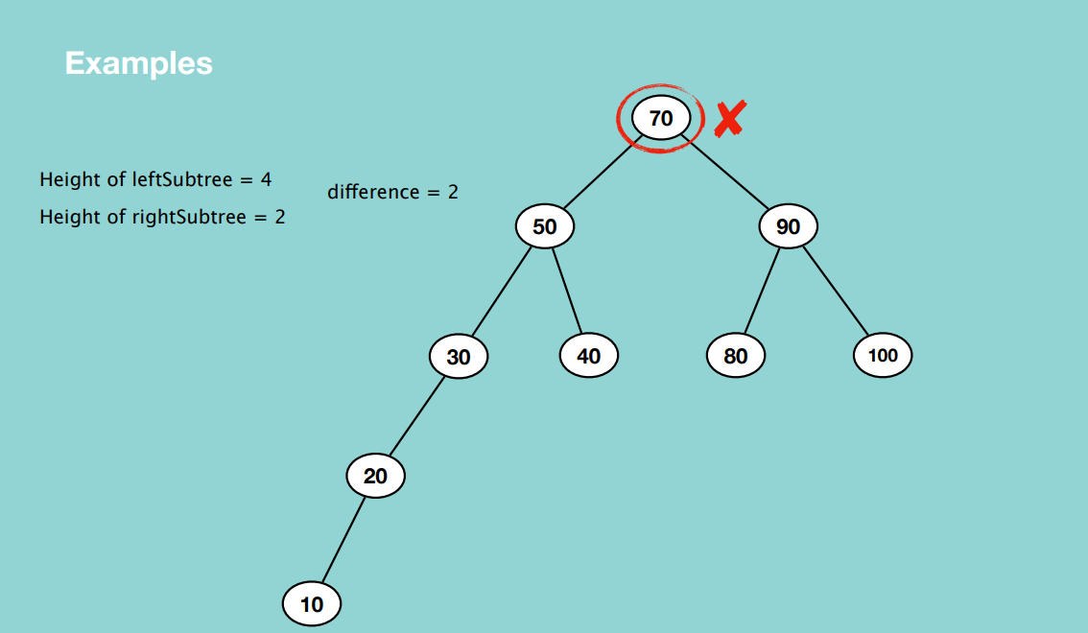

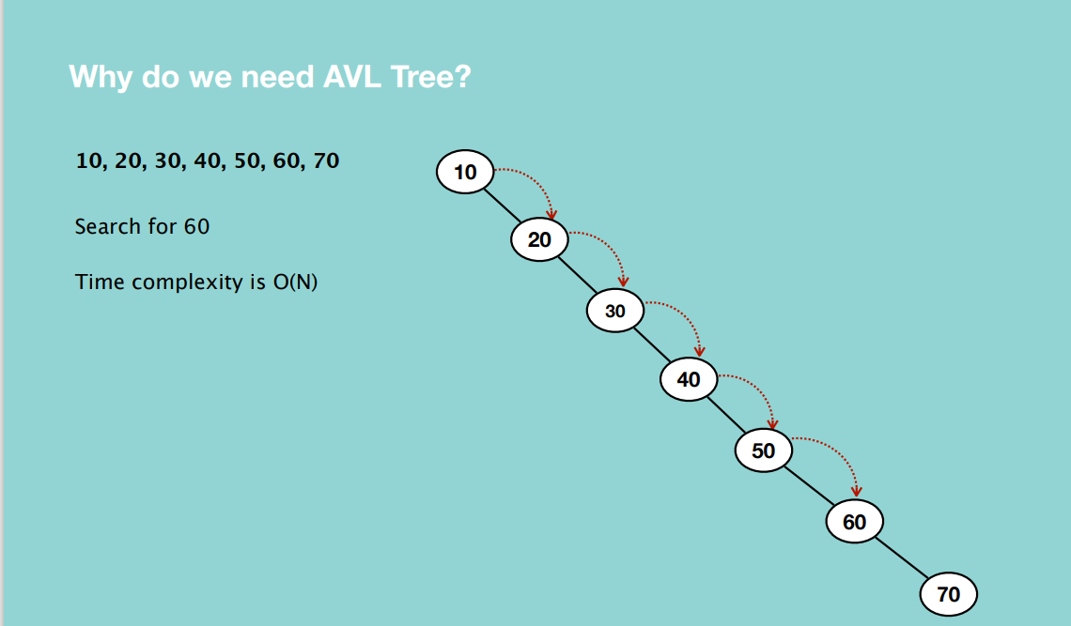

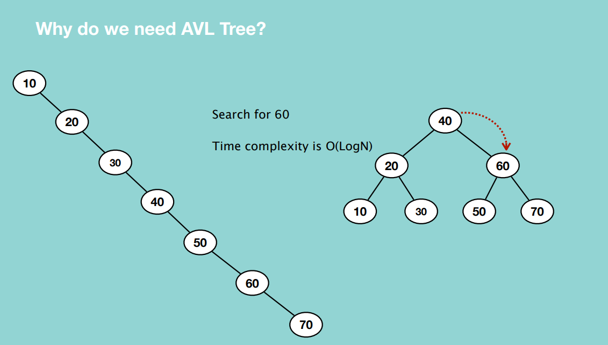

**NOTE:** AVL trees enable us to make an unbalanced tree balanced to avoid issues of a time complexity to search for an item being O(n) instead of O(logN).

Rotation is required when the Binary Search Tree is unbalanced i.e. when the difference between the height of the left subtree and right subtree is more than one.

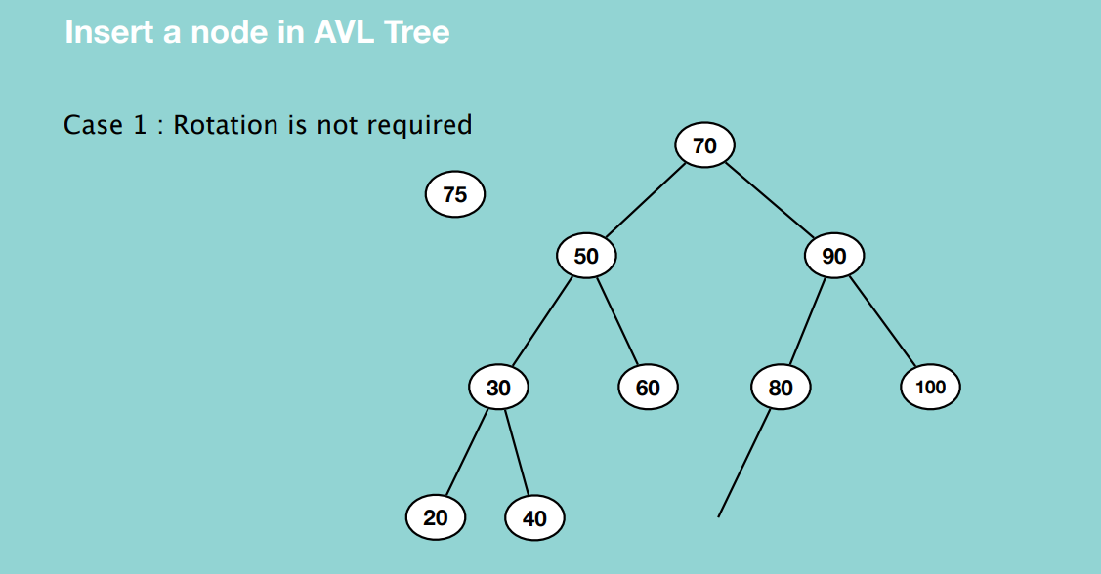

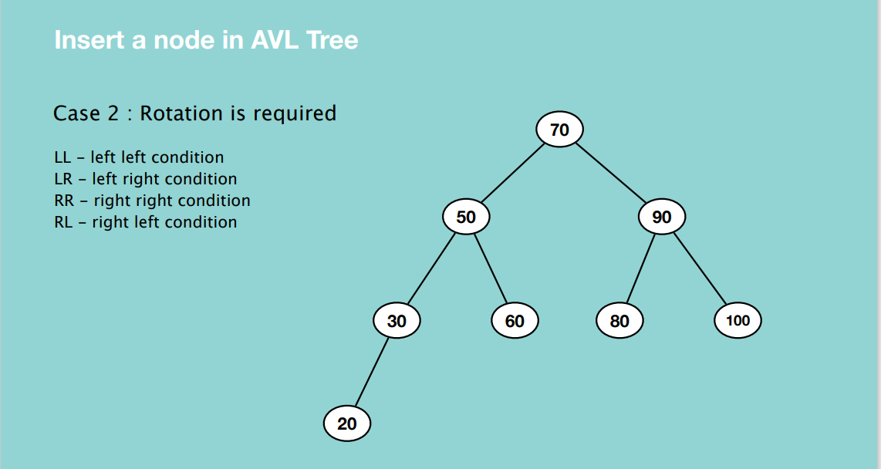

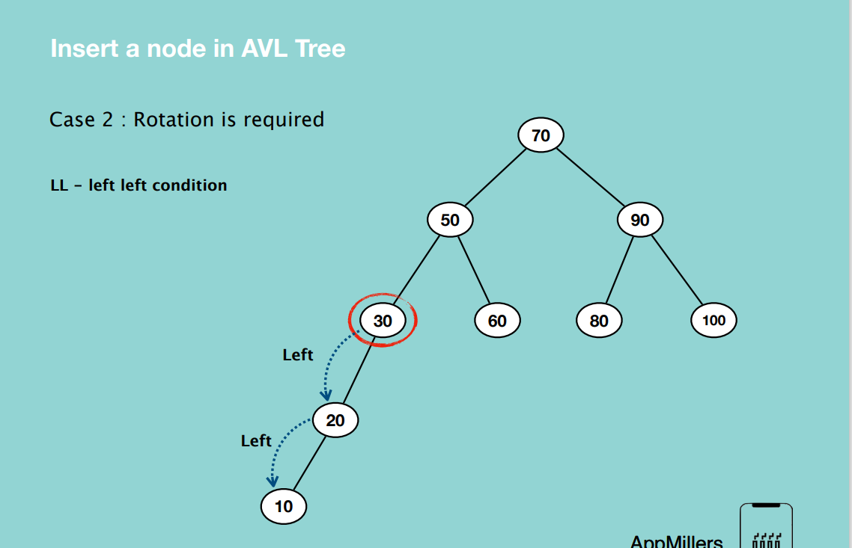

LL-Left left condition: In case of this condition, the right rotation is required i.e. we have to right rotate the unbalanced node. To find out the node that causes imbalance, start counting from the leaf node going upwards as you determine the difference between the left and right subtrees for the difference nodes.

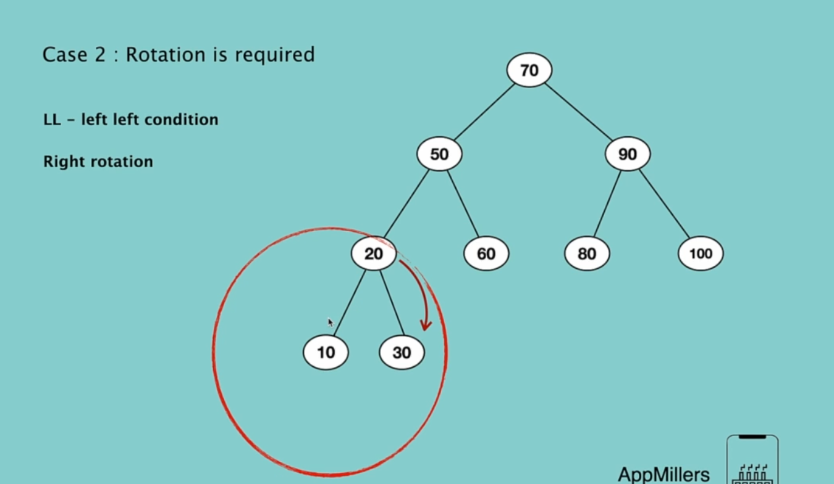

In the right rotation, root node which is 30, goes down, and 20 and 10 go up.

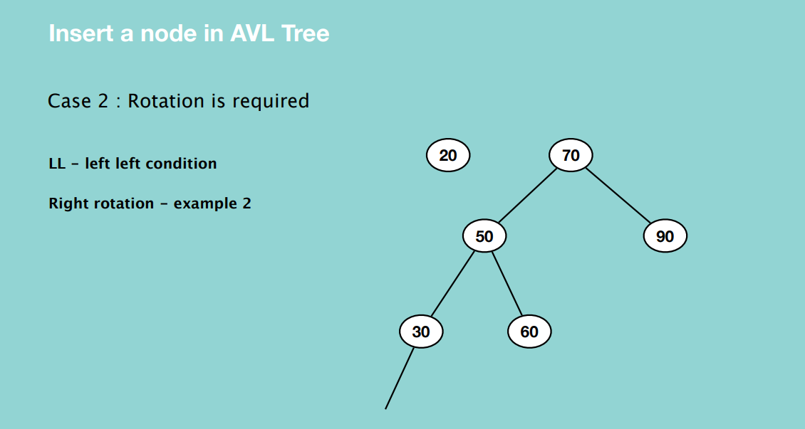

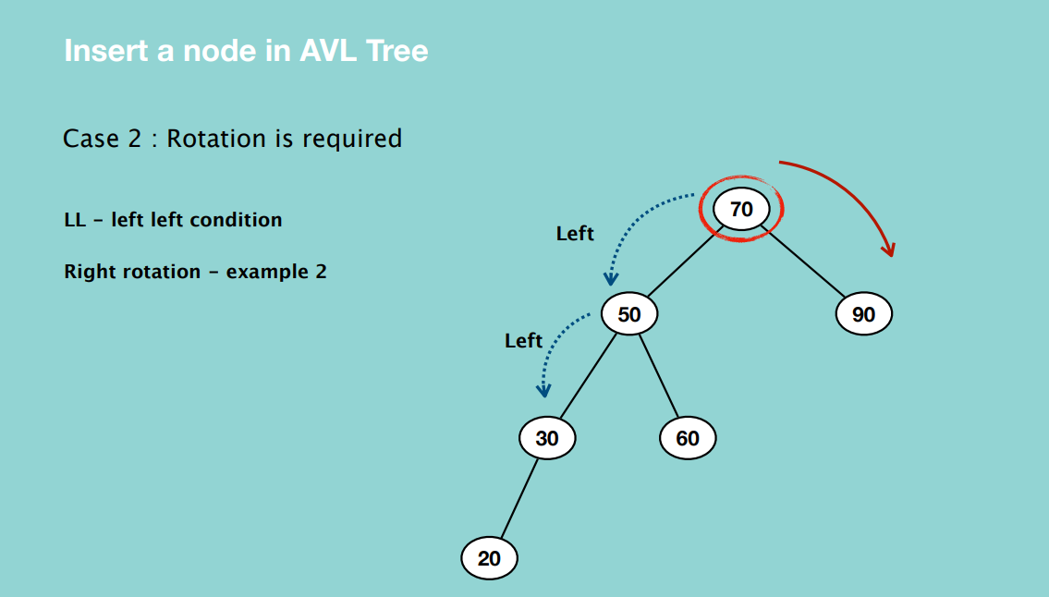

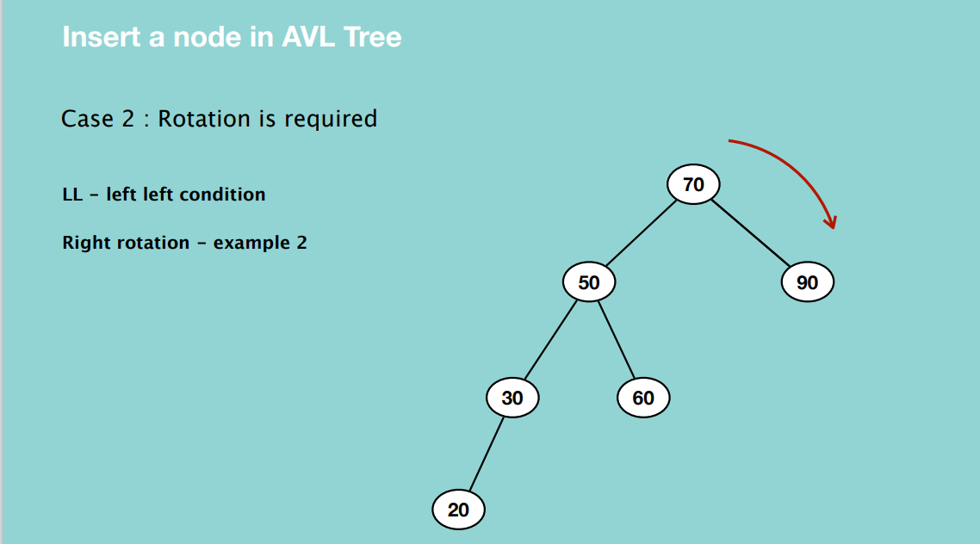

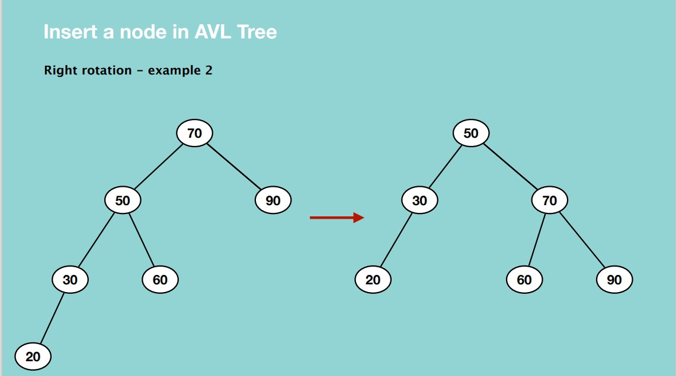

Time complexity – O(1)

Space complexity – O(1)

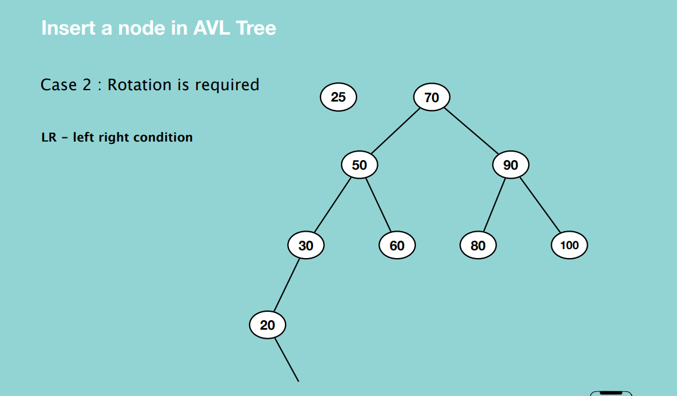

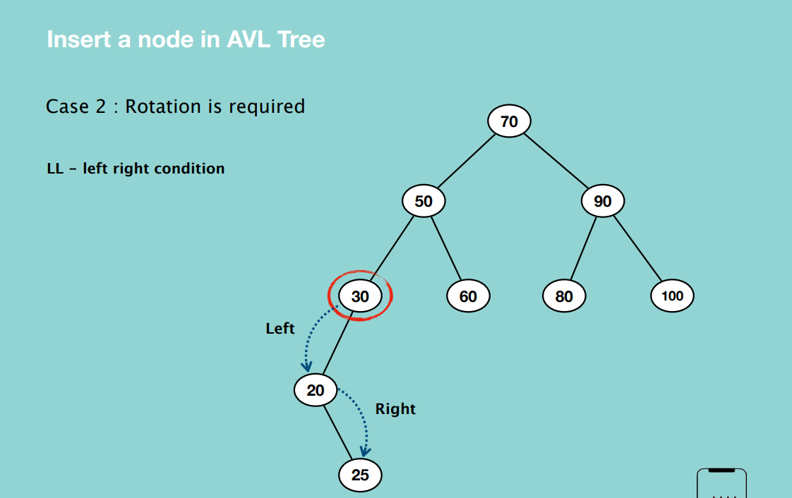

First, we do a left rotation of the left child of the disbalanced node, it will then become left left condition, then you move the right child to the place of its parent and the parent is moved to the left child of the new root node. Then you make a right rotation where the parent child becomes the right child of its left child.

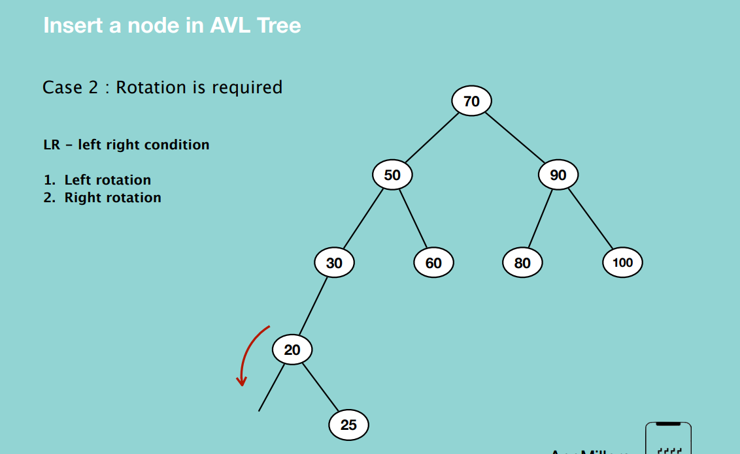

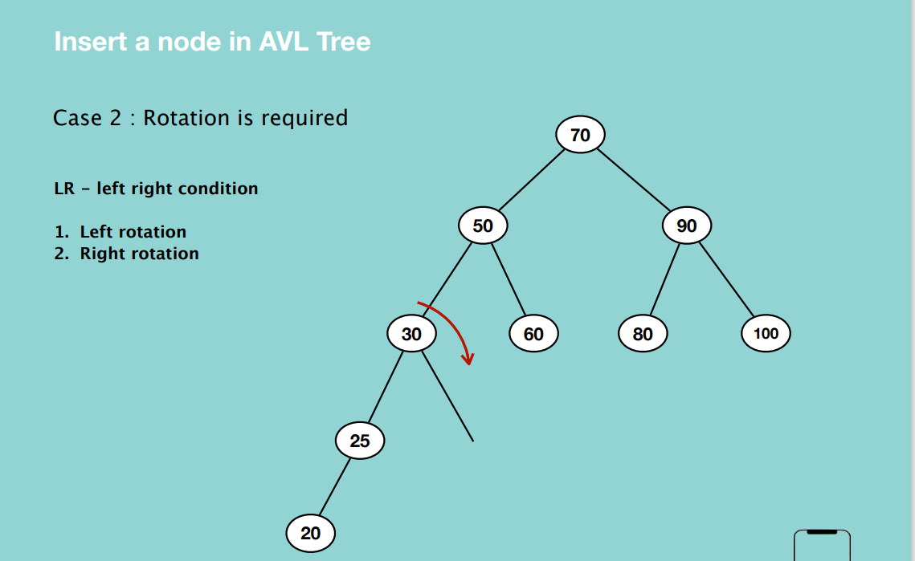

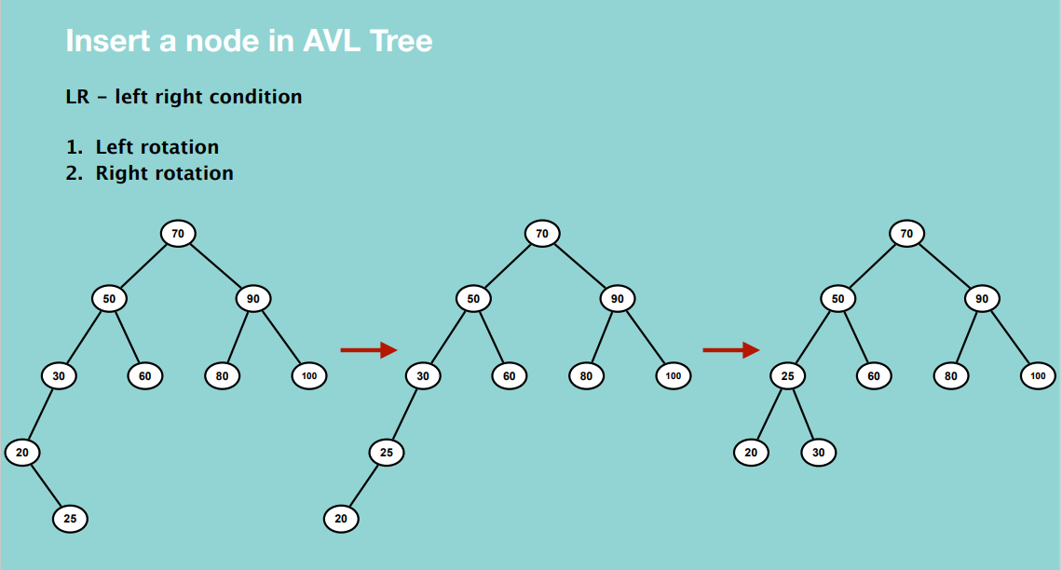

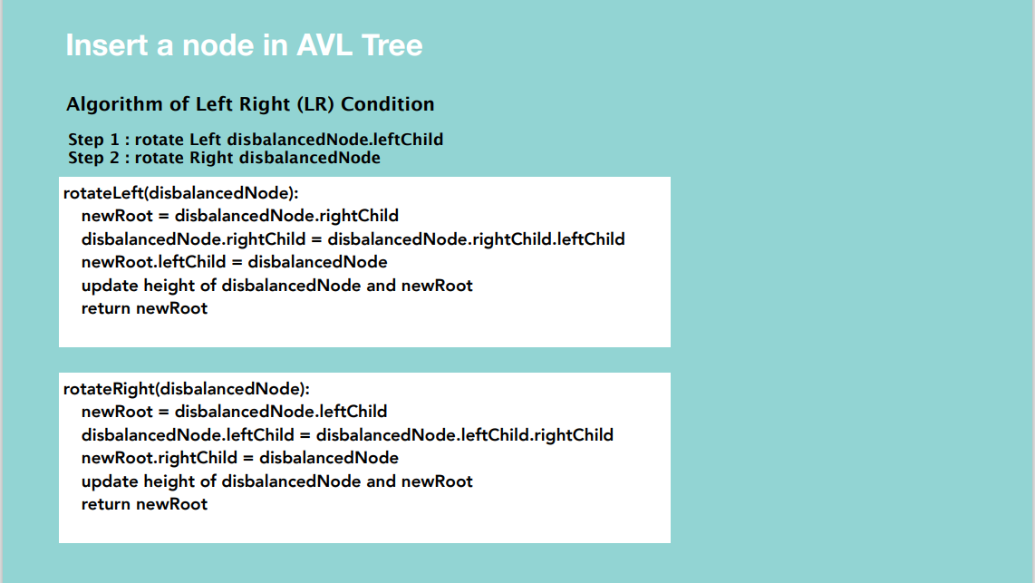

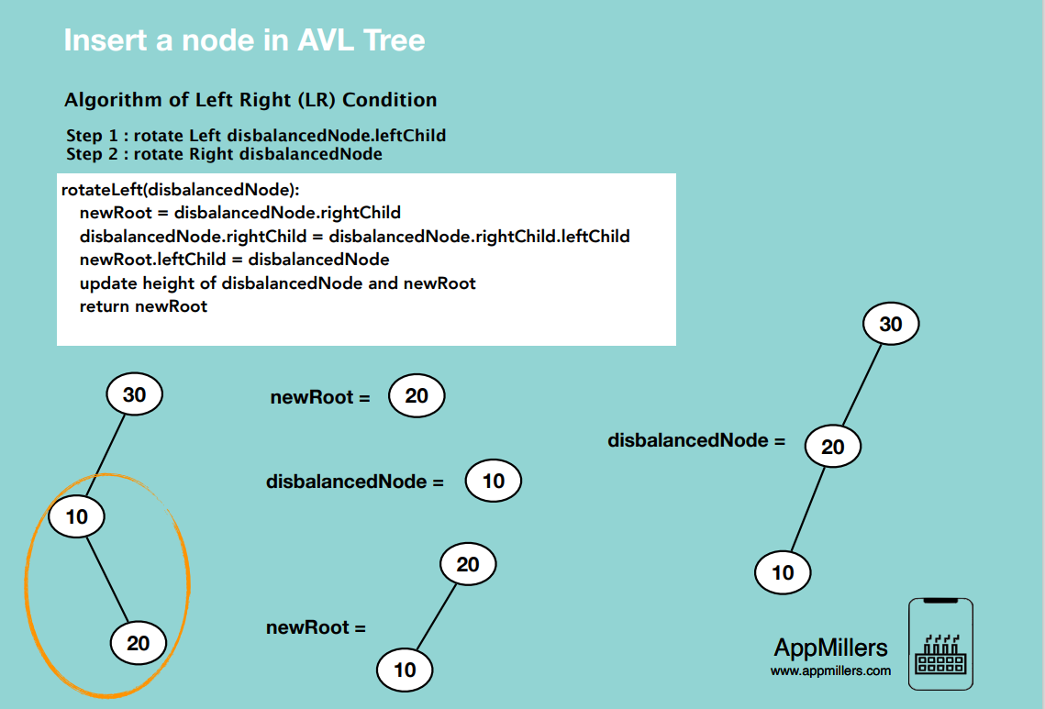

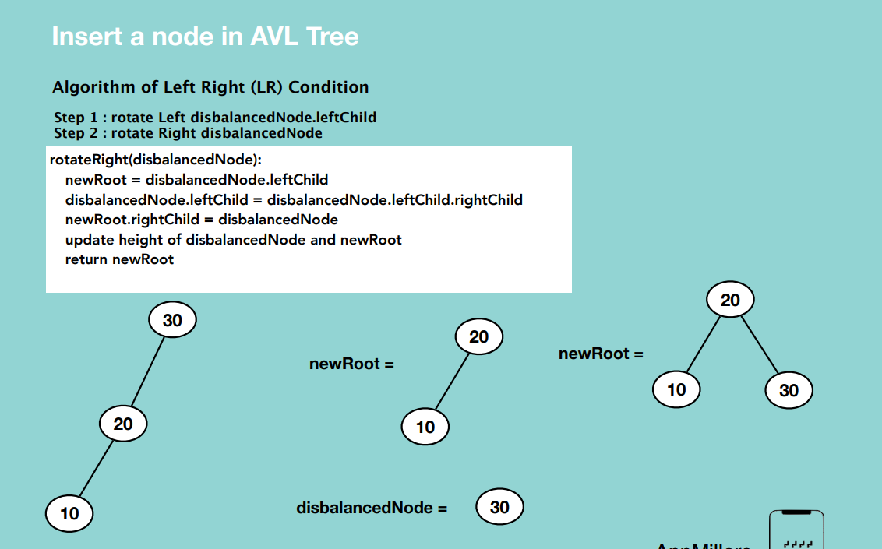

Time complexity: O(1)

Space complexity: O(1)

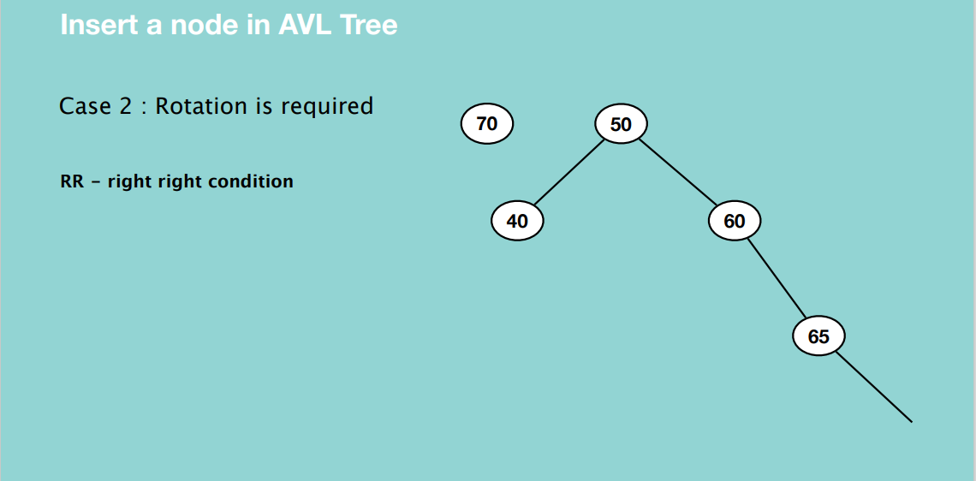

In the right right condition, we do a left rotation, where the disbalanced node (parent node) will come down on the left and the right child of the disbalanced node will come up and become the parent.

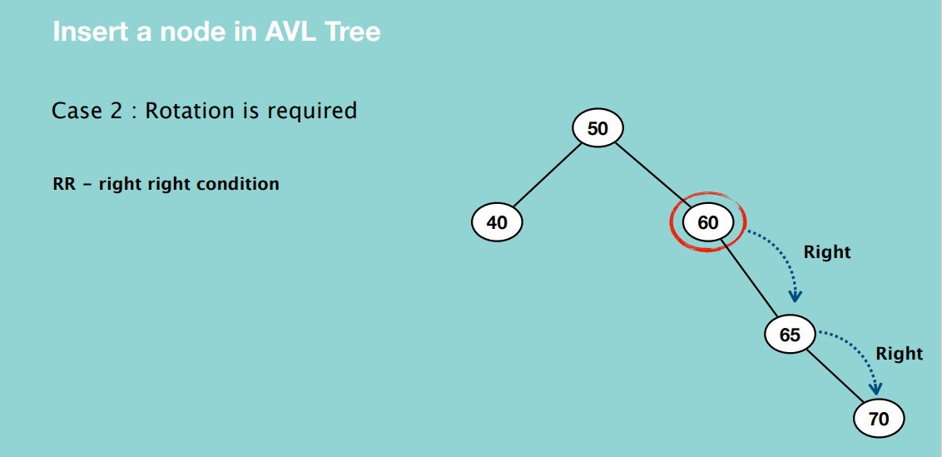

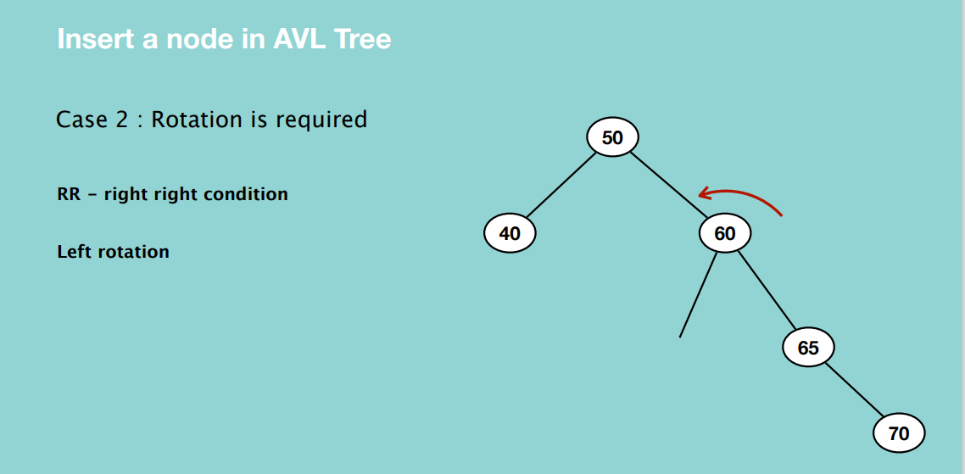

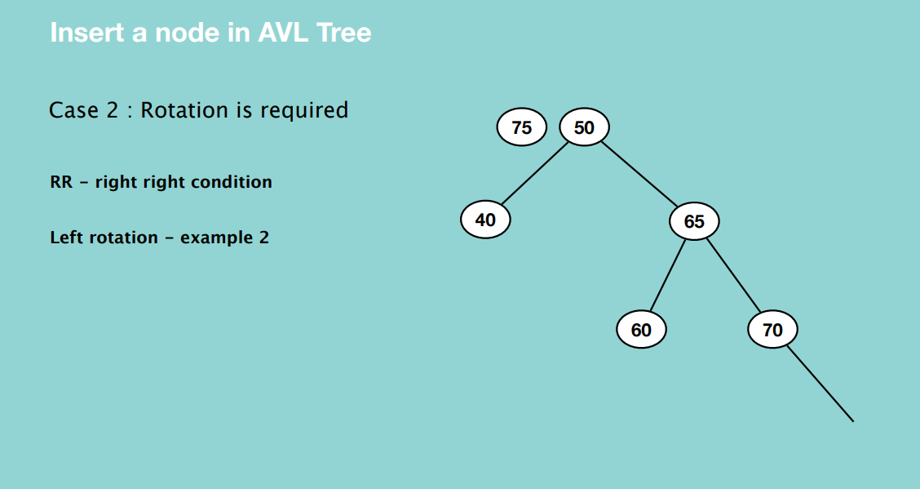

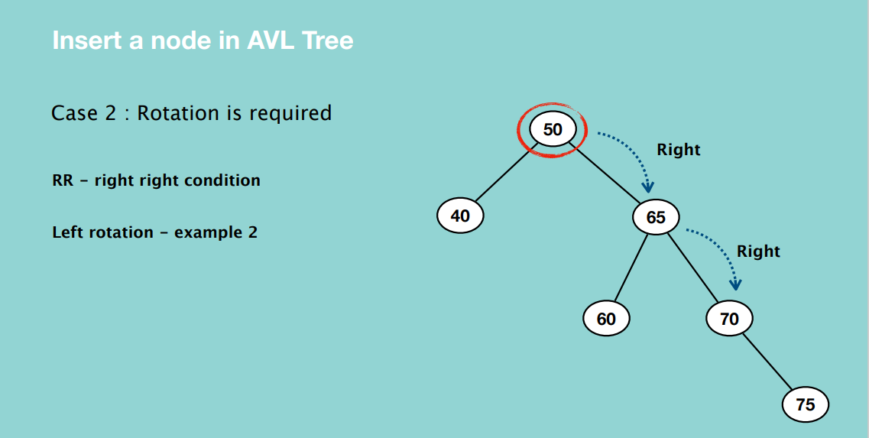

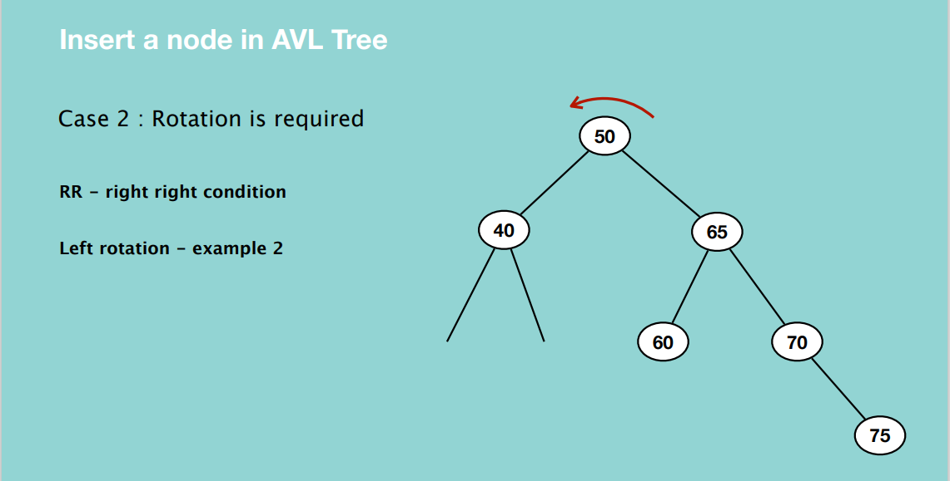

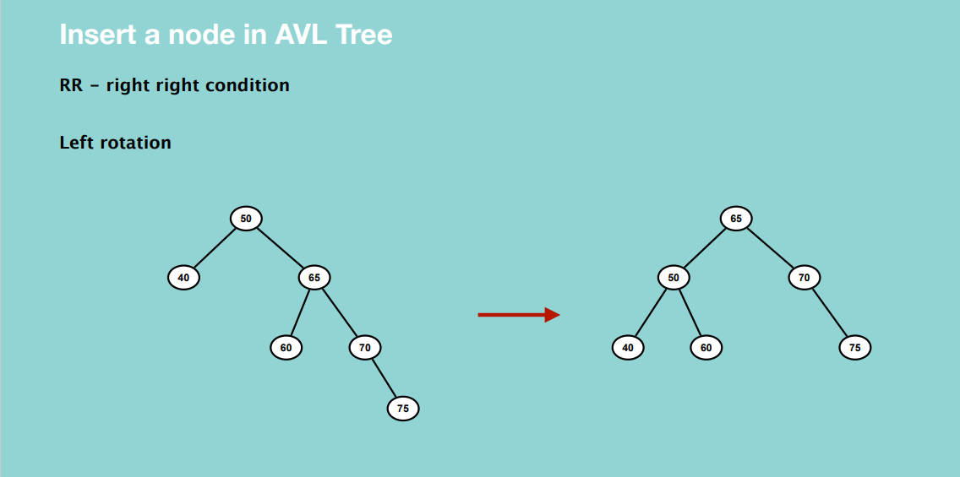

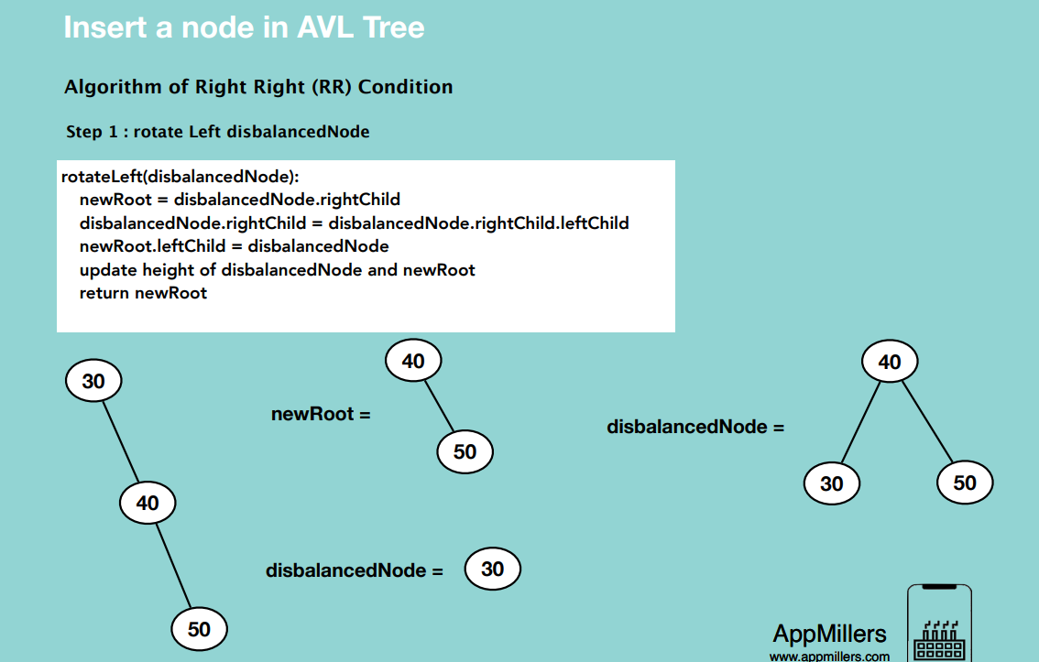

Time complexity: O(1)

Space complexity: O(1)

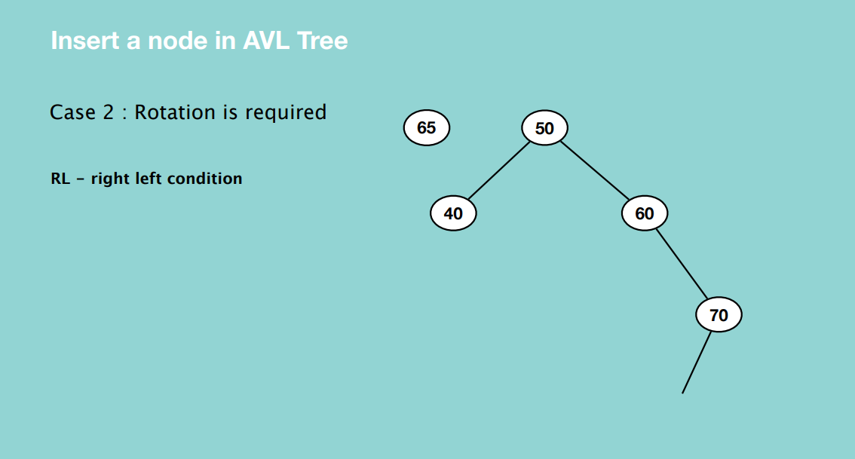

Make a right rotation for the right child of the disbalanced node. i.e. 70 comes down and 65 becomes the parent of 70. Then it will become right right rotation. 60 will now come down and become the left child of the new subtree.

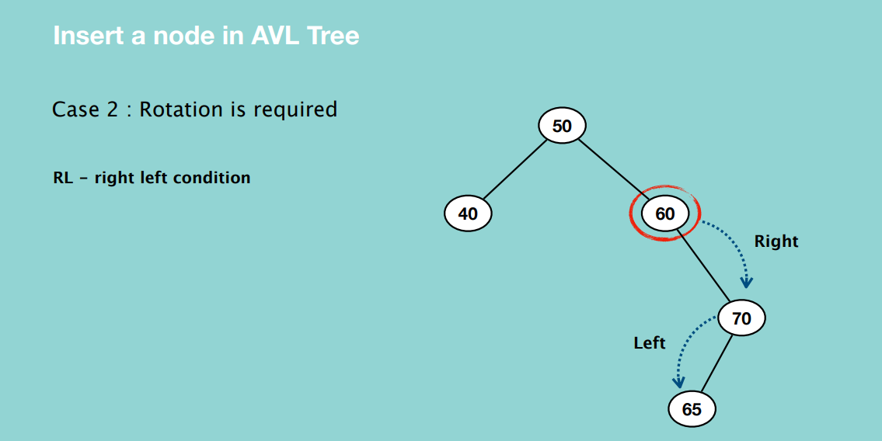

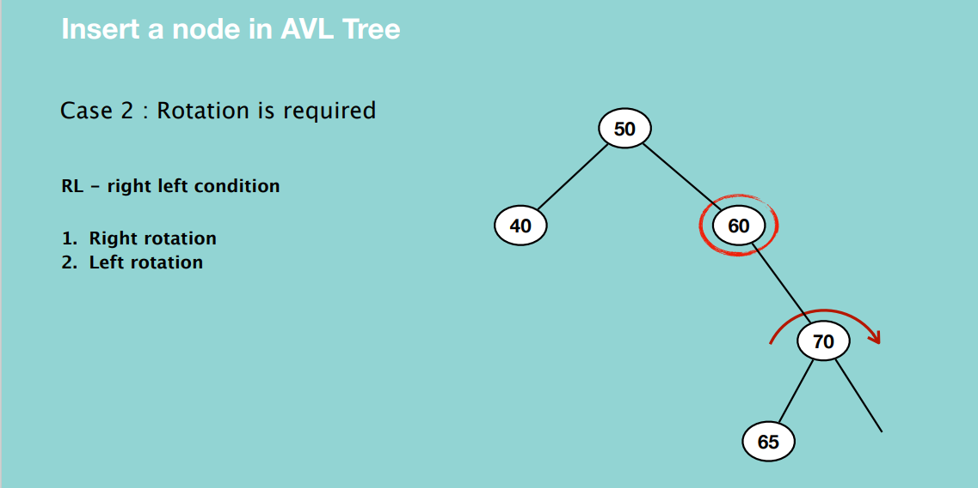

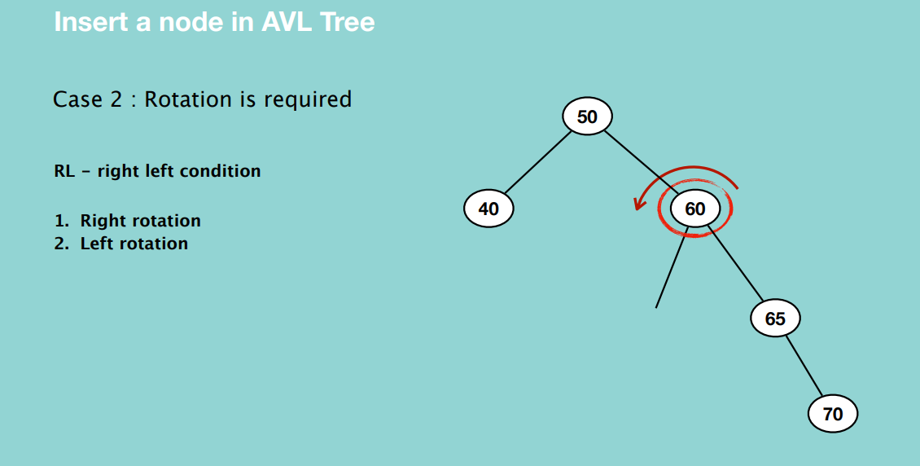

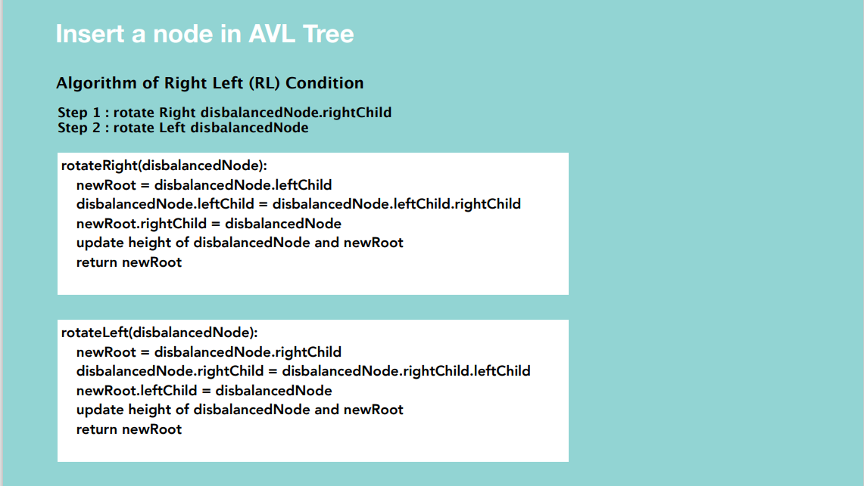

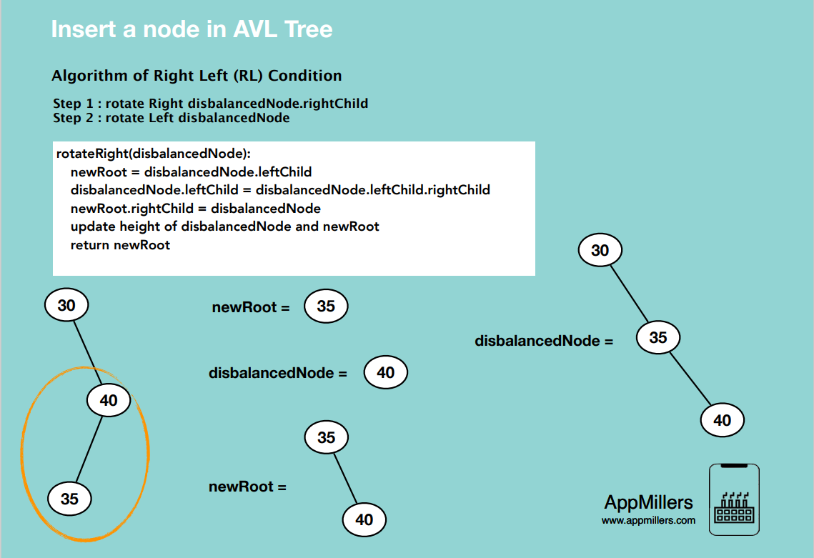

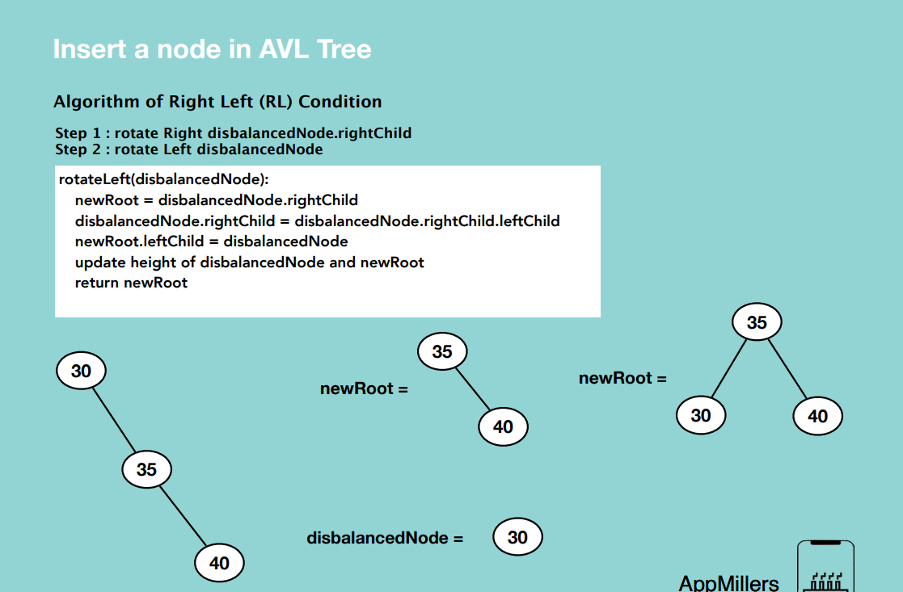

Time complexity : O(1)

Space complexity : O(1)

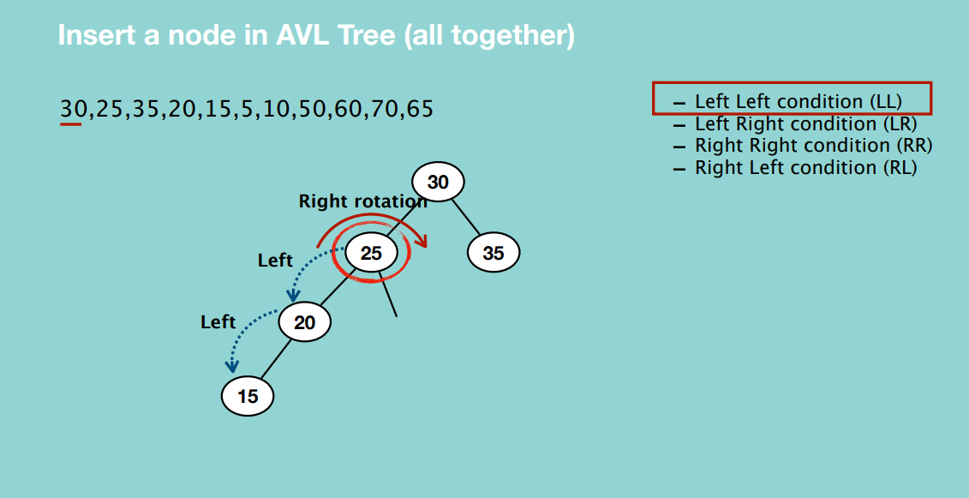

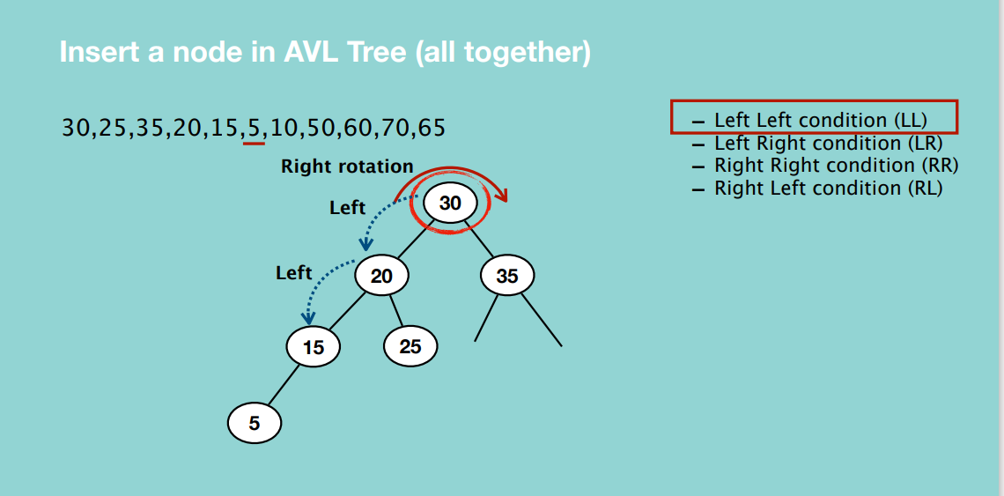

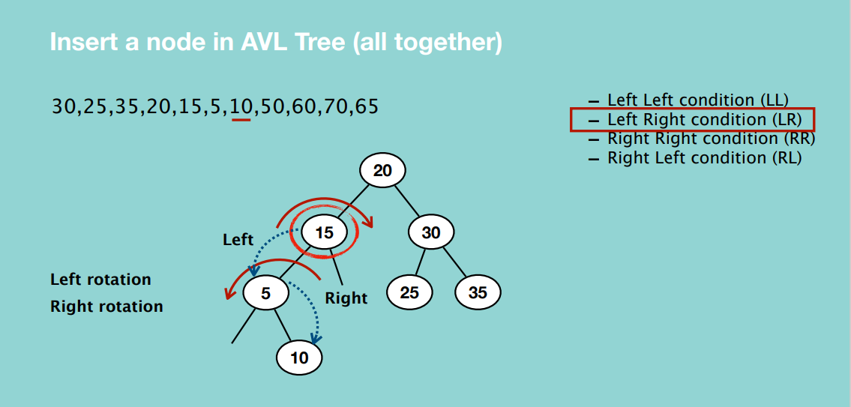

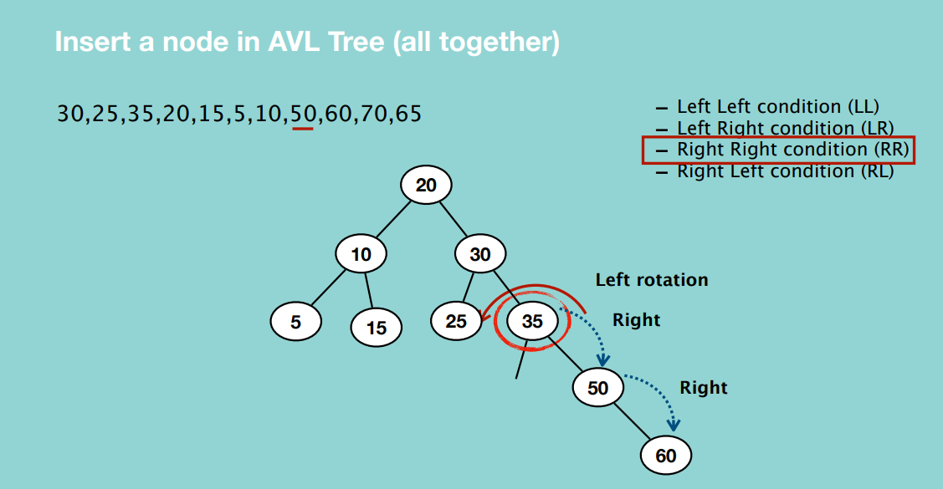

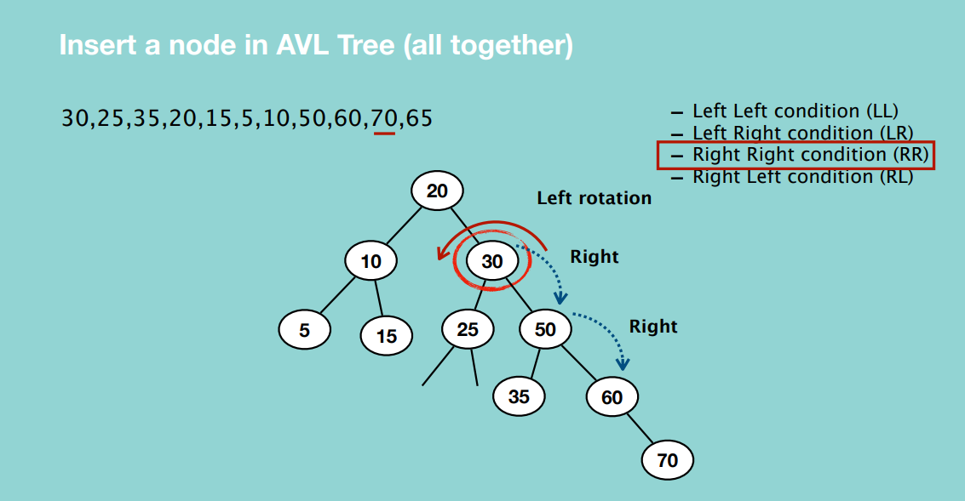

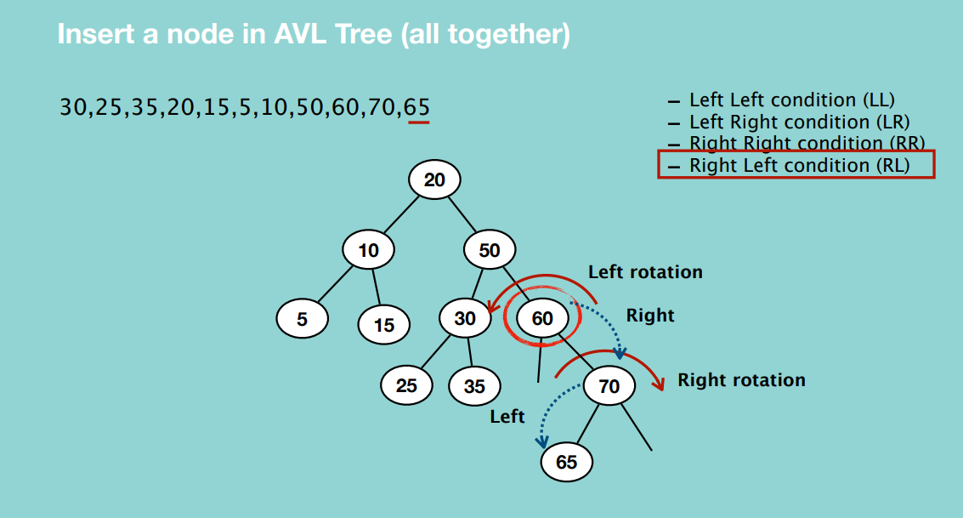

It involves continuously checking the height of the search tree after each insertion and performing the appropriate rotations where necessary.

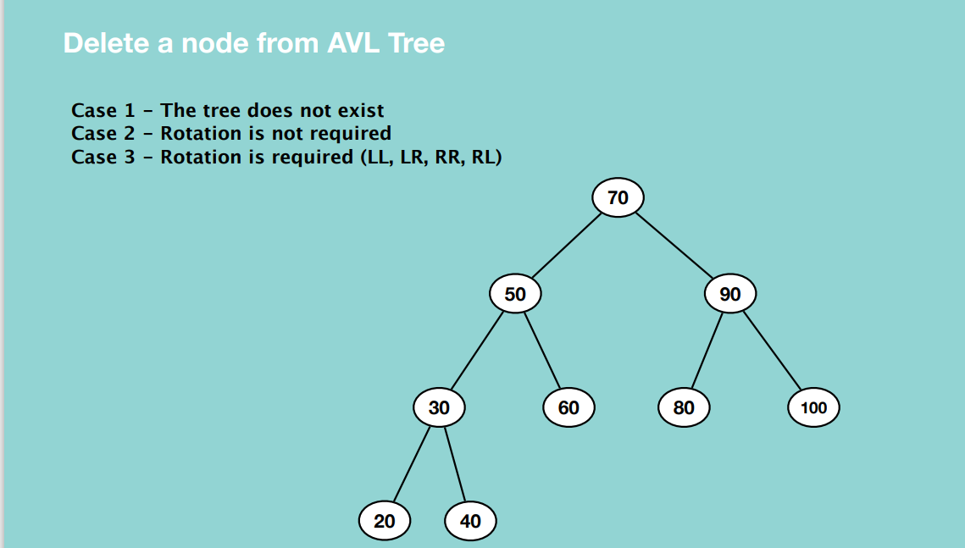

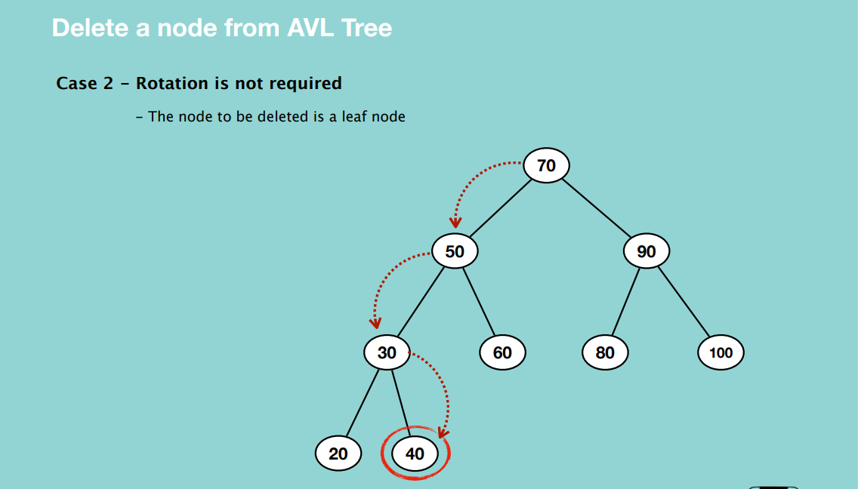

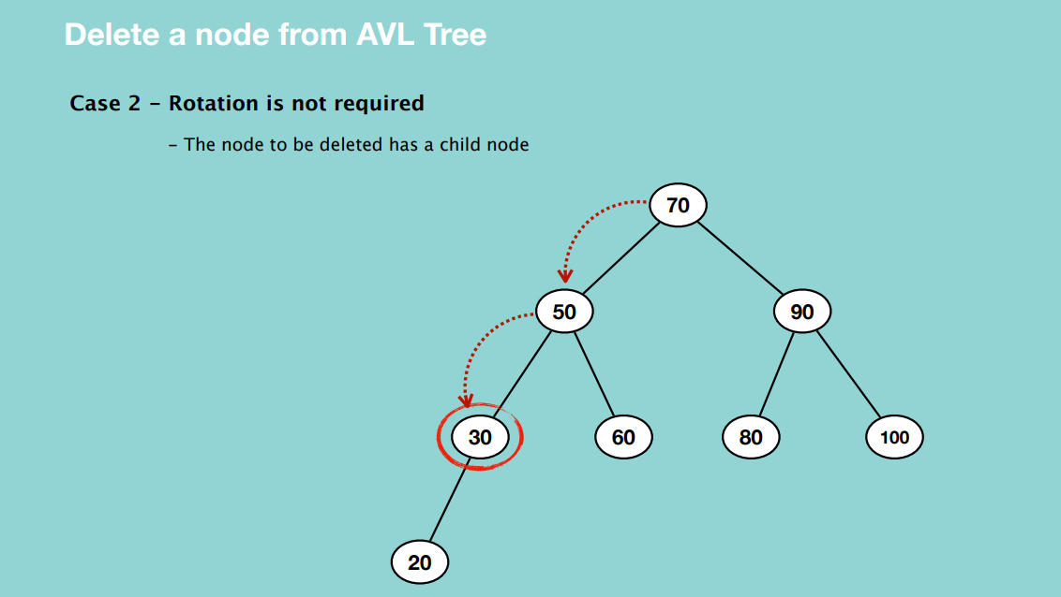

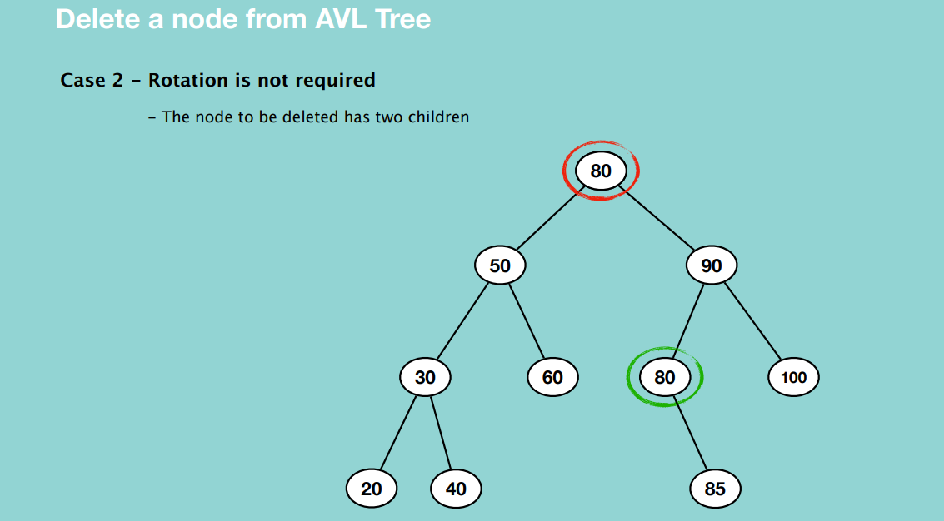

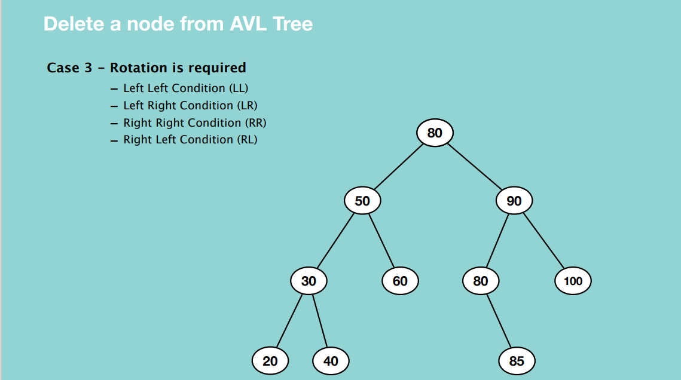

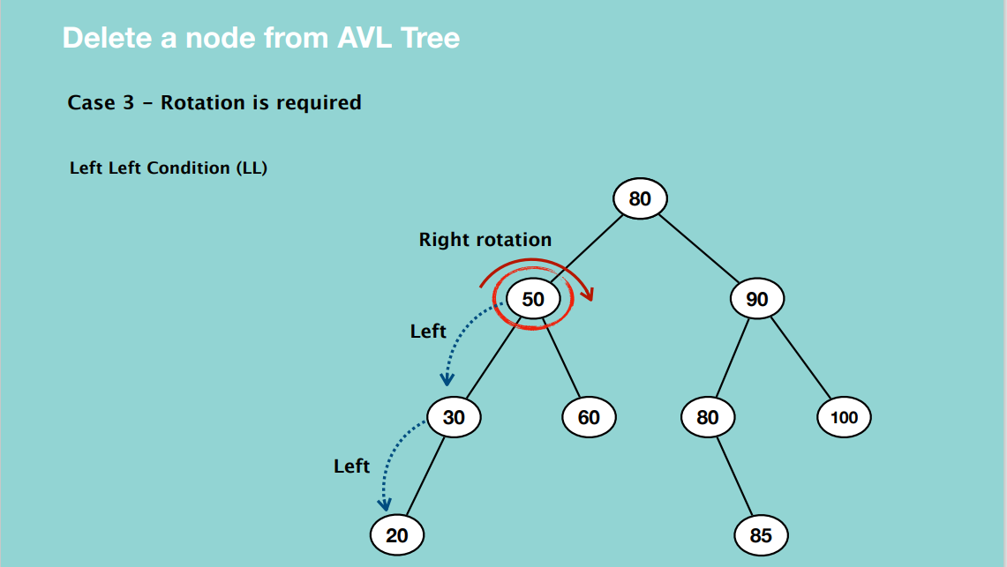

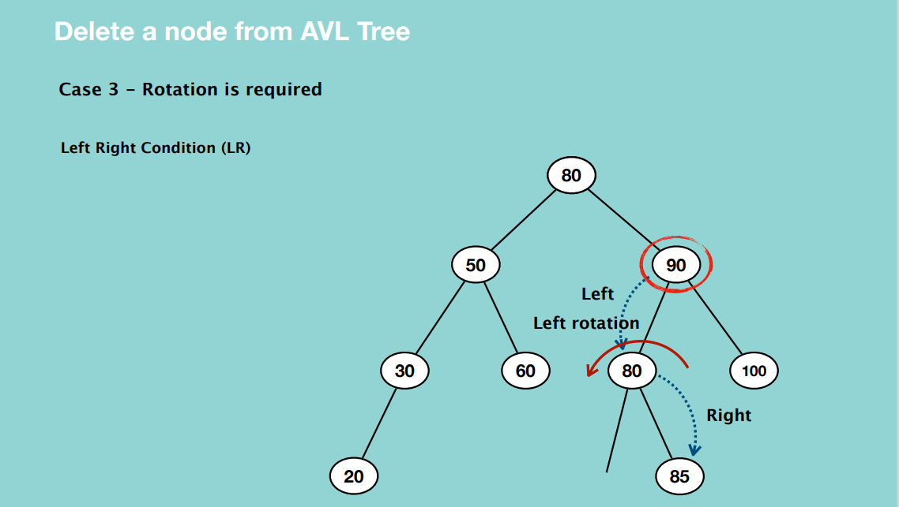

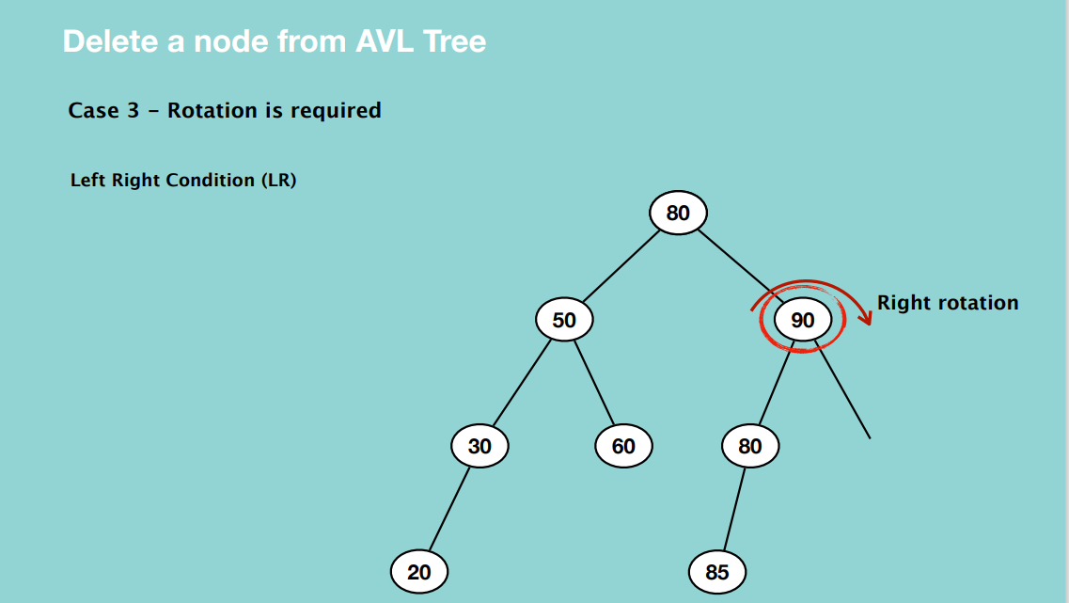

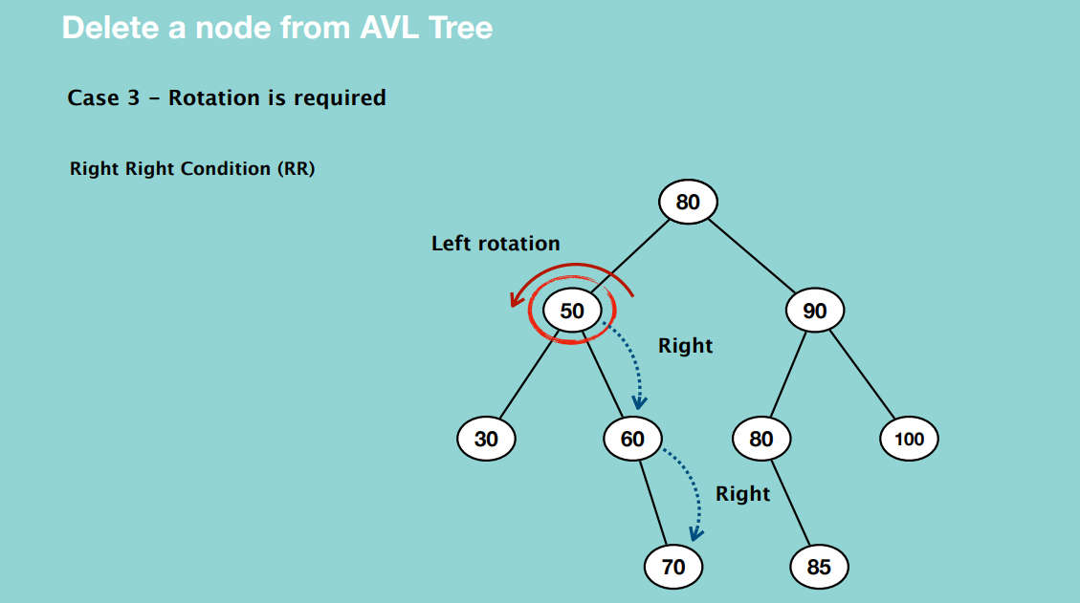

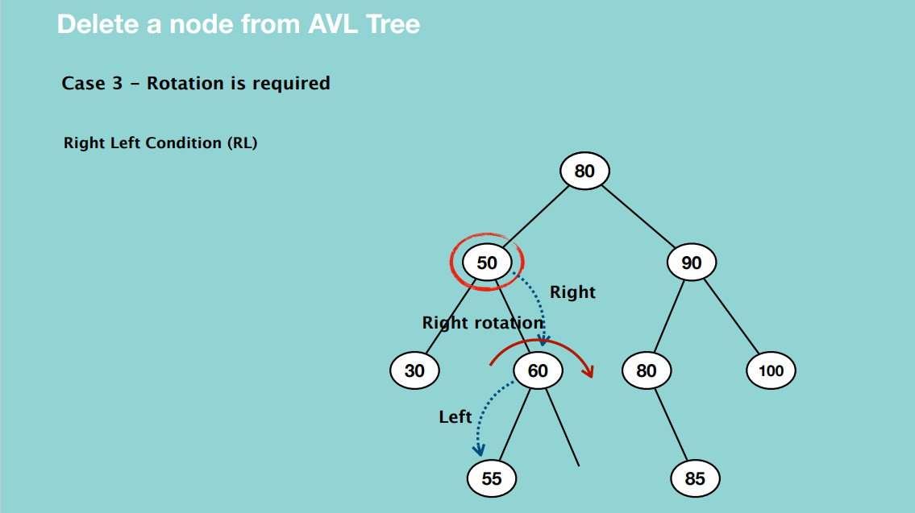

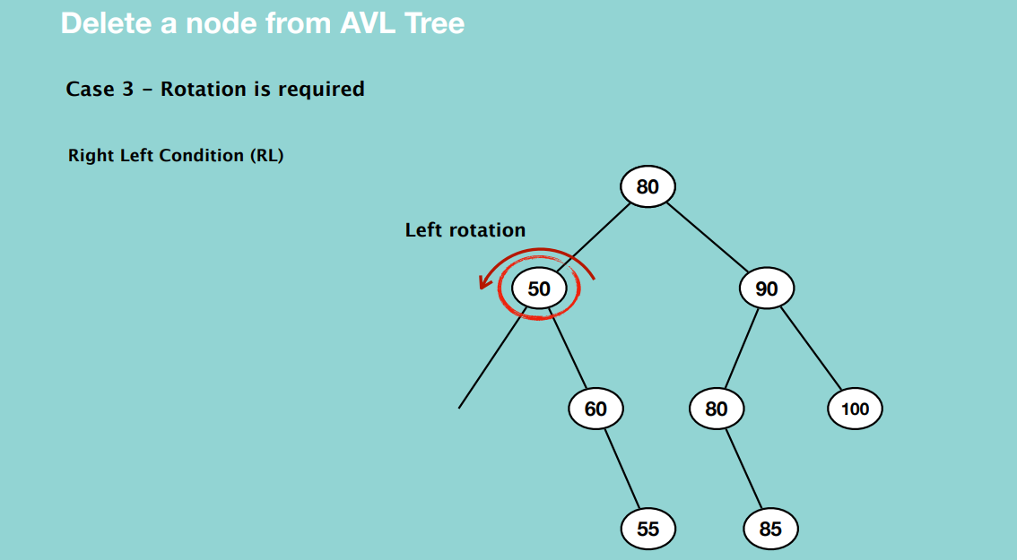

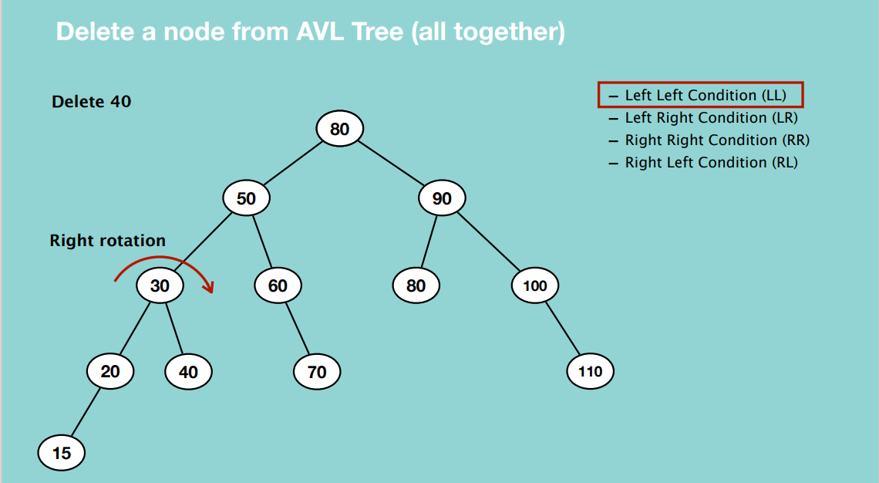

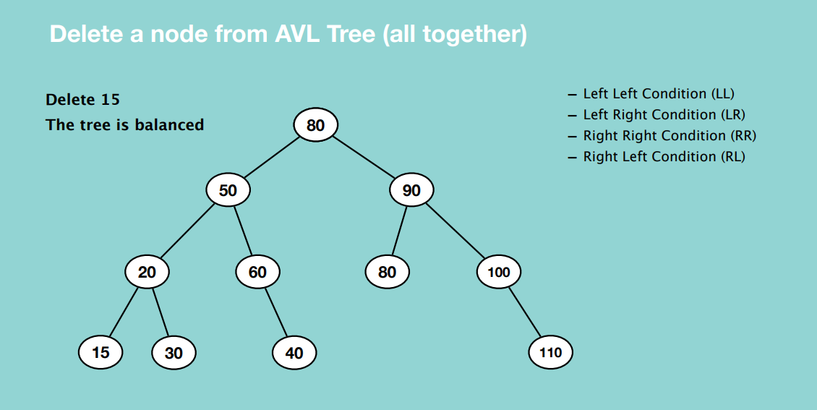

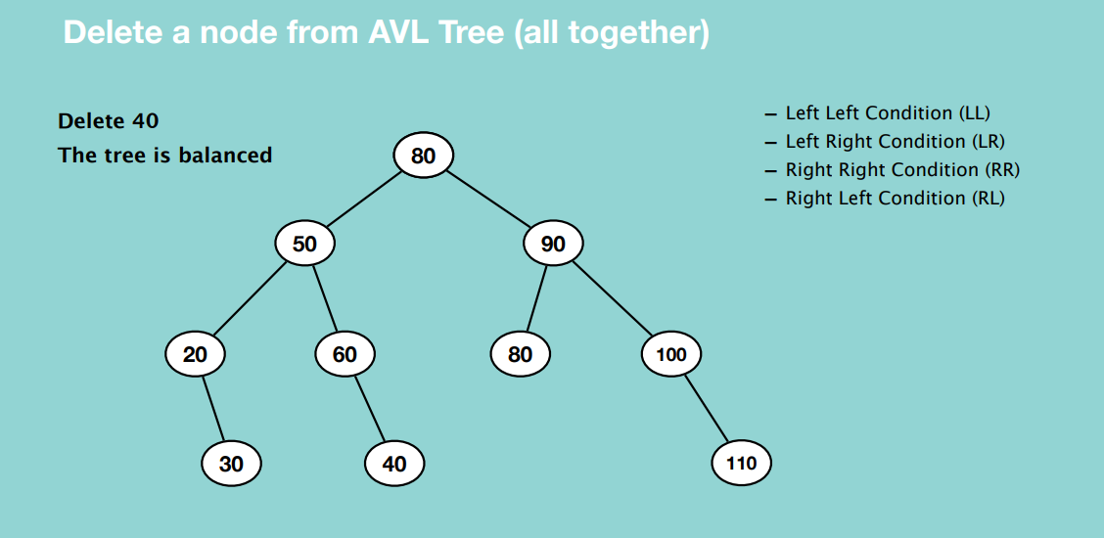

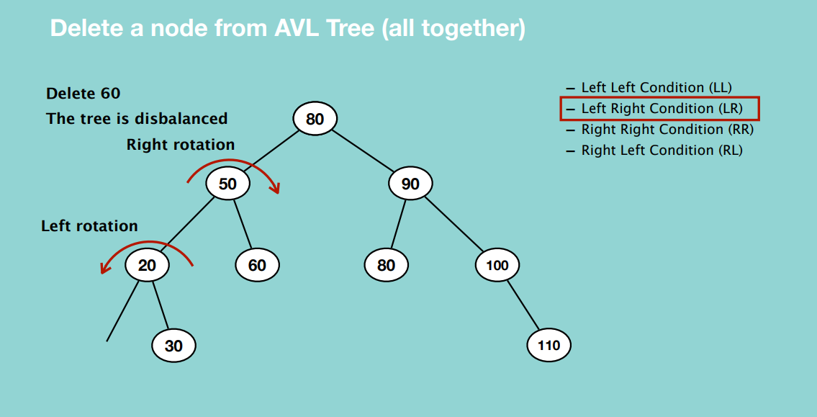 

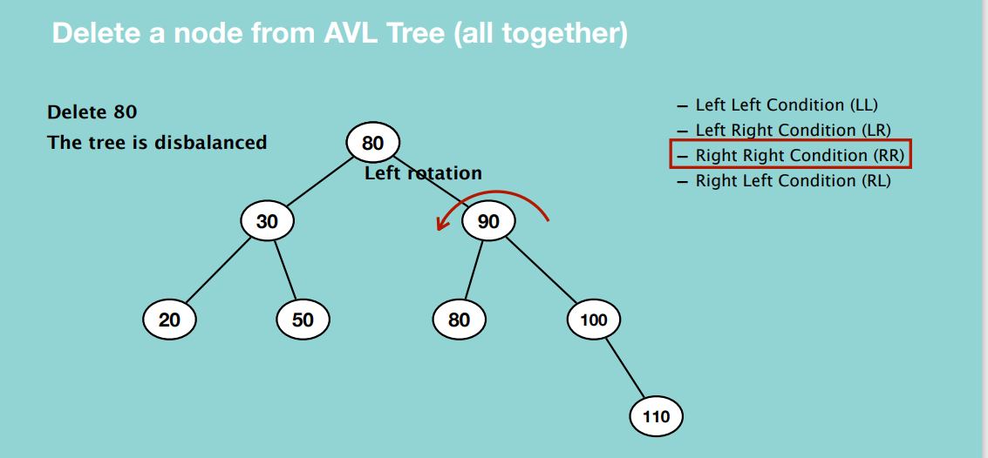

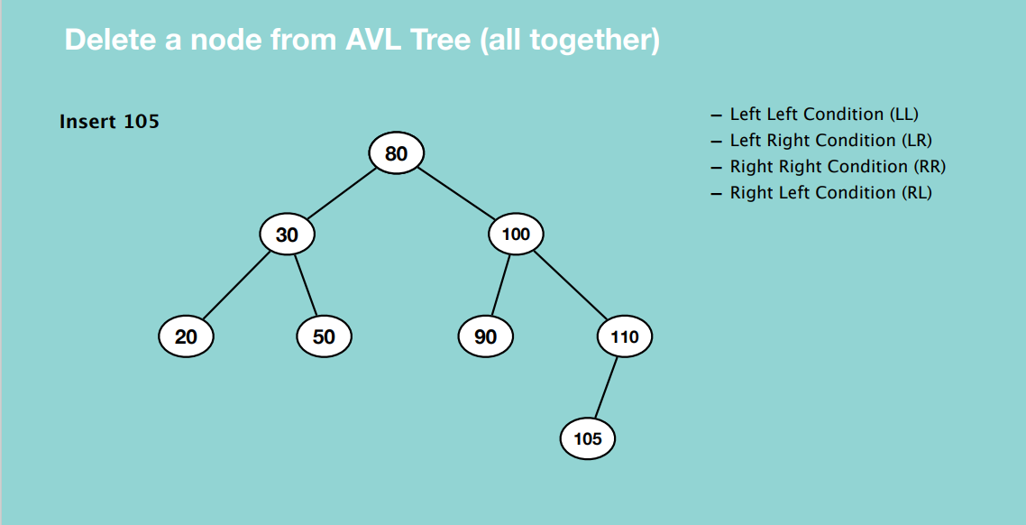

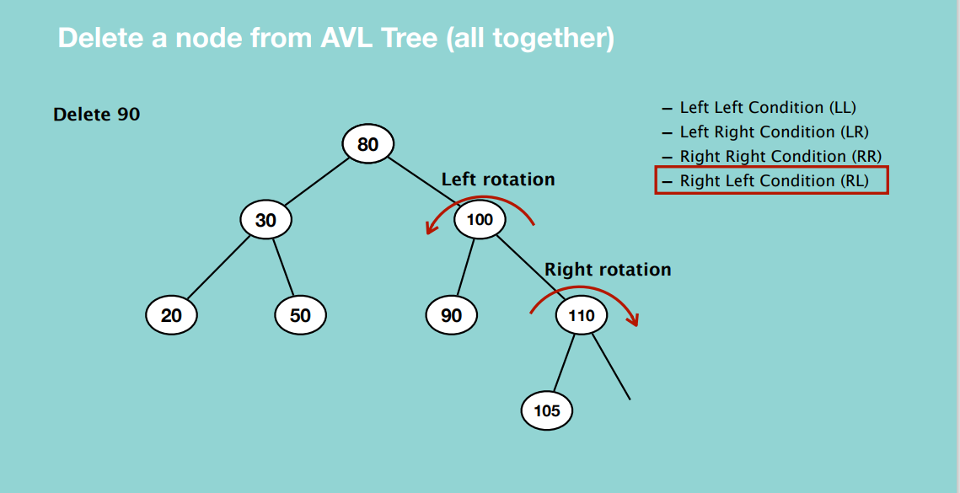

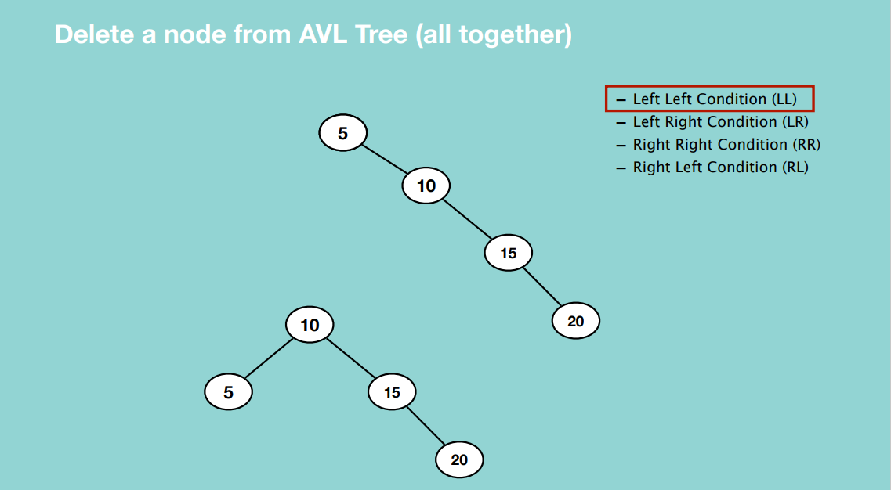

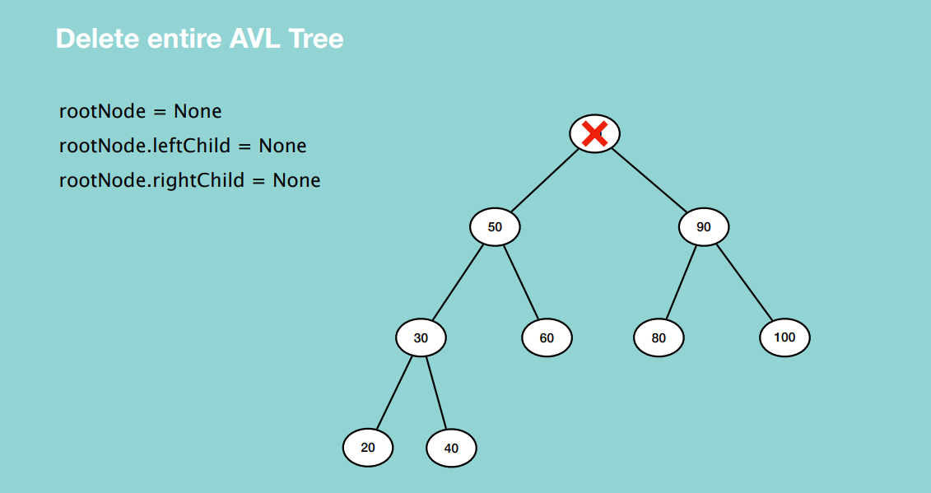

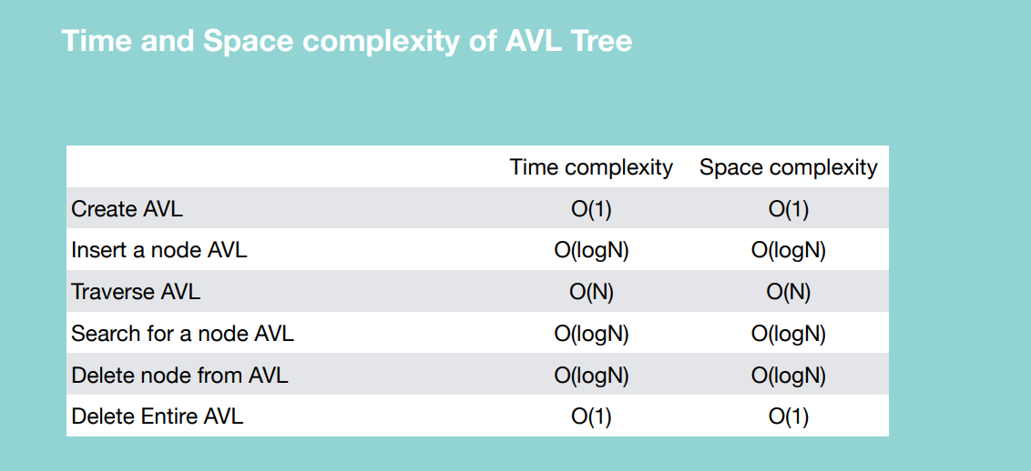

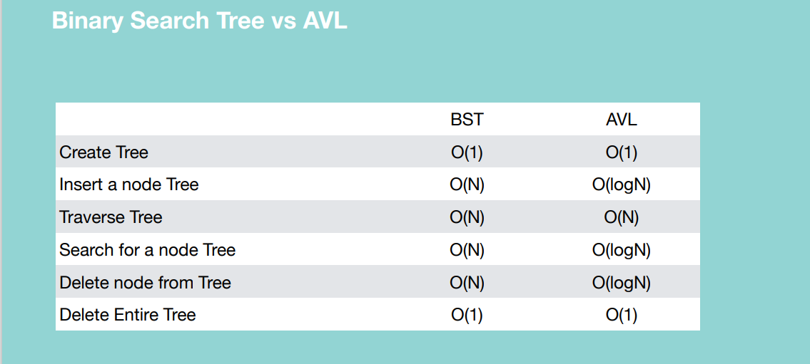

**BINARY HEAP**

A Binary Heap is a Binary Tree with following properties.

* A Binary Heap is either Min Heap or Max Heap. In a Min Binary Heap, the key at root must be minimum among all keys present in Binary Heap. The same property must be recursively true for all nodes in Binary Tree.
* It’s a complete tree (All levels are completely filled except possibly the last level and the last level has all keys as left as possible). This property of Binary Heap makes them suitable to be stored in an array.
* A value of any given node, must be less than or equal to its children for min heap OR a value of any given node, must be greater than or equal to its children for max heap.

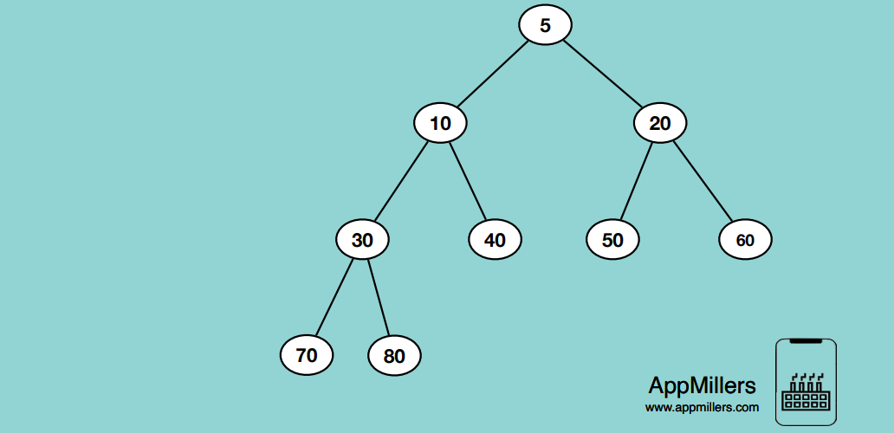

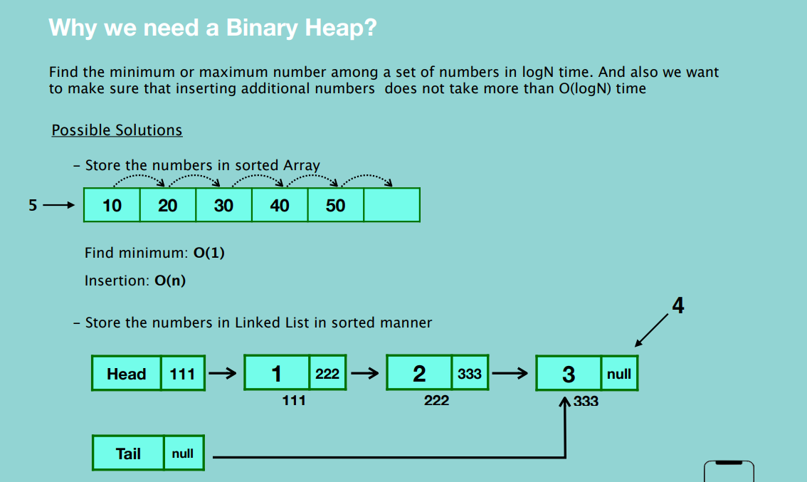

Practical Use

- Prim’s Algorithm

- Heap Sort

- Priority Queue

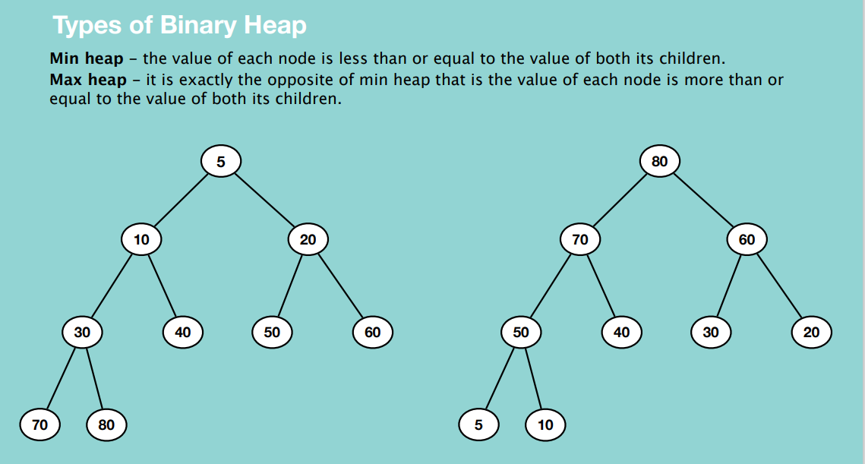

**INSERTION**

This involves first inserting the new node as the last node, then continuously swapping it with its parent elements until its less than both its child nodes.

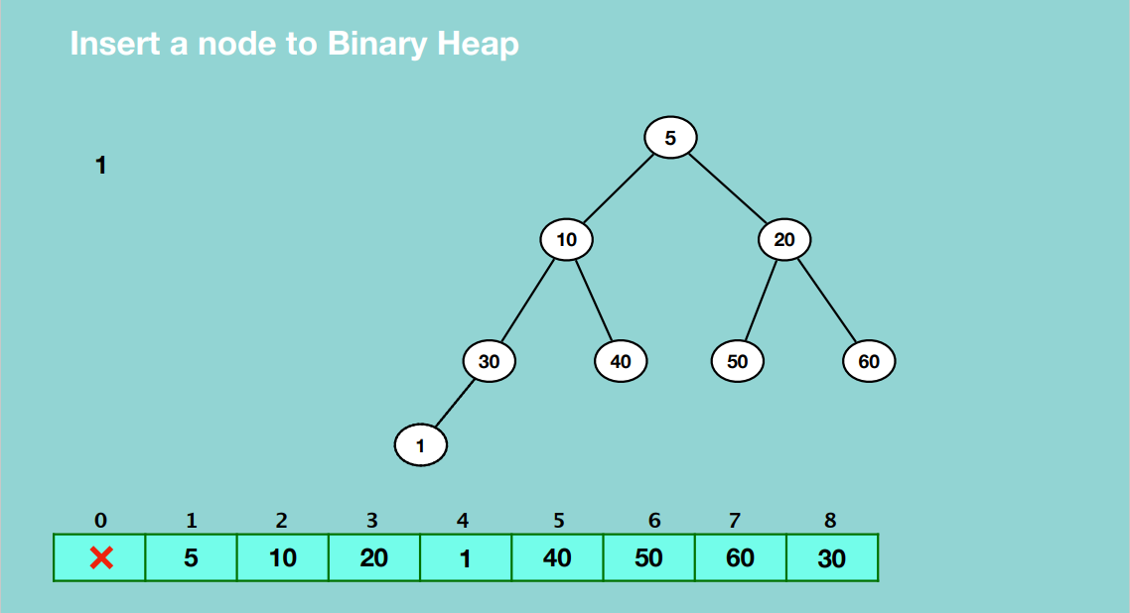

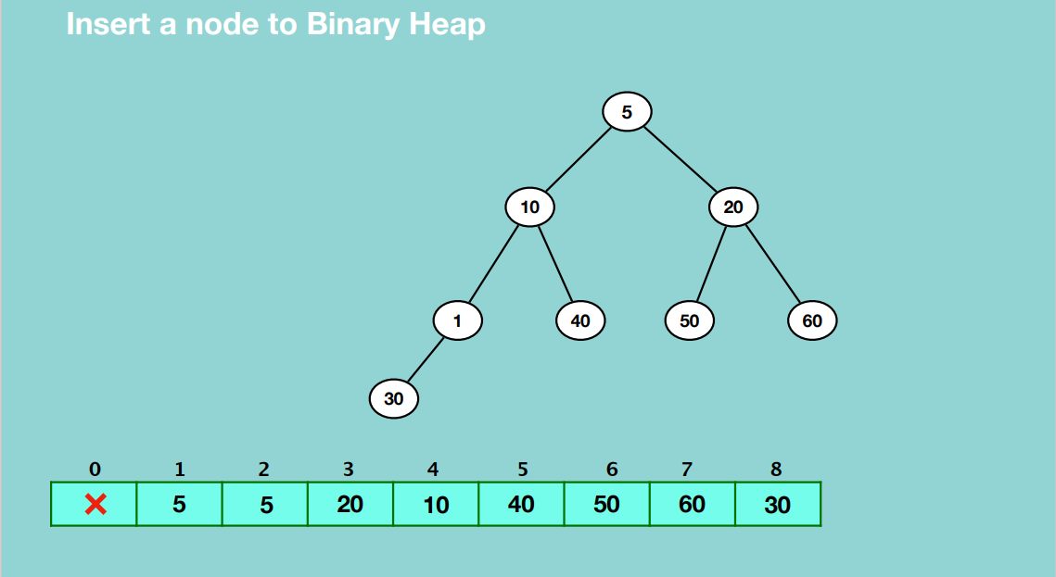

**EXTRACTING**

This involves extracting the root node of the tree. It involves first replacing the root node with the deepest node in the tree such that the entire tree is not deleted. Then continuously compare the new root node with its corresponding children elements and continuously replace it with the one that’s smaller until it finds its right position in the tree.

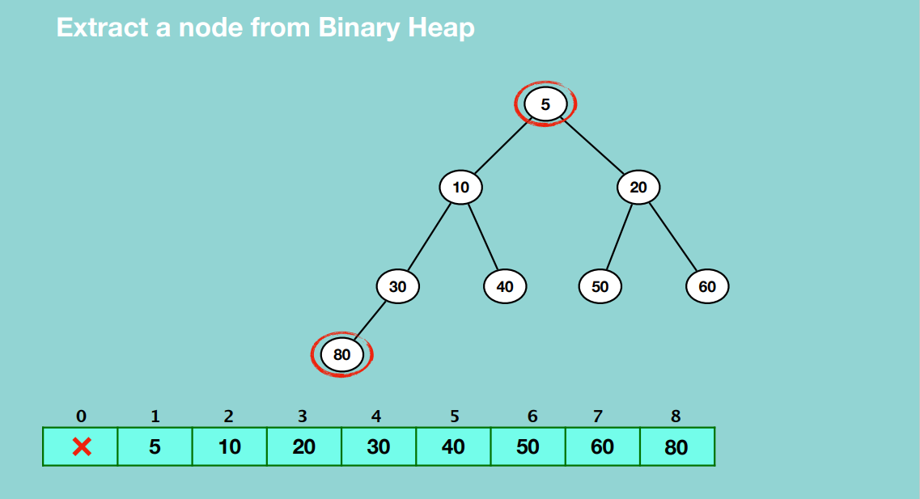

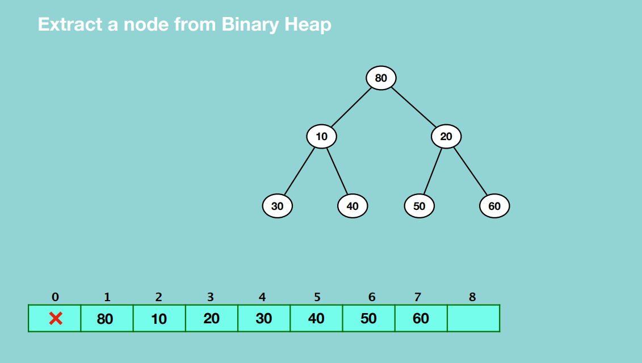

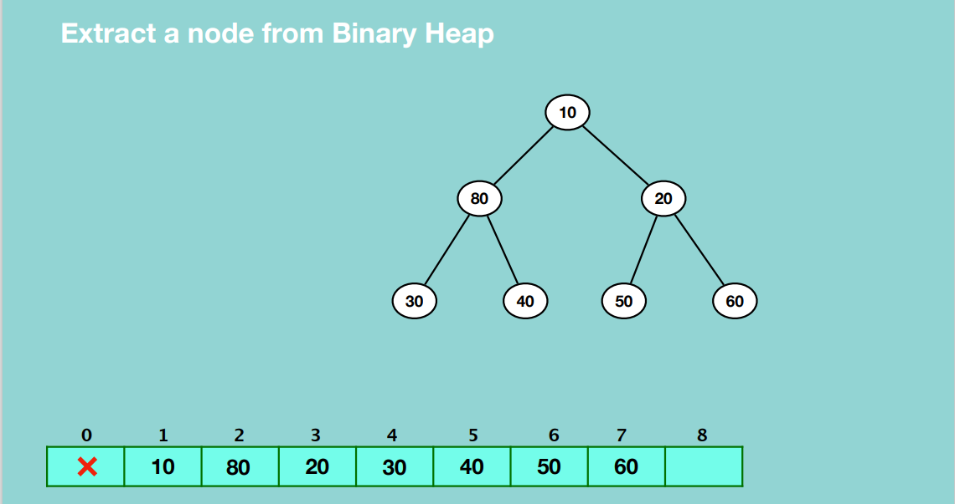

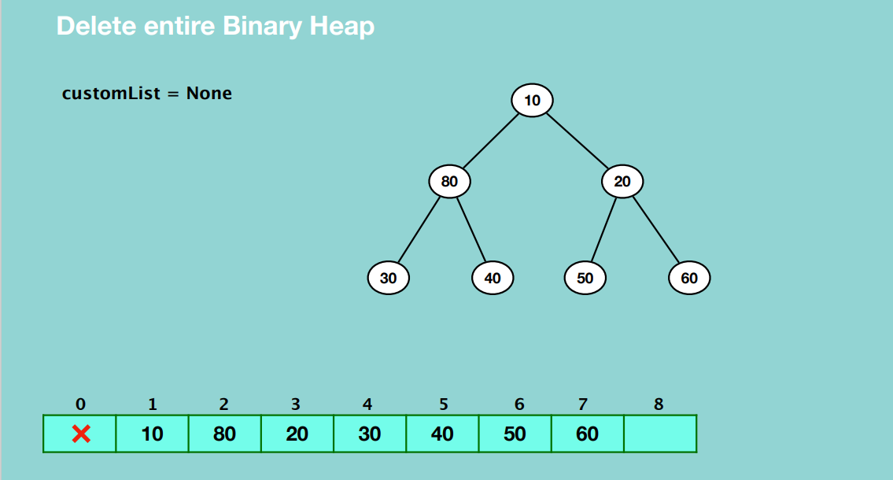

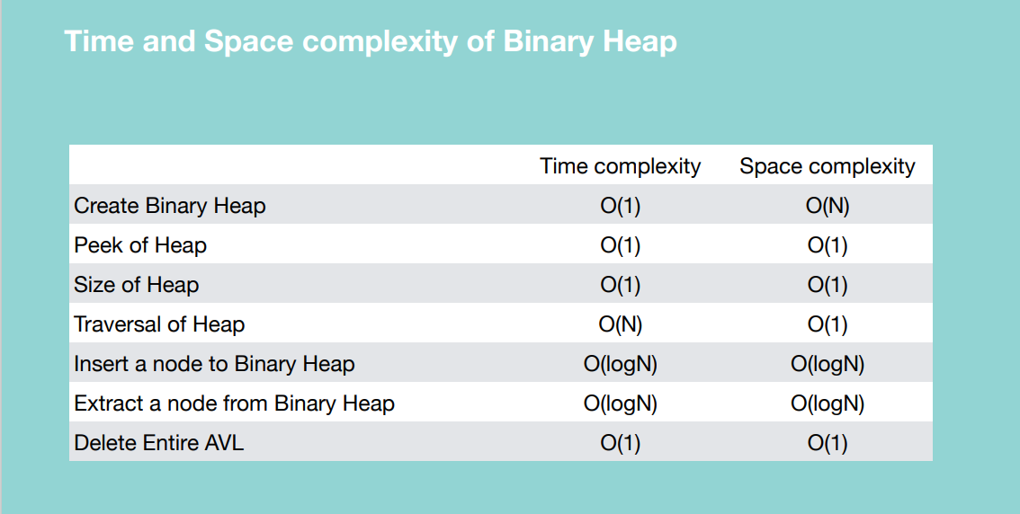

**TRIE**

A Trie is a tree-based data structure that organizes information in a hierarchy.

Properties:

* It is typically used to store or search strings in a space and time efficient way.
* Any node in trie can store non-repetitive multiple characters
* Every node stores link of the next character of the string
* Every node keeps track of ‘end of string’

AIR, AIT, BAR, BIL, BM

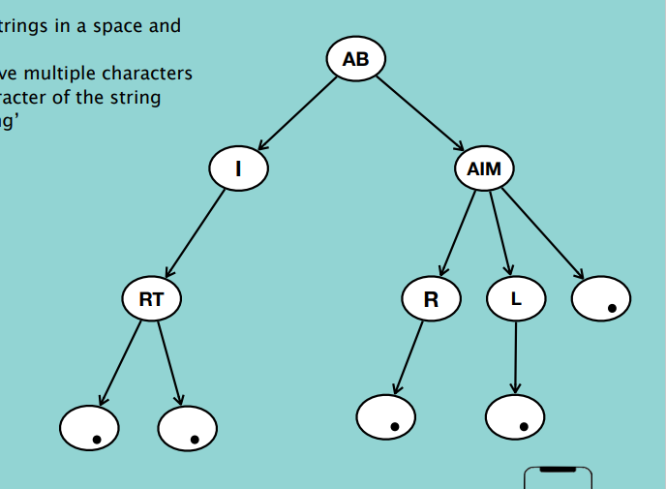

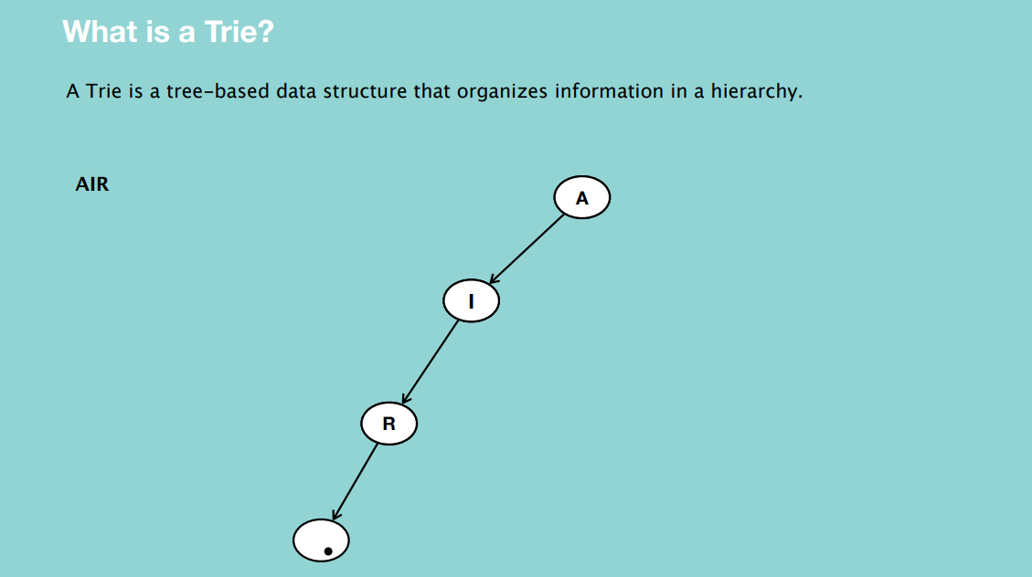

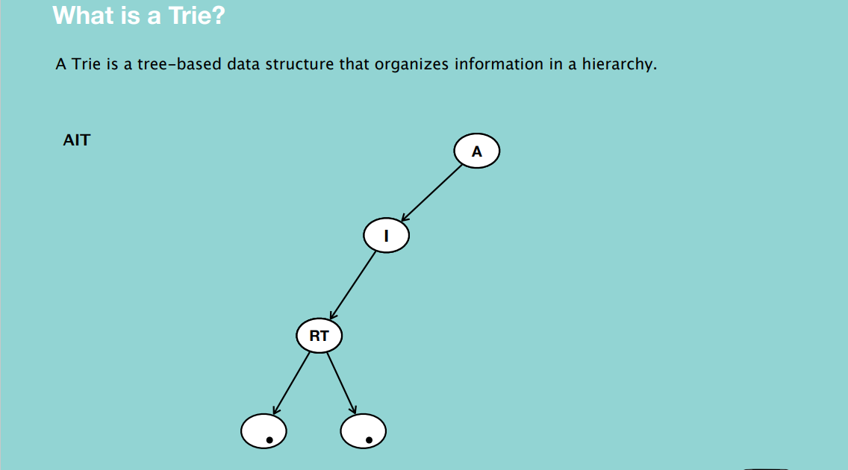

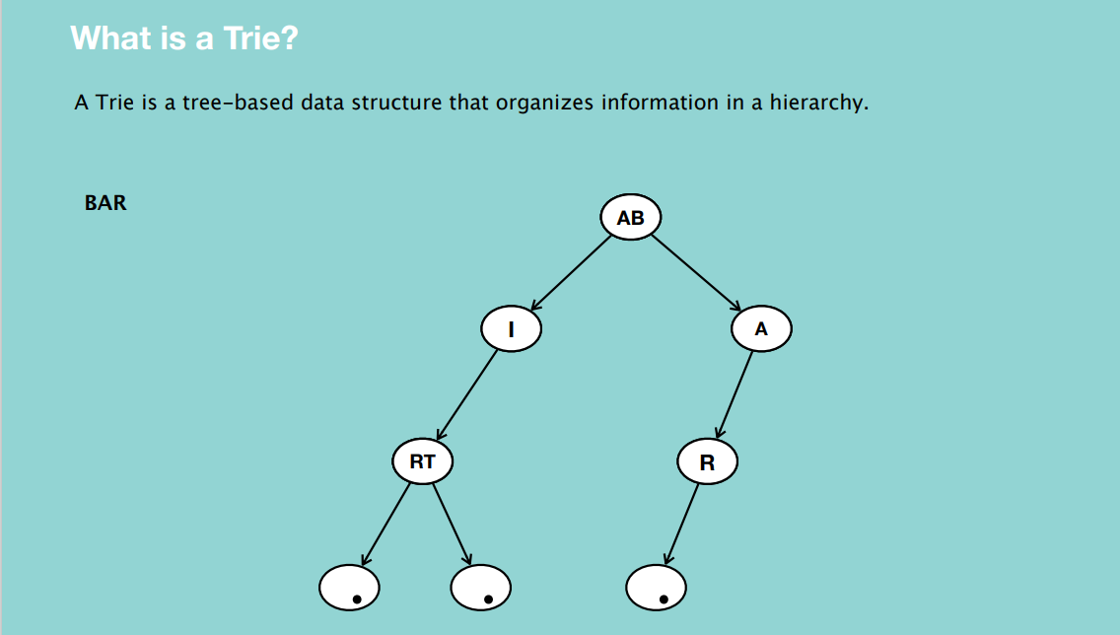

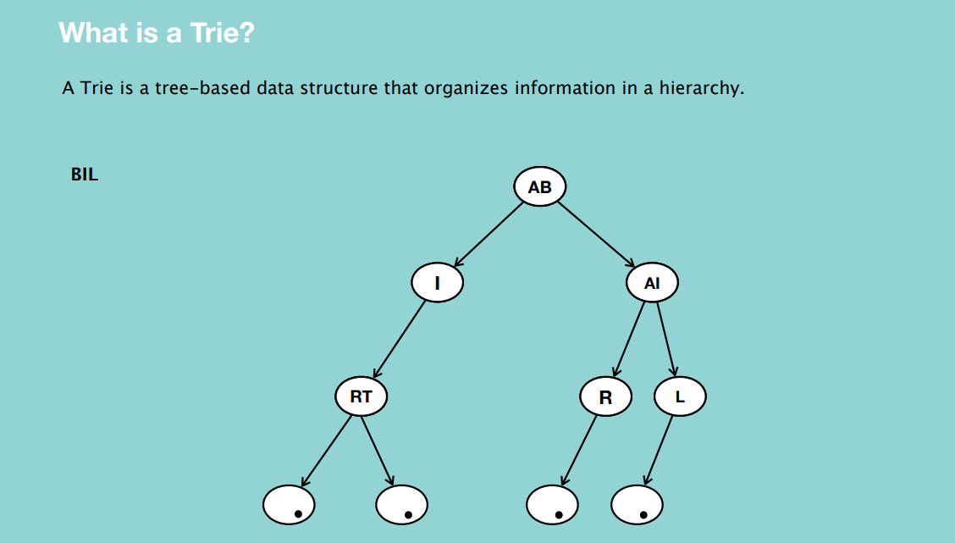

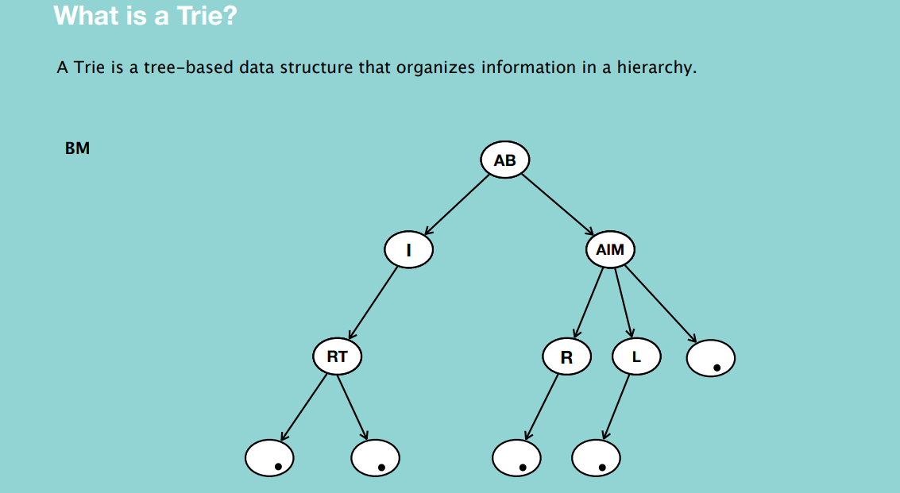

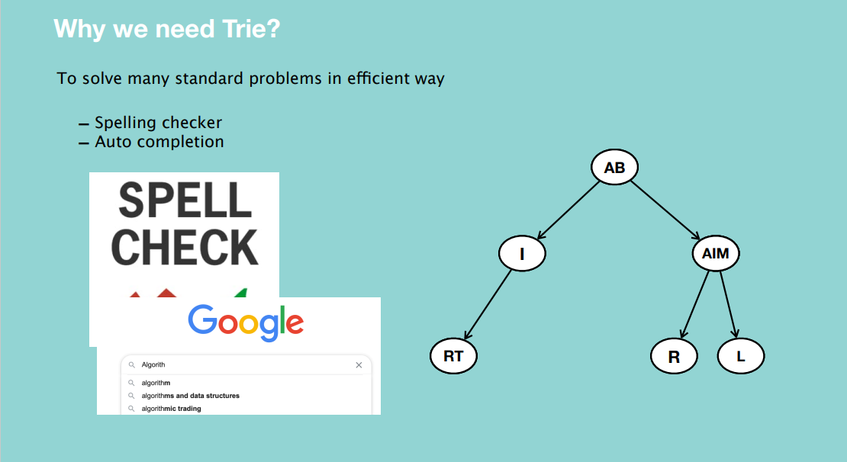

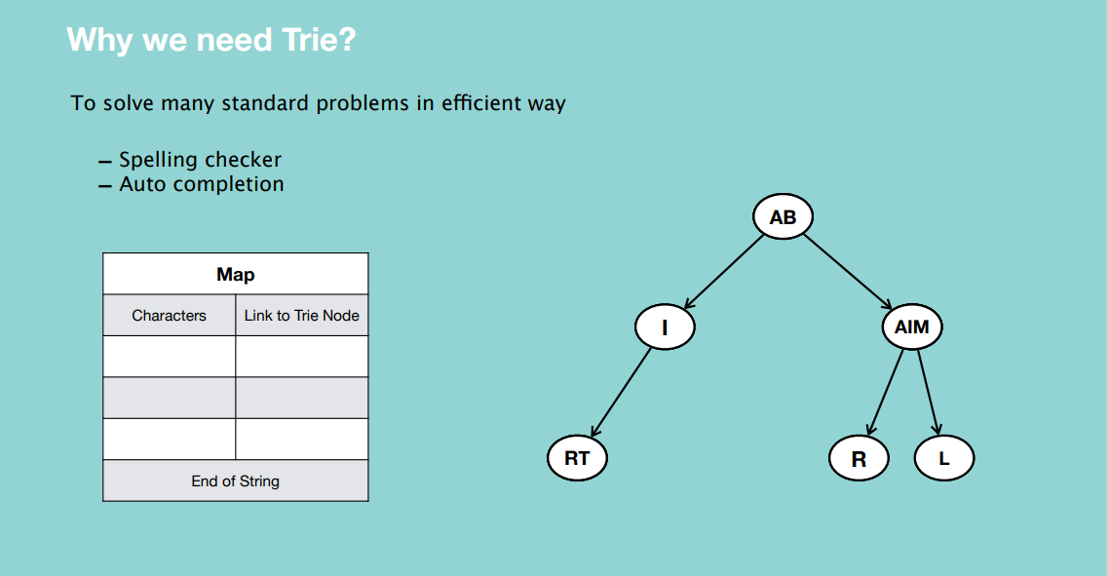

**INSERTION**

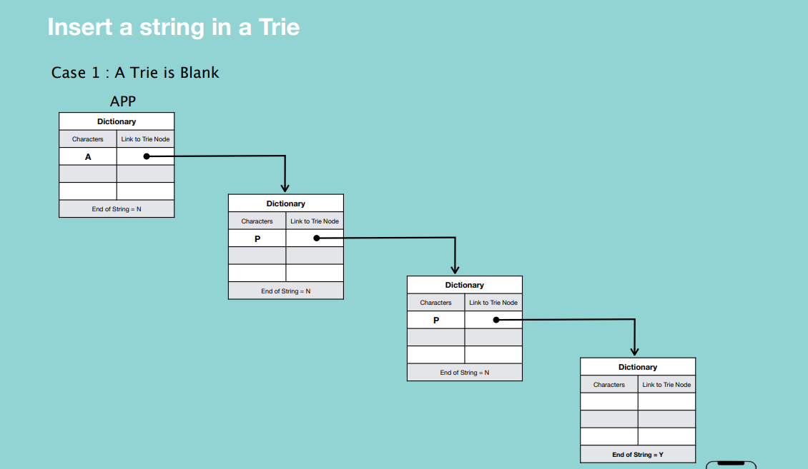

* Create nodes and assign characters to the nodes with links to the next nodes.
* If the node is a blank node meaning the end of the string, set “End of String” to Yes.

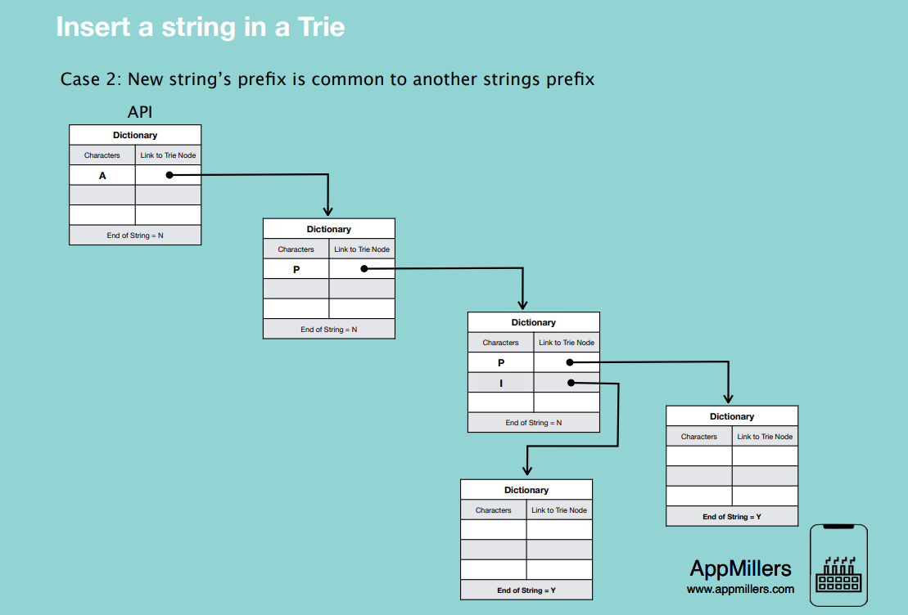

* We will not create A and P again, in the third node we will insert new data i.e. I with a link to the next node which is a blank node indicating the end of the string.

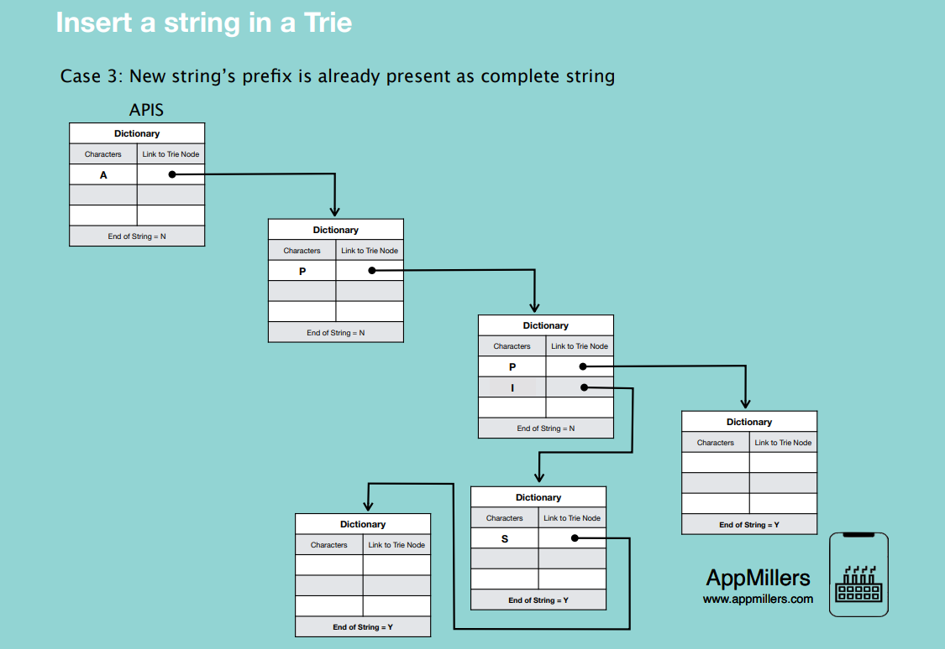

* Set the blank node’s character to S, create a new blank to and link S to it, then set the blank node’s end of string to yes.

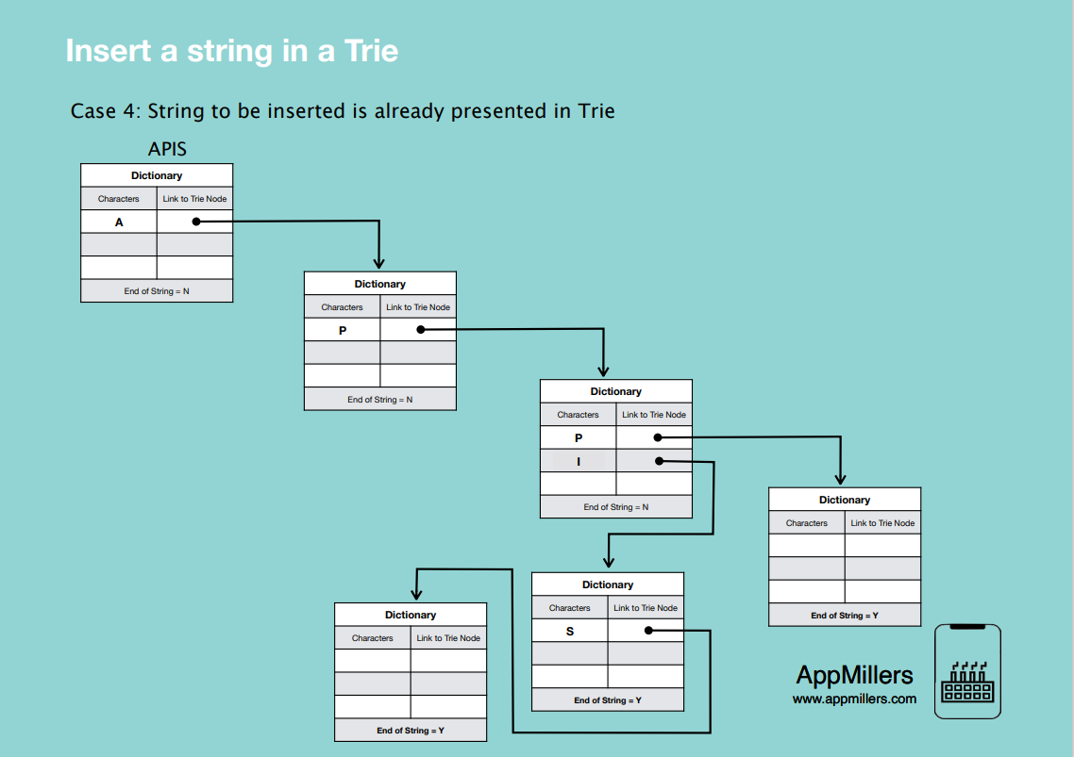

* Here we don’t insert any node into the Trie.

**SEARCHING**

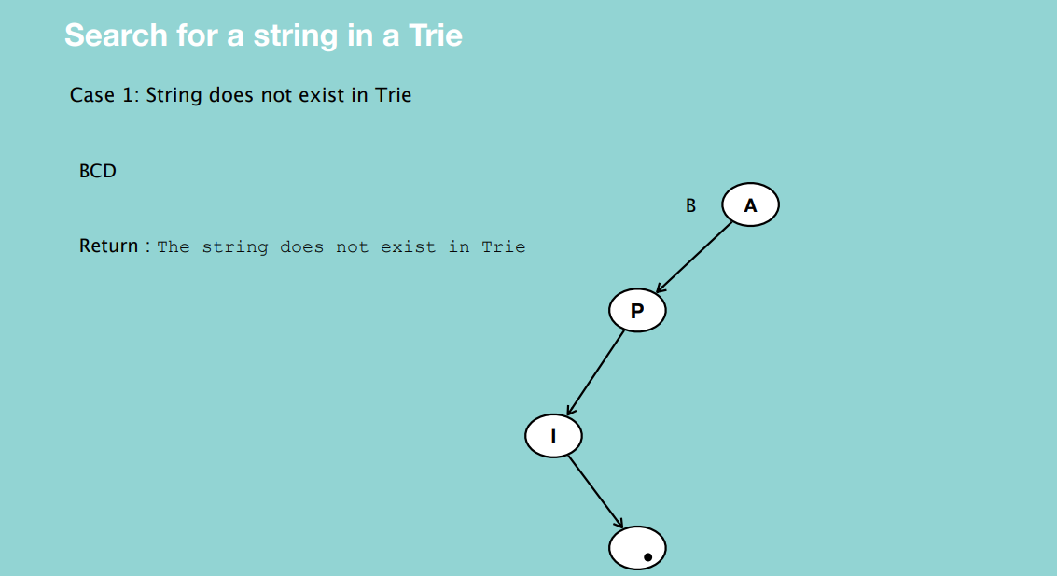

* If first character does not exist in root node, string does not exist in the Trie.

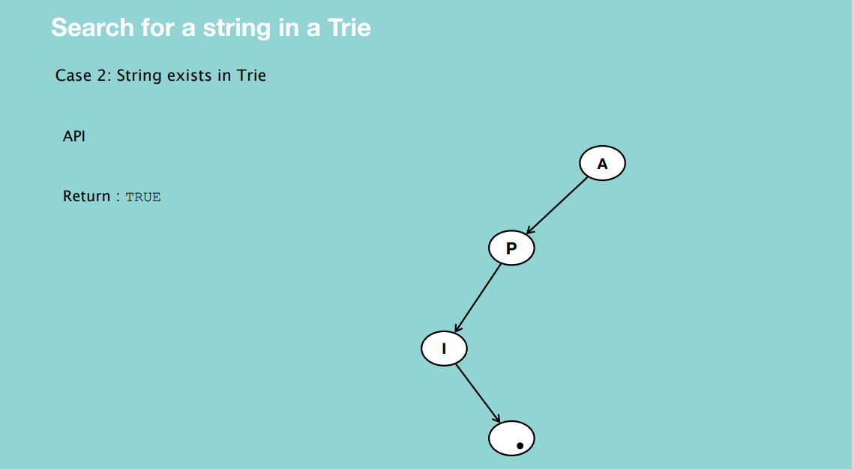

* Traverse through the entire Trie and check that all characters exist in the Trie and the confirmation is that the last node must show the end of the string.

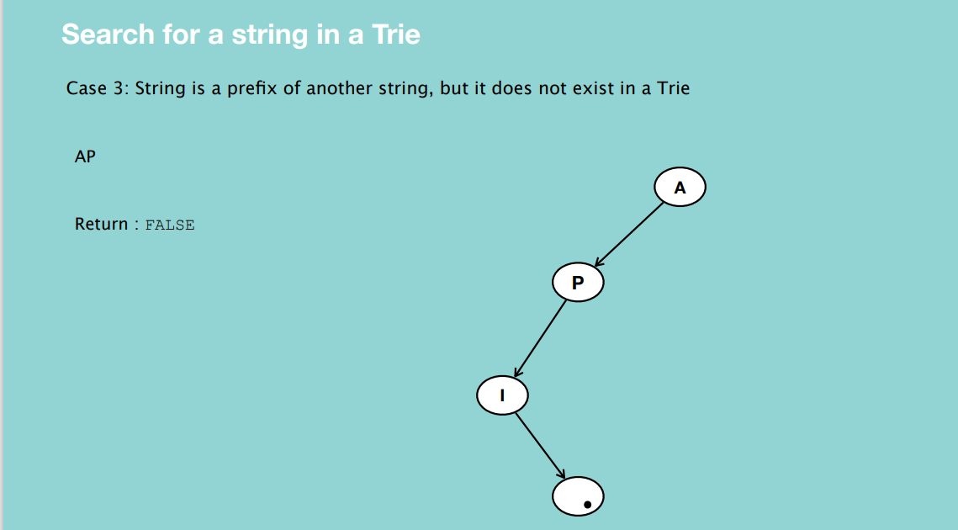

* AP doesn’t exist in the Trie because the node after finding the strings AP shows   
  “End of String” as false.

**DELETION**

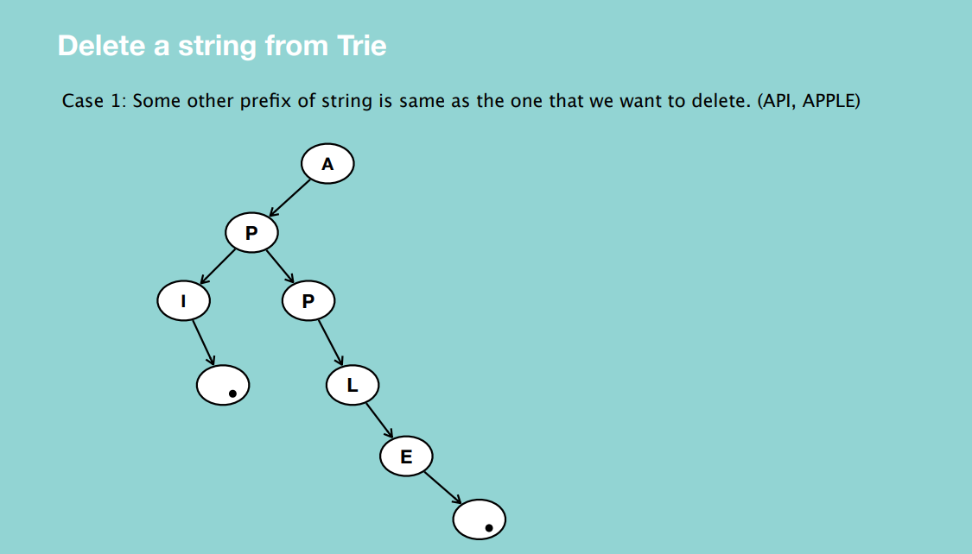

* Deletion of any string from Trie always happens from the leaf node.
* First check if the string is in the Trie then start from the leaf node going upwards checking if the corresponding string is part of the one you’re trying to delete.
* Note that you should make sure that the nodes you delete don’t impact on other nodes in the Trie.

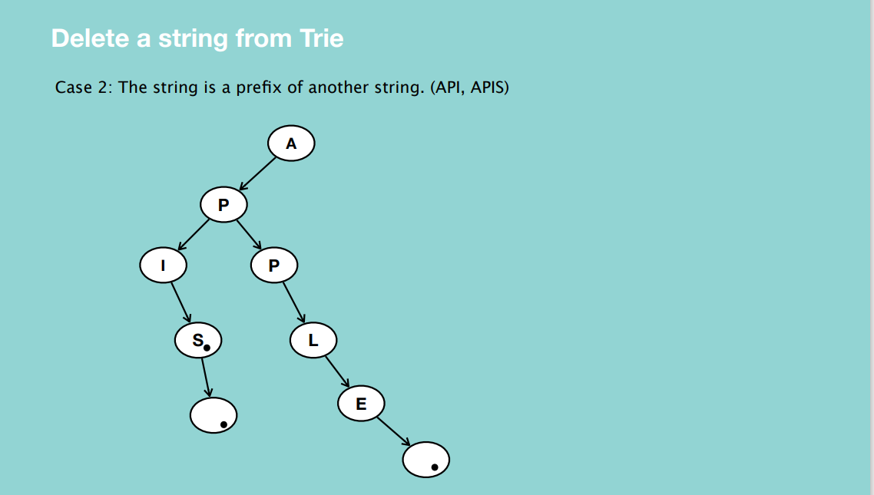

Here you begin from the root node, and when you reach the end of string, update it to False hence API will not be recognized in this Trie.

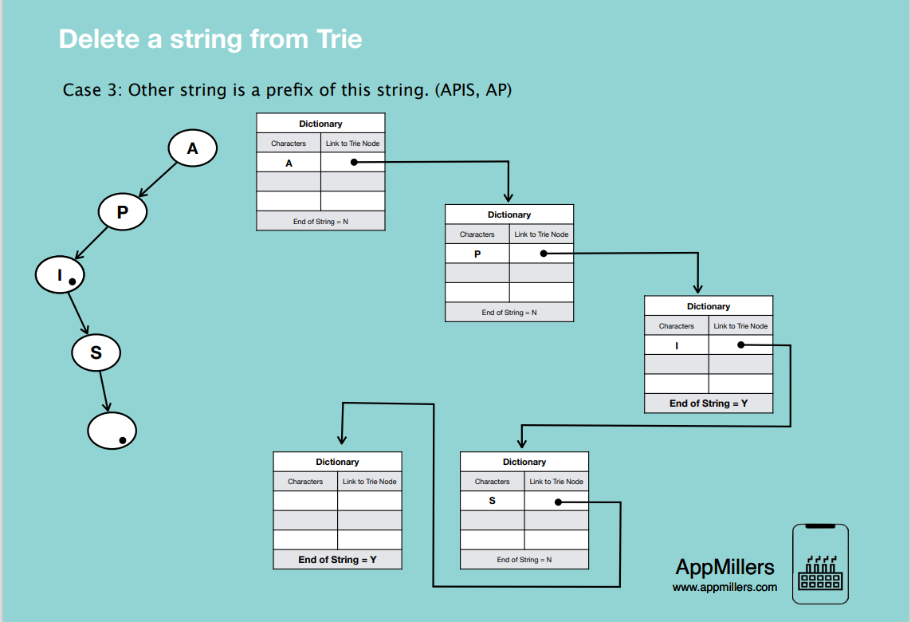

First check if APIS exists, then start from the end of the string deleting upwards. Make sure the nodes you delete don’t impact other nodes. When you reach I and its end of string is set to Yes, you’ll delete I alone still leaving the end of string as Yes.

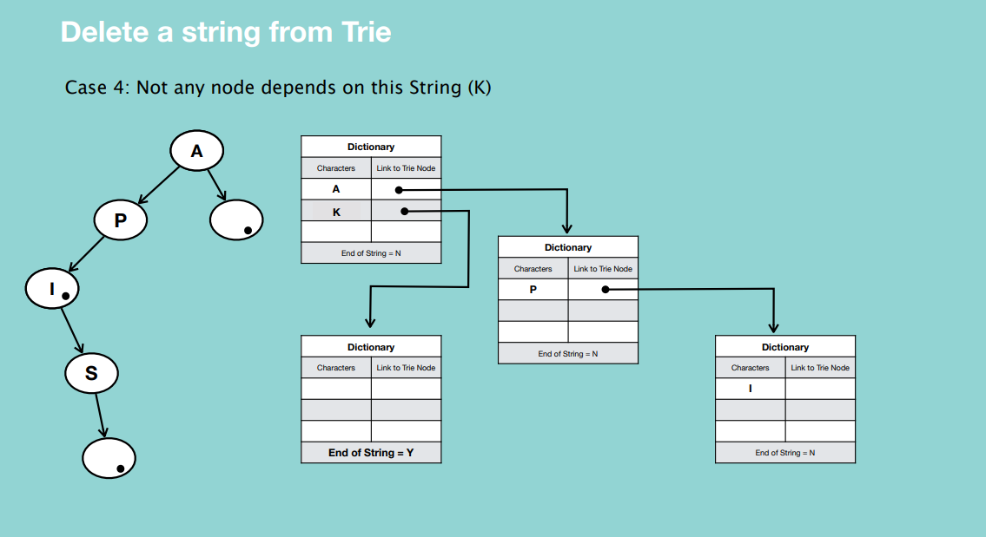

* First check if there are any other nodes dependent on K. Then start from the leaf node of K which is the property of end of string set to Yes. Then in the node where K is contained just delete the K.

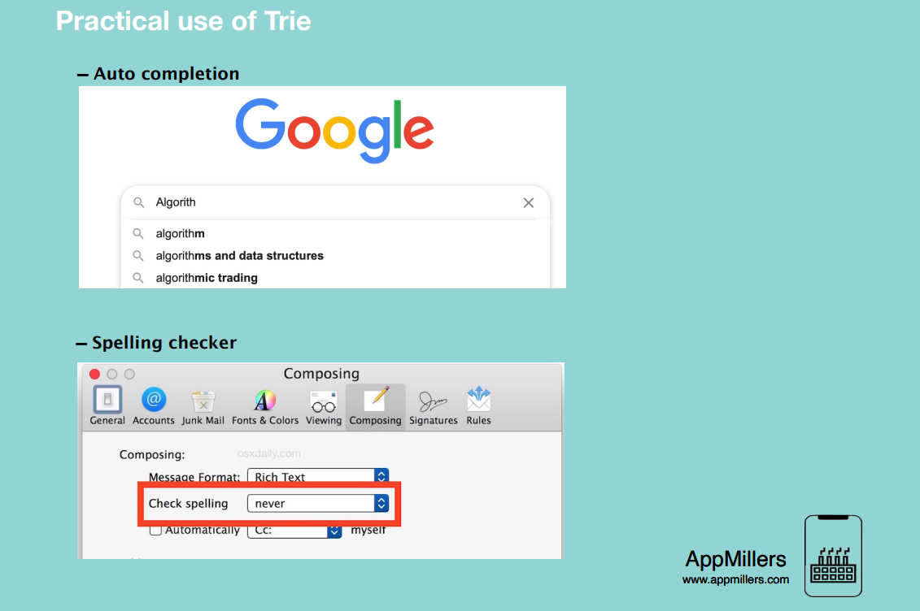

**HASHING**

What is Hashing?

Hashing is a method of sorting and indexing data. The idea behind hashing is to allow large amounts of data to be indexed using keys commonly created by formulas

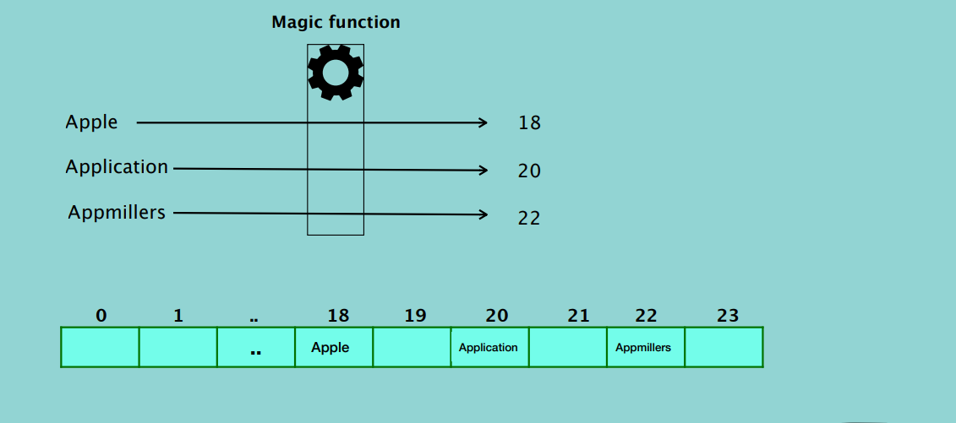

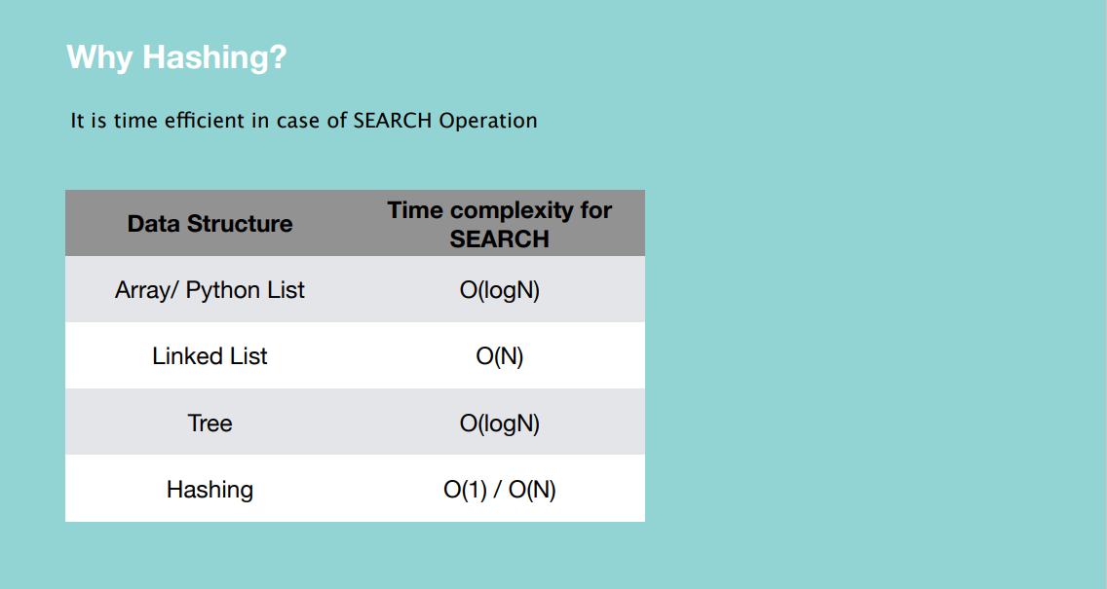

Hashing works better than any other data structures in terms of searching.

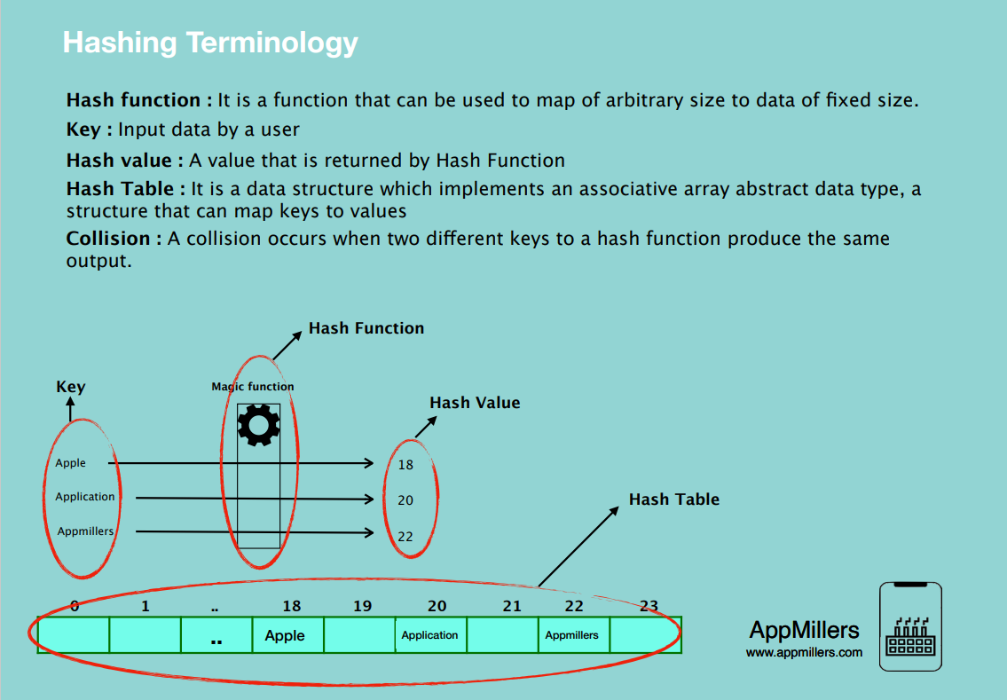

* Hash function is a function that can be used to map data of arbitrary size to data of a fixed size.

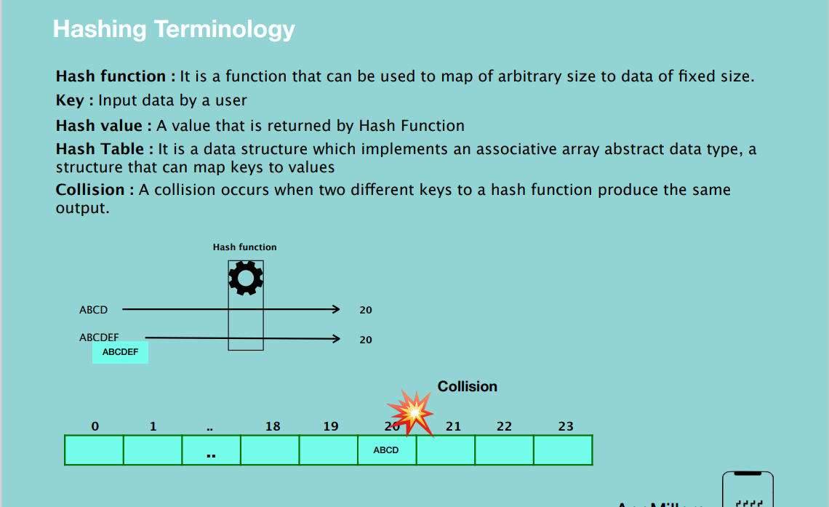

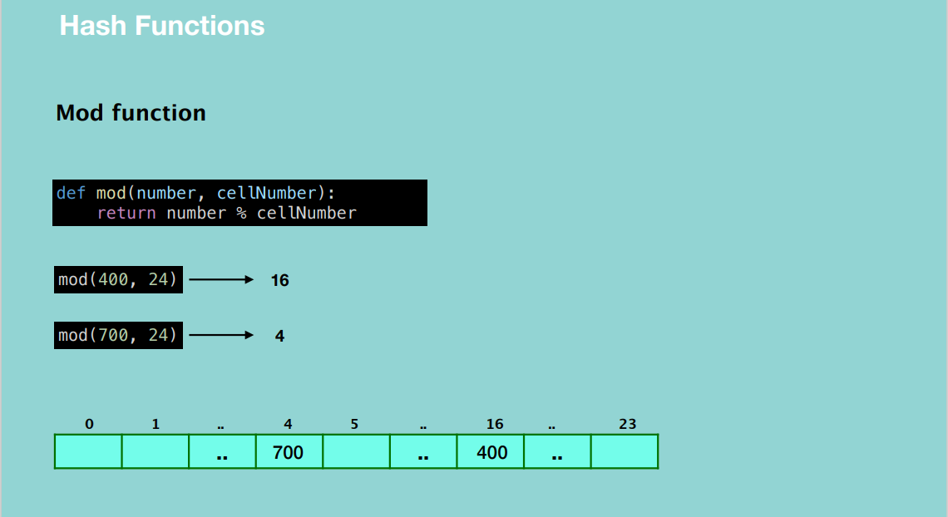

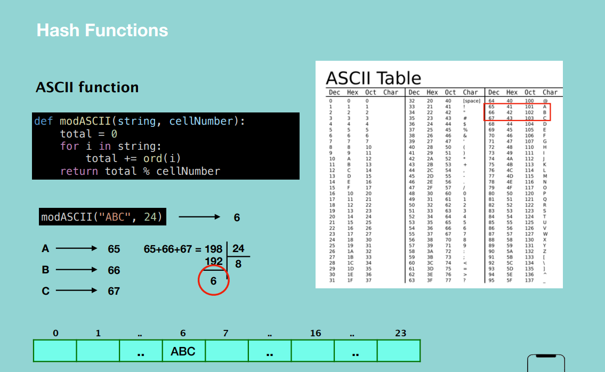

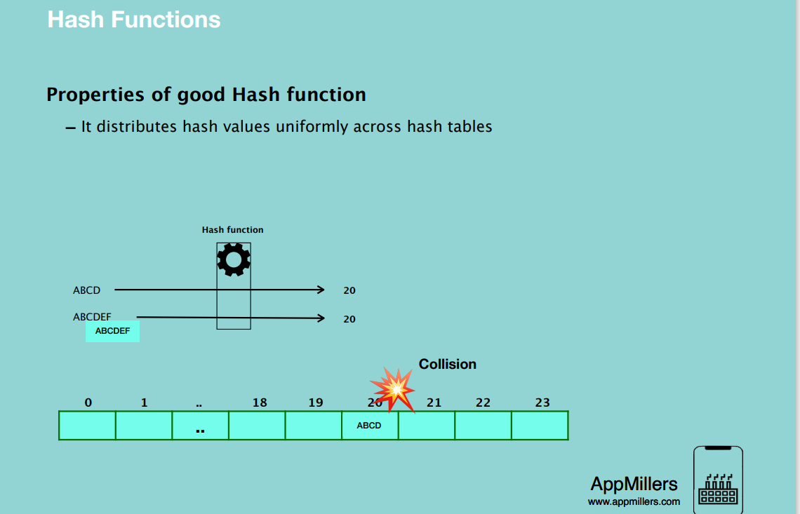

Basically, a good hash function minimizes collisions.

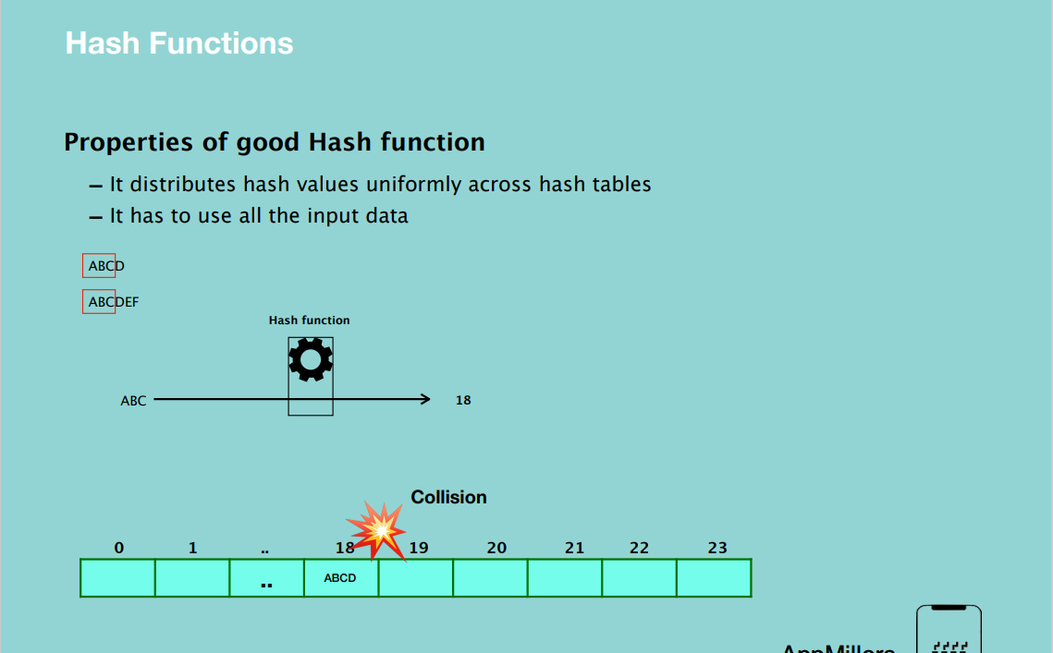

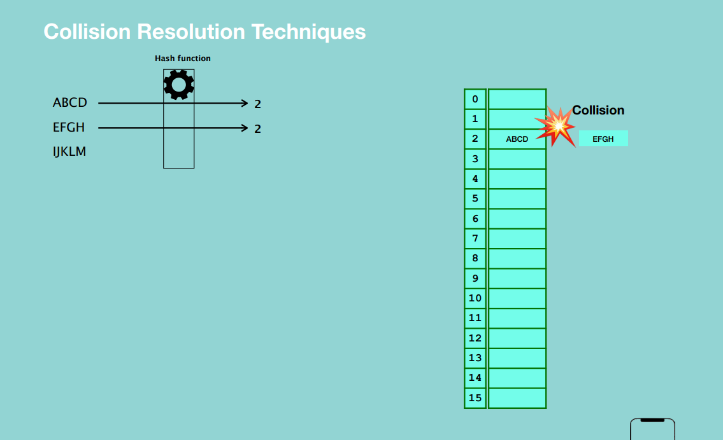

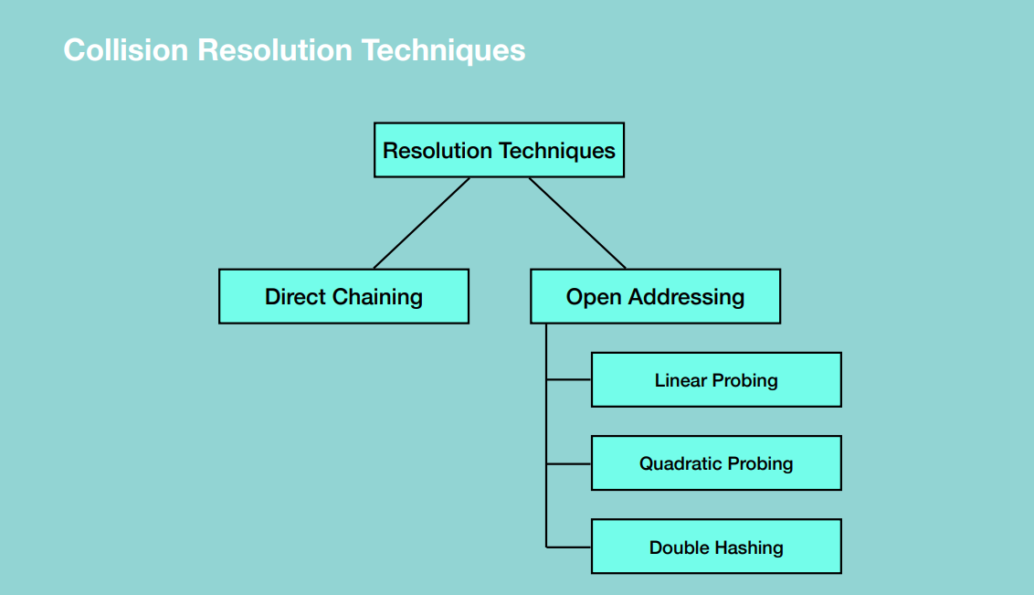

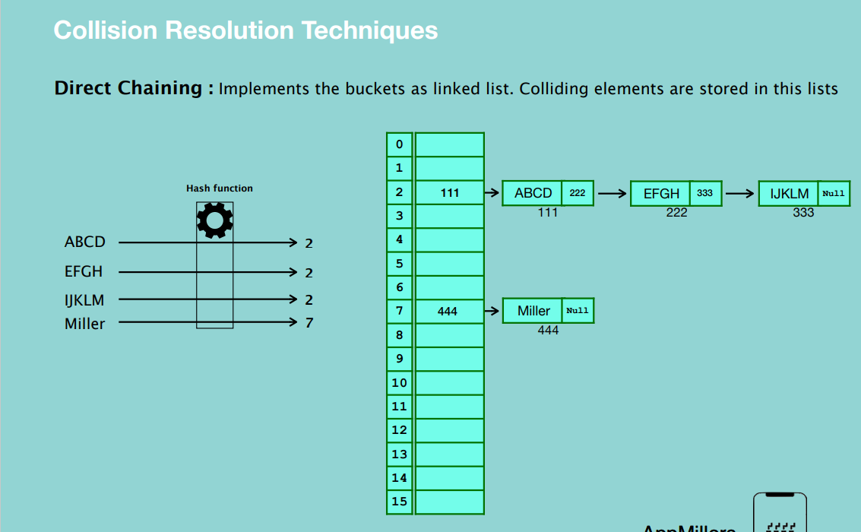

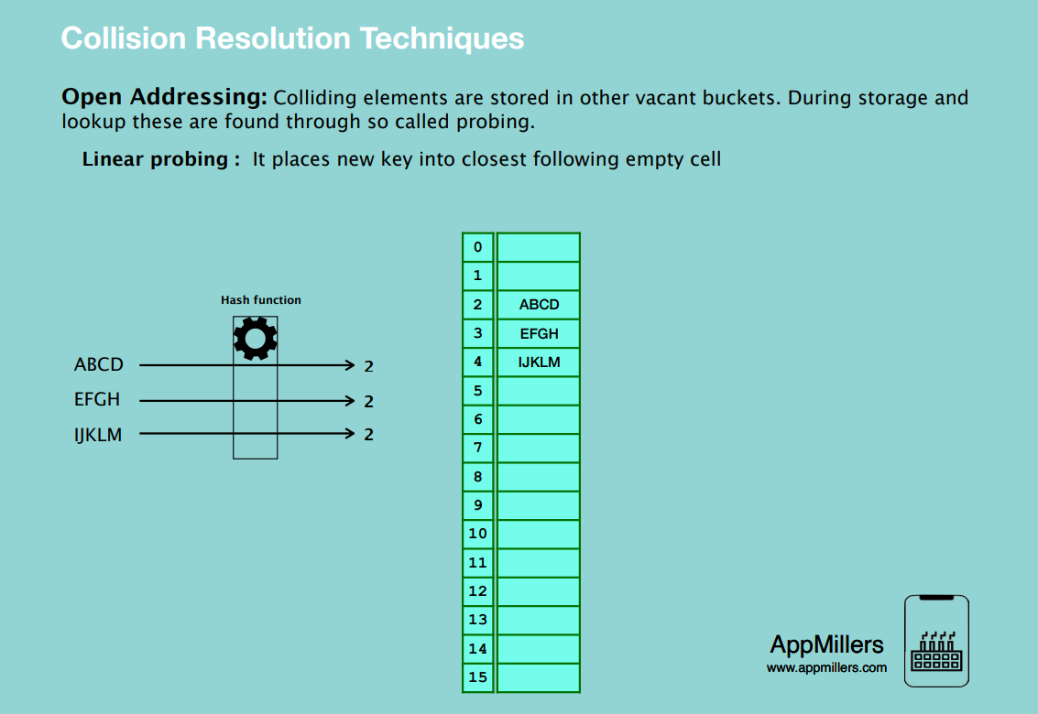

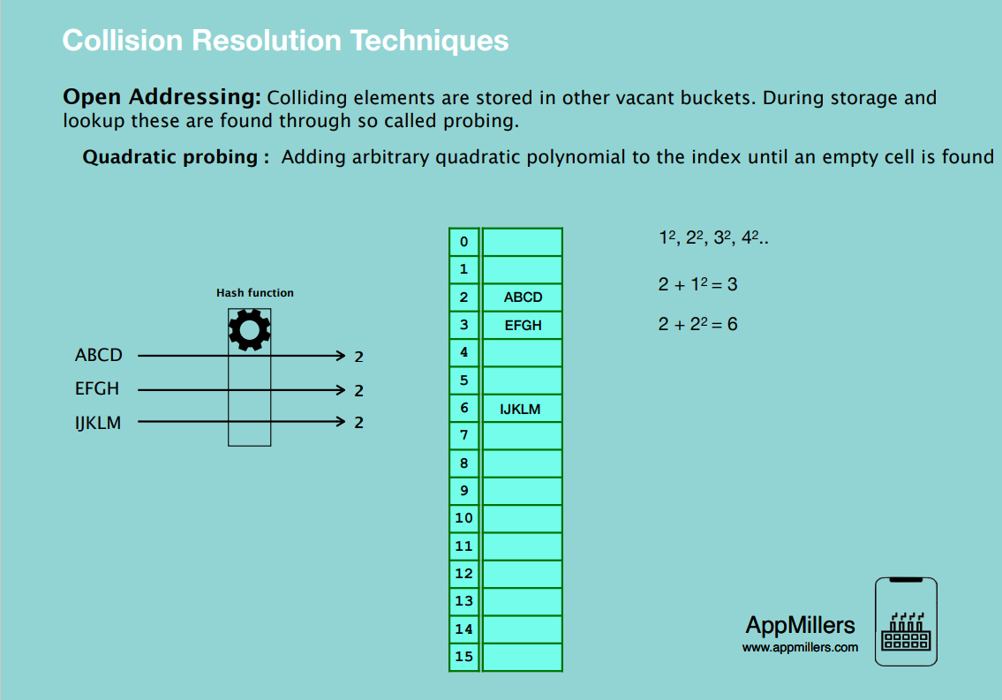

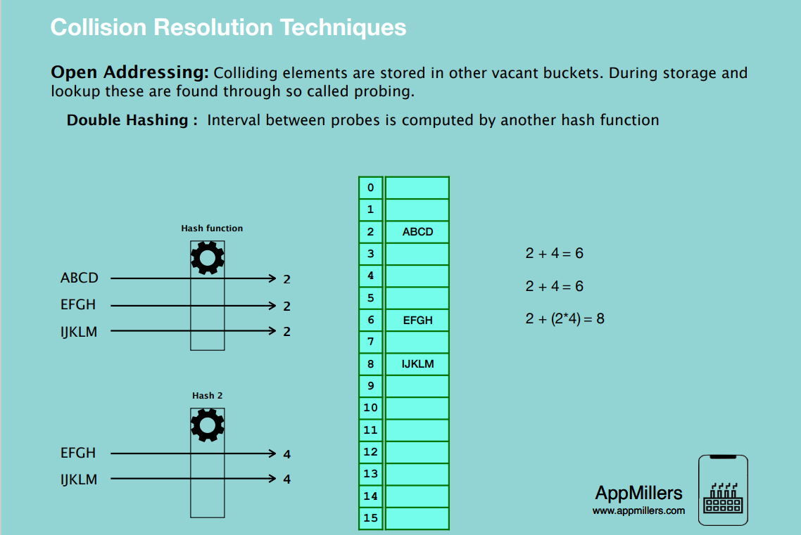

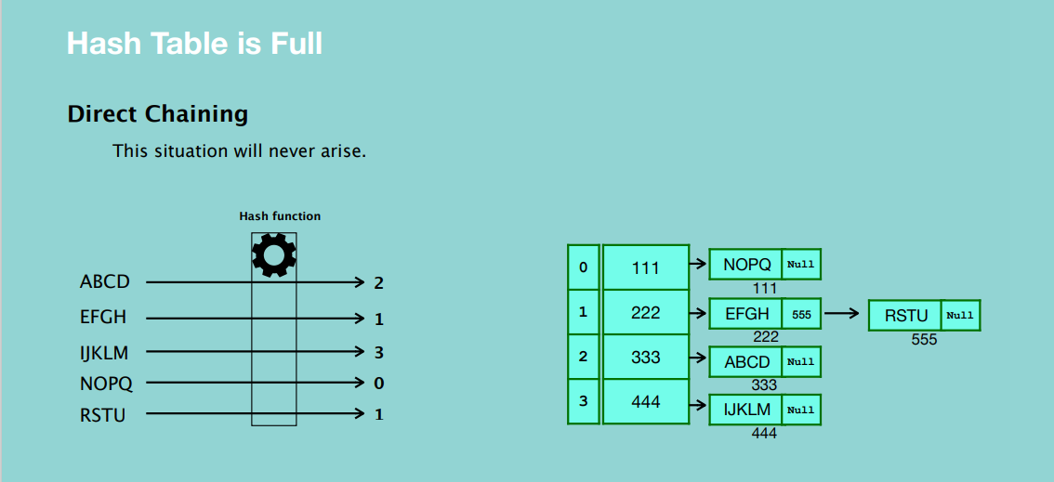

* With direct chaining, a hash table will never be full.

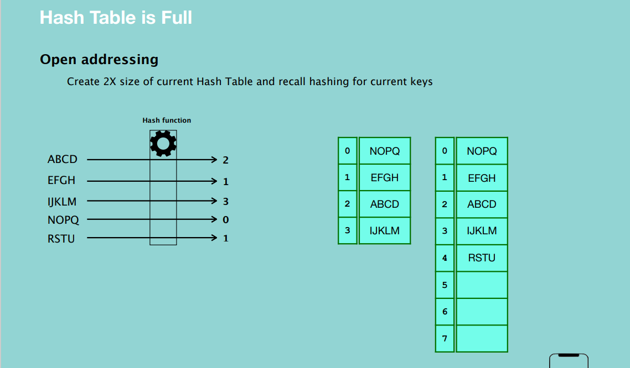

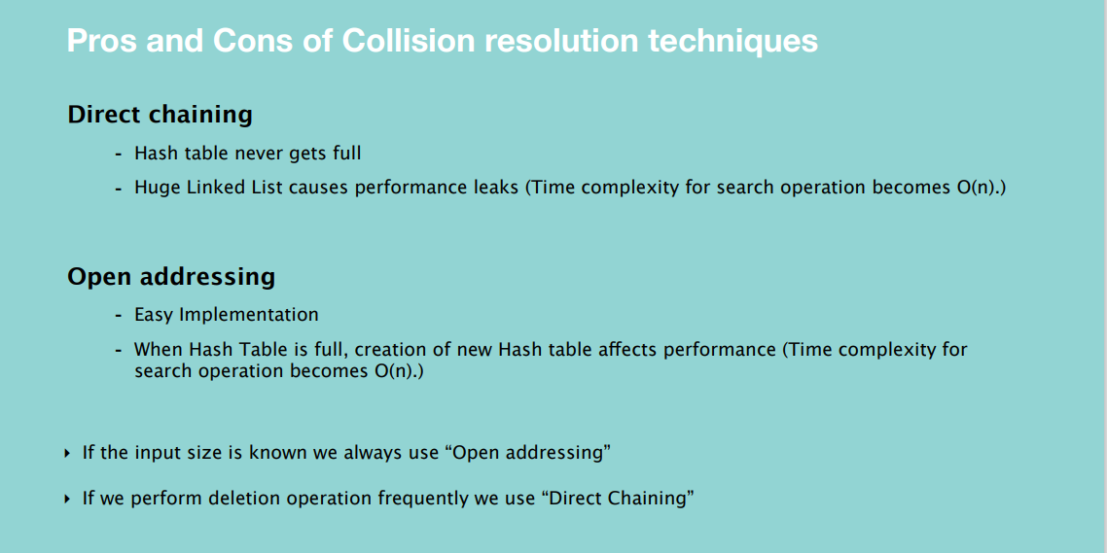

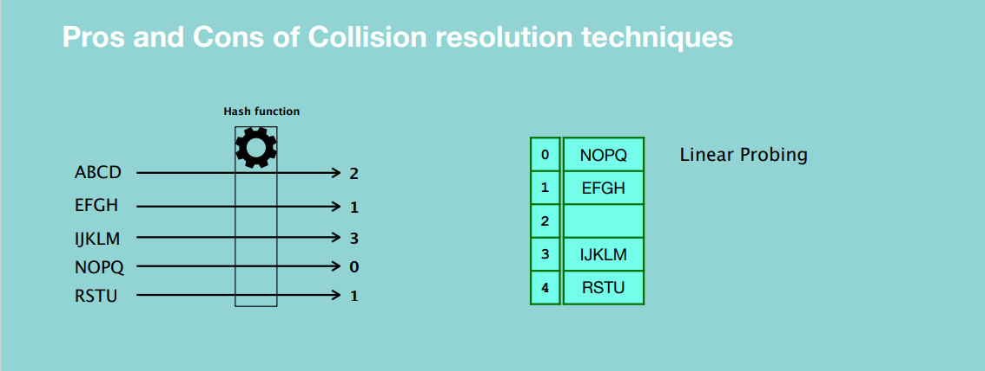



* A hashing function is one-way traffic, we can only get a hash value from the key, we cannot get the key from the hashing function. i.e. you cannot get a user’s password using the hashing function.

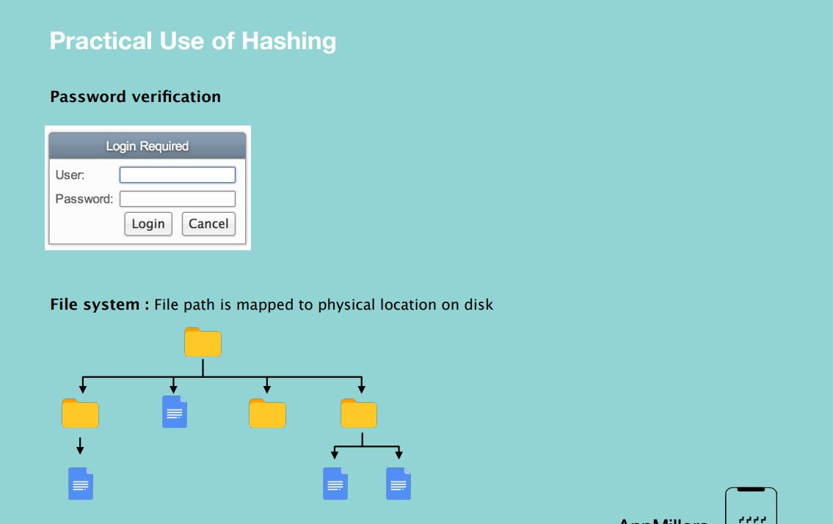

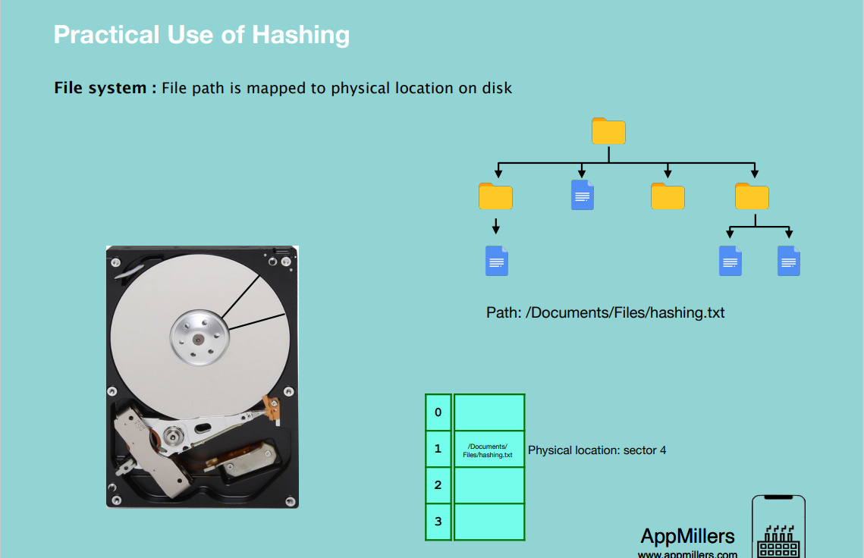

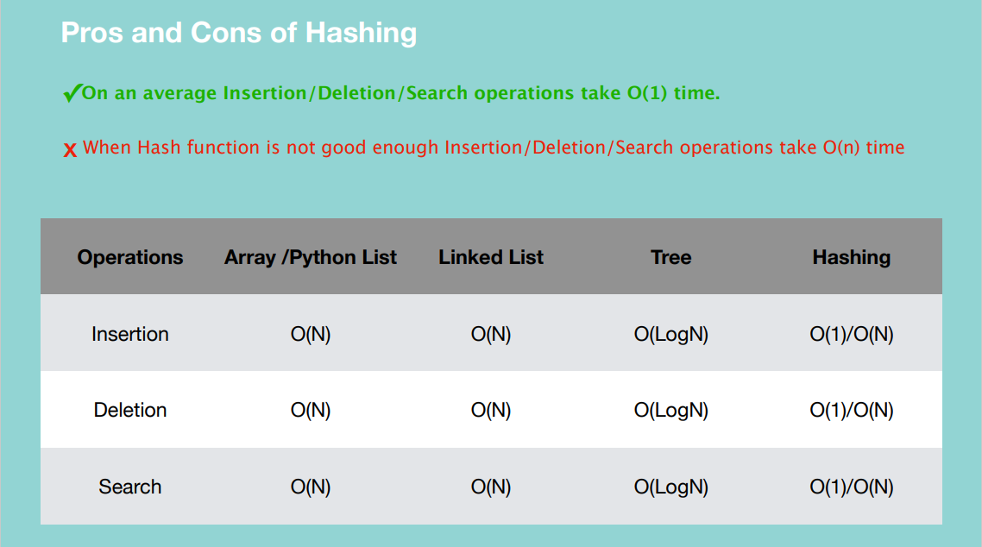

**NOTE: Hashing is implemented in the Python Data Structure for Dictionary.**

**SORTING ALGORITHMS**

What is Sorting?

By definition sorting refers to arranging data in a particular format: either ascending or descending.



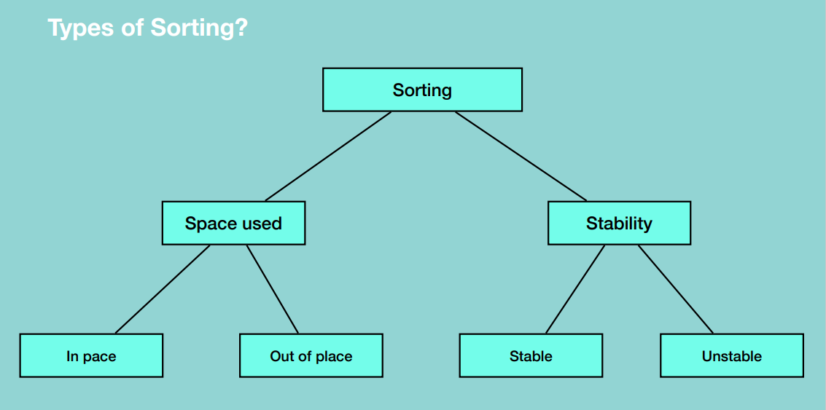

* Inplace

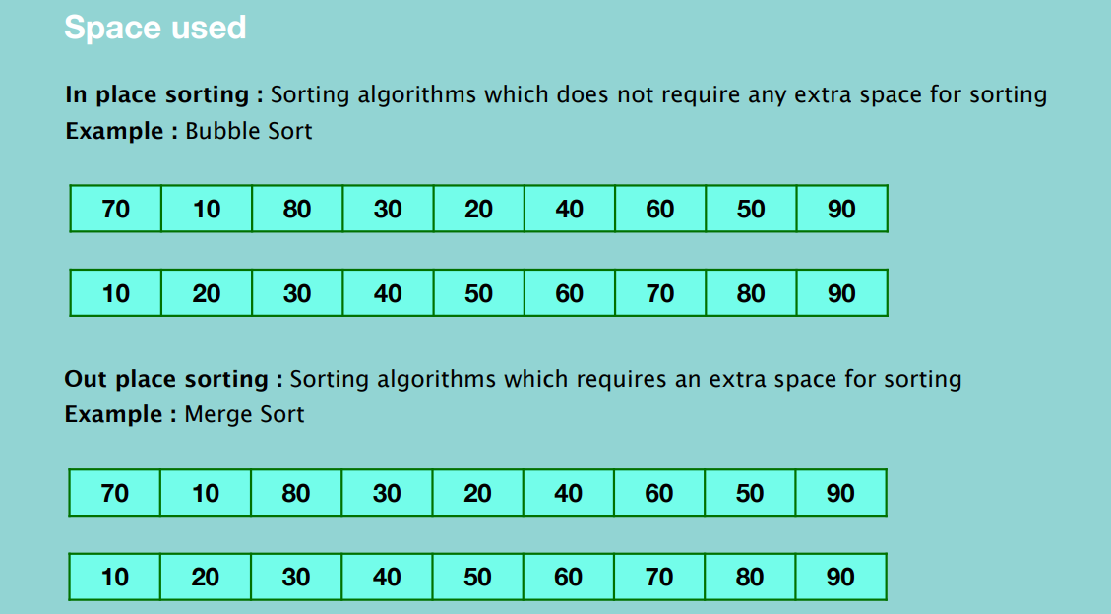

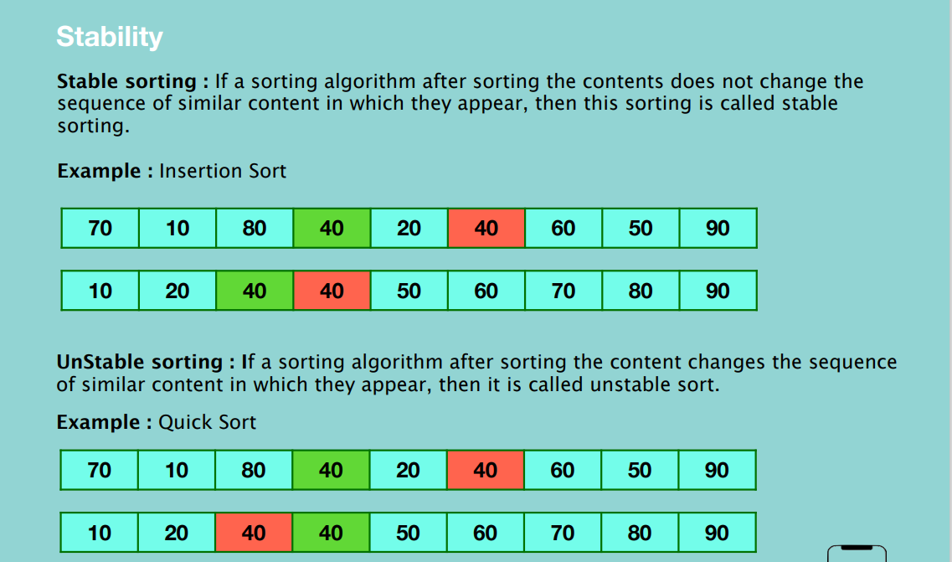

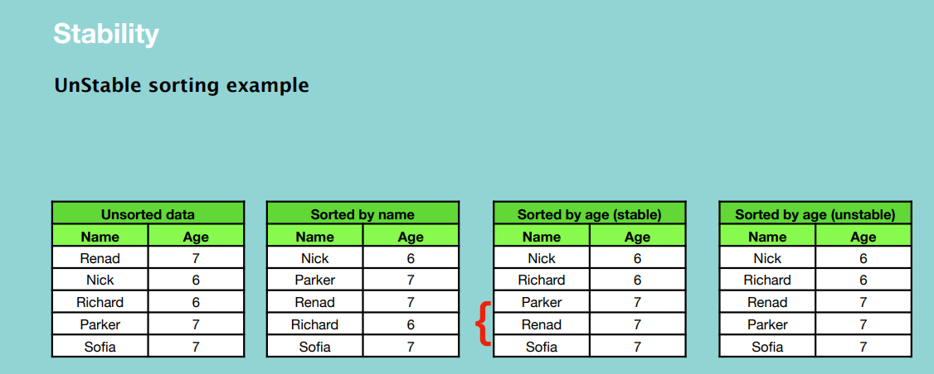

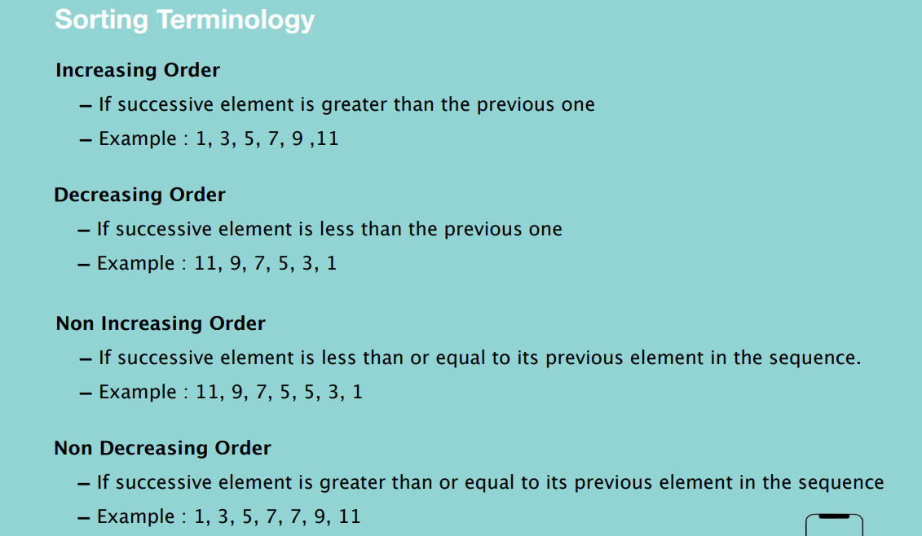

Sorting Algorithms

Bubble sort

Selection sort

Insertion sort

Bucket sort

Merge sort

Quick sort

Heap sort

Which one to select?

- Stability

- Space efficient

- Time efficient

**BUBBLE SORT**

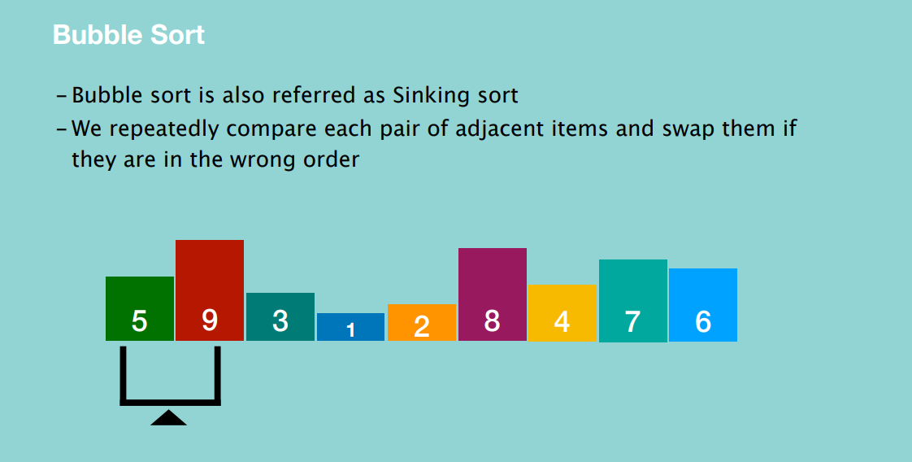

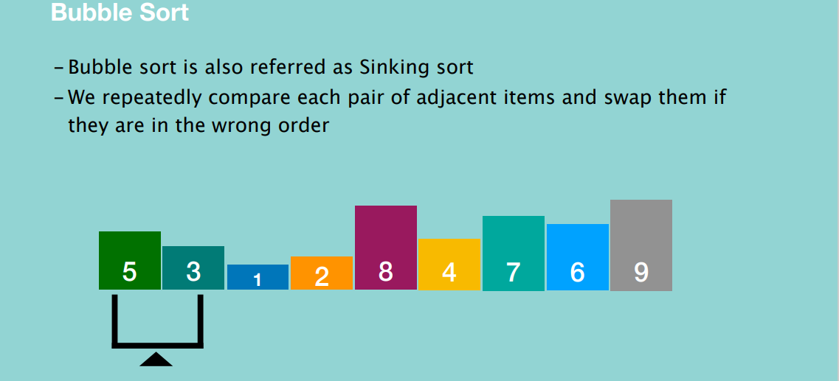

After the first round of comparison, the biggest number will be moved to the right edge and it will be fully sorted.

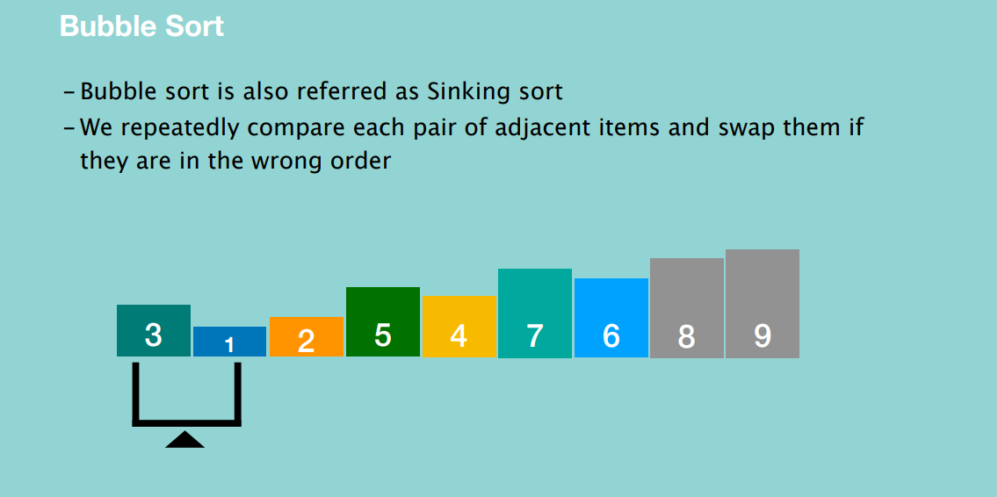

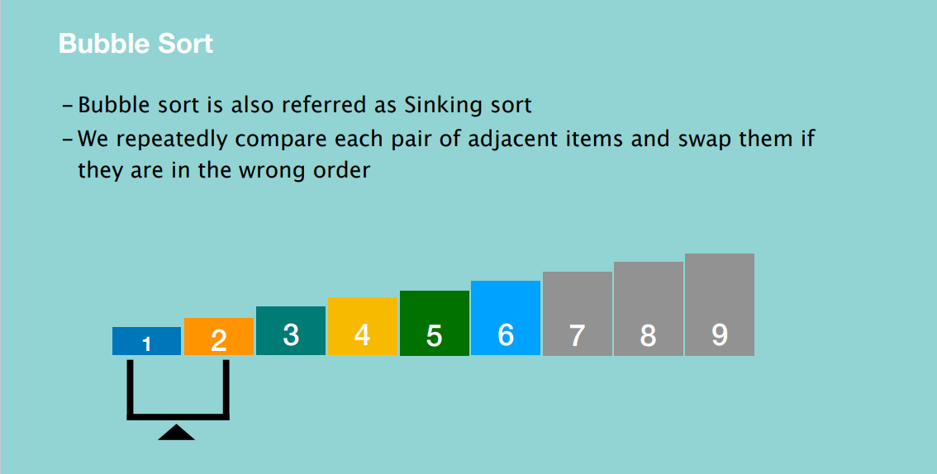

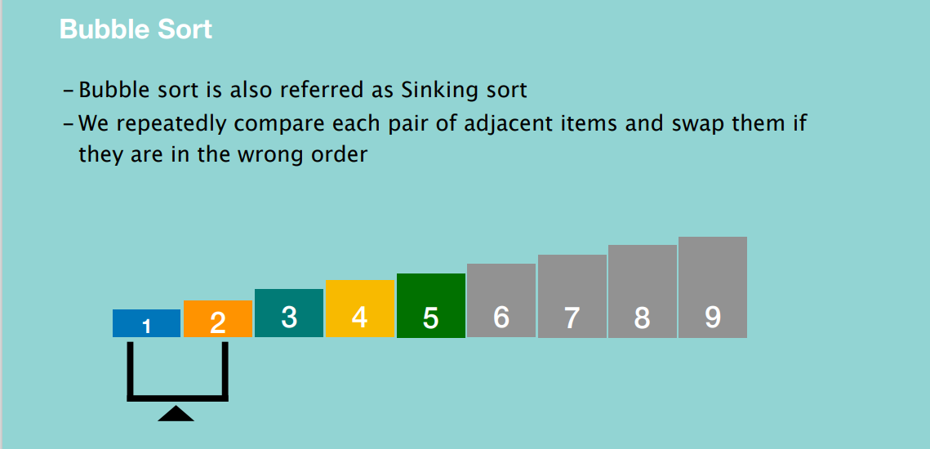

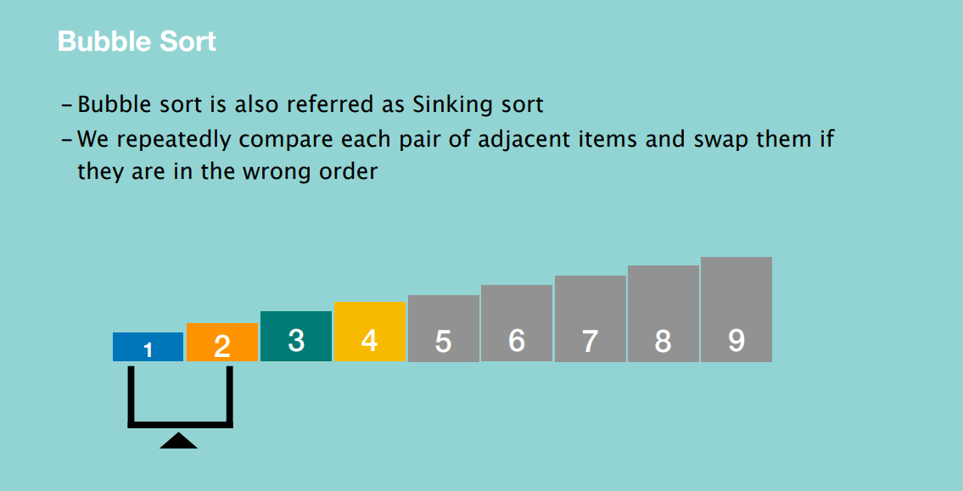

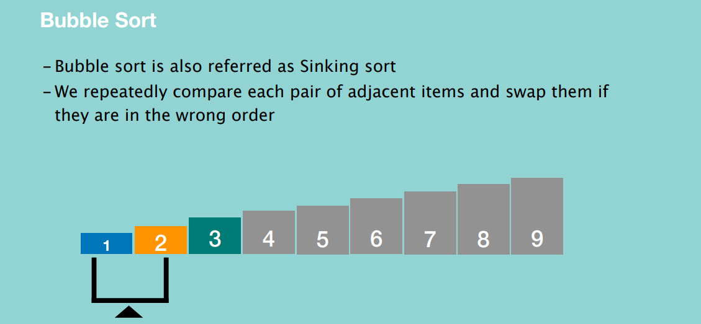

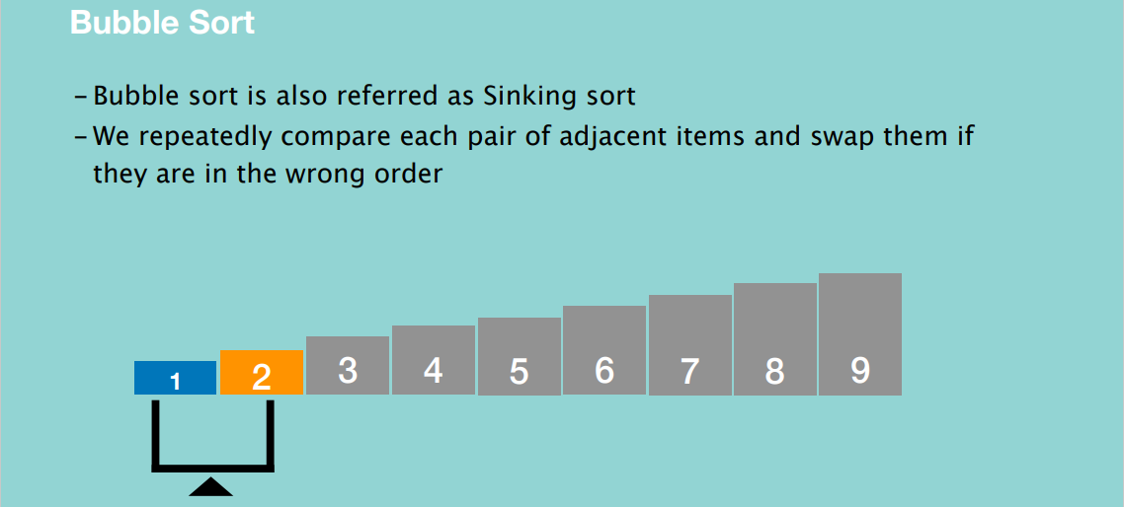

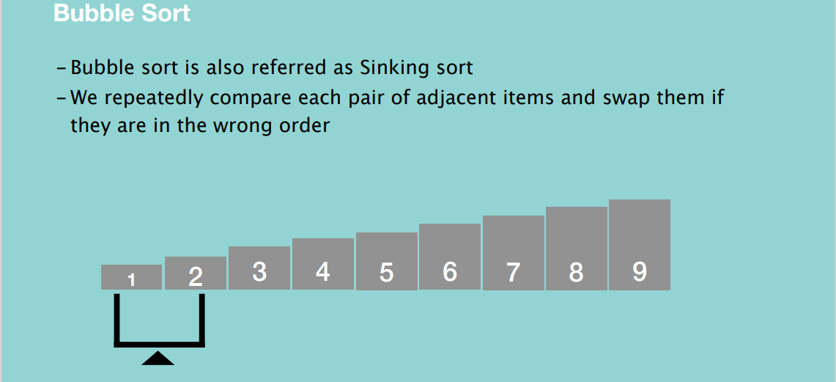

When to use Bubble Sort?

- When the input is already sorted

- Space is a concern

- Easy to implement

When to avoid Bubble Sort?

-Average time complexity is poor

**SELECTION SORT**

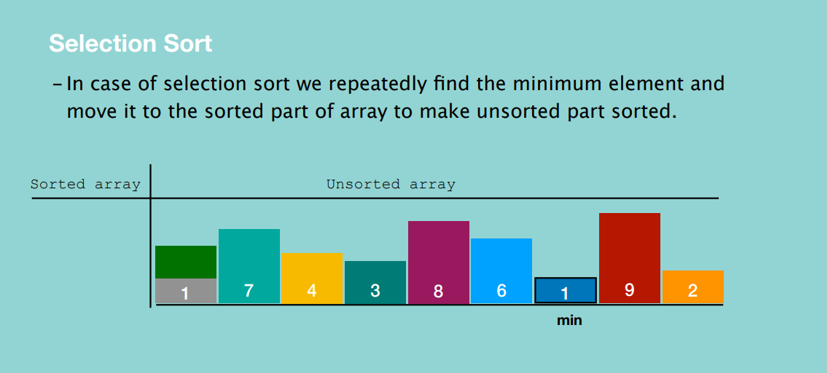

We begin by dividing the list into a sorted array and unsorted array. Then we move through the elements in the unsorted array and find the minimum, then we swap the minimum number with the first element in the unsorted array, then increase the size of the sorted array by one. Then we repeat the process for the rest of the elements.

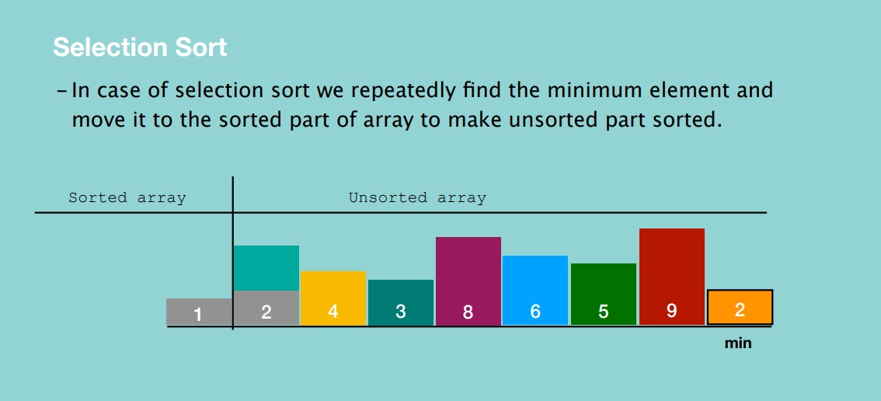

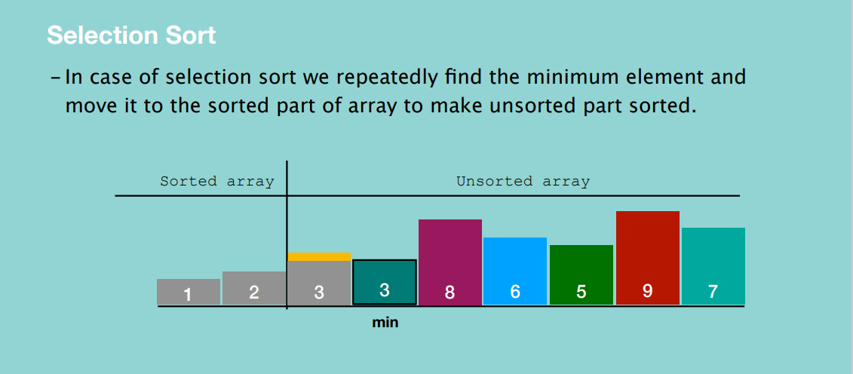

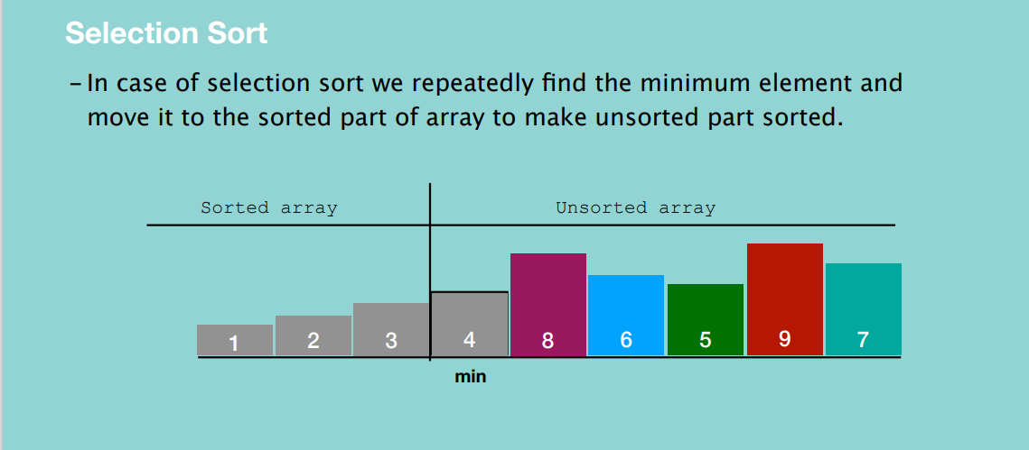

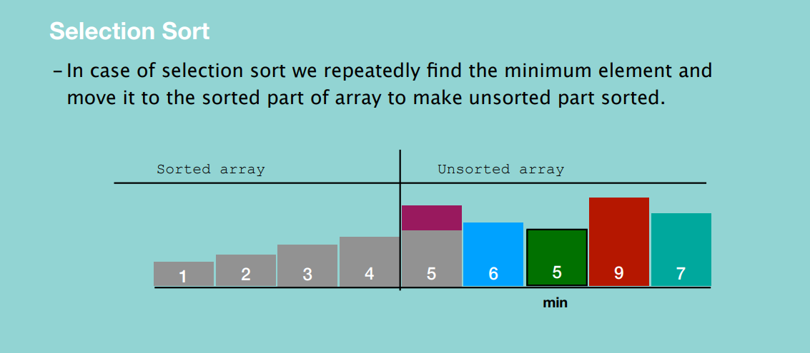

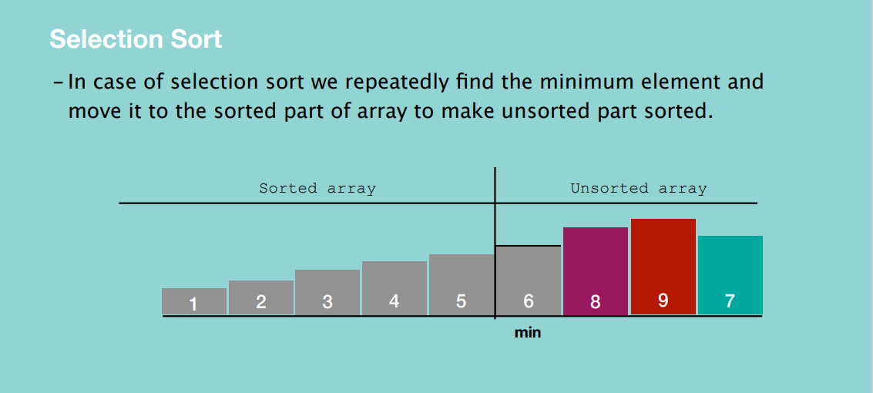 

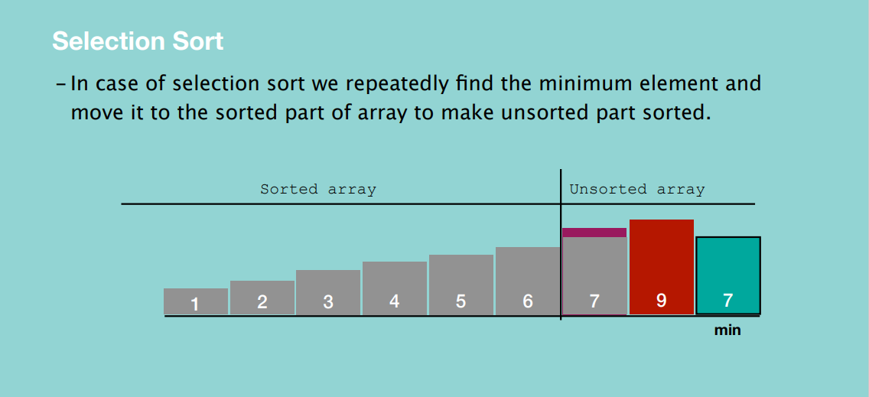

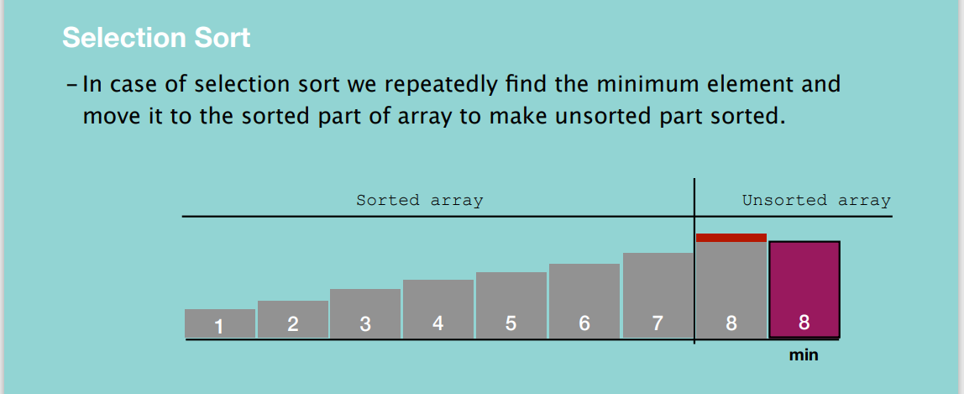

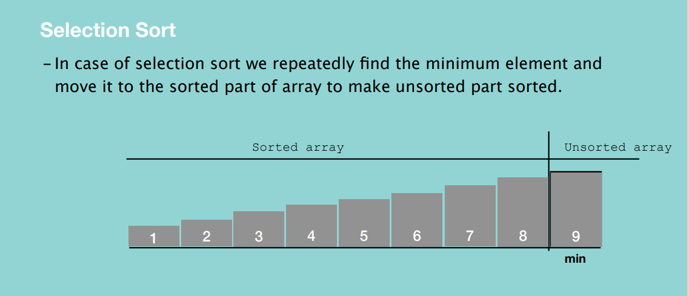

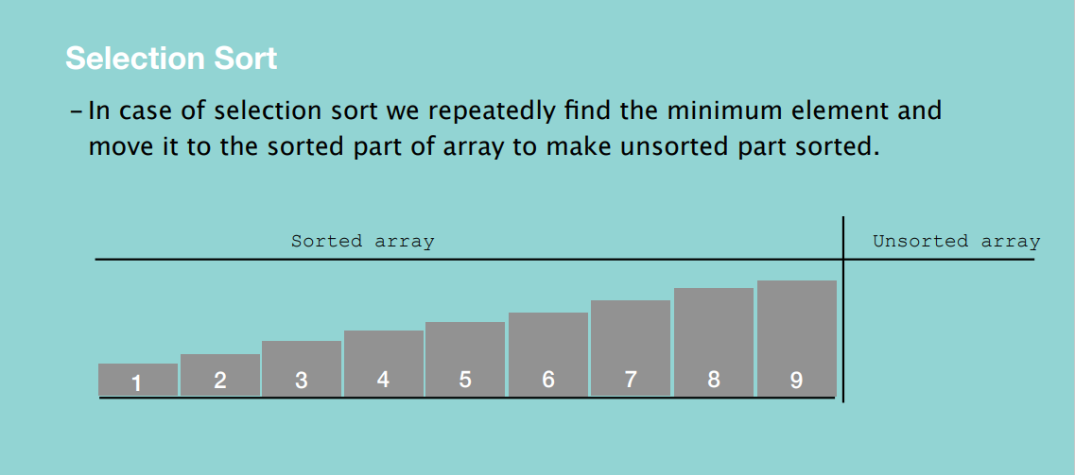

Selection Sort

When to use Selection Sort?

- When we have insufficient memory

- Easy to implement

When to avoid Selection Sort?

- When time is a concern

Main advantage is that it performs well on small lists. Additionally, since it’s an in-place sorting algorithm, no additional memory is needed to perform the sorting action. Big disadvantage is it has poor efficiency when dealing with a huge list of items. Its performance is easily influenced by the initial ordering of items before the sorted process. Hence the selection sort is only good for a list of few elements in random order.

**INSERTION SORT**

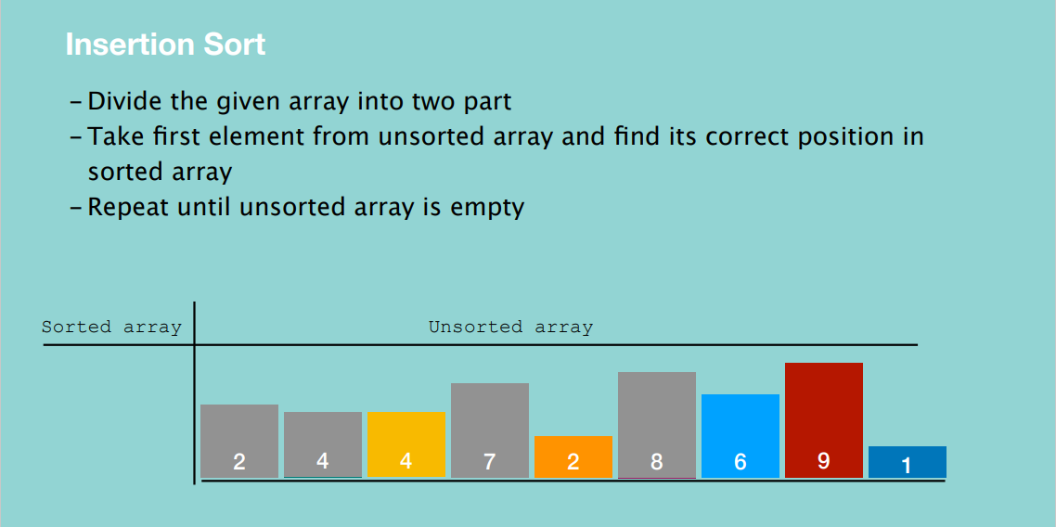

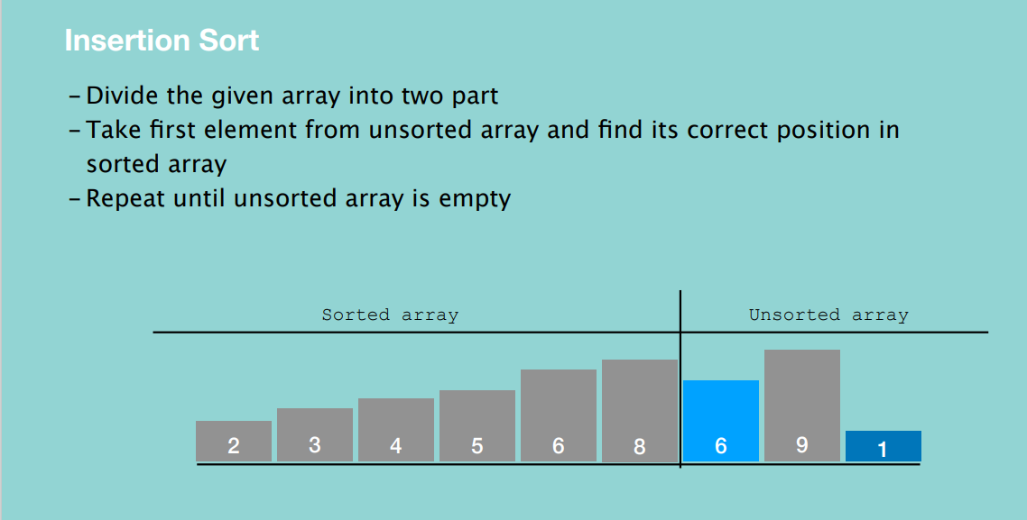

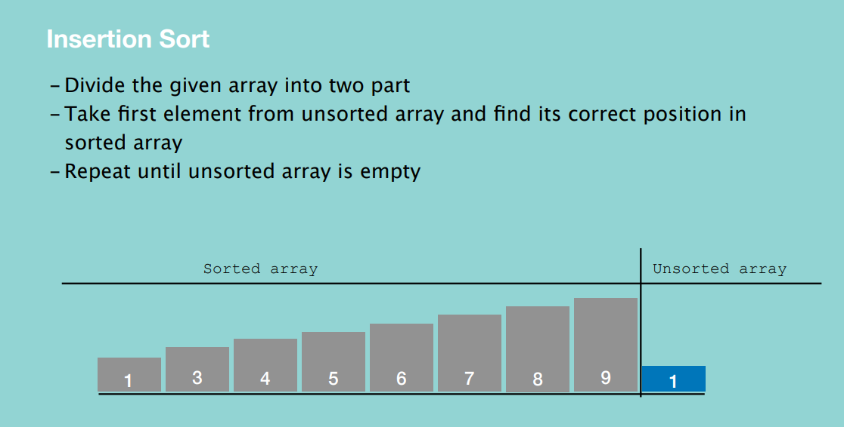

When to use Insertion Sort?

- When we have insufficient memory

- Easy to implement

- When we have continuous inflow of numbers and we want to keep

them sorted

When to avoid Insertion Sort?

- When time is a concern

**BUCKET SORT**

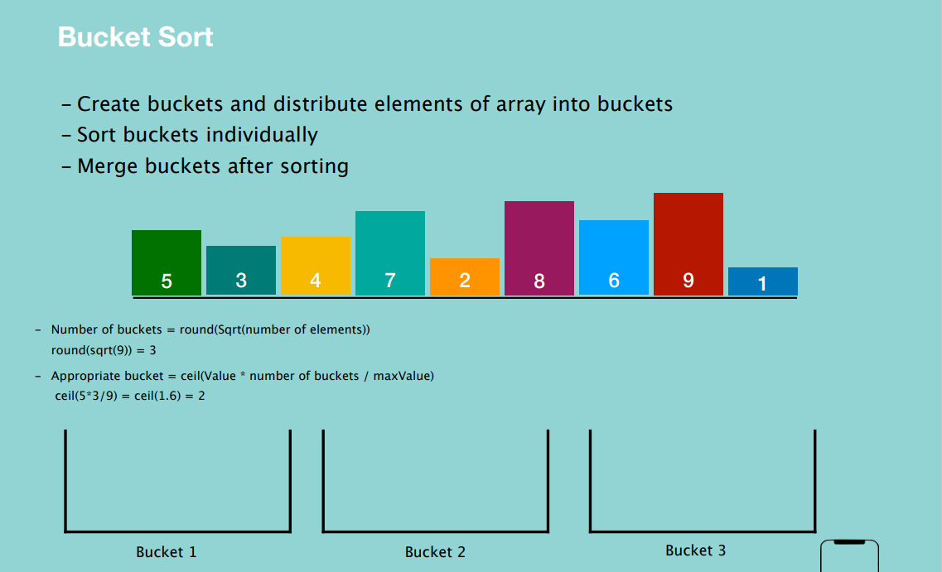

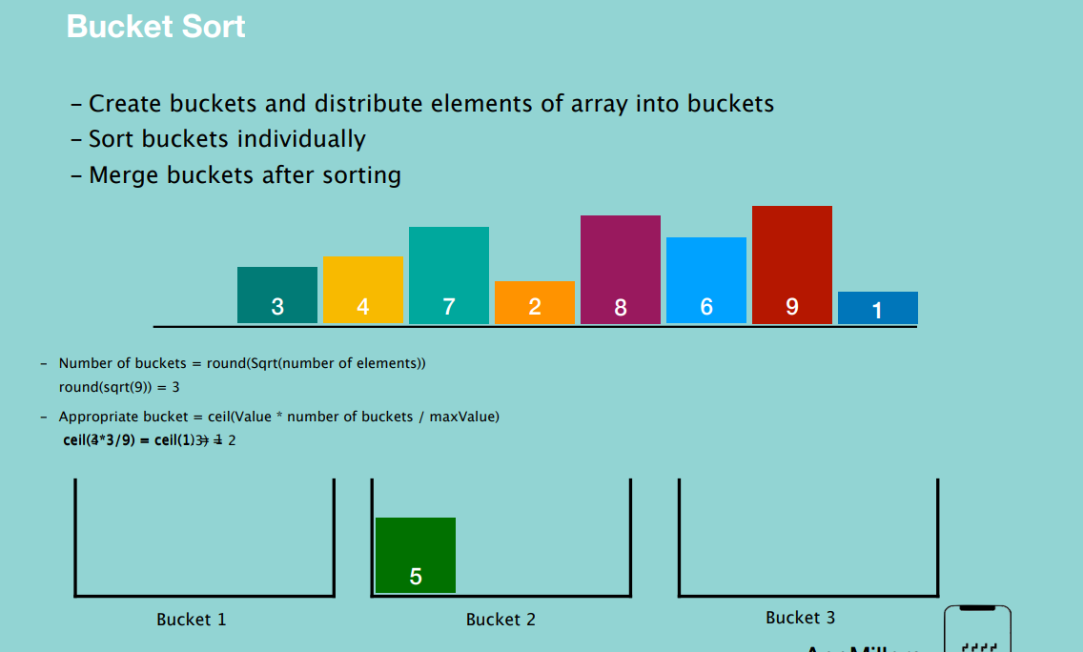

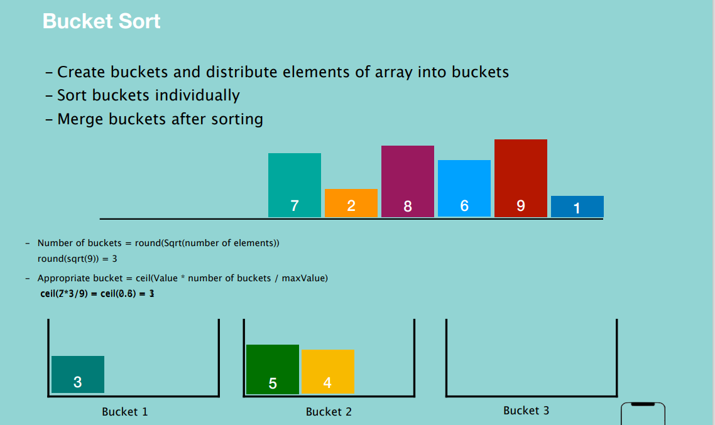

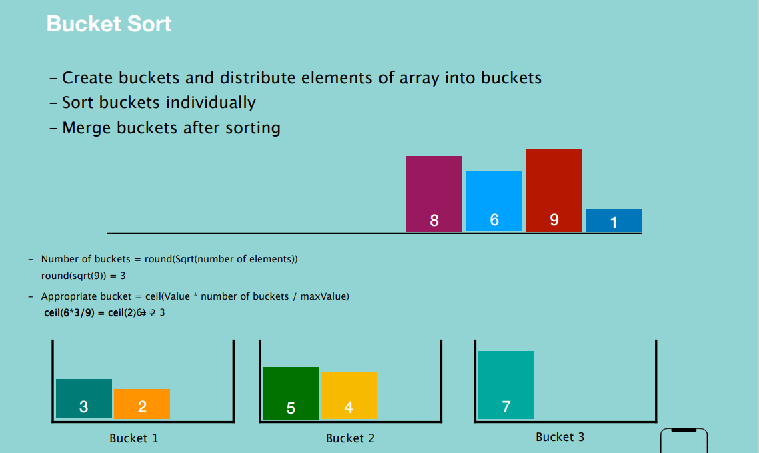

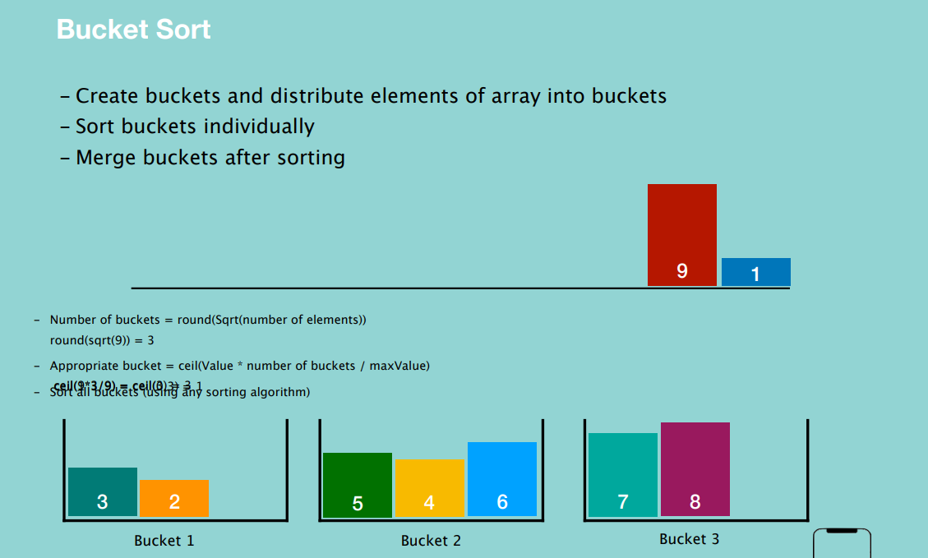

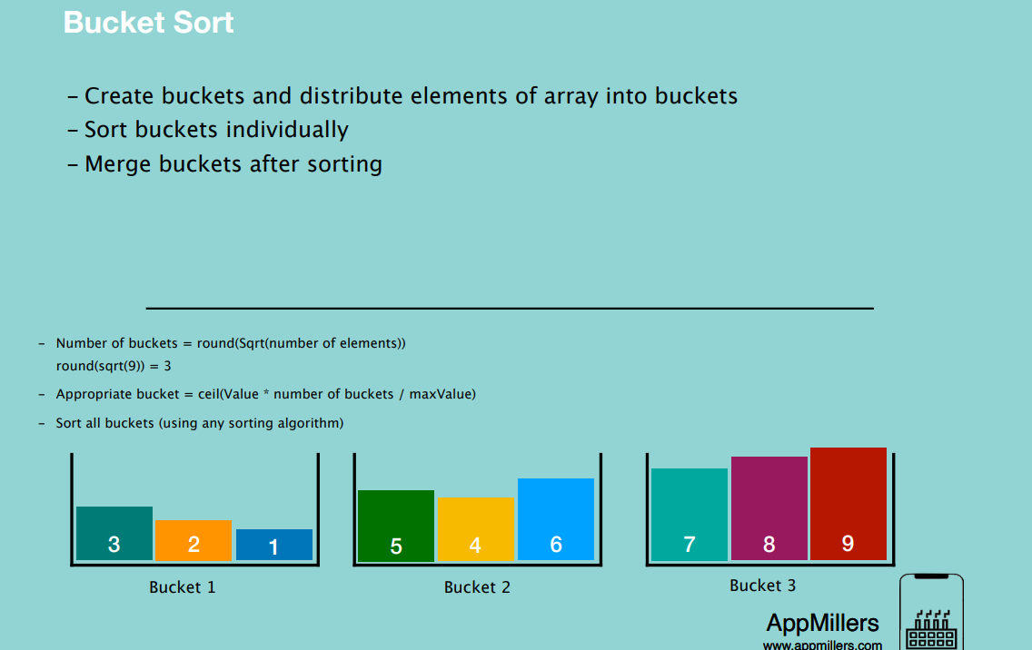

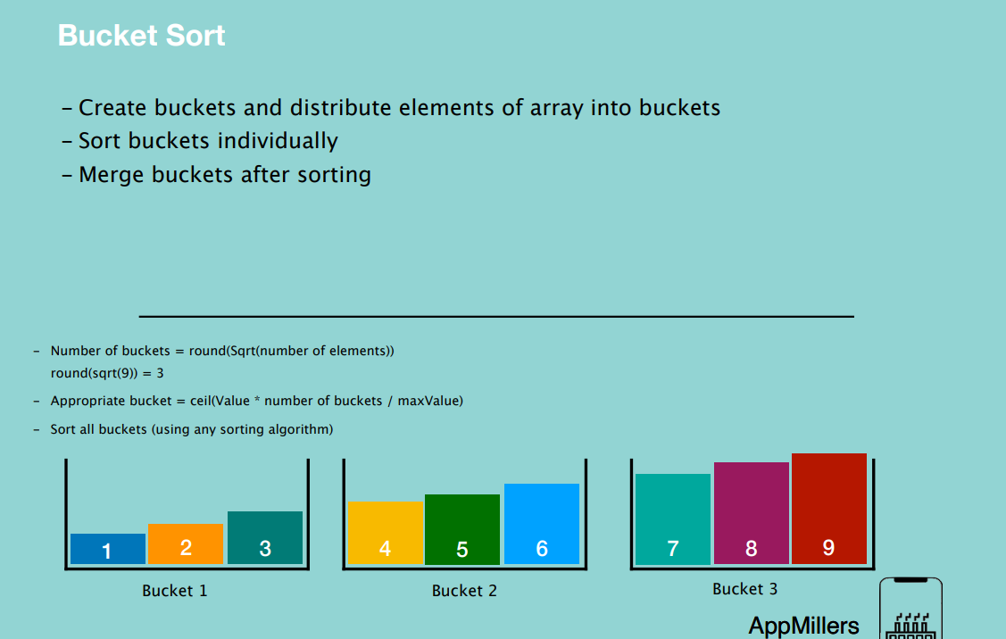

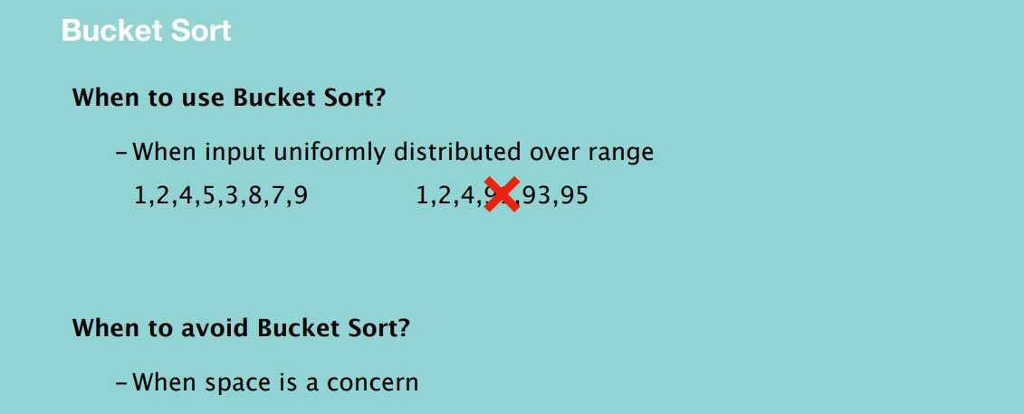

**MERGE SORT**

- Merge sort is a divide and conquer algorithm

- Divide the input array in two halves and we keep halving recursively until they

become too small that cannot be broken further

- Merge halves by sorting them

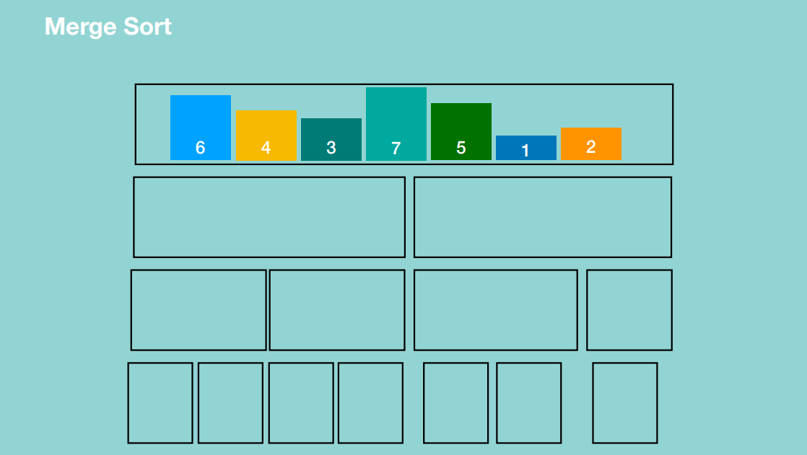

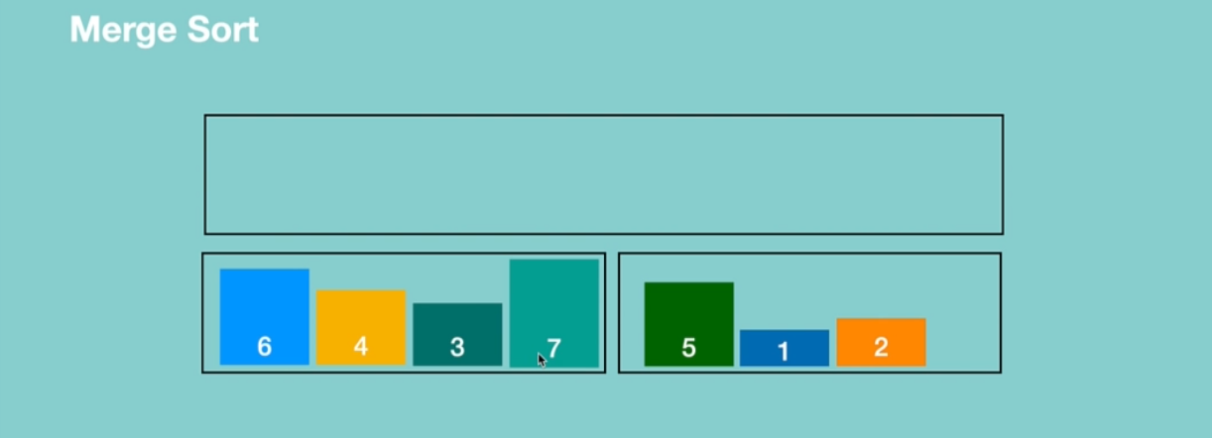

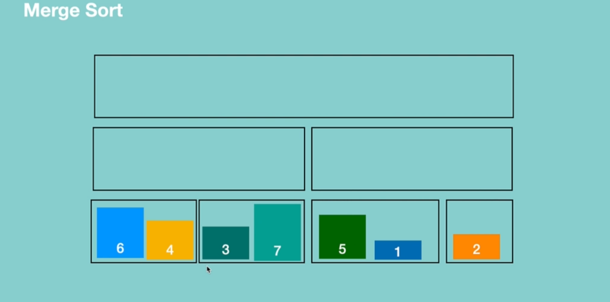

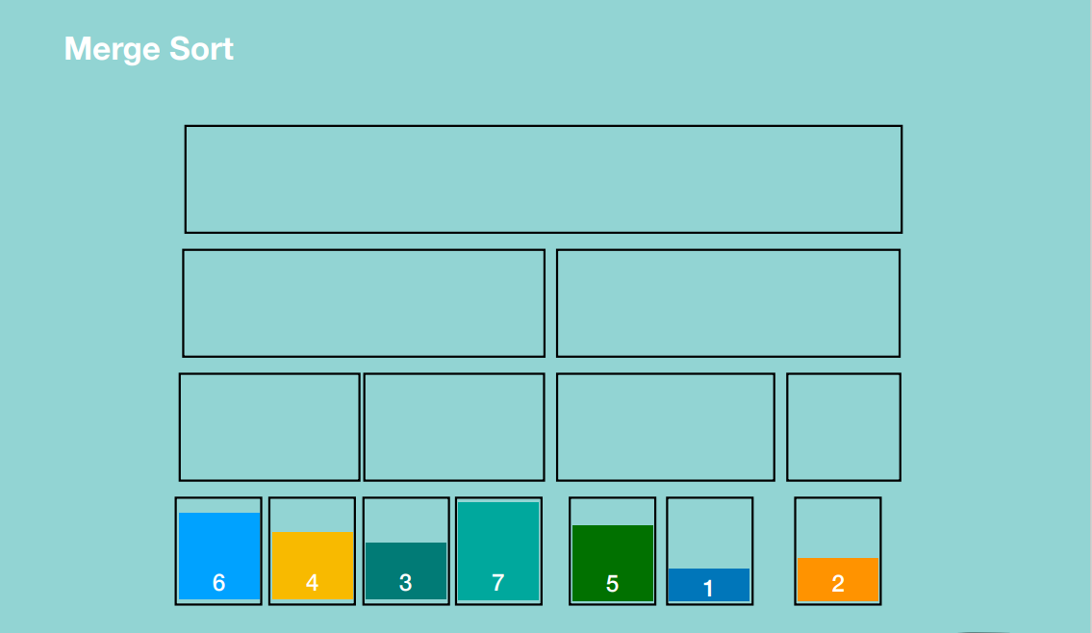

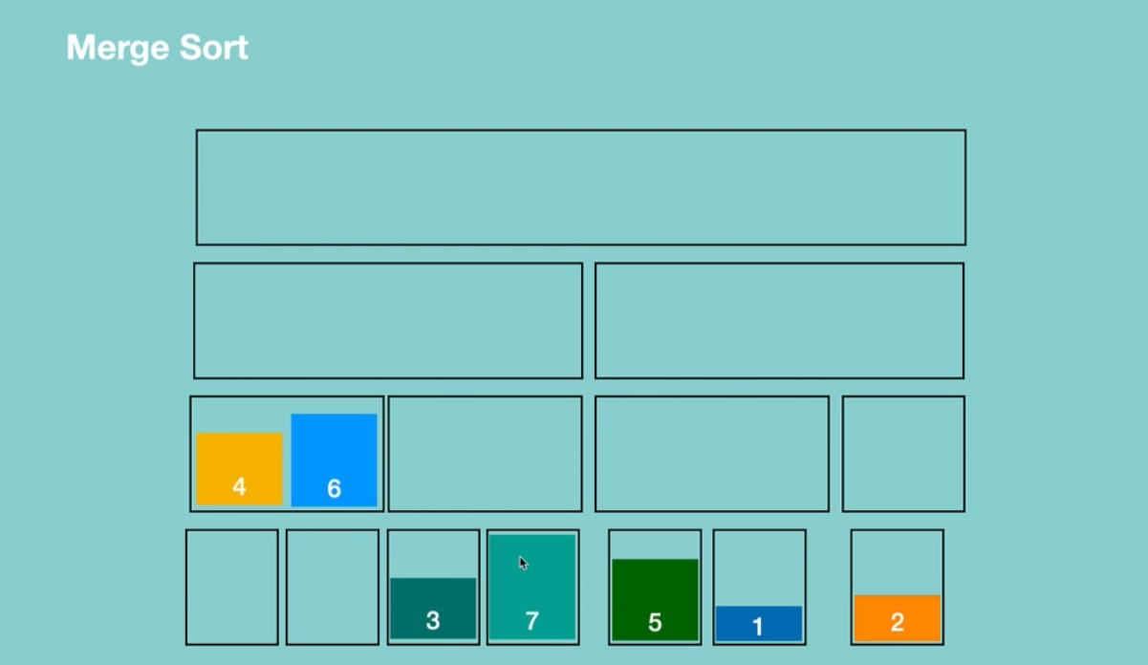

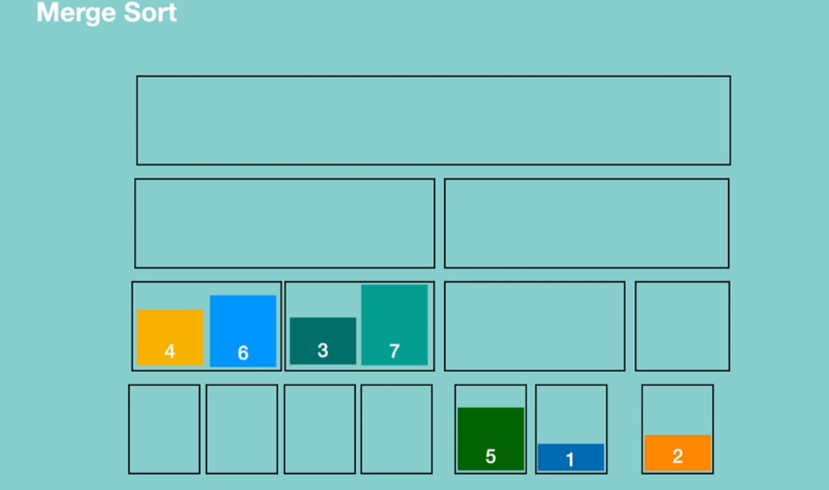

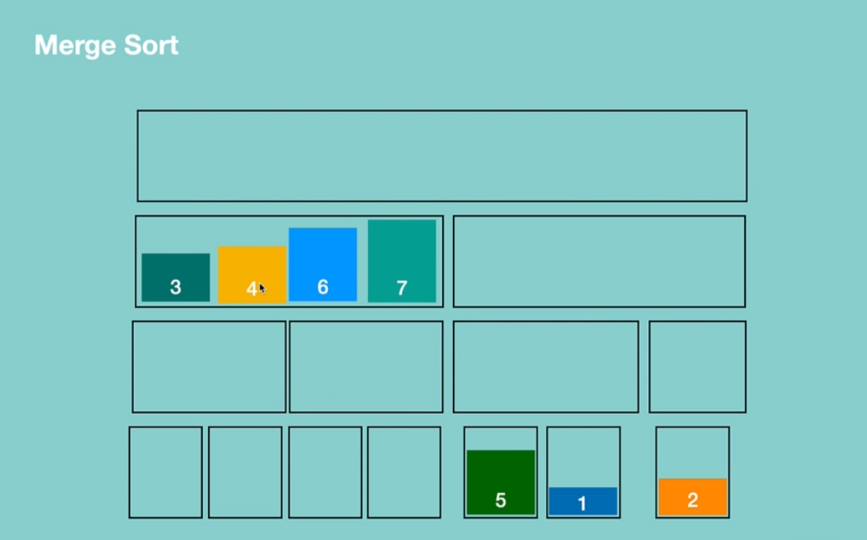

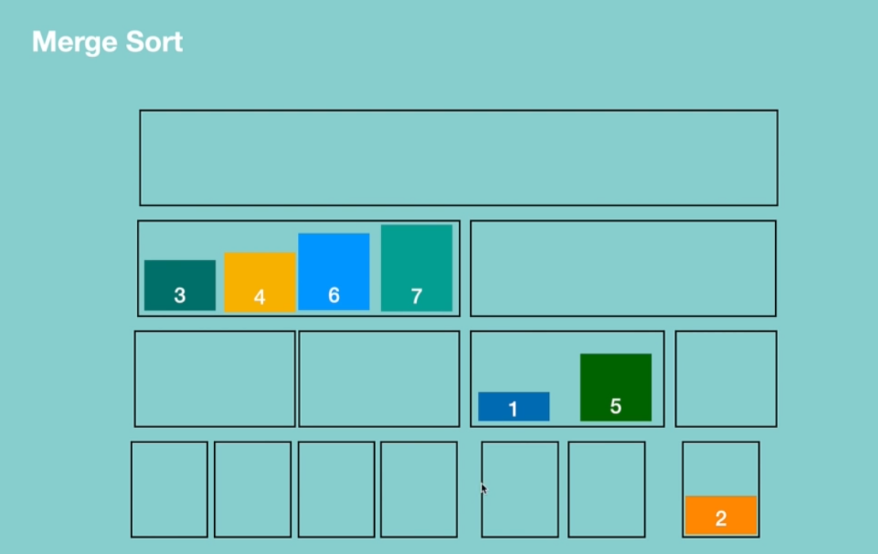

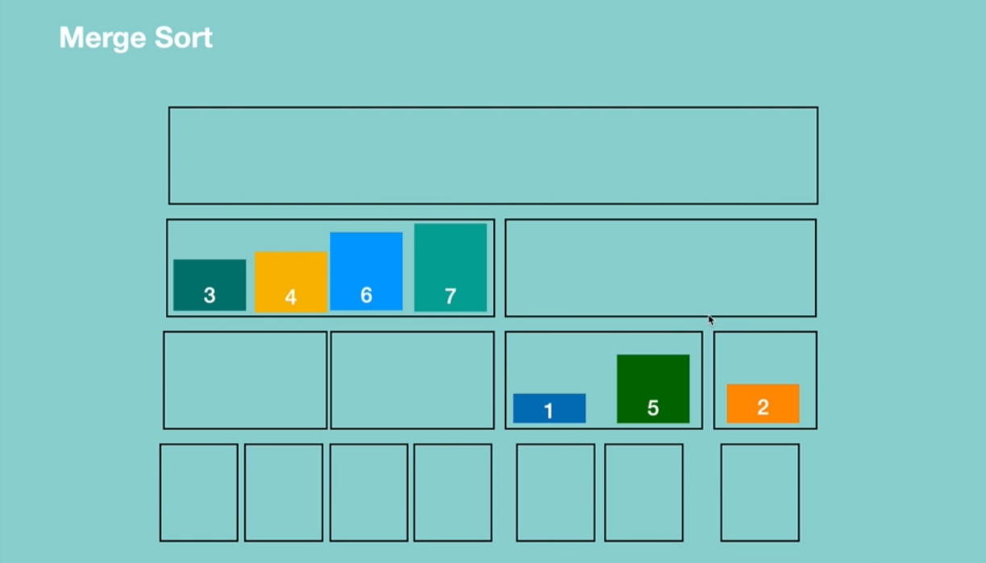

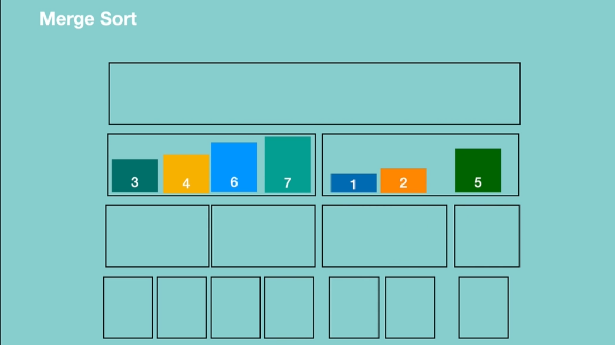

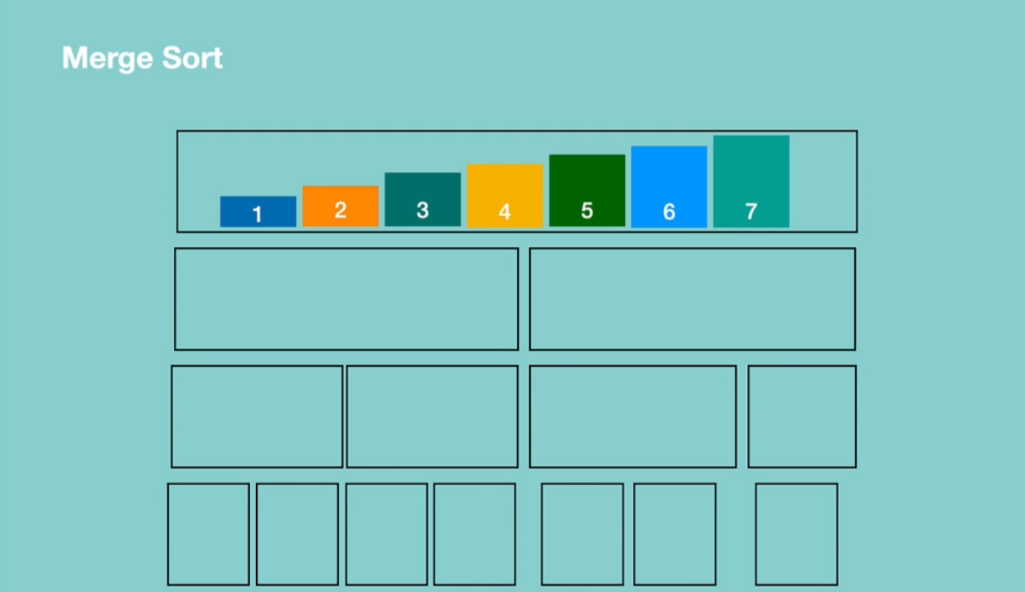

When to use Merge Sort?

- When you need stable sort

- When average expected time is O(NlogN)

When to avoid Merge Sort?

- When space is a concern

**QUICK SORT**

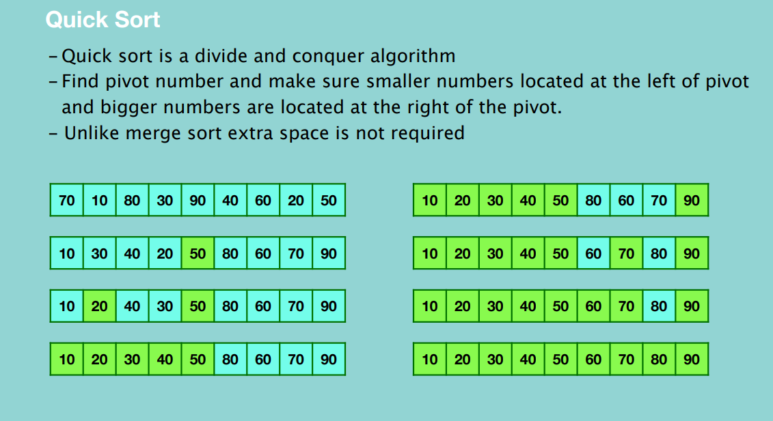

We take the right most number as a pivot and place all numbers that are less than the pivot on the left and all elements that are greater than the pivot on the right.

In the first round, 50 is chosen as the pivot.

In the second round, we apply quick sort for the left subarray and also for the right subarray.

For the left sub array, the right most number 20 is taken as a pivot number and we place all elements that are greater than it on the right and less on the left.

Then on the next sub array, 10 is the only element which means it’s full sorted, and for the right 30 is taken as a pivot number and it’s placed with 40 and hence the right sub array will be sorted.

Then we take 90, as a pivot and realize all elements are already less than 90 so 90 will be sorted.

The next sub array, we take 70 as the pivot and perform the sorting of elements greater and less than 70 in their appropriate positions, then 70 will be fully sorted.

We then move to 60 and since it’s one element, it’ll be fully sorted then we move to 80 and it will also be fully sorted.

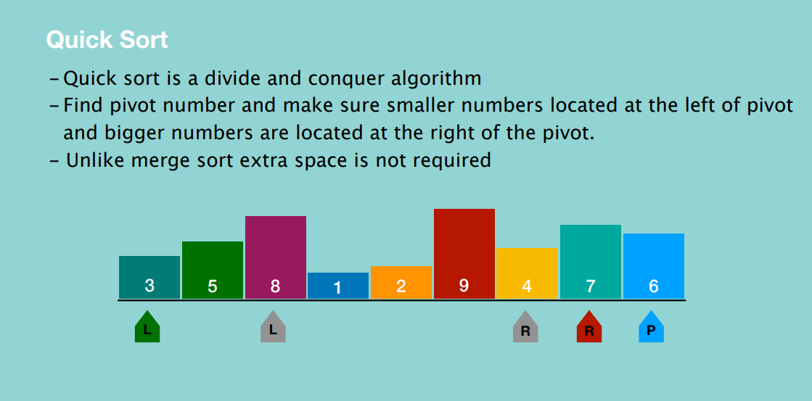

After selecting the pivot, place the left marker as the left most number and the right marker as the right most number. The left marker will move to the right and in each step compare the number with the pivot number, when it reaches a number that’s greater or equal to the pivot number, it stops moving. When the left marker stops, the right marker starts moving and we stop on a number that’s less than the pivot. When both right and left markers are stopped, the marker’s numbers are swapped.

In this way, the left marker finds the numbers that are greater or equal to the pivot and the right marker finds the numbers that are less than the pivot. And by swapping these numbers we can gather numbers that are less than the pivot on the left side of the sequence and those that are greater than or equal to the pivot on the right side of the sequence.

After the swapping, the left marker continues moving to the right until it reaches a number that’s greater than or equal to the pivot and the whole process repeats.

When right marker reaches the left marker’s position it stops. When both left and right markers stop on the same position, that number’s position is swapped with the pivot’s position. And the number that’s occupied by both the left and right markers is considered fully sorted and the first round stops. You notice the numbers less than the pivot will be located on the left and those that are greater will be located at the right.

The next round is performed recursively on both the left and right sequences created by division.

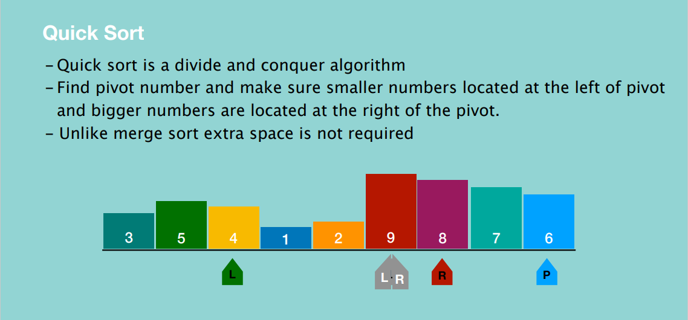

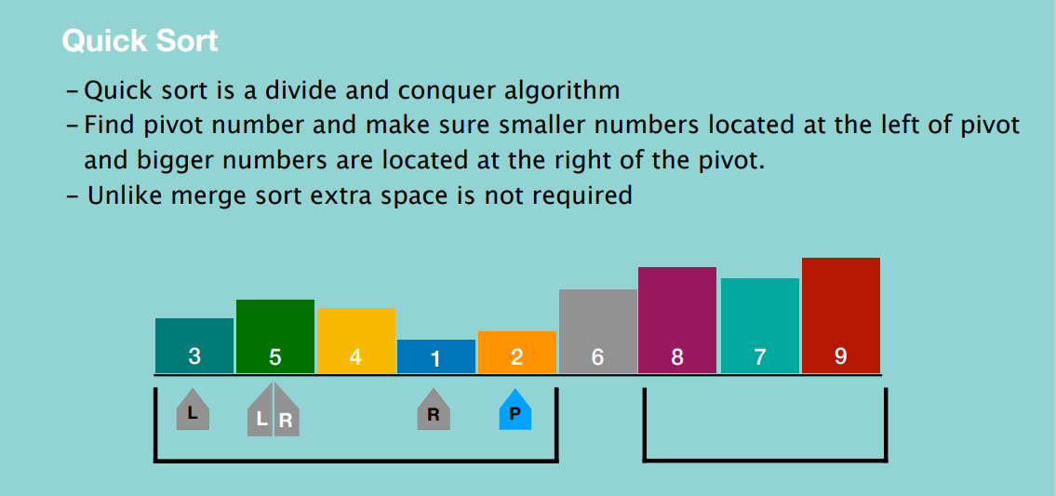

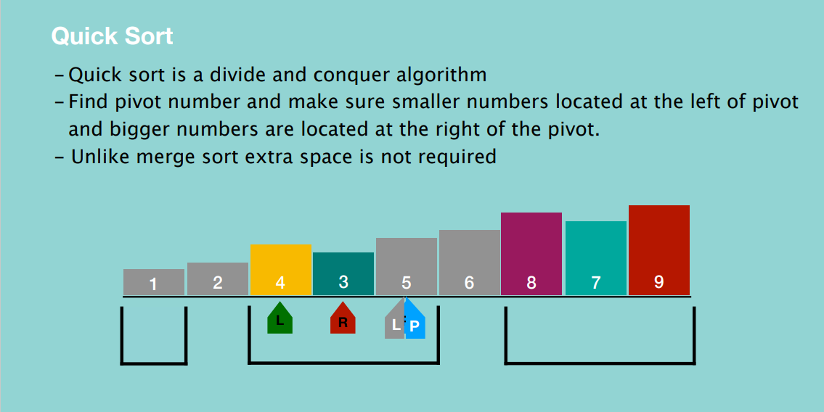

NOTE: If the left marker reaches the right marker, **movement doesn’t stop. It has to be the right marker that reaches the left marker for it to stop.** When the left marker reaches the most right index and the right marker can’t move because it has already been passed by the left marker, the pivot number will be considered sorted.

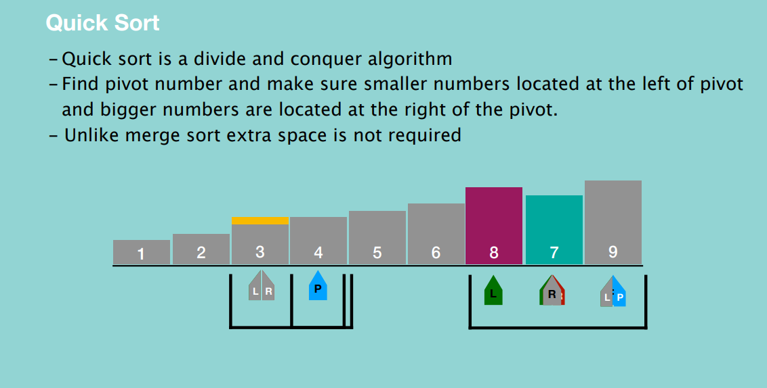

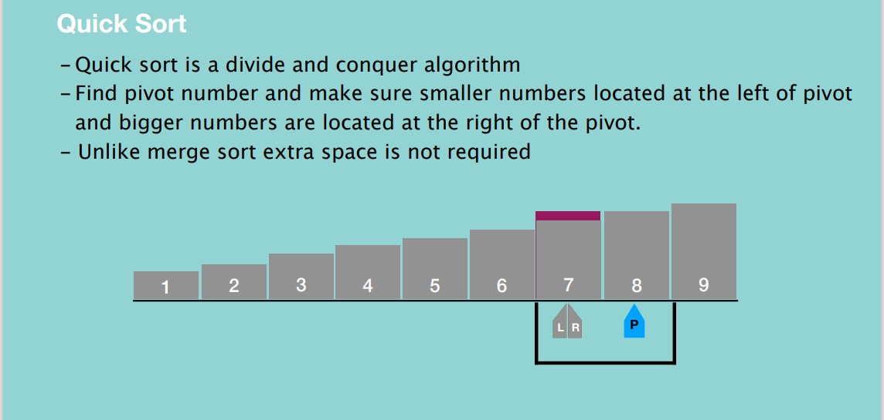

Quick Sort

When to use Quick Sort?

- When you need stable sort

- When average expected time is O(NlogN)

When to avoid Quick Sort?

- When space is a concern

**HEAP SORT**

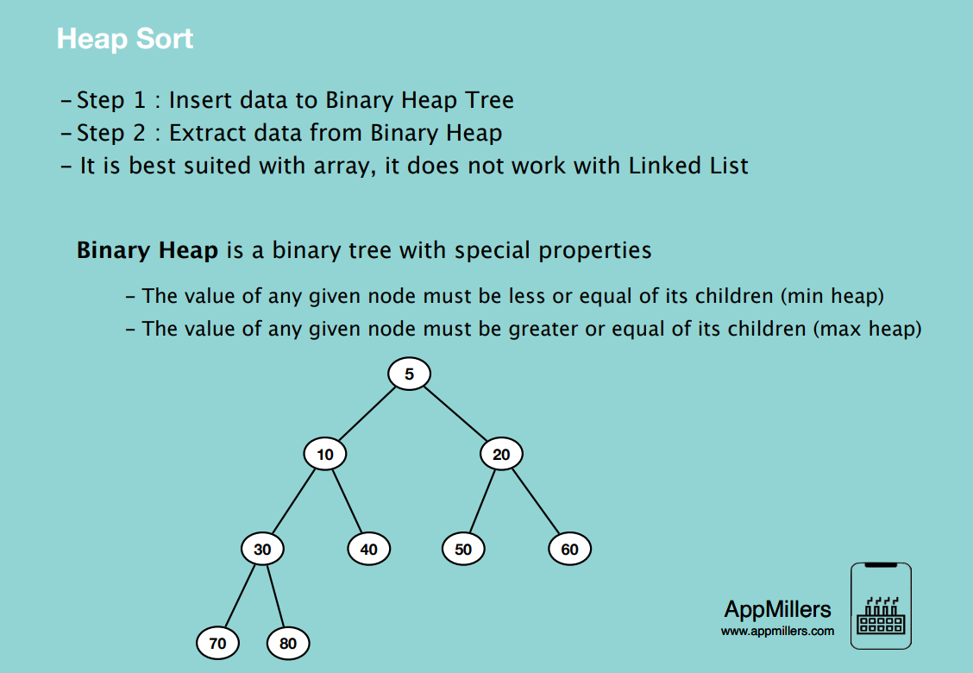

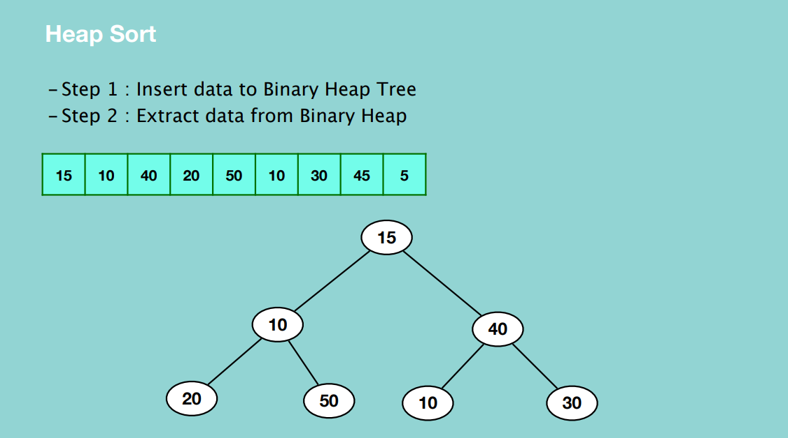

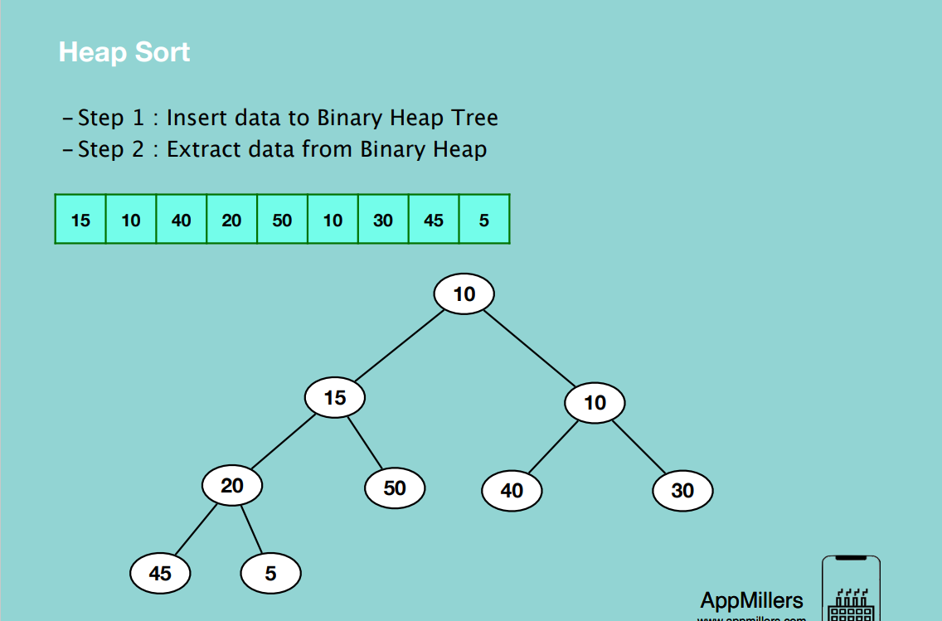

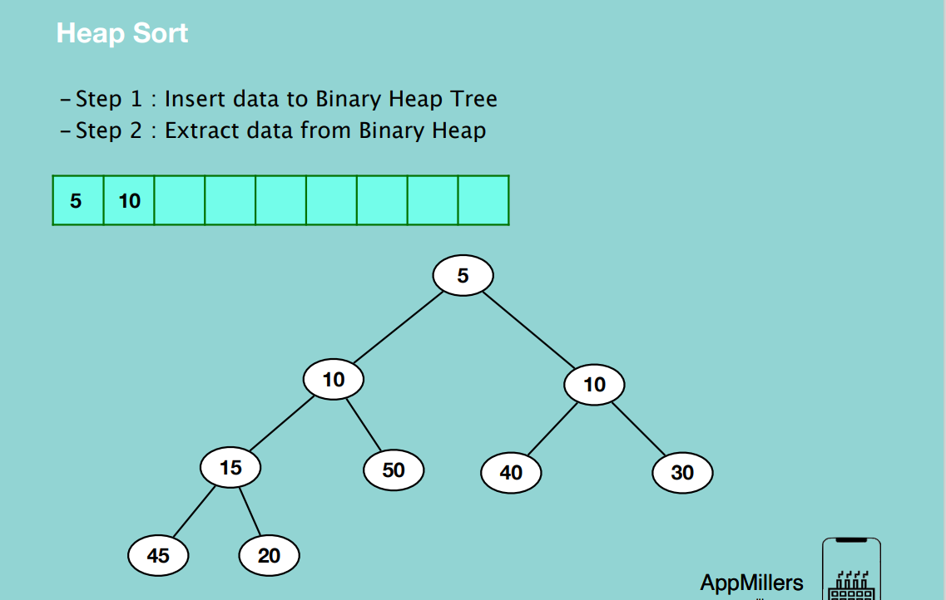

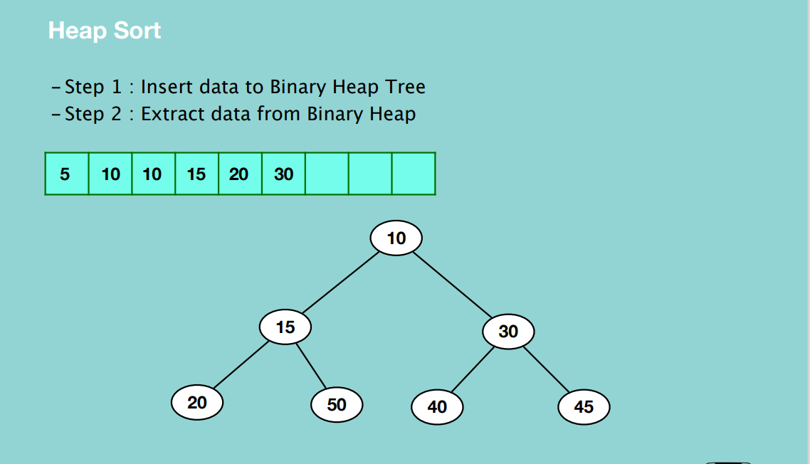

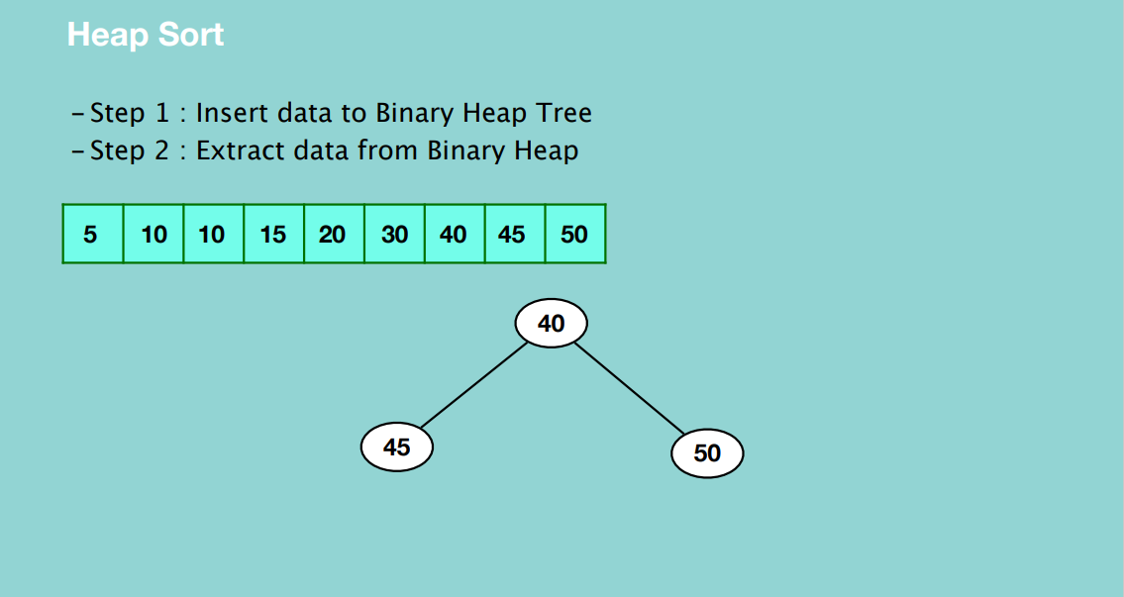 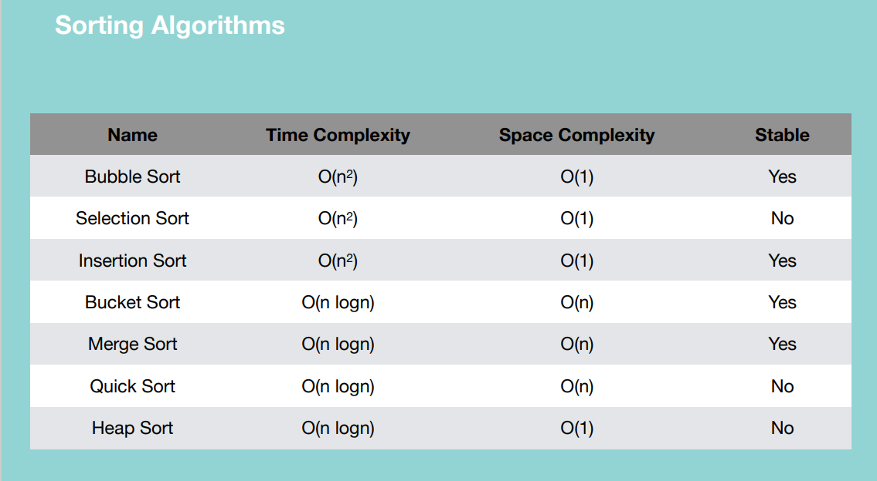

**SEARCHING ALGORITHMS**

**Linear Search aka sequential search**

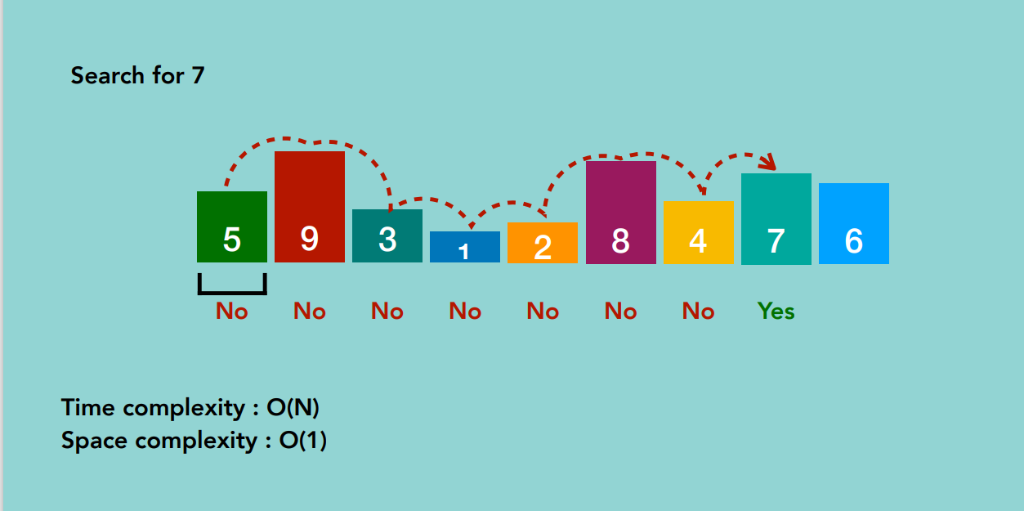

If we have an unsorted array, linear search is a good algorithm. If we have an unsorted array, then other algorithms are better used.

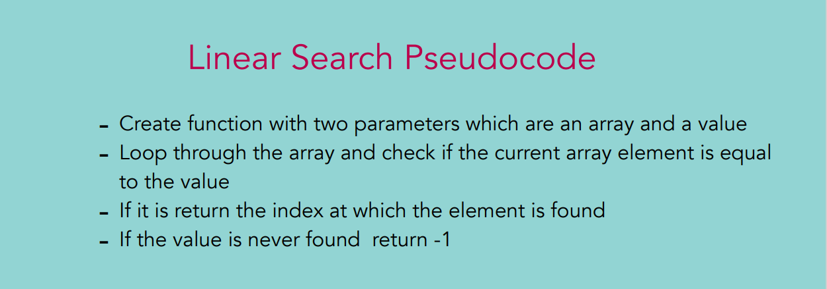

**Binary Search**

- Binary Search is faster than Linear Search

- Half of the remaining elements can be eliminated at a time, instead of

eliminating them one by one

- Binary Search only works for sorted arrays.

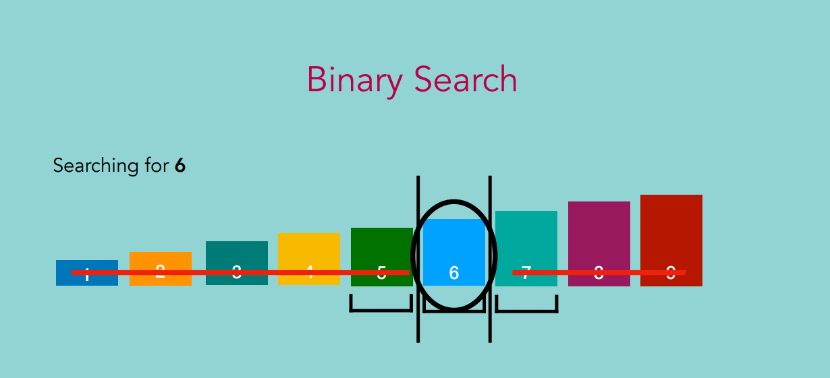

Find the middle element in the array, if the element is greater than the value we are looking for, then the value we are looking for will be located on the right of the middle element else the opposite. Then in the right sub array, you repeat the process again after locating the middle element.

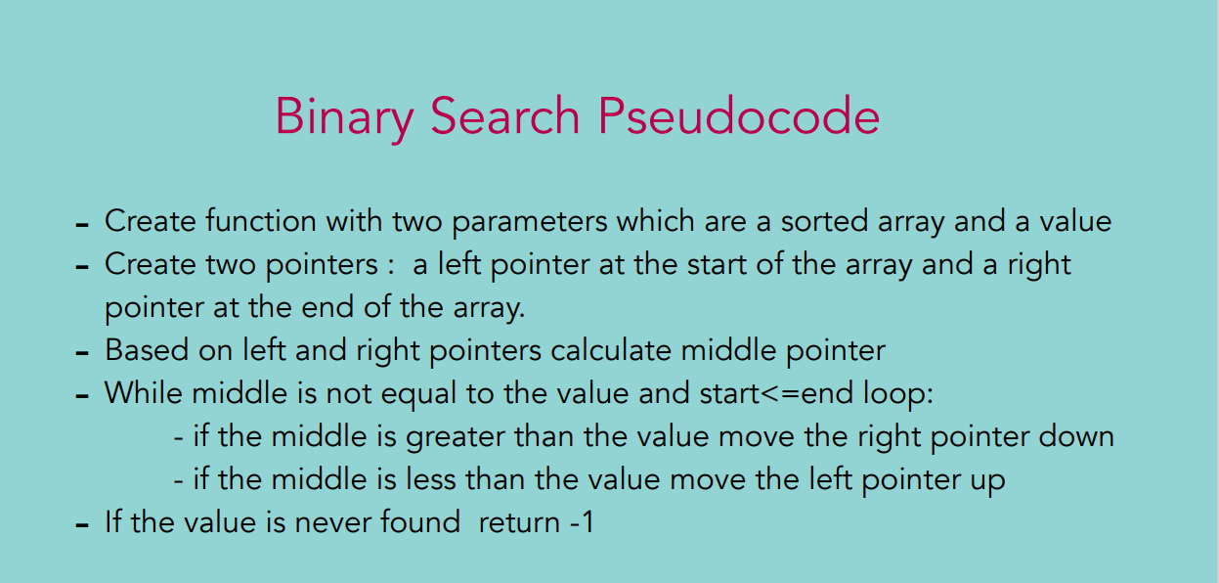

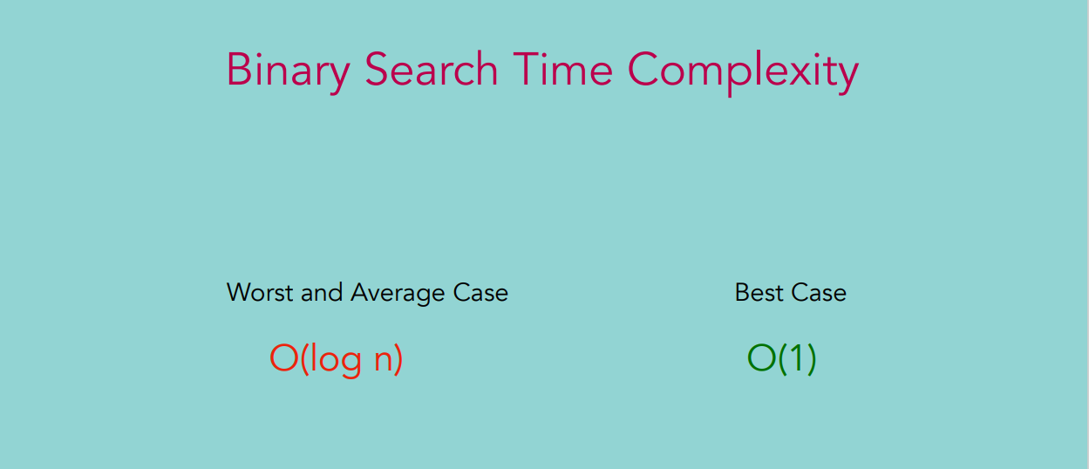

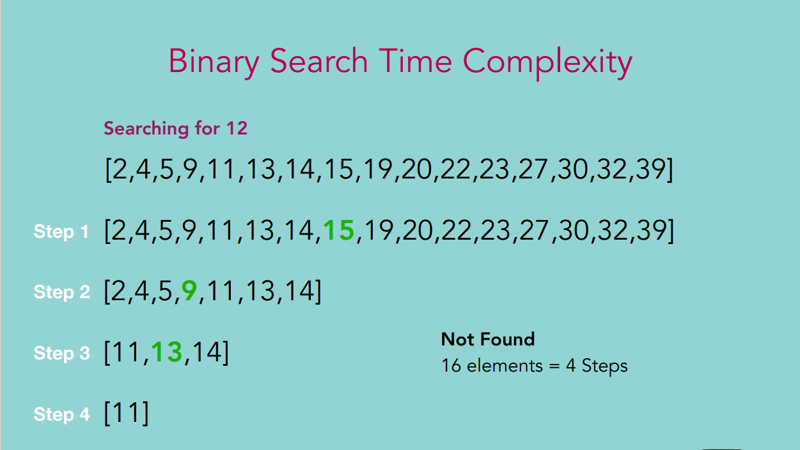

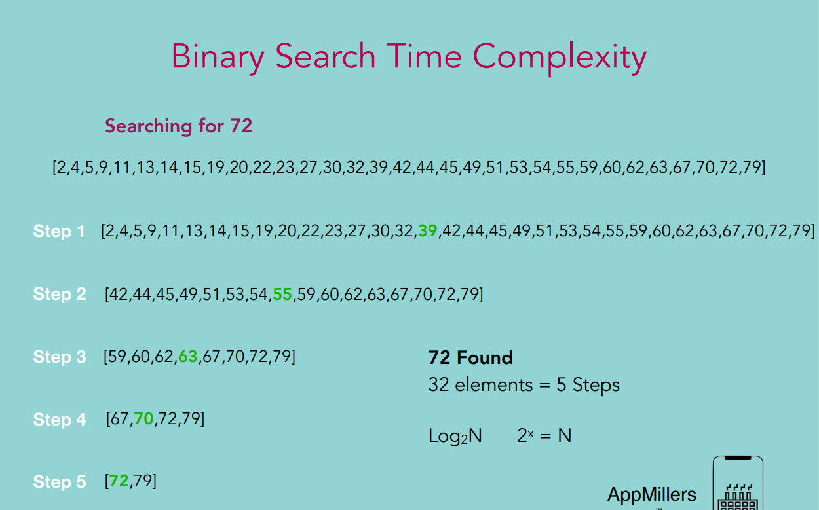

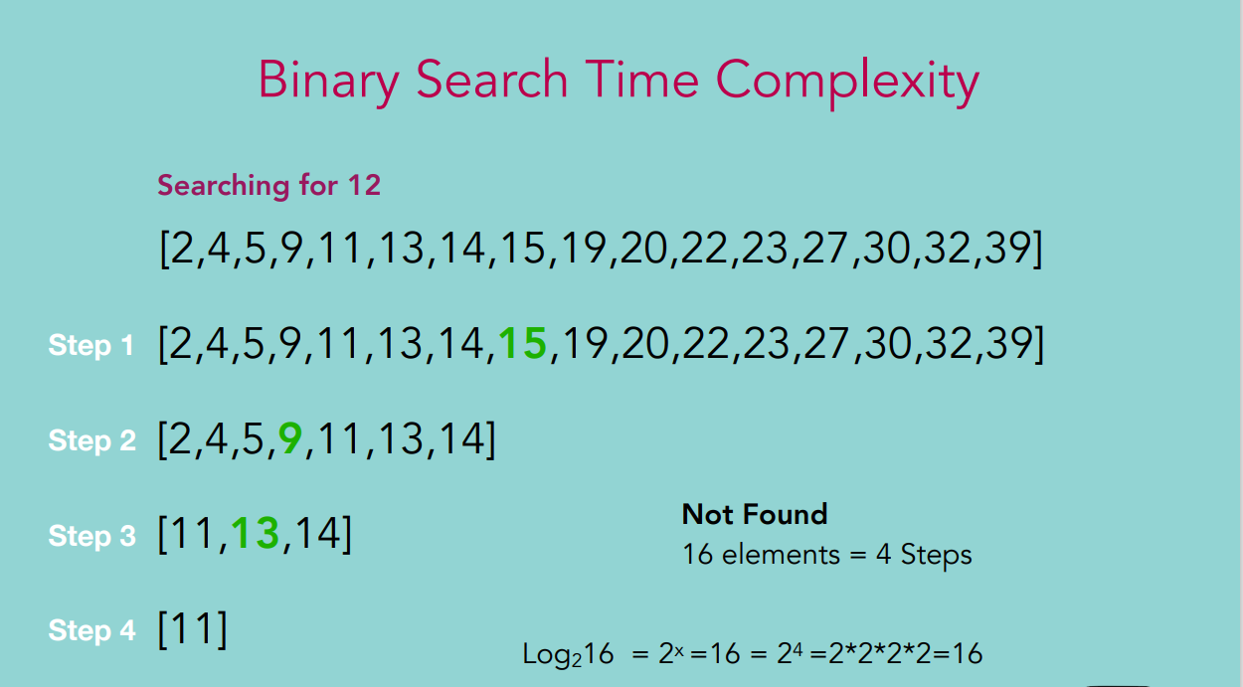

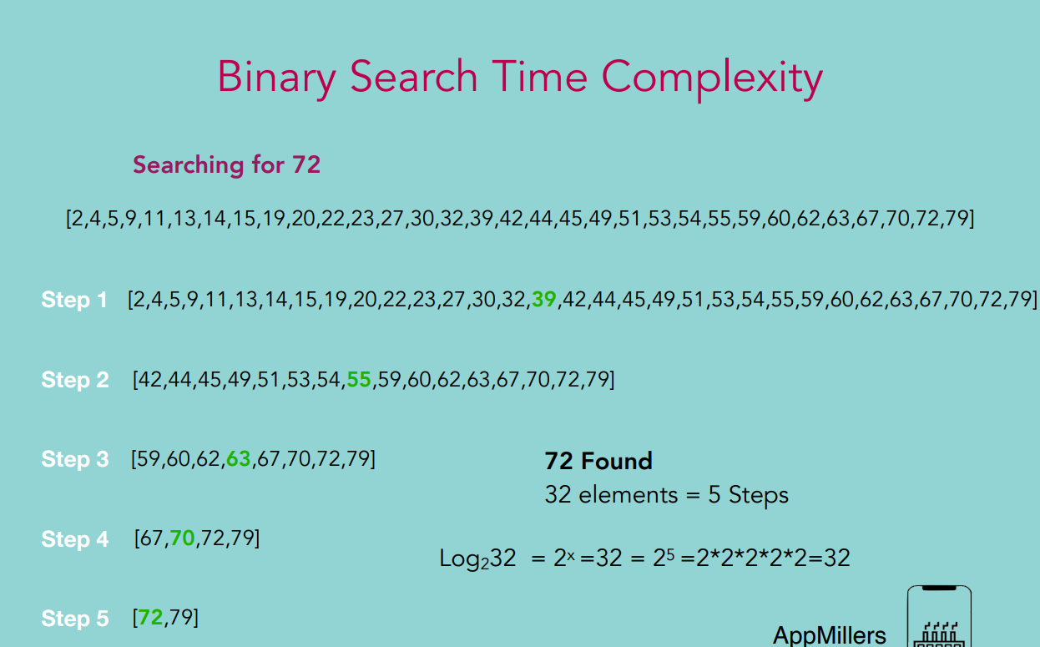

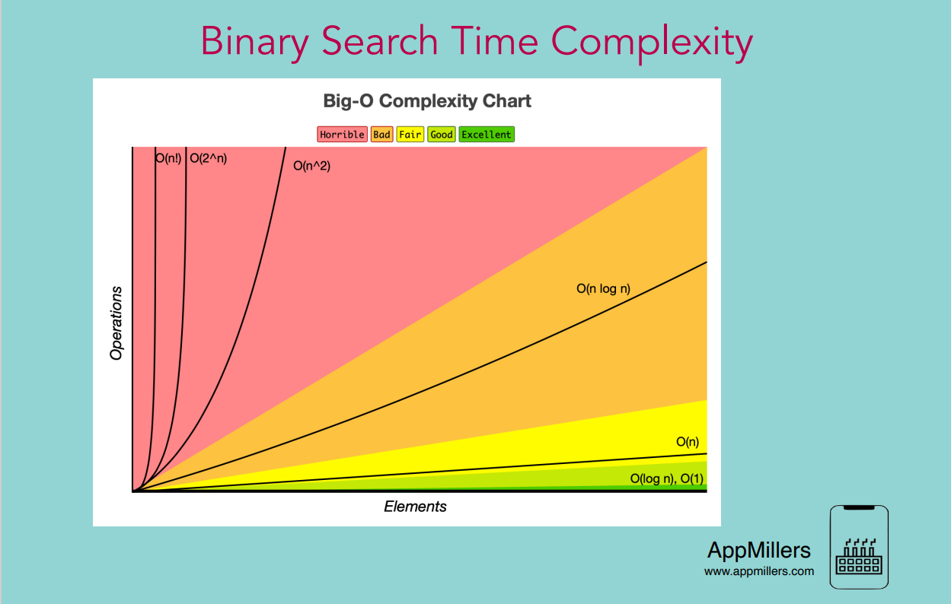

**GRAPHS**

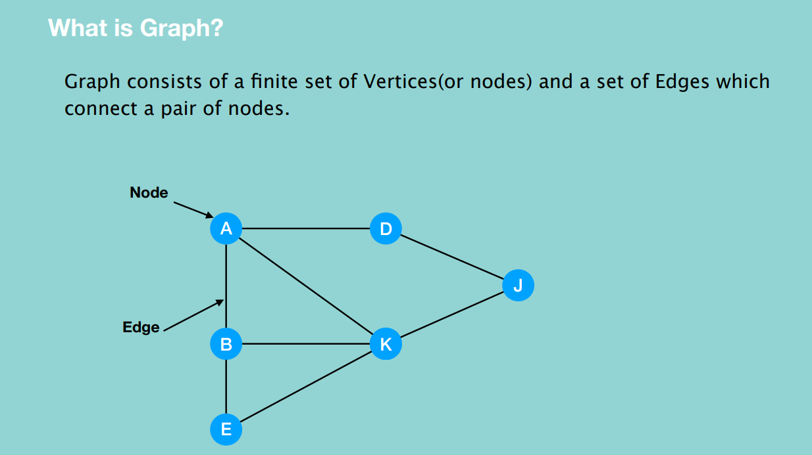

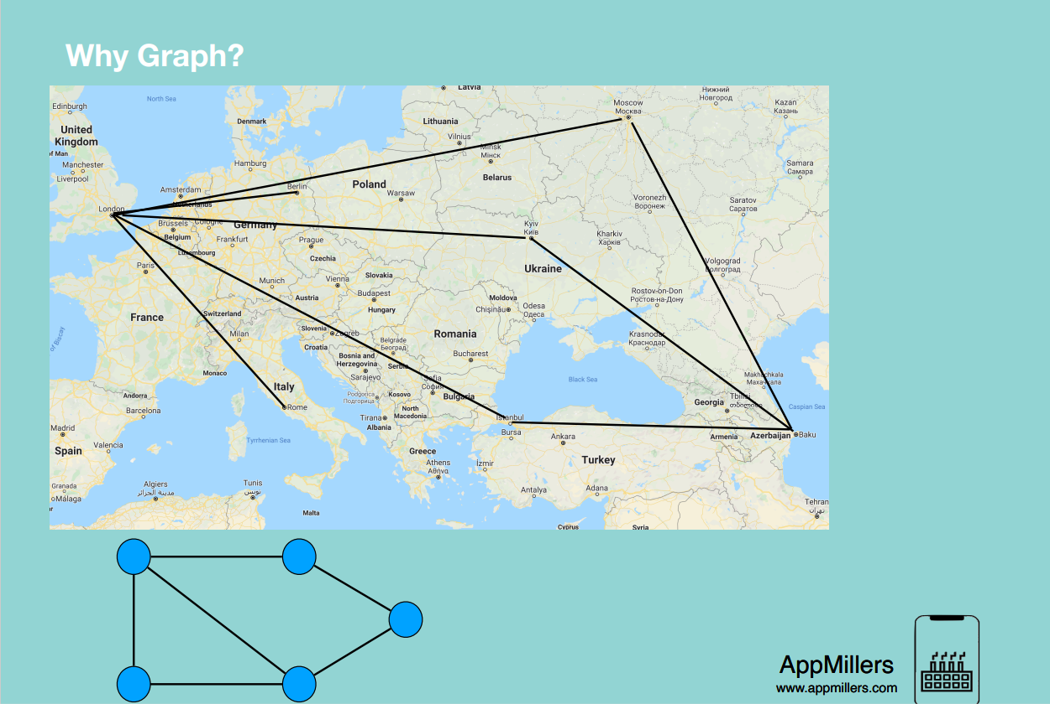

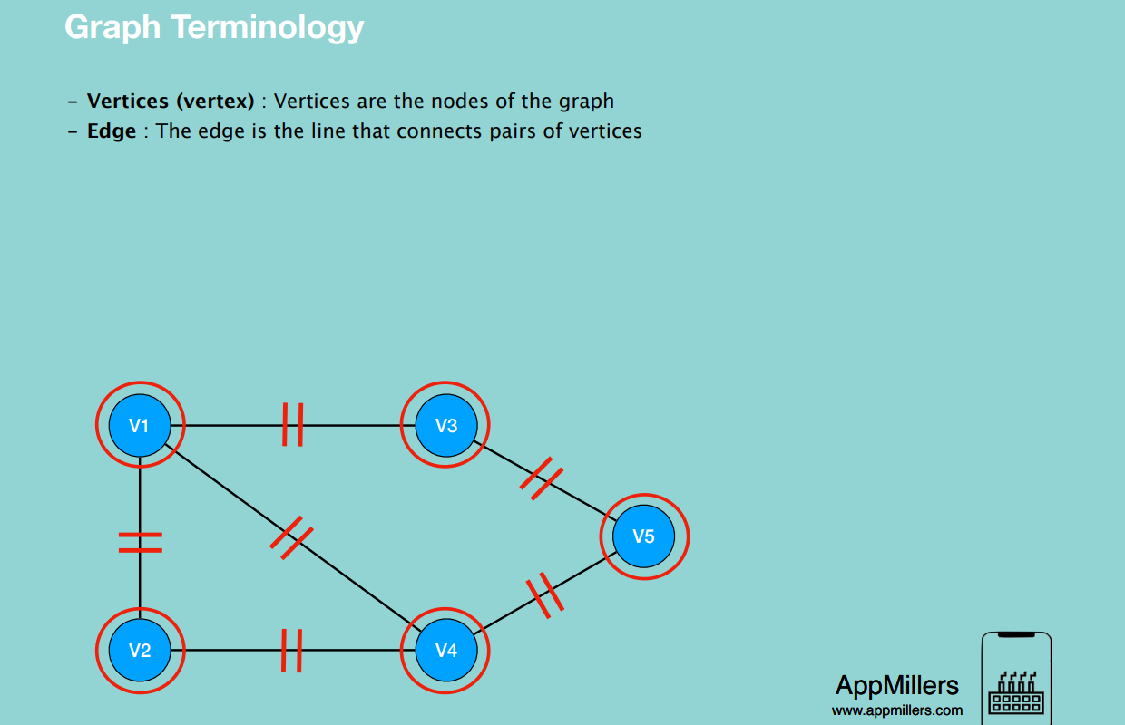

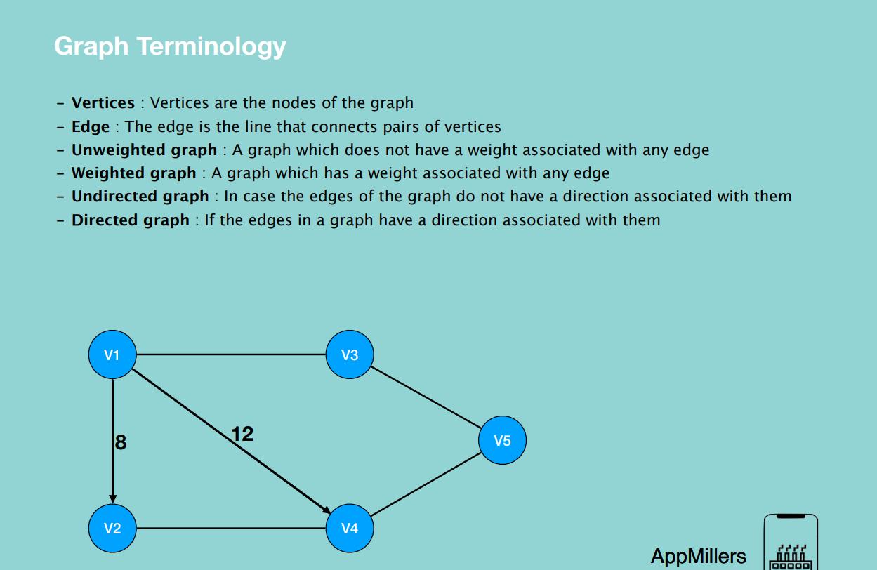

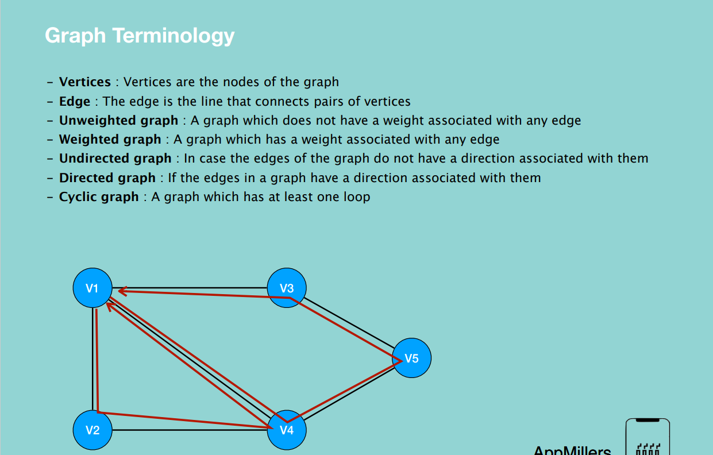

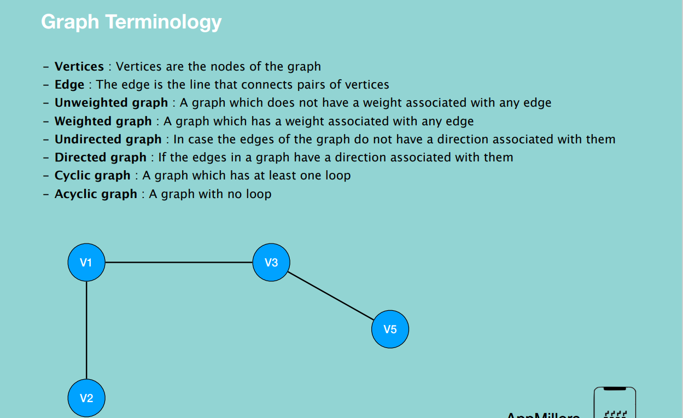

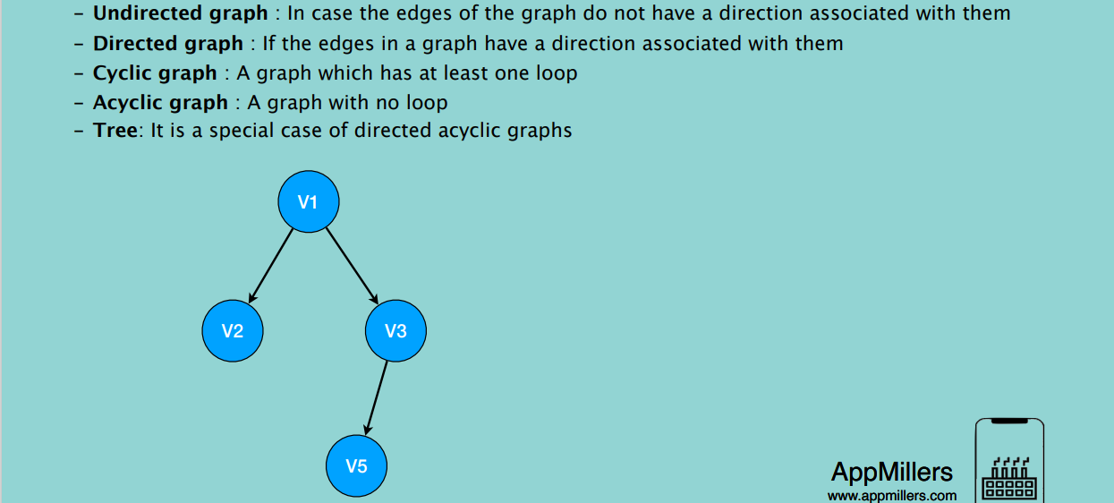

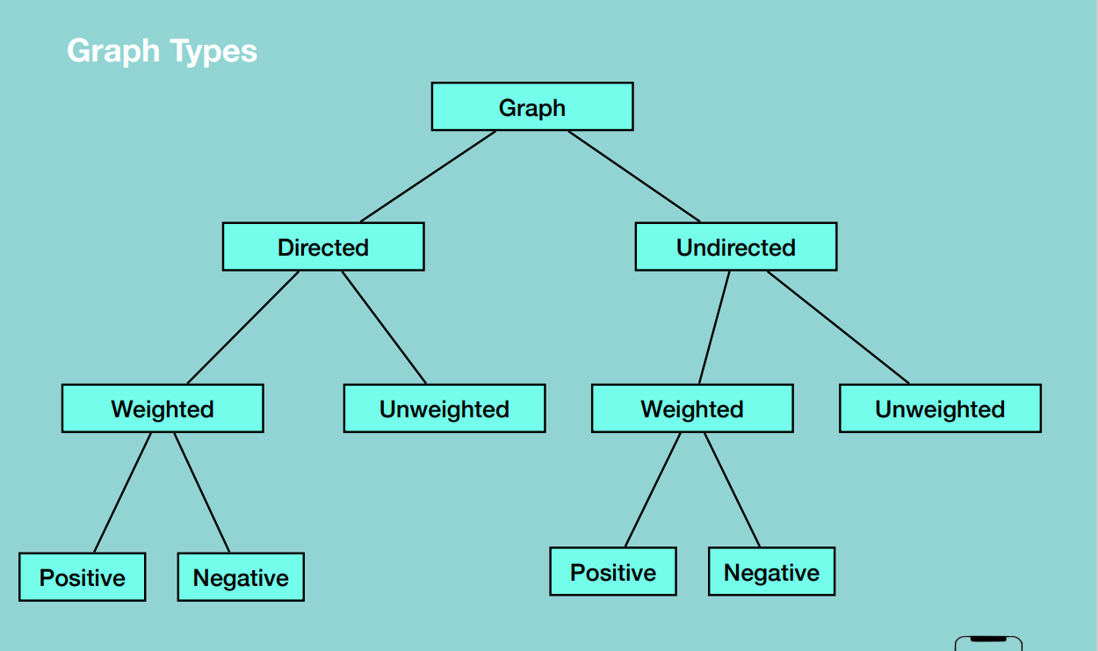

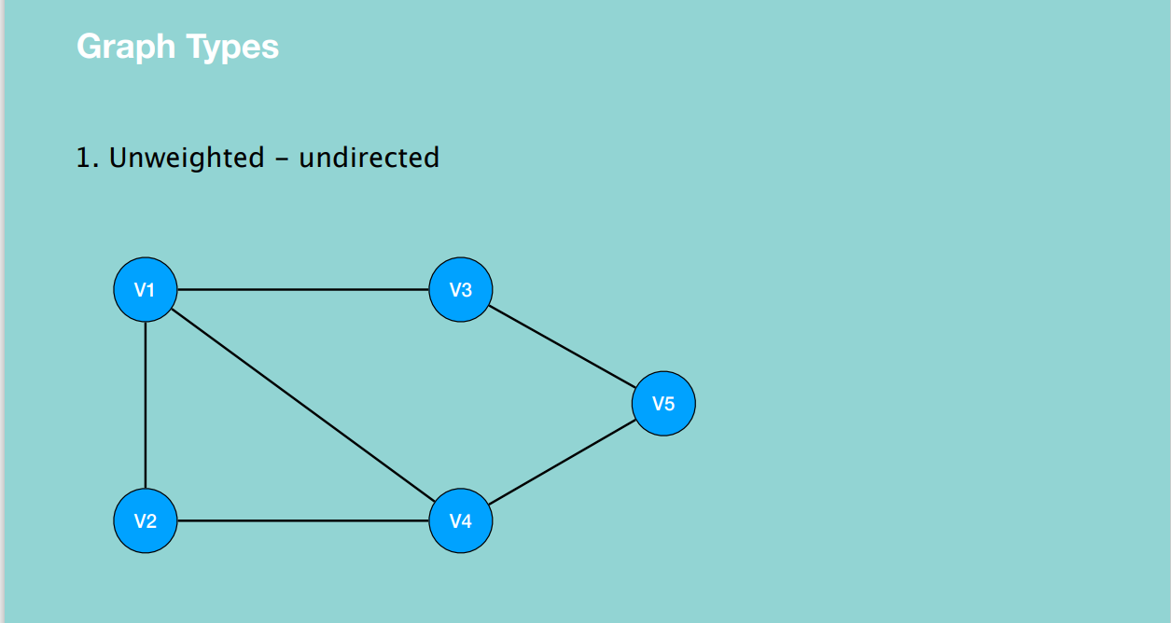

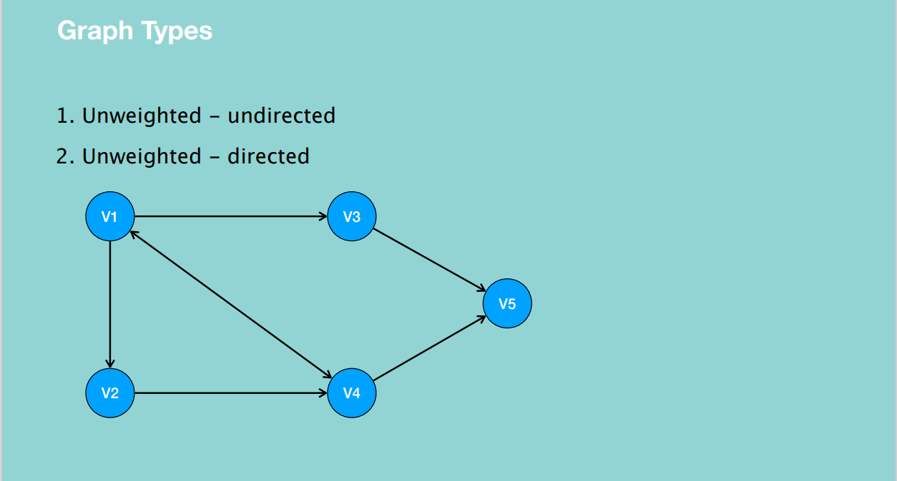

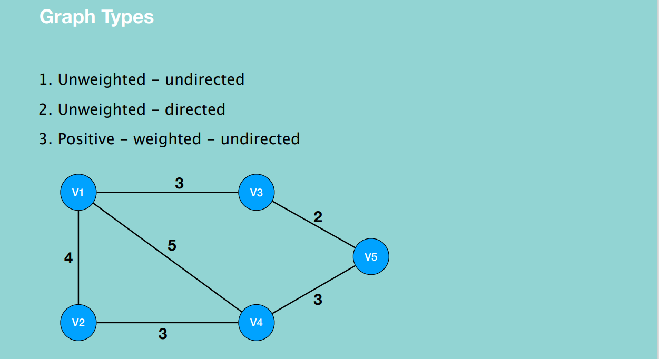

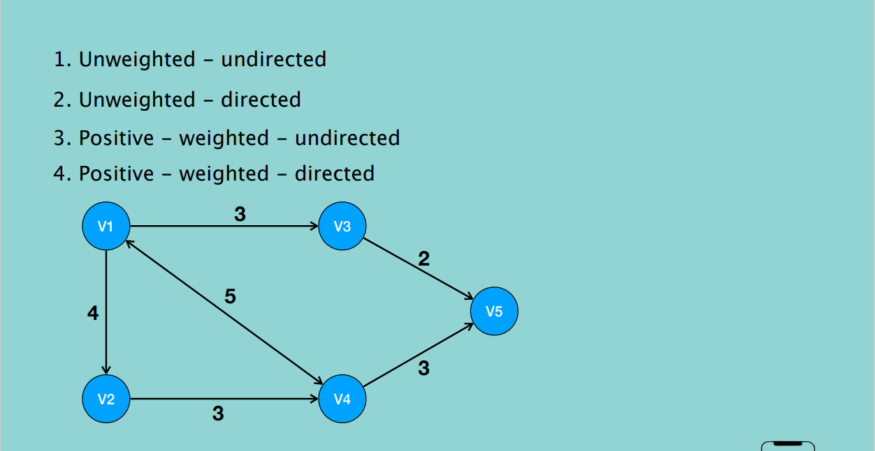

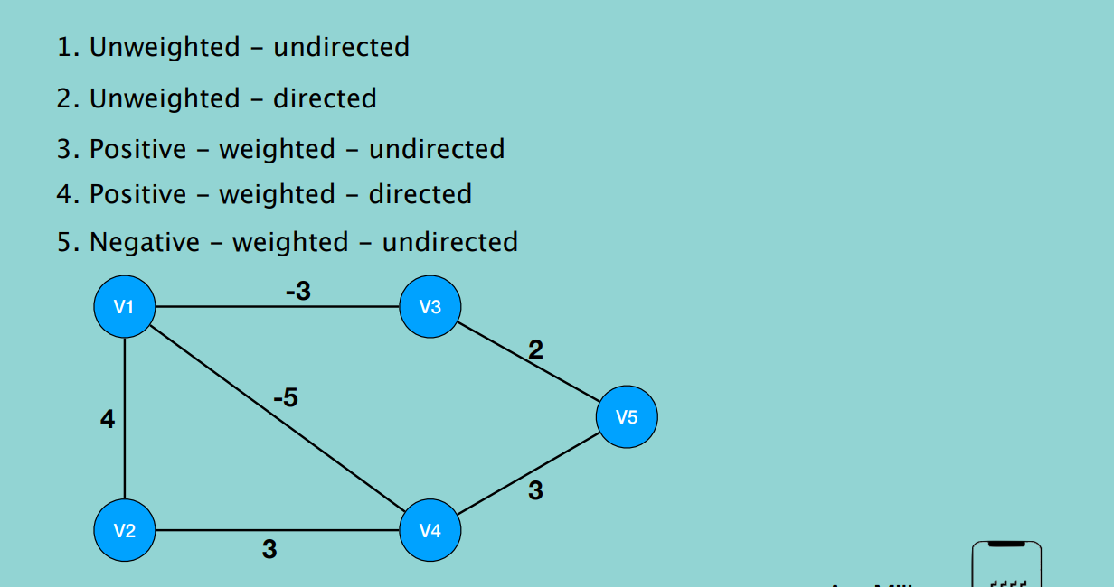

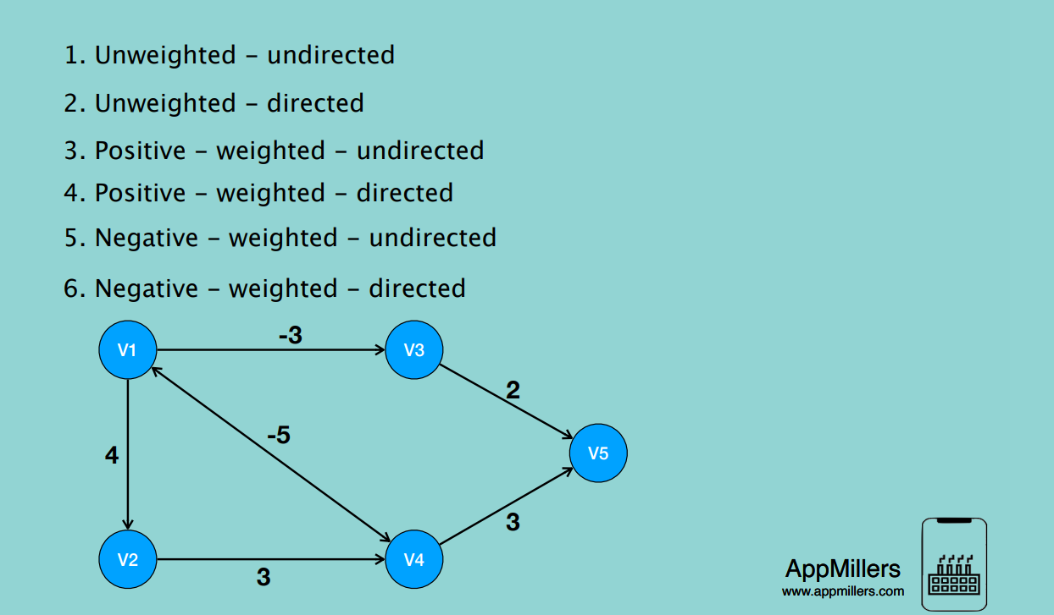

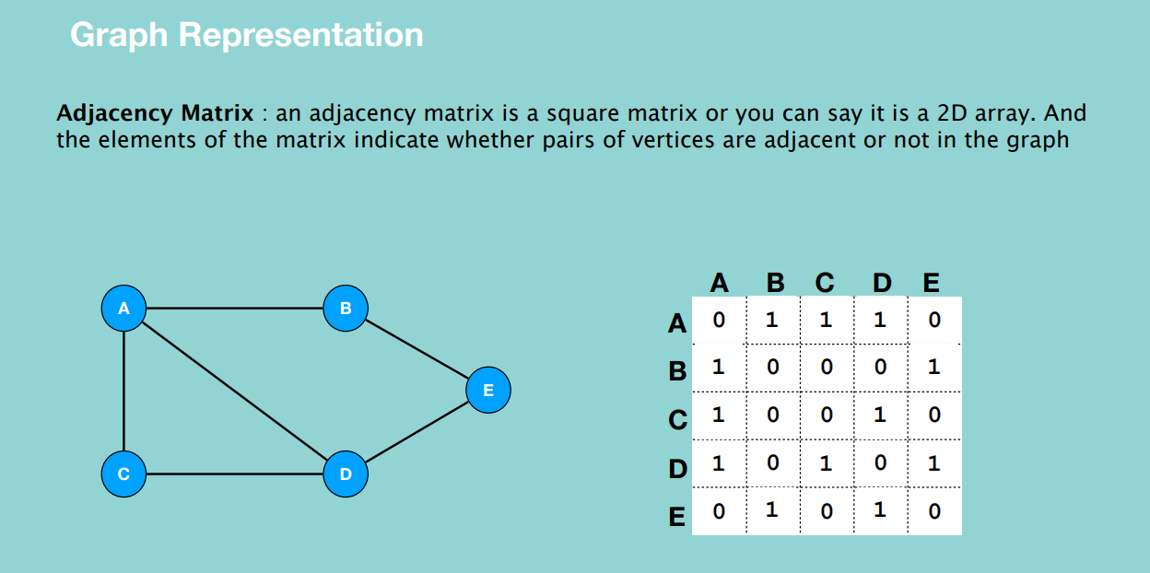

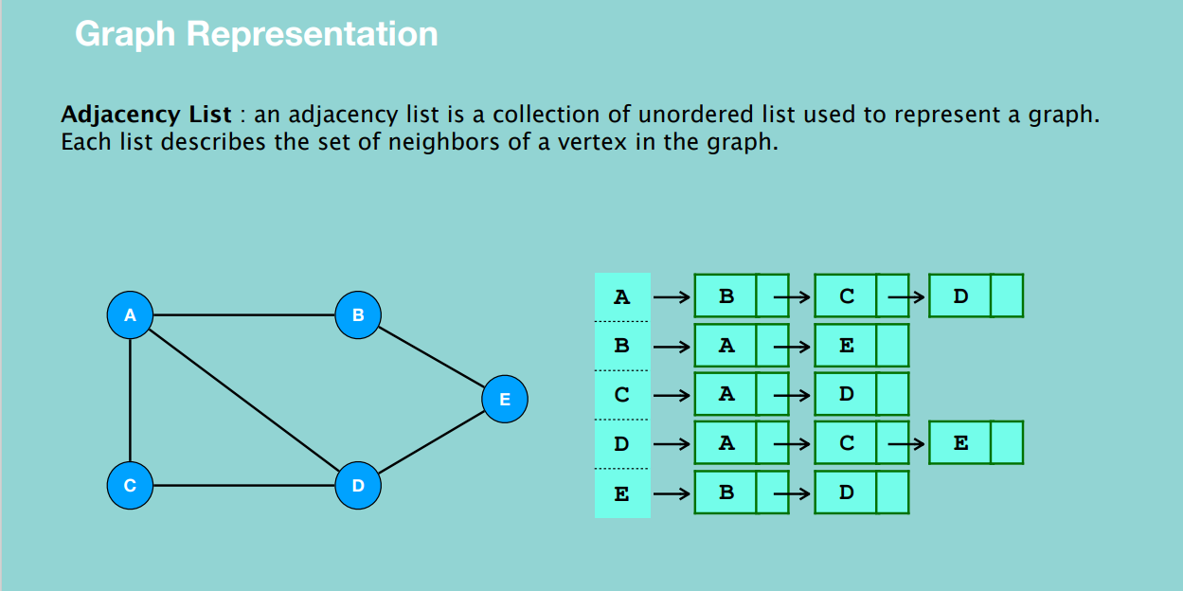

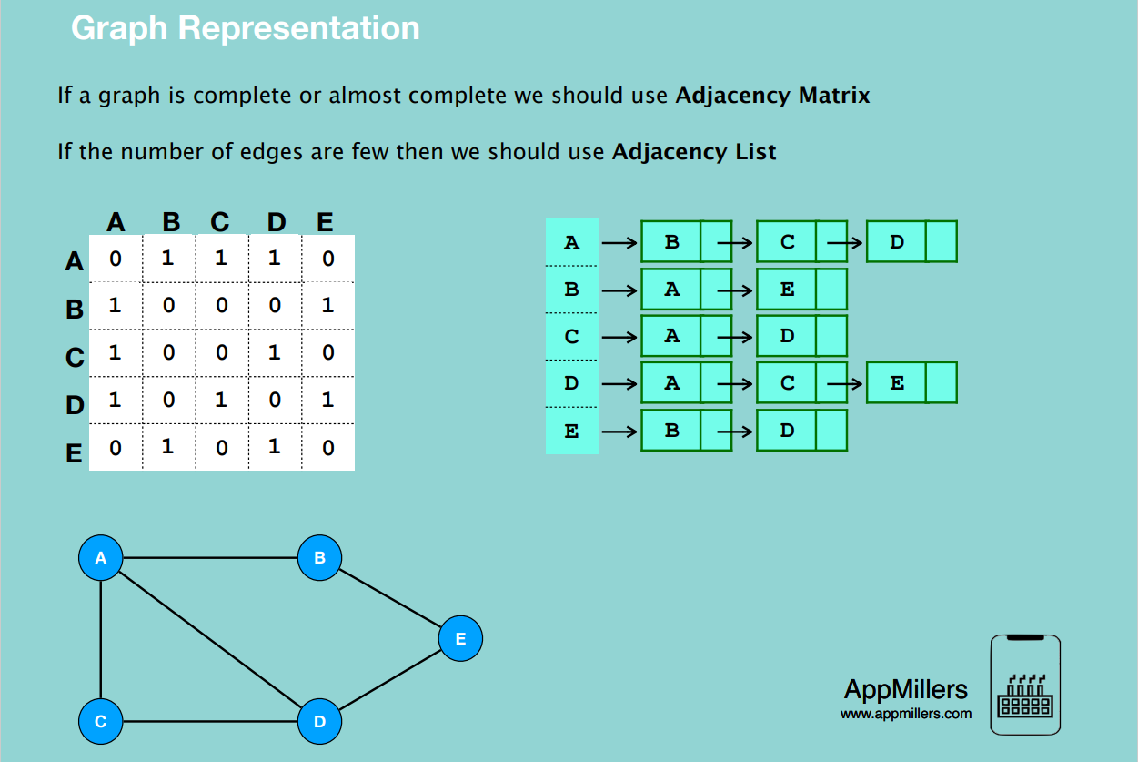

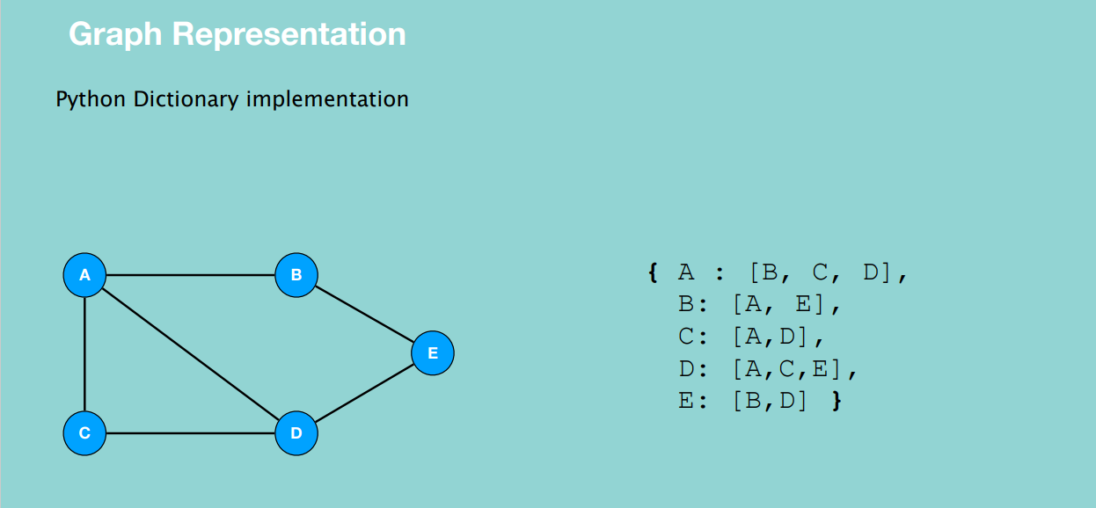

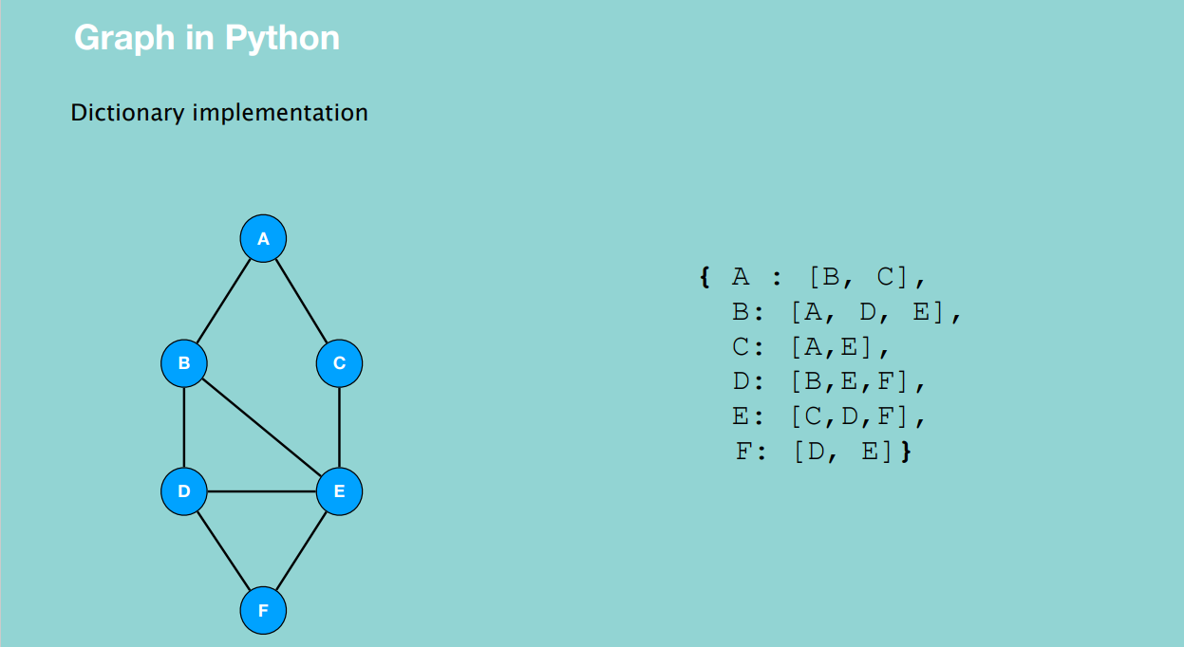

**GRAPH TRAVERSAL**

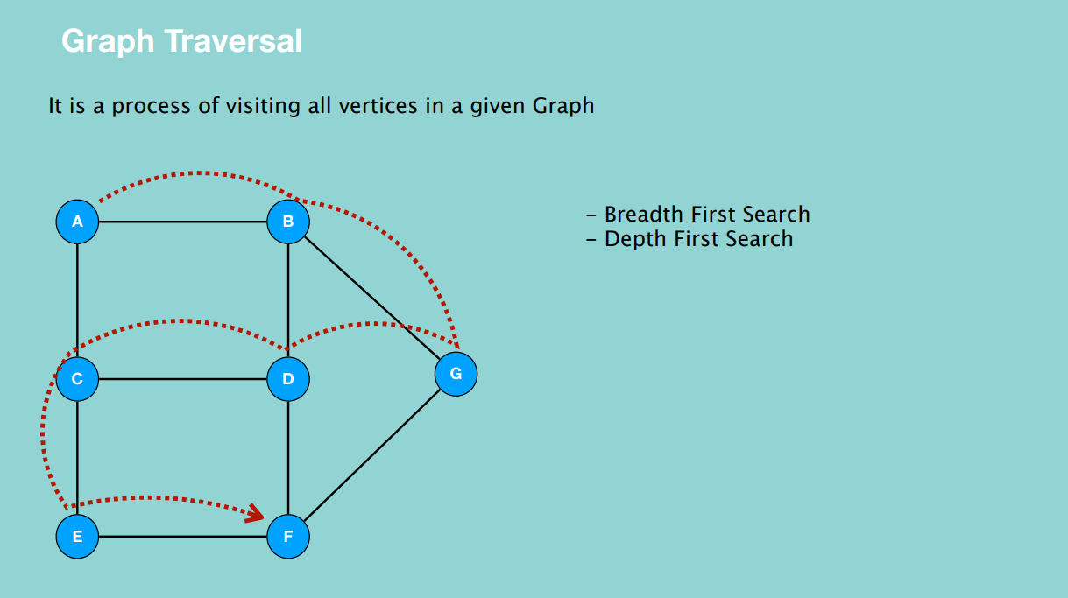

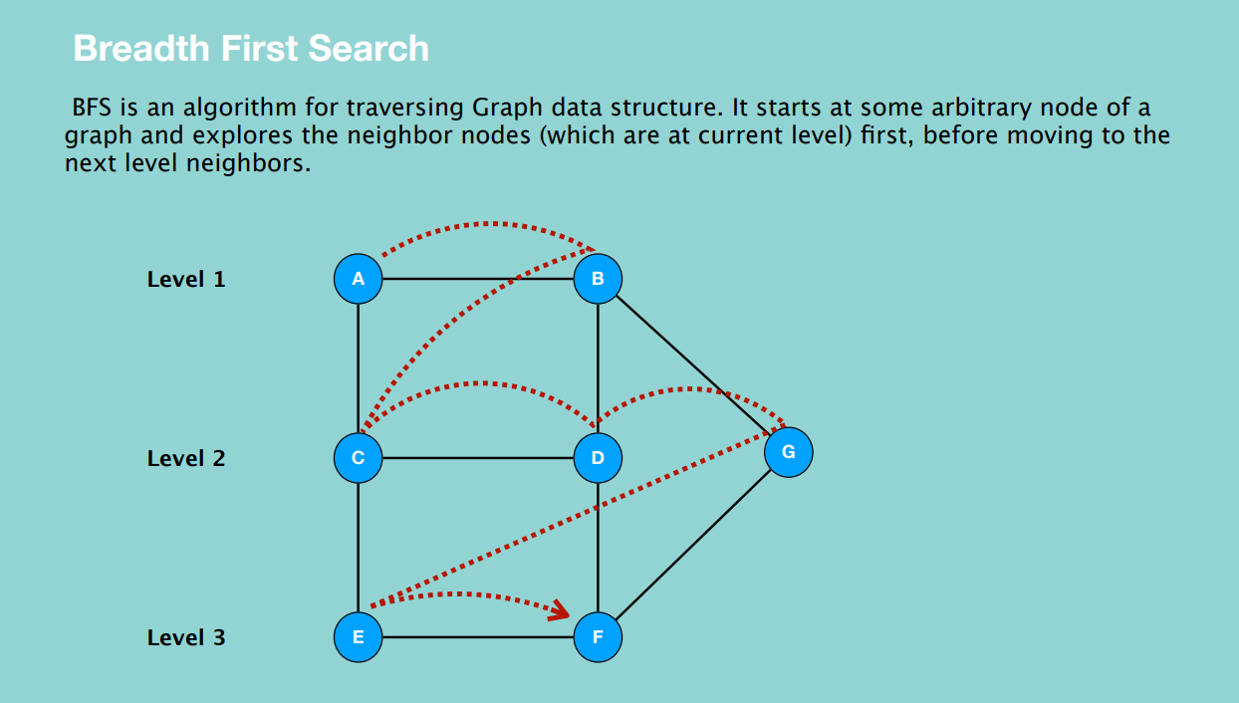

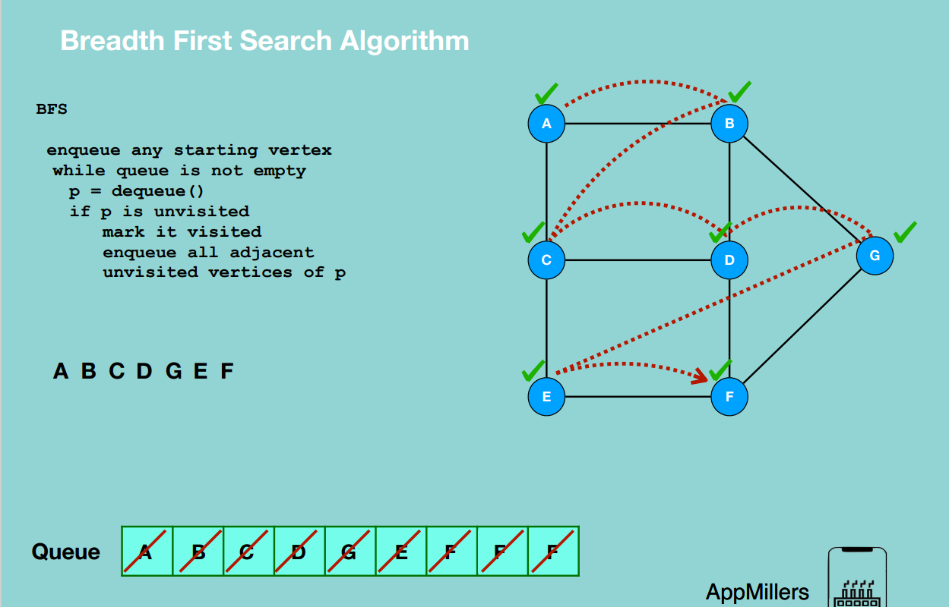

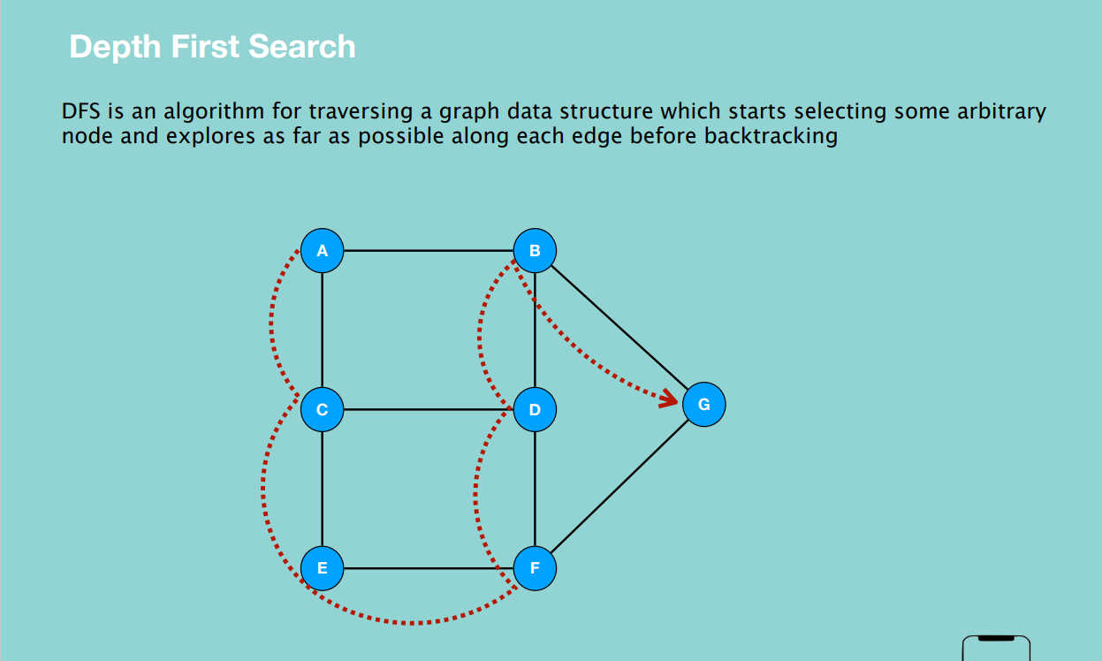

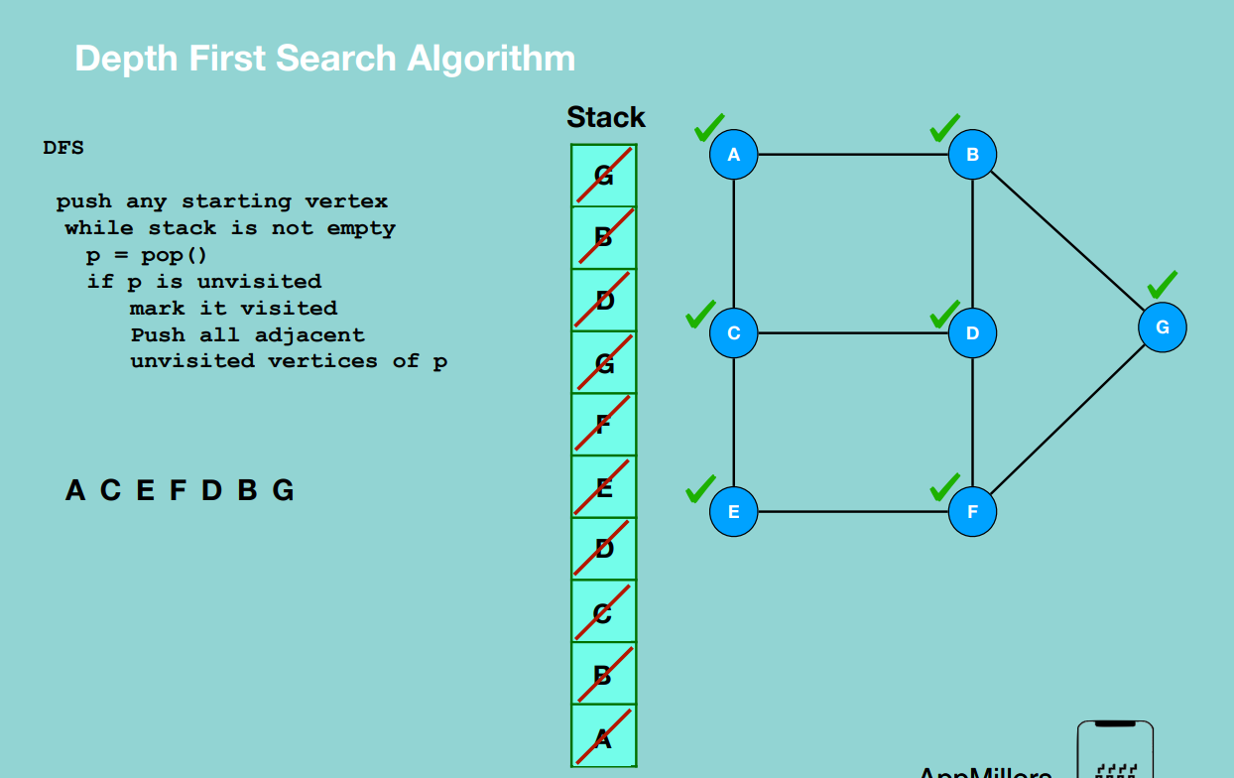

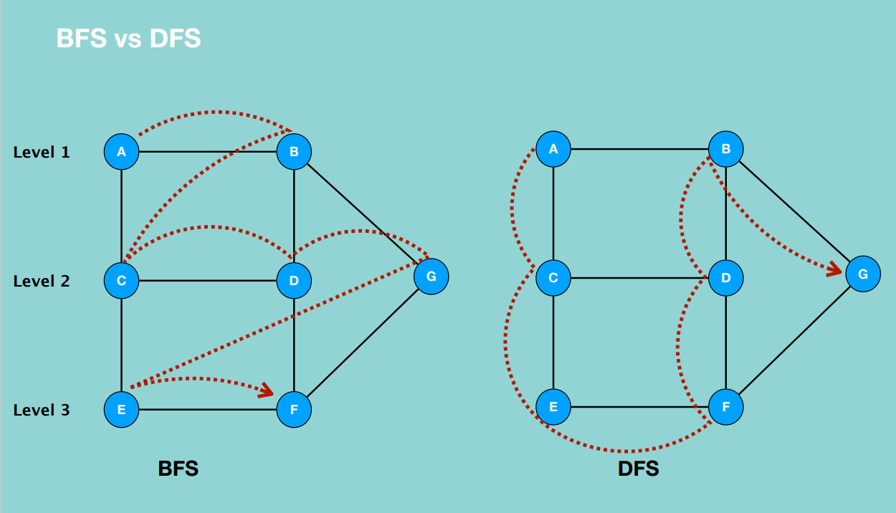

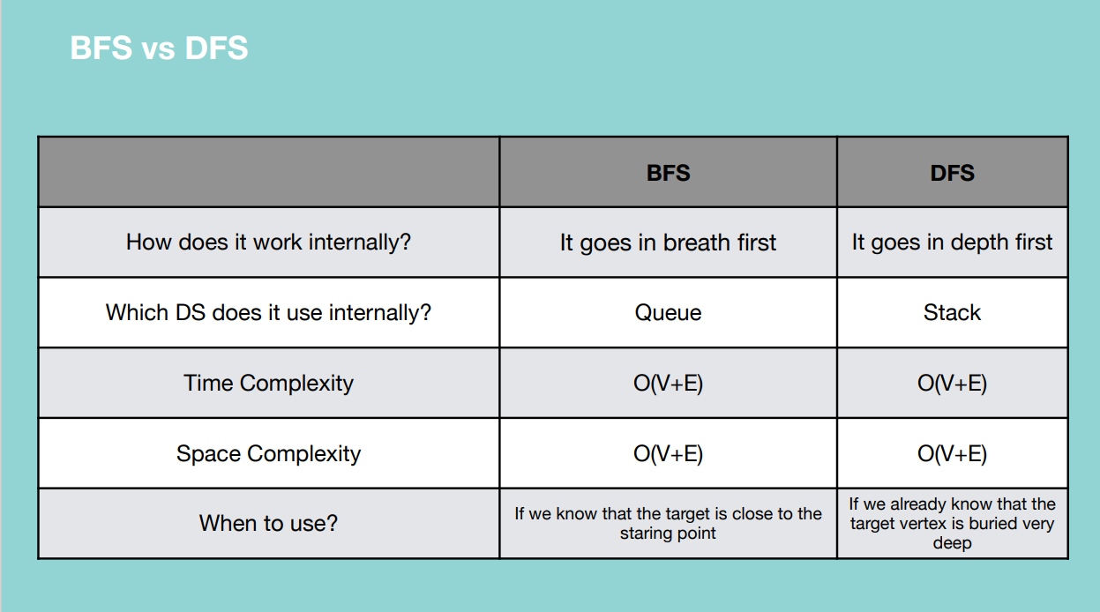

**TOPOLOGICAL SORT**

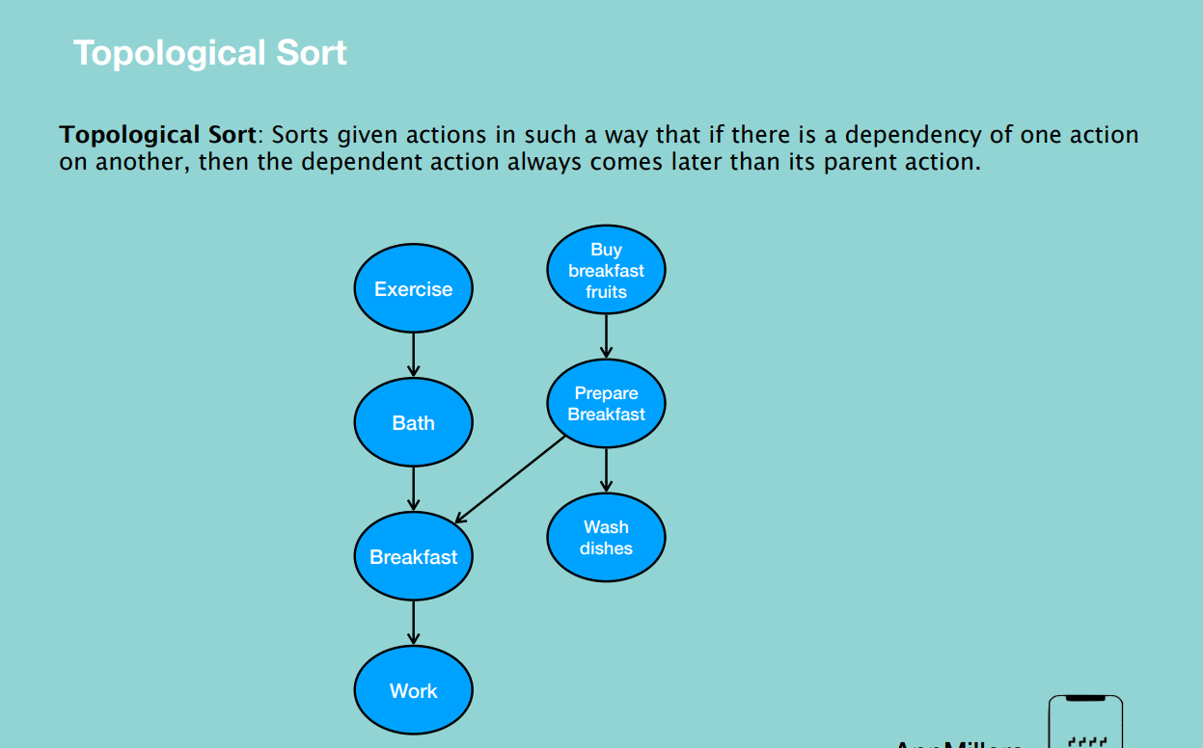

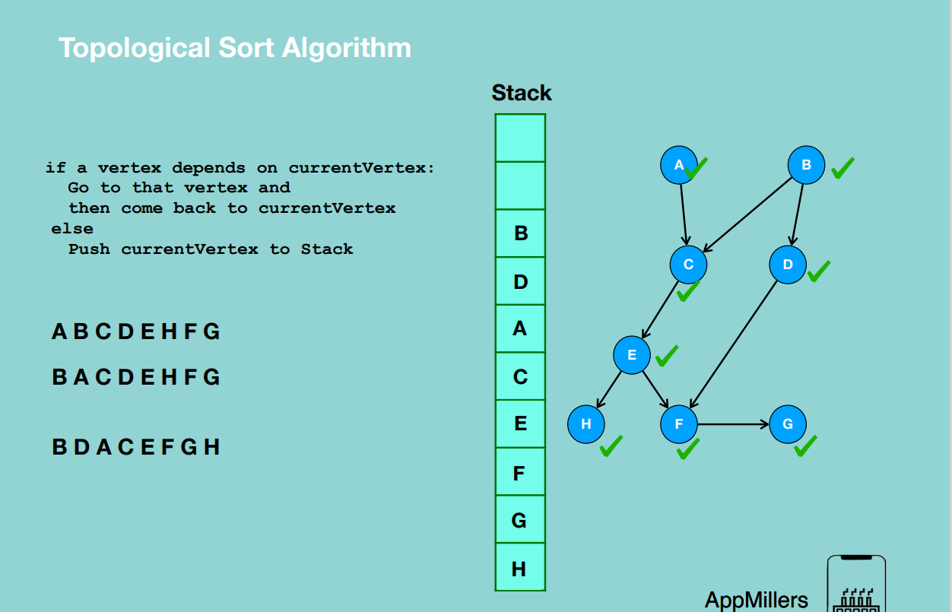

Solutions can be difference based off the vertex you start with.

**SINGLE SOURCE SHORTEST PATH**

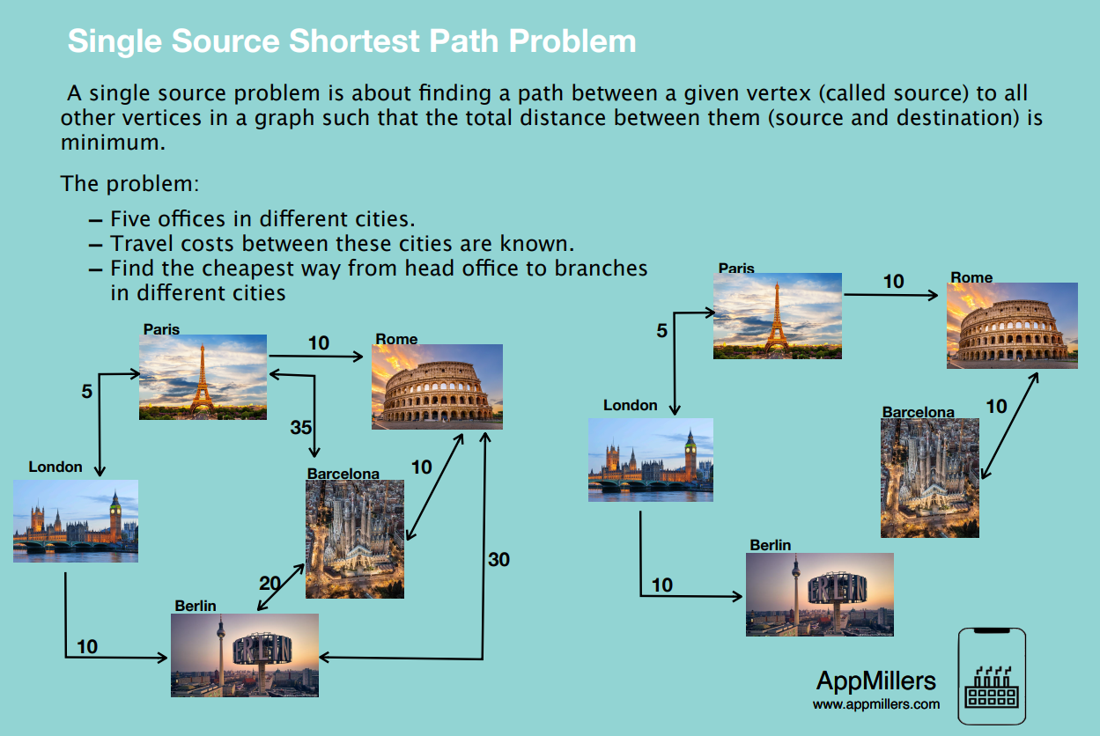

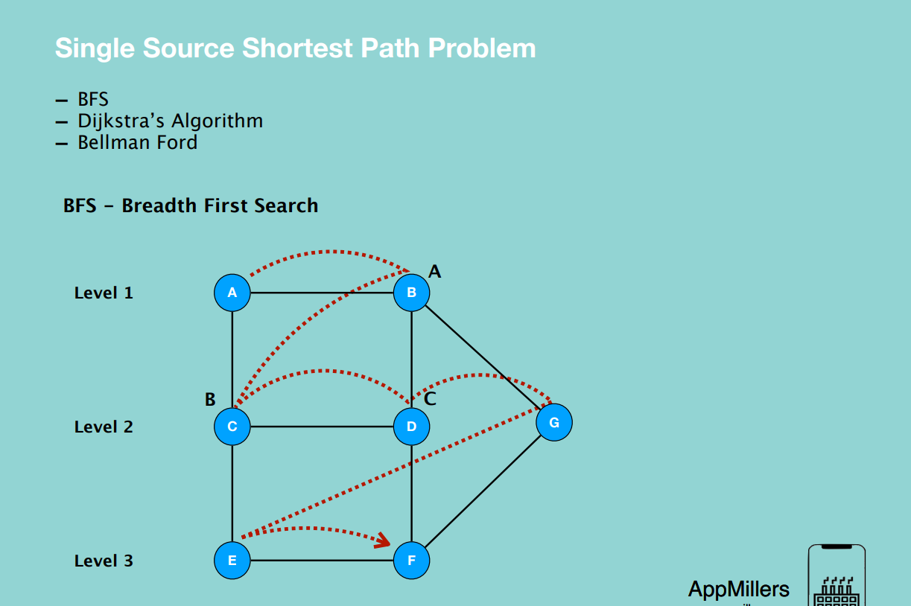

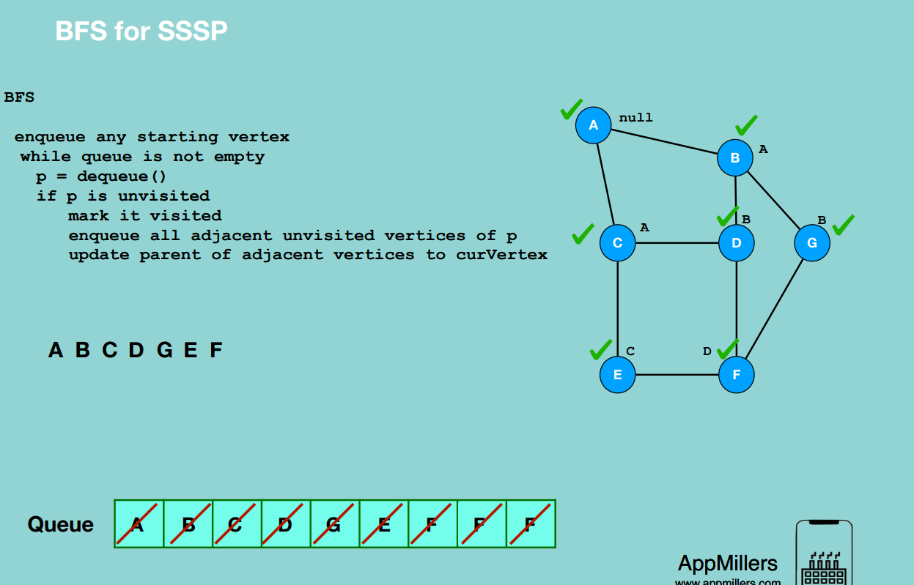

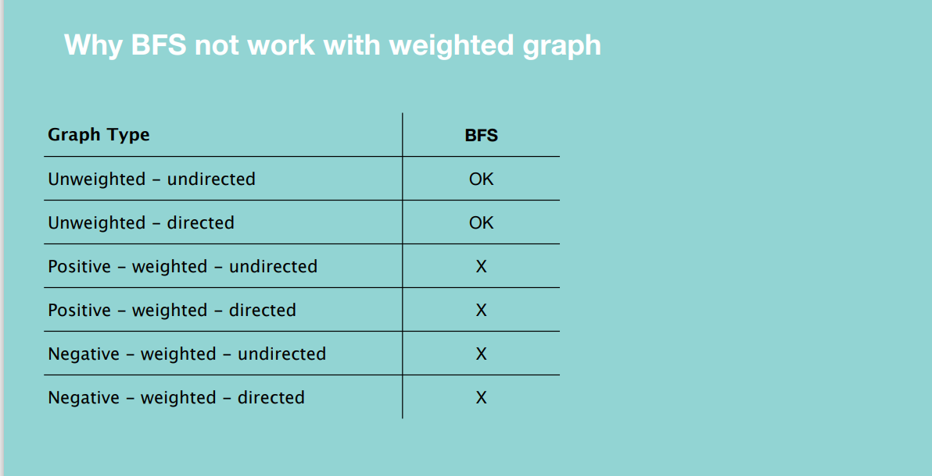

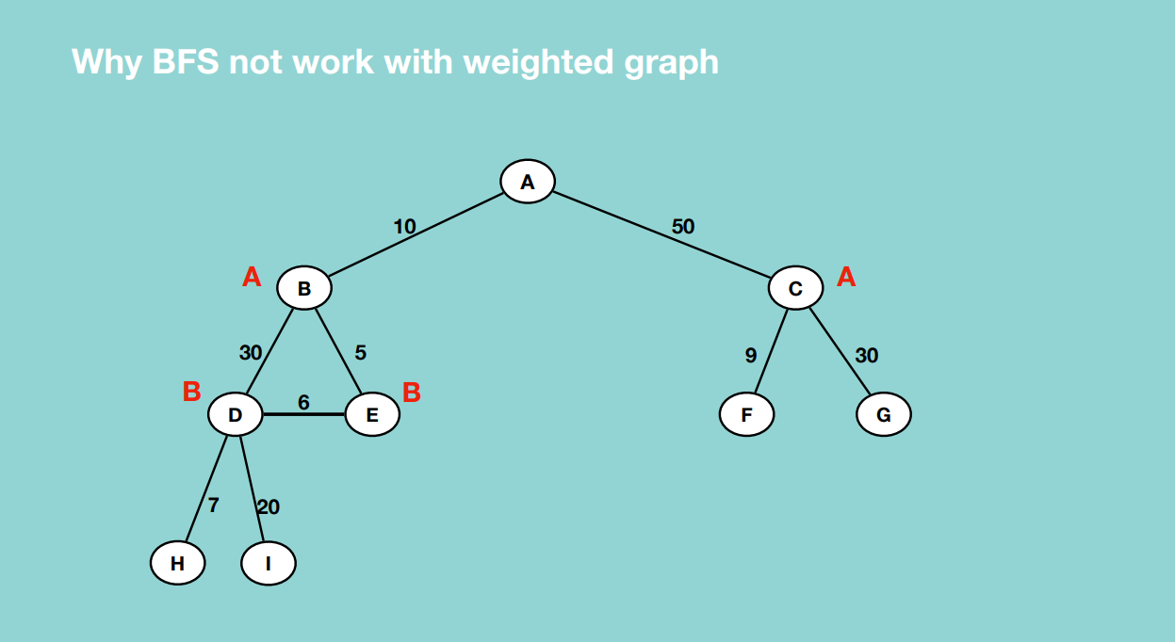

From A to D, we have to go through A, B , D which takes 40 units yet we have a better option of going through A, B, E, D which takes 21 units.

